Introduction

This guide explains how to install the ScoMIS Encryption Service Software onto a laptop computer. There are three stages to the installation which should be completed in order.

The installation has been designed to be completed by the main laptop user, for example the teacher. ScoMIS has made the installation process clear and simple with on screen prompts and check boxes to ensure you are made aware of the important information and steps.

Installation Summary

The first step involves backing up data on the laptop onto removable storage or the school network. This is important because if the hard drive inside your laptop has a mechanical defect the encryption process may cause it to fail. The second stage involves a CHKDSK which is a windows utility to check the health of the hard drive and finally the actual encryption installation itself. Although the steps should be completed in order they do not have to be done immediately after one another. You could backup the data at school one day; run CHKDSK a couple of days later at home before finally installing the encryption software in school a few days later (bear in mind any work done between backup and installation would be at risk).

Contents

Chapter 1 – Backing Up Your Data 2
Chapter 2 – Running a CHKDSK 3
Chapter 3 – Installing the Encryption Software 5
Chapter 4 – Getting help and support for problems 18
Chapter 6 – The ScoMIS Encryption Maintenance Utility 20
Appendix A – Removing / re-installing the encryption software 21
Appendix B – How the encryption software works 22

Chapter 1 – Backing Up Your Data

The encryption software installation is a major change to your laptop, all data is rewritten during encryption so can be at risk in the event that something goes wrong with the installation. It is therefore vital that you take a backup of all of your data before moving onto step 2 and 3.

Before backing up your data check with the person responsible for ICT in your school for advice on how you should carry it out. Each school will have a different setup in regards to their users, network & server configuration so unfortunately we can’t provide definitive instructions in this guide.

General Guidance on Backup:

- Your backup needs to be on an external device such as the school network drive, a CD-R/DVD-R or removable USB device.
  - It is no good simply copying your data to a folder on the laptop itself as this will be lost if there is a problem during the encryption installation
- To backup your data you can either use the windows utility, simply copy your files and folders onto the backup location or use a third party backup utility.
  - To launch the backup utility in Windows XP go to: Start > All Programs > Accessories > System Tools > “Backup”
  - To launch the backup utility in Windows Vista go to: Start > Control Panel > System and Maintenance > “Backup and Restore Centre”
  - To launch the backup utility in Windows 7 go to: Start > Control Panel > System and Security > “Backup and Restore”
- After backing up you should test that you can restore a file to prove that your backup worked successfully.

Important:

- If you backup your data onto a removable media such as a CD-R/DVD-R or USB device ensure that it is kept in a secure location such as the school safe.
- Never keep the backup media with the laptop in transit, for example in the laptop carry case

Chapter 2 – Running a CHKDSK

Before installing the software for the ScoMIS Encryption Service installation we need to run a process to check that the Hard Disk inside your laptop is mechanically healthy.

- Depending on the size of your Hard Disk and speed of your laptop this can take anything from 30 minutes to 3 hours.
- It can be set to start and left to run providing the computer is plugged into the mains as the battery is likely to run out otherwise.
- You do not need an internet connection so it can be run at home.
- Once started it cannot safely be interrupted so please bear this in mind when choosing when to run this process.
- Close any applications you have open before starting this process.

Log into windows as normal  Click Start > “Run” | 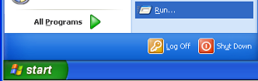
Enter "cmd" in lower case without the quotes  Click “OK” | 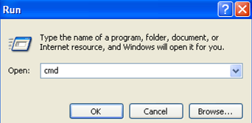
In the black window type  CHKDSK C: /R  Hit “Enter” | 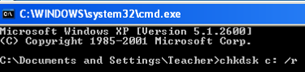
Type “y” and hit “Enter” | 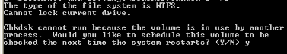
You should see a confirmation that the process has been set to run with the computer’s next start. | 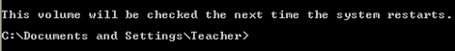
Restart Windows | 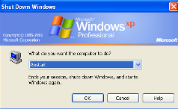
Before Windows loads you will see the following screen as the CHKDSK process runs | 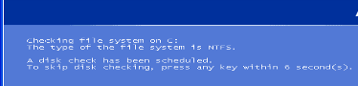
Depending on the speed and size of the hard disk inside your computer it may take up to three hours to complete | 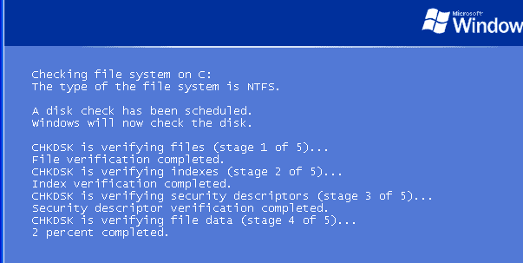
After it has finished Windows will load normally | 
You are now ready to move onto the next stage of installation

Chapter 3 – Installing the Encryption Software

This is the third and final part of the ScoMIS Encryption Service installation. Before proceeding you should have completed the preceding steps:

- You have completed step One and backed up your data
- You have completed step Two and run the CHKDSK procedure

Before we begin you should also have:

- Been given the installation password
- Been given the ScoMISEncryptionService.exe network location
- Arranged enough time to complete the installation which takes approximately 30 minutes and must not be interrupted
- Connected your laptop to the mains power supply
- Connected your laptop to the internet, either at home or on the school network either with a network cable or through Wi-Fi

Launch the  ScoMISEncryptionServiceSetup.exe  (to do this double click the icon) | 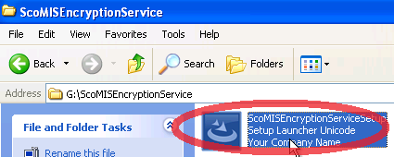
Choose to “Run” on any file security warnings you receive | 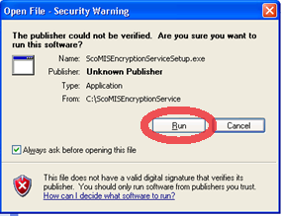
Wait for the setup process to be extracted | 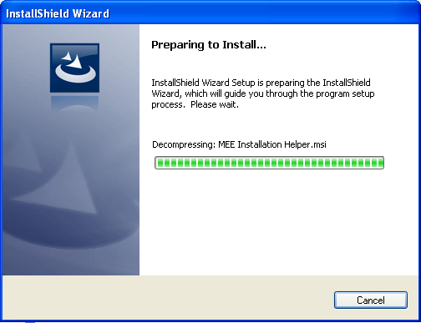
Click Next | 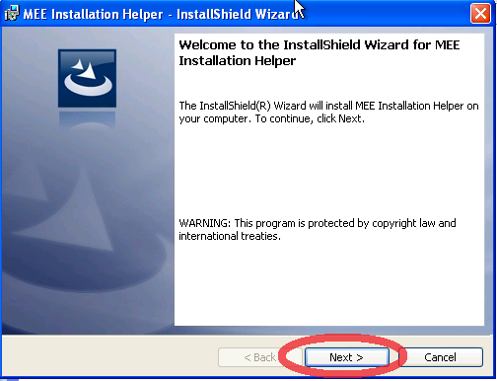
Click Install | 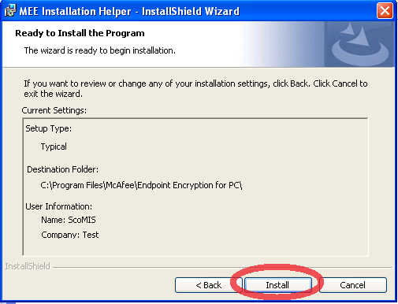
Click Finish | 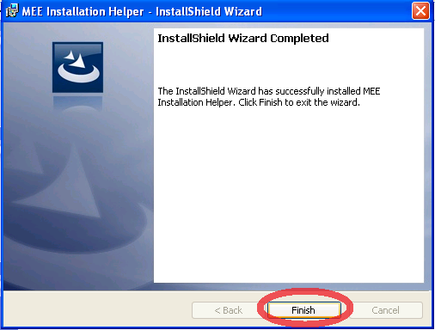
Enter your school’s 7 digit DfES/DCSF number  Enter the password that was emailed to your school  Click Continue | 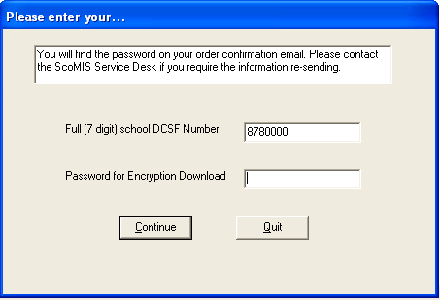
Read and understand the backup and CHKDSK confirmation  If you are unsure please refer to the previous chapters for instructions | 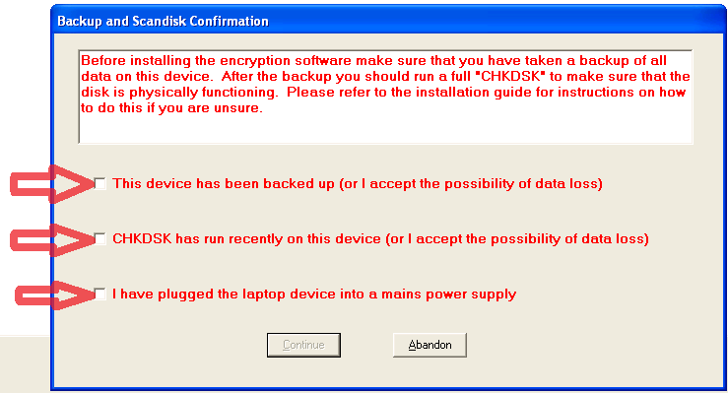
1) Once you are confident that the device has been backed up, tick the box.  2) Once you are confident that the CHKDSK has been run or you accept responsibility that your data may be lost, tick the box.  3) Check that your laptop is plugged into a power supply; do not rely on the laptop’s battery alone. Then put a tick in the box.  If you are unable to confidently tick these boxes then click the abandon button.  Otherwise Click Continue | 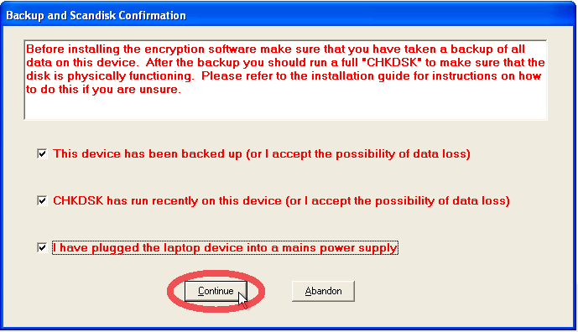
Wait whilst your laptop makes some checks until you see the ‘Installation Confirmation Screen’ | 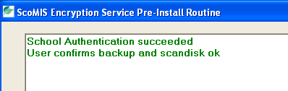
Once your laptop has passed its check you will be given an option.  If you do not have time to complete the installation which should take approximately 20 minutes then ‘Quit without installing’  Otherwise click ‘Continue with Encryption Installation’. | 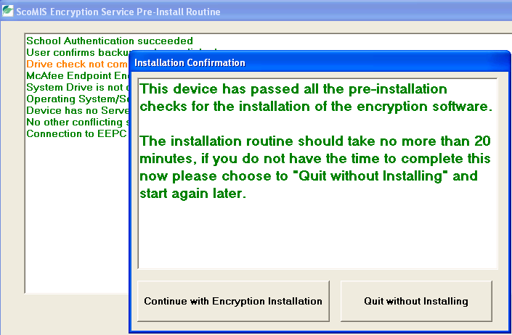
After the setup status completes you will receive a warning as it is important to follow the installation through to the end. | 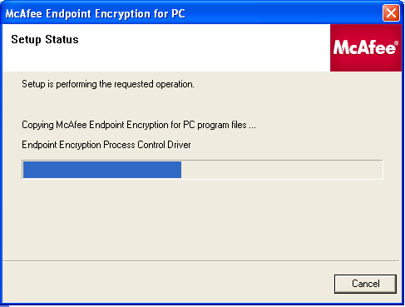
DO NOT shut down your computer. DO NOT disconnect from the internet or terminate the process in anyway.  Please note that the process will involve restarting your computer on two occasions. | 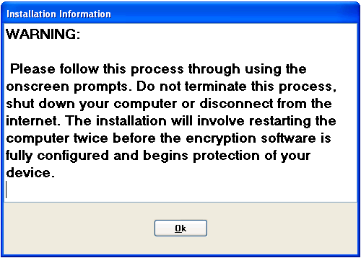
You will need to create/assign a user of the ScoMIS Encryption Service.  If you are not already a user of the ScoMIS Encryption Service ensure the option ‘New User’ is selected.  Then click next. | 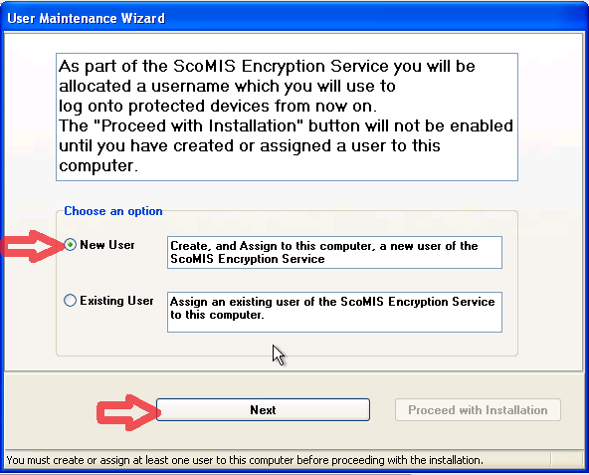
Enter your first name and your surname into the appropriate boxes  (has to be lower case).  Look at the preference boxes – please note if somebody else has the same name as you and already has an account in our database it will be necessary for the software to assign a numeric suffix to your user name.  You will be informed of your user name on a later screen.  Click “Create and assign user”. | 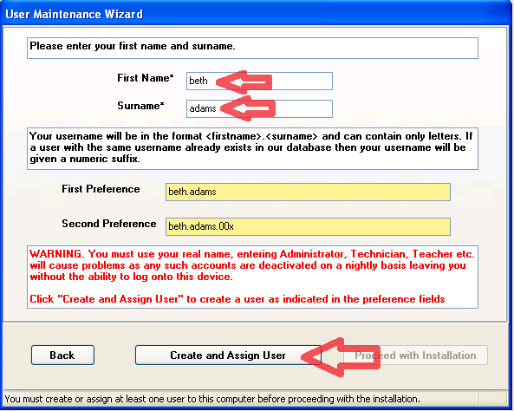
Click Yes to confirm – this is the last chance to correct any spelling mistakes in your name | 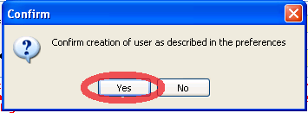
You will then be shown your new username.  MAKE A NOTE OF YOUR USERNAME | 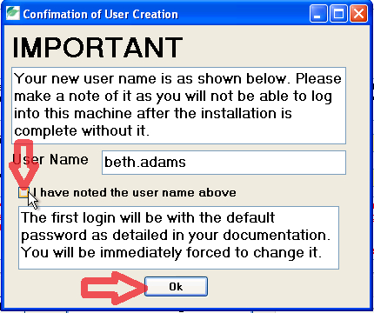
Then put a tick in the box to show that you have noted your username  click ok. | 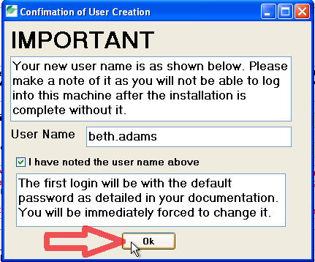
You are now required to answer 3 questions.  Do not write these down.  Choose questions that you can easily remember as you will need to answer them if calling the Service Desk to get your password reset  To select a question to answer click on the questions. | 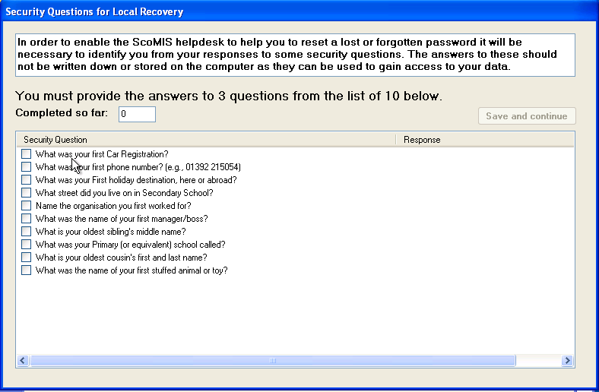
You will be presented with a box to type your answer in.  Type your answer and then click save.  Repeat this step until you have answered 3 different questions | 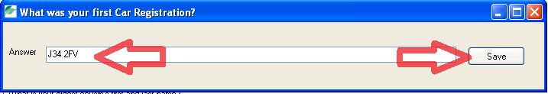
You will then be informed that you have answered sufficient questions.  Click on Save and Continue | 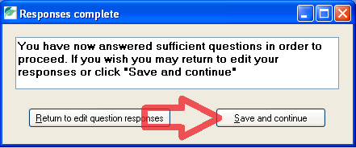
When your profile has been updated click ok | 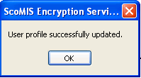
Once the user has been assigned it will show the user name.  Click ok | 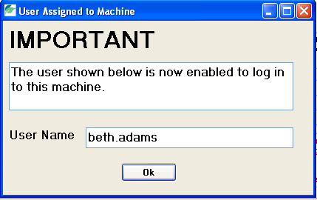
If you are the only user of this laptop click ‘Proceed with installation’.  Note: additional users can be added later after the installation has finished | 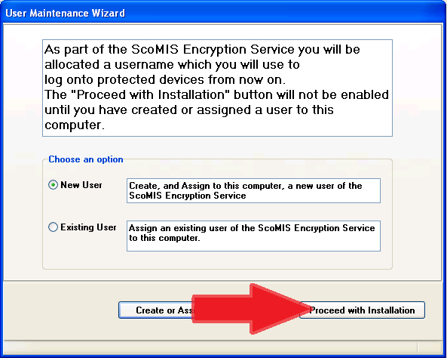
The machine will restart in 30 seconds.  To restart faster click ‘Restart Now’ | 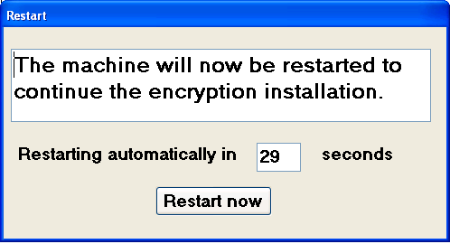
You will see Windows shutting down and restarting in the normal manner | 
Sign into your laptop with your usual windows username and password and click ok.  This is not the username you have just been given). | 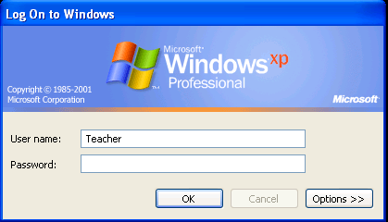
Wait for the installation to begin settings synchronization or to start faster click ‘Start Now’ | 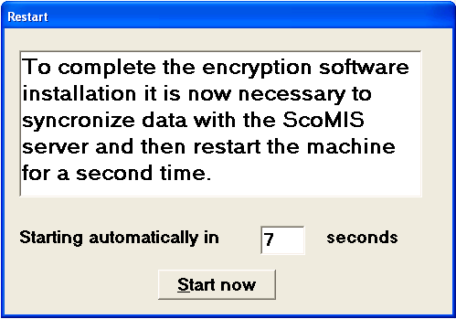
Depending on the speed of your connection the initial synchronization may take up to 15 minutes | 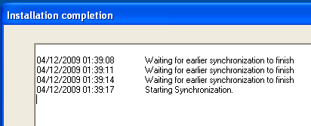
Read the instructions on the screen.  You will be given your initial password of 12345 which you will later be forced to change when first logging in  Once you have read and understood all the information and accept responsibility to keep your data secure, put a tick in the box and click ok. | 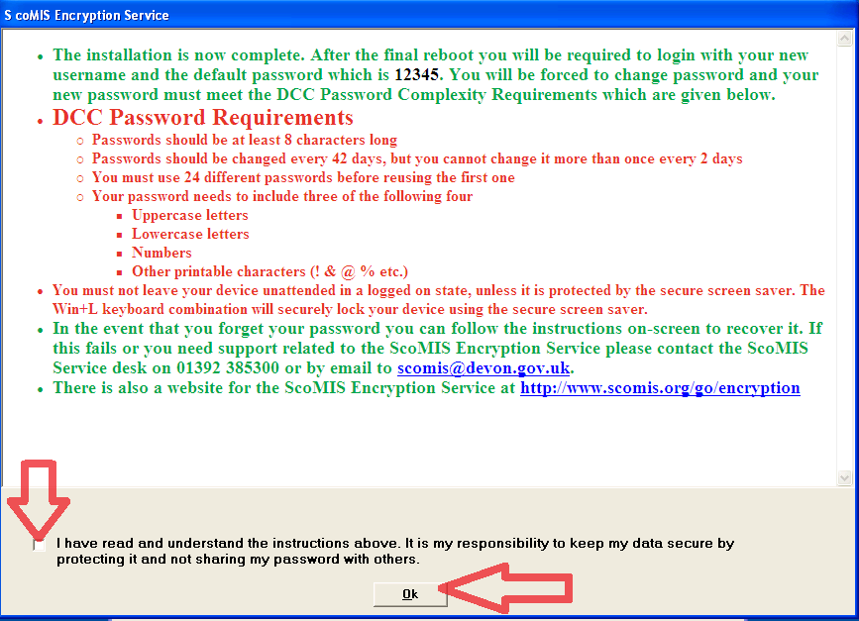
Your machine will restart in 30 seconds or to restart faster click Restart Now. | 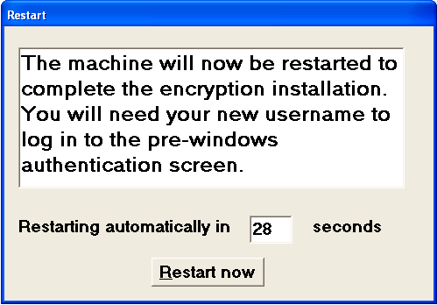
Enter the username you were given earlier.  Enter password 12345 and click ok. | 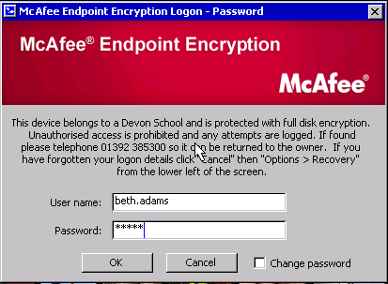
Enter your new password.  Your password will need to be at least 8 characters in length and  Contain 3 of the following:  - Uppercase Letters  - Lowercase letters  - Numbers  - Special Characters for example (£%&*@?)  Confirm your new password and click ok | 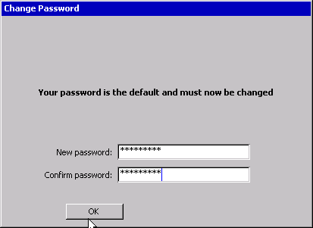
Click yes to enrol in Local Recovery.  Note: This is a separate recovery from the questions already asked that will allow you to recover from a forgotten password without needing to telephone the service desk | 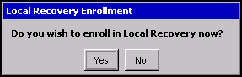
It will ask you to answer 3 questions.  Use the drop down arrow to select your question then type your answer.  Click Next. | 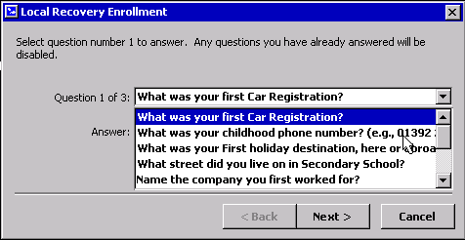
Then use the drop down menu to select another question.  You can use the same questions that you used earlier in the installation if you choose to. | 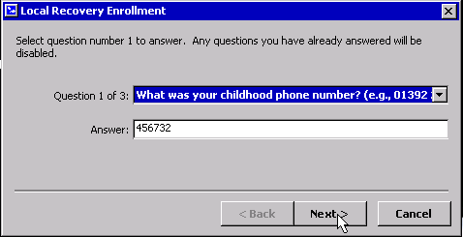
Any questions that you have already answered will show in the list | 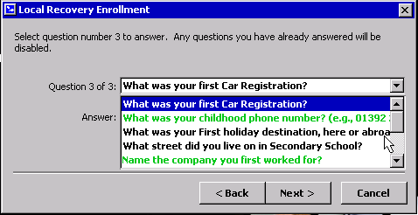
When you have answered 3 questions you will see a message to tell you have completed the local recovery. Click Finish. | 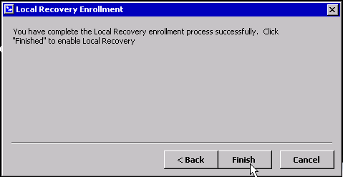
Windows will now start.  Enter your windows username and password and click enter.  The encryption software is now active and will capture your windows username and password so that you do not have to enter it again. This SSO (Single Sign On) function is explained in detail in one of the appendix chapters at the end of this guide | 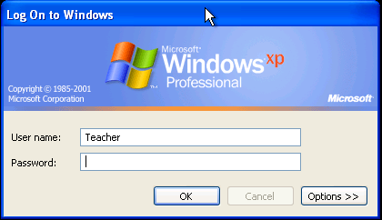
Restart windows for the final time, log in with your new username and password then you will see how the encryption software automatically logs you into windows | 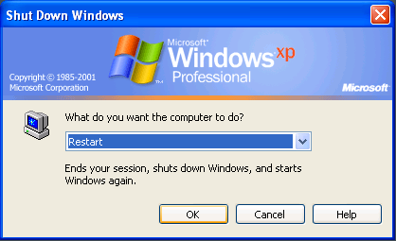
Congratulations, the encryption software is now fully installed and protecting your device.

- The actual encryption is completely transparent to your day to day use of Applications and Windows
- You can view the status of the installation by doing a right click on the Encryption Icon in the system tray in the lower right hand side of your screen by the time. The encryption icon is the one with the padlock
- The initial encryption takes a number of hours to complete and during this time you will notice your laptop feels slower than normal
- Once complete the status screen will show green, all the data on your hard drive is now completely encrypted and secure in the event of loss or theft
- The encryption will run unobtrusively in the background and should have a negligible performance impact for your day to day use

Chapter 4 – Getting help and support for problems

If you are having problems logging onto your laptop; for example if you have forgotten your password:

- First attempt local recovery following the onscreen instructions in the pre-boot login screen.
- If successful this will let you choose a new password and enable you to log back onto your laptop.

If you have problems with local recovery please telephone the ScoMIS Service Desk on 01392 385300. We will go through a short recovery process and reset your password after completing an identity check based on the questions set during your account creation. If you forget your security questions we will still be able to reset your password but only by us calling the main school number to confirm your identity.

The ScoMIS Service Desk is open from 8am until 6pm during school term time (8am to 5pm Fridays) and 9am until 5pm during school holidays.

For non urgent issues or queries please check the next chapter which covers common questions and answers and the ScoMIS website which will be kept up to date with FAQ’s and the latest version of this guide.

If your query is not answered in our user guide or website you should log a call with ScoMIS. You can either telephone on 01392 385300 or send us an email scomis@devon.gov.uk to log a call.

We also welcome feedback on the documentation provided for encryption service. If you have any suggestions for improvements please send us an email to systems@devon.gov.uk – please note this is a feedback address and should not be used to log issues or calls for assistance
Chapter 5 – Answers to common questions / FAQ’s

- How do I know that my device is encrypted?
  - If the encryption software is installed onto your device you will see the McAfee login screen before Windows loads
- How long does the initial encryption process take?
  - Depending on the speed and size of your hard drive the initial encryption process may take a number of hours
  - You can shutdown and restart during this time, the encryption will take up where it left off each time Windows is started
  - During the initial encryption your laptop may feel sluggish as all data on the hard disk is rewritten
- Will I notice the encryption software once it has been installed?
  - Once installed the encryption is transparent to Windows and your applications.
  - Remember only the laptop’s internal hard drive is encrypted so you shouldn’t copy sensitive information onto removable media unless it is for backup purposes and kept in a secure location
- How do I remove or reinstall the encryption software?
  - See Appendix A in this guide
- What happens if my device hardware is upgraded?
  - Added RAM will not effect encryption however upgrading the hard disk will mean that you need to contact ScoMIS for advice
- I want an easier to remember password?
  - All devices and users on the ScoMIS Encryption Service must adhere to the DCC Password policy.
  - A strong and hard to guess password does not necessarily need to be hard to remember for example you could use a line from a favourite song: Never4getWhereYou’veComeHereFrom
  - Alternatively try generating one with the memorable password generator > http://www.safepasswd.com/
- Where can I find out more information?
  - Check http://faq.scomis.org/categories/services/encryption
  - Log a call with the ScoMIS Service Desk for any other queries

Chapter 6 – The ScoMIS Encryption Maintenance Utility

ScoMIS have included a maintenance utility to allow you to carry out the following tasks:
- User Maintenance
  - New user - create a new user and assign to the machine
  - Existing user – assign an existing user to the machine
  - Group – assign multiple existing users to the machine, you may choose to add all users to all devices if they are regularly shared for example
- Reassign device
  - Allows you to update the device description in our database
- View DCC Password Rules
  - Used when creating a new user so that you can explain the password policy before they attempt log on for the first time
- Force Synchronisation
  - Should be run after making any changes using the functions above, this pulls down the settings to the device from the central database
To launch the utility go to:
Start > All Programs > “ScoMIS Encryption Maintenance Utility”
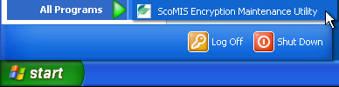
Notes:
- A “new user” means one that doesn’t already have a login for the encryption service, if they use another encrypted device use the “existing user” option to allow them access to the device in question
- The user maintenance functions are protected and require you to enter the schools unique installation key, if this has been lost or forgotten please log a call with the ScoMIS Service Desk
- Depending on your windows security settings you may need administrator rights to run this application
- If you have any problems or see any errors using this application please note them down or take a screen shot and log a call with the ScoMIS Service Desk

Appendix A – Removing / re-installing the encryption software

Once installed the encryption software cannot be removed by the end user or school. To remove the software you will need to log a call with the ScoMIS Service Desk.

If the encryption software needs to be re-installed for example following a repair after hardware failure please log a call with the ScoMIS Service Desk. We will need to manually delete the old device from our database to avoid the school being charged for a duplicate device.

Common reasons for removing the software may include
- A laptop is due to be replaced – the encryption software should be removed so it can be installed onto the replacement device without the school incurring a duplicate charge
- The security profile of the laptop has changed – Our advice is to encrypt all teacher and administration laptops. If a laptop changes role to be used in the curriculum, by pupils or supply teachers for example the encryption software should be removed
Common reasons for re-installing the software may include
- Windows has become corrupted – you will need to re-install the encryption software after re-installing the Windows operating system
- Hardware Failure – if the laptop hard drive fails you will need to re-install the encryption software after the fault has been rectified

Please Note: It is possible to reinstall the Windows operating system by using the installation CD or running a recovery mechanism such as a ghost reload. This will mean there is no encryption on the hard drive however the original data will remain encrypted and still be secure.

Appendix B – How the encryption software works

On protected devices for example Laptops or PCs, the client side of Endpoint Encryption, in simple terms, takes control of the user’s hard disk away from the operating system. Endpoint Encryption’s driver encrypts every piece of data written to the disk, and decrypts every piece of information read off the disk. If any application managed to break through the Endpoint Encryption barrier and read the disk directly, it would find only encrypted data, even in the Windows swap file and temporary file areas.

Even if a Data Recovery agency tries to retrieve information from a Endpoint Encryption-protected hard drive, without access to the Endpoint Encryption System via the passwords or recovery information there is no way of accessing this data – total security.

Endpoint Encryption installs a mini-operating system on the user’s hard drive, this is what the user sees when they turn on the PC. Endpoint Encryption looks and feels like Microsoft Windows, with mouse and keyboard support, moveable windows etc. This Endpoint Encryption OS is completely contained and does not need to access any other files or programs on the hard disk, and is responsible for allowing the user to authenticate with their password.

Once the user has entered the correct authentication information, the Endpoint Encryption operating system starts the crypt driver in memory, and boots the protected machine’s original operating system. From this point on the machine will look and behave as if Endpoint Encryption was not installed. The security is invisible to the user, and because the only readable data on the hard disk is the Endpoint Encryption operating system, and the encryption key for the hard drive is itself protected with the user’s authentication key, the only possible way to defeat Endpoint Encryption is to either guess the hard disk encryption key (a one in 2256 chance with the AES256 algorithm), or to guess the user’s password.

Every time an Endpoint Encryption protected device boots, and after a set period of time, Endpoint Encryption tries to contact its "Object Directory". This is a central store of configuration information for both machines and users, and is managed by Endpoint Encryption Administrators. The Object Directory could be on the user’s local hard disk (if the user is working completely stand-alone), or could be in some remote location and accessed over TCP/IP via a secure Endpoint Encryption Server (in the case of a centrally managed enterprise).

The Endpoint Encryption protected machine queries the directory for any updates to its configuration, and if needed downloads and applies them. Typical updates could be a new user assigned to the machine by an administrator, a change in password policy, or an upgrade to the Endpoint Encryption operating system or a new file specified by the administrator. At the same time Endpoint Encryption uploads details like the latest audit information, any user password changes, and security breaches to the Object Directory. In this way, transparent synchronization of the enterprise becomes possible.

