New functionality for The Scomis Desktop allows the teacher/user to view attendance and conduct analytics from the Student Registration screen. Analytics can be displayed for a registration (Tutor) group or a class (Seconday)

Analytics

From the Student Registration screen select the black box to the right of the screen

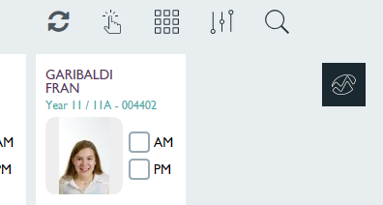

The following analytics for attendance (AM/PM) and conduct will be displayed for the relevant registration (Tutor) group

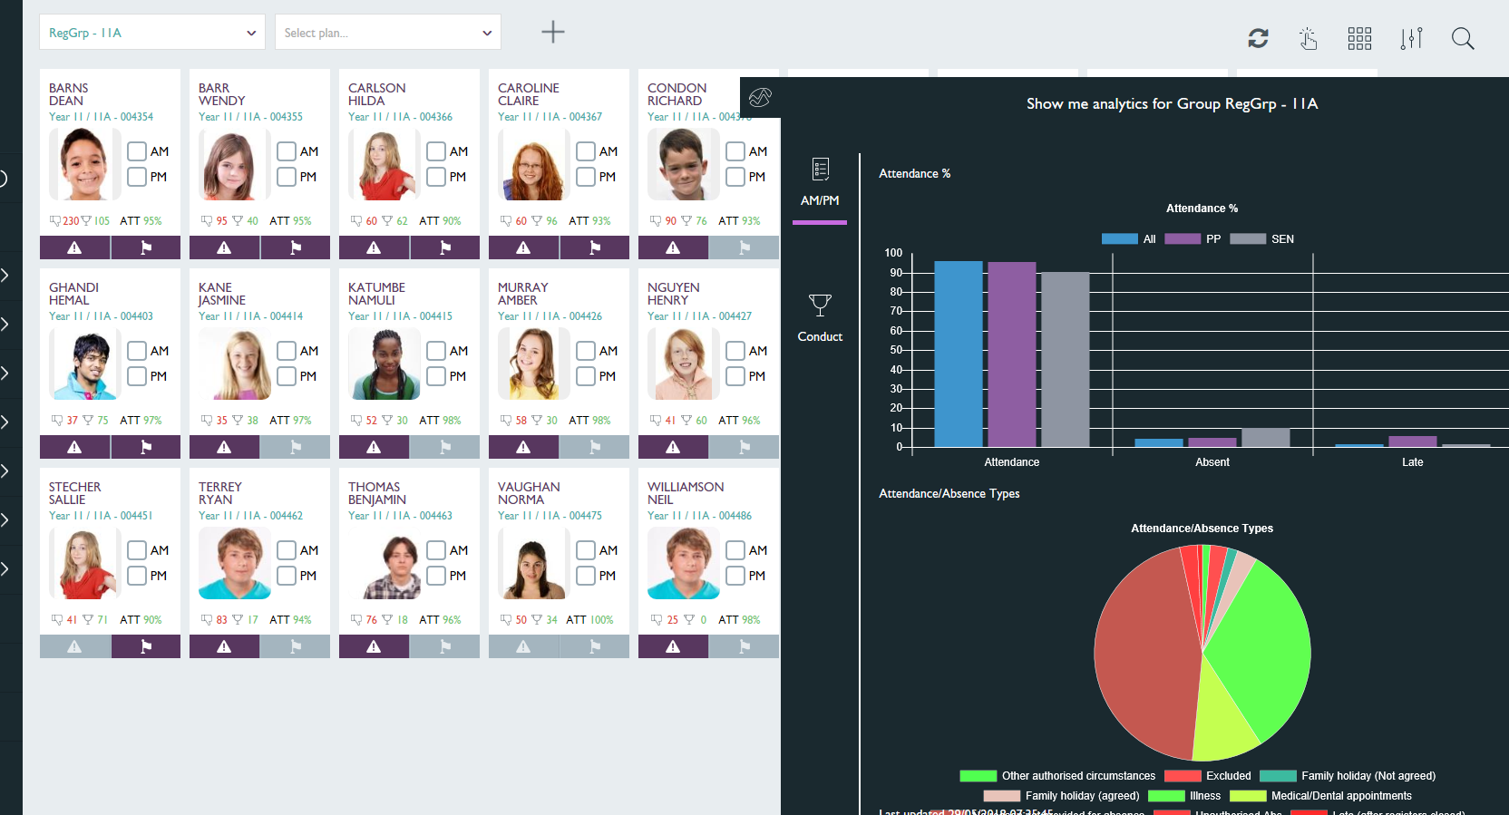

You can also display attendance for the class

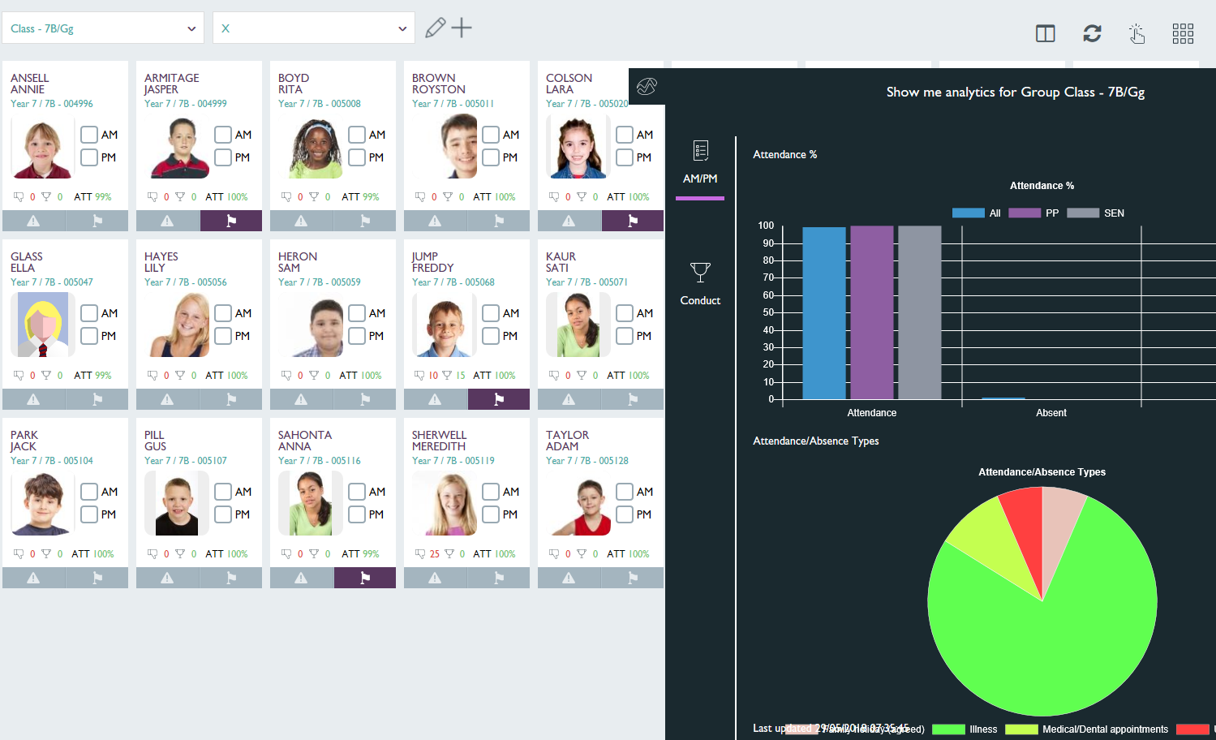

Attendance for All of Reg Group - OAK
Attendance for Pupil Premium students in Registration Group - OAK
Attendance for SEN students in Registration Group – OAK

Hovering over the columns in the bar graph will provide the percentage

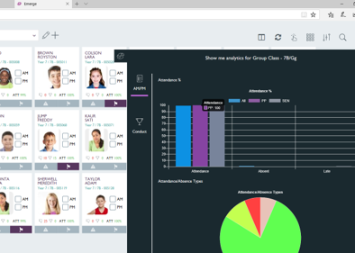

Hovering over the segments will provide the category

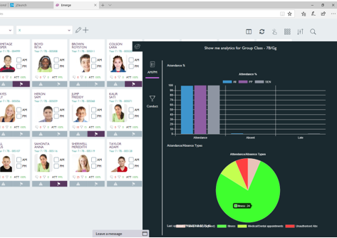

It is possible to change the pie chart display by removing categories by clicking to deselect/select

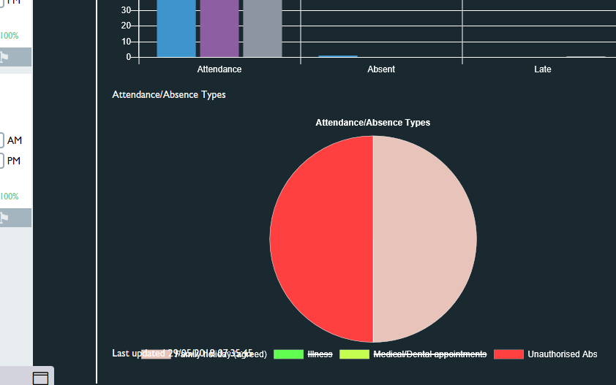

To change the analytics to view Conduct click on ‘Conduct’ from the left-hand side of the graph

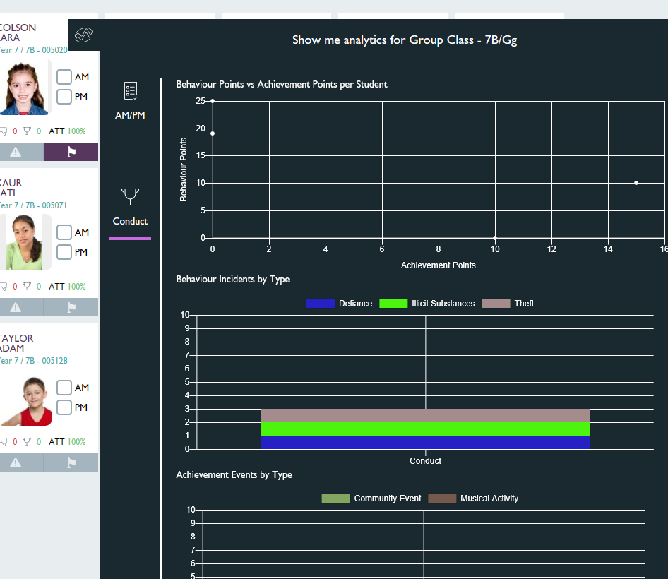

Hover over the chart points to identify student and Behaviour Points i.e. Dean Barns
Hover over the segments to identify the types of Behaviour or Achievement and totals

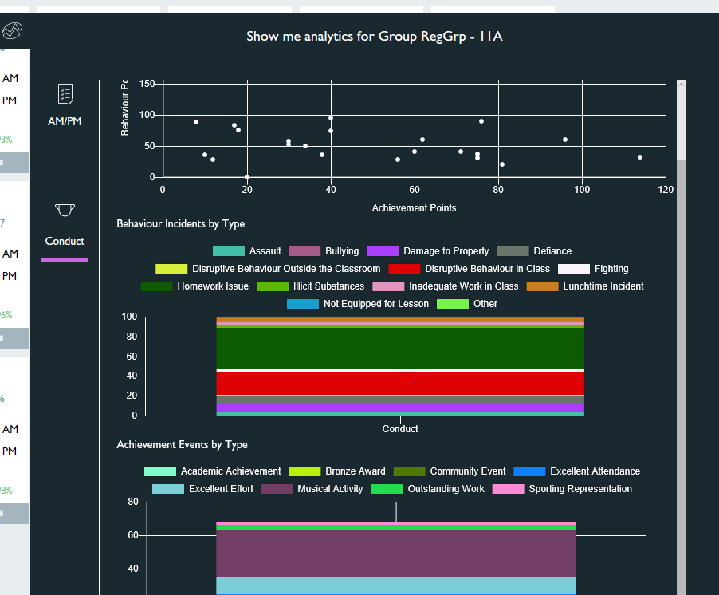

To return to previous screen click on the analytics icon

