Quick Reference Sheet for ‘Class Layout’ in The Scomis Desktop

Class Layout

From the student registration screen select the ‘+’ (Add Plan)

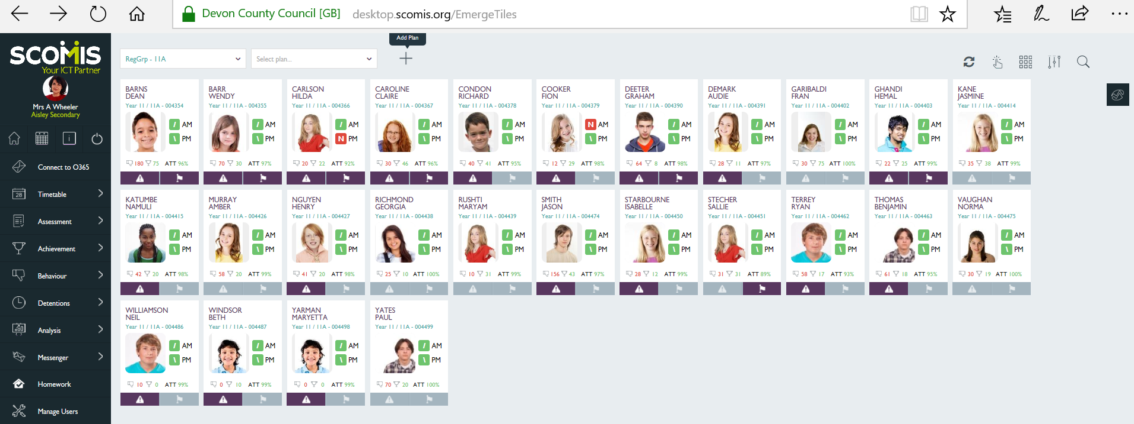

Layout defaults to 6 columns, 6 rows

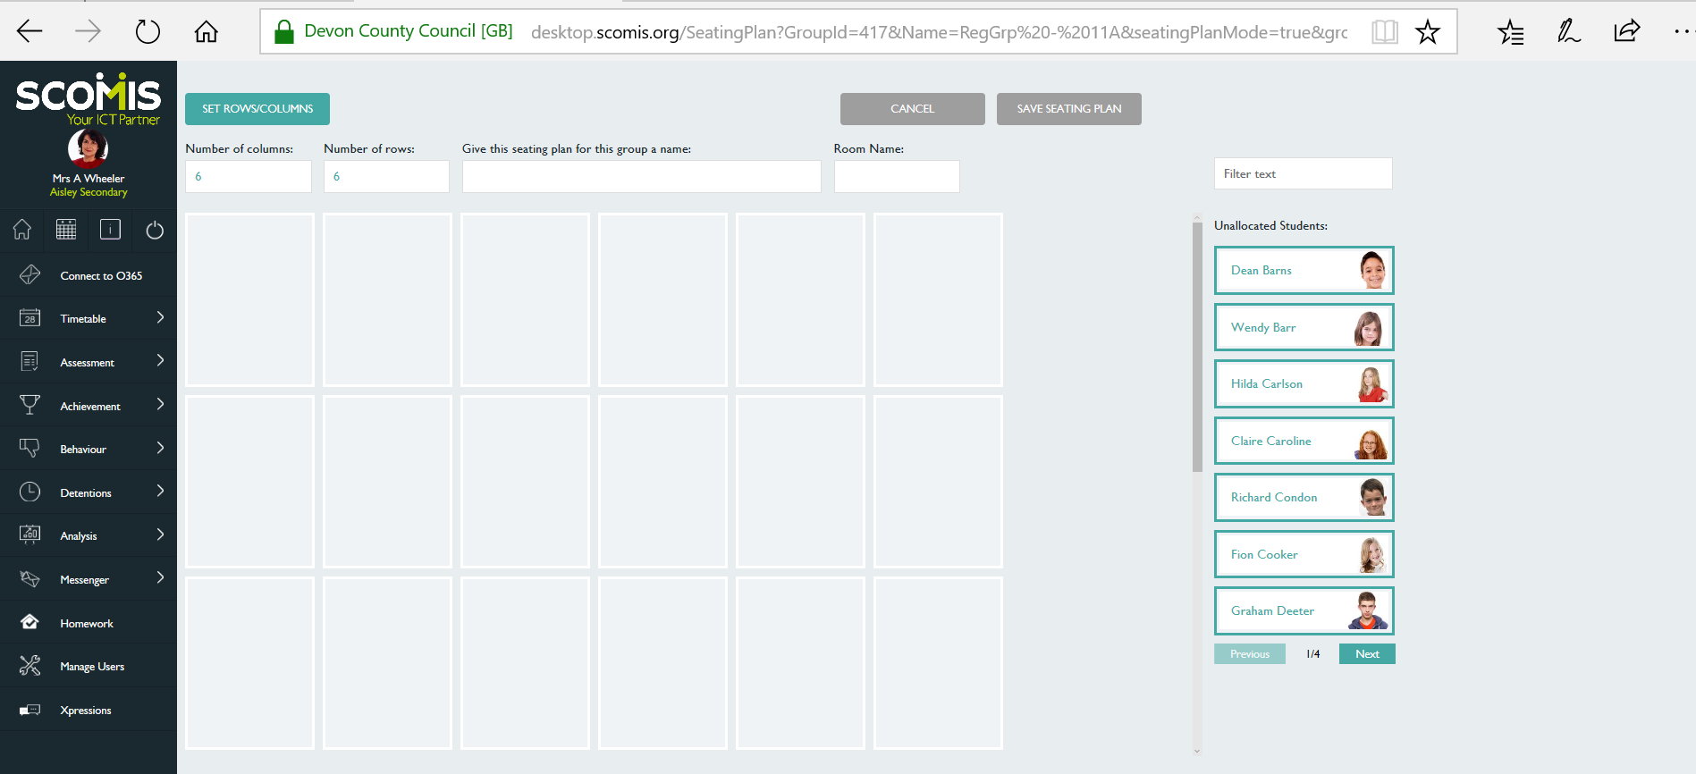

Students appear for selection

Change the number of columns (i.e. 5), number of rows (i.e.4), provide a name for the seating plan, enter room name and then select ‘Set Rows/Columns’

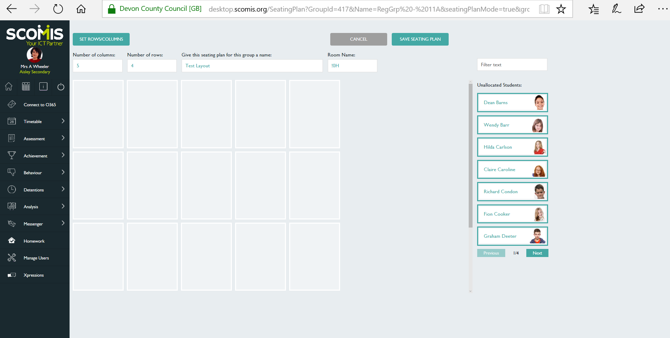

Select student(s) from list and drag across screen, drop into seat(s) as appropriate

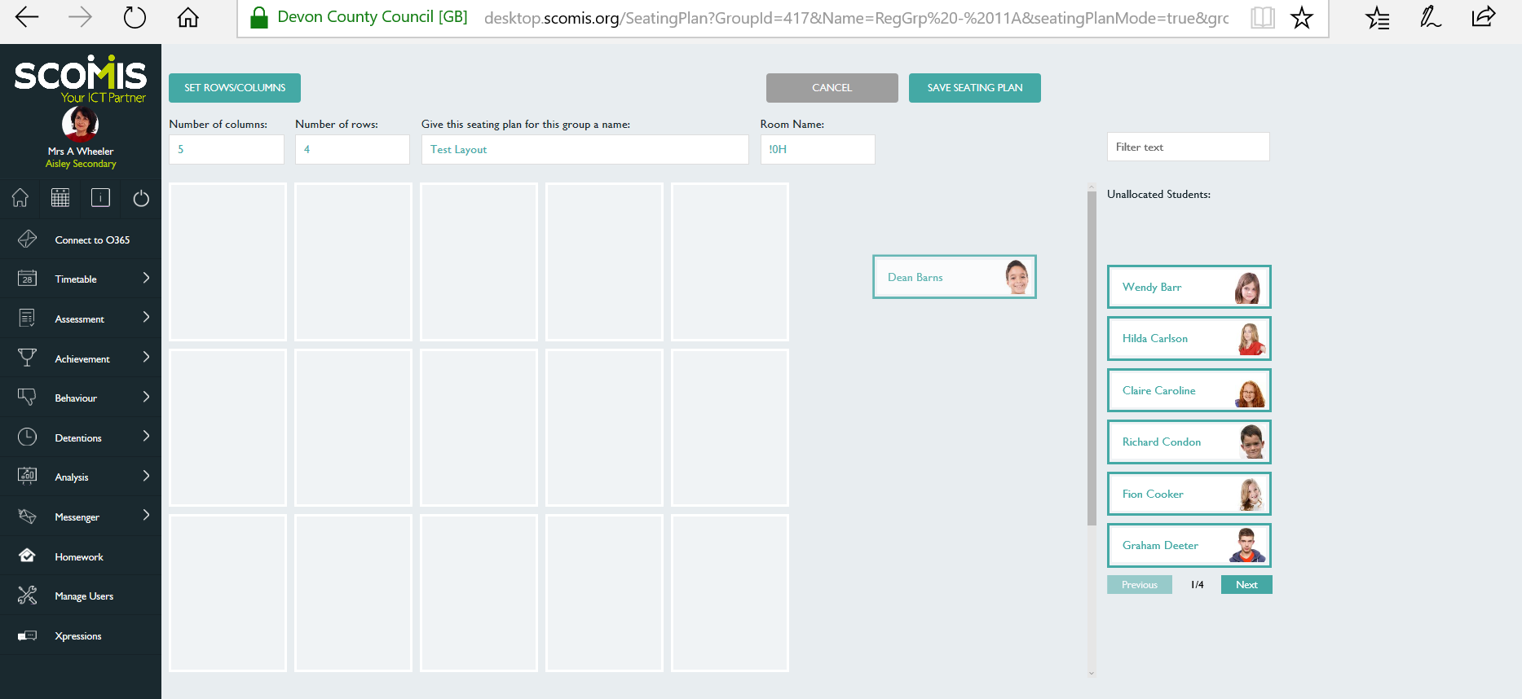

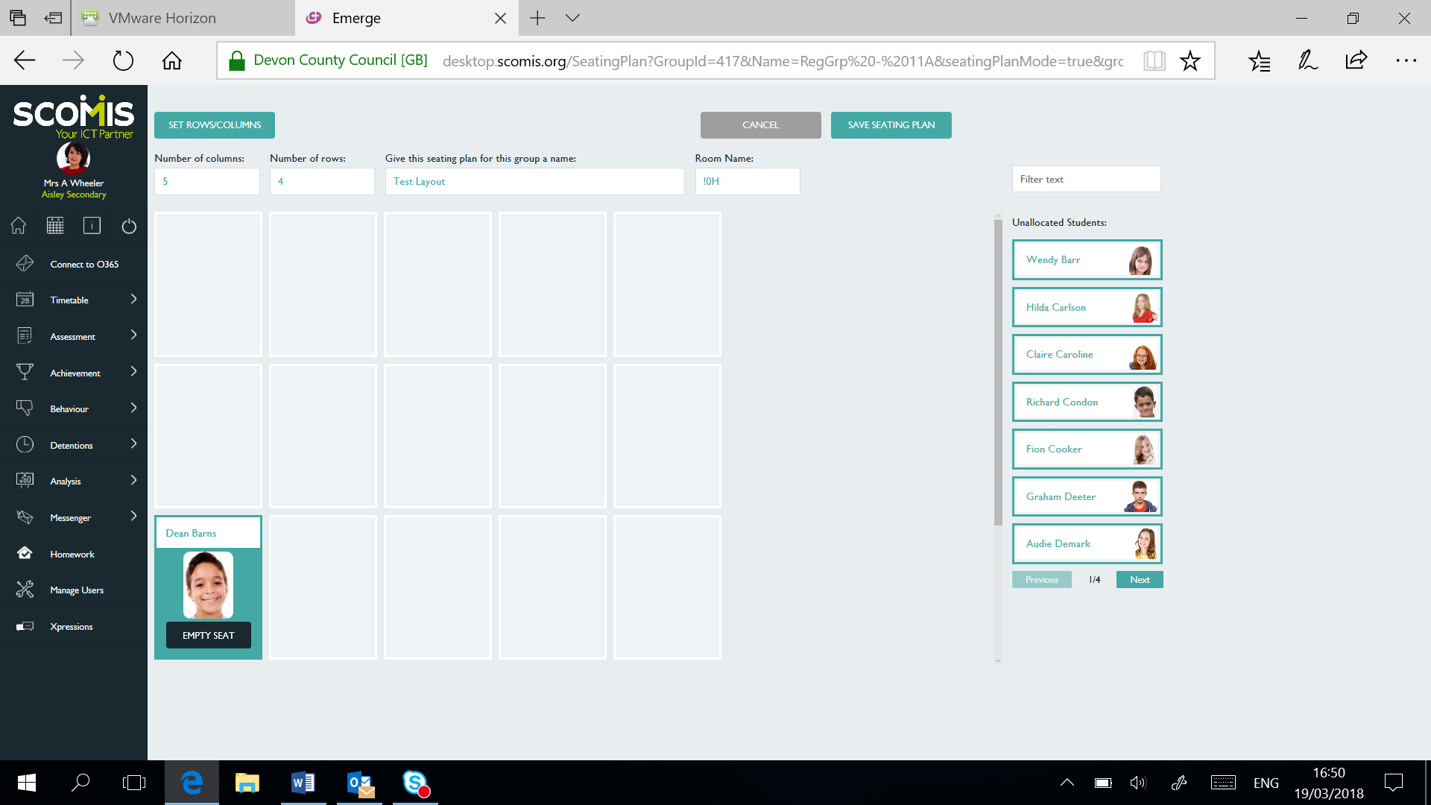

For Example:

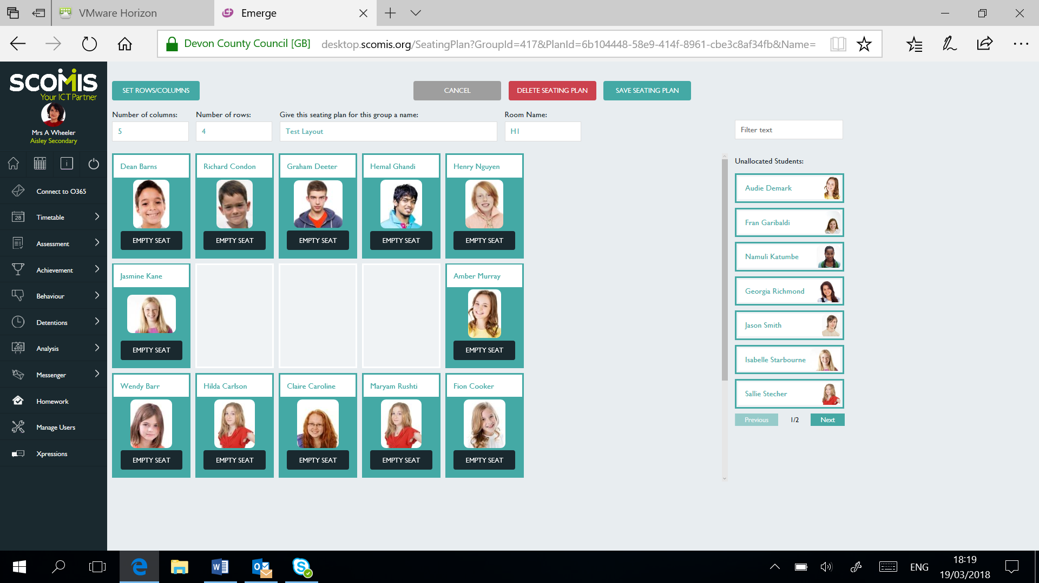

Save the Seating Plan

Save
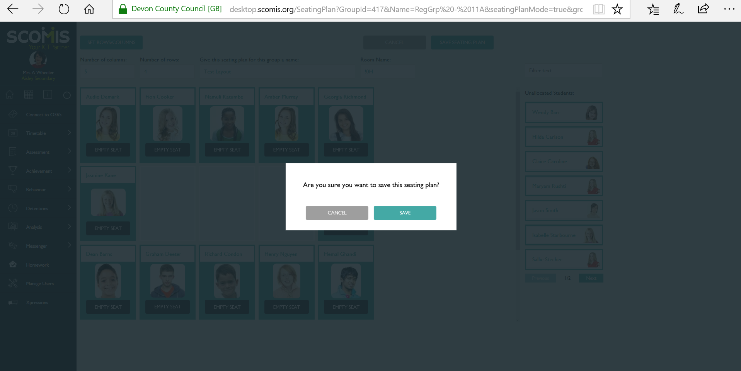

Close

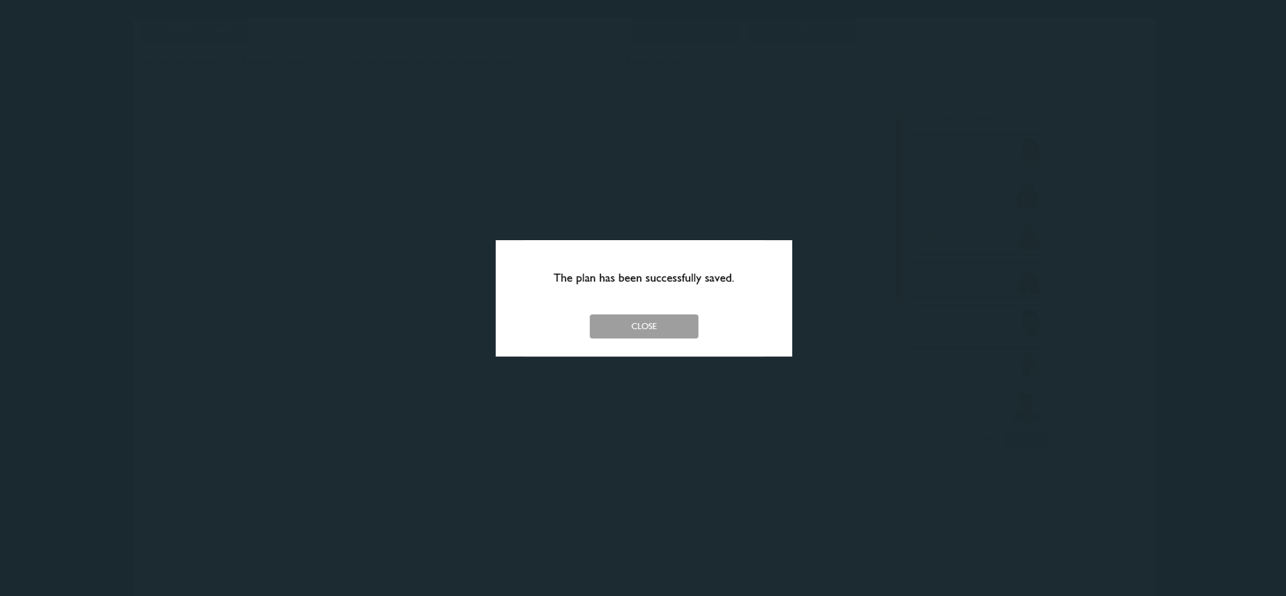

The Scomis Registration Group home screen will be displayed with a pen indicating there are Seat plans to select

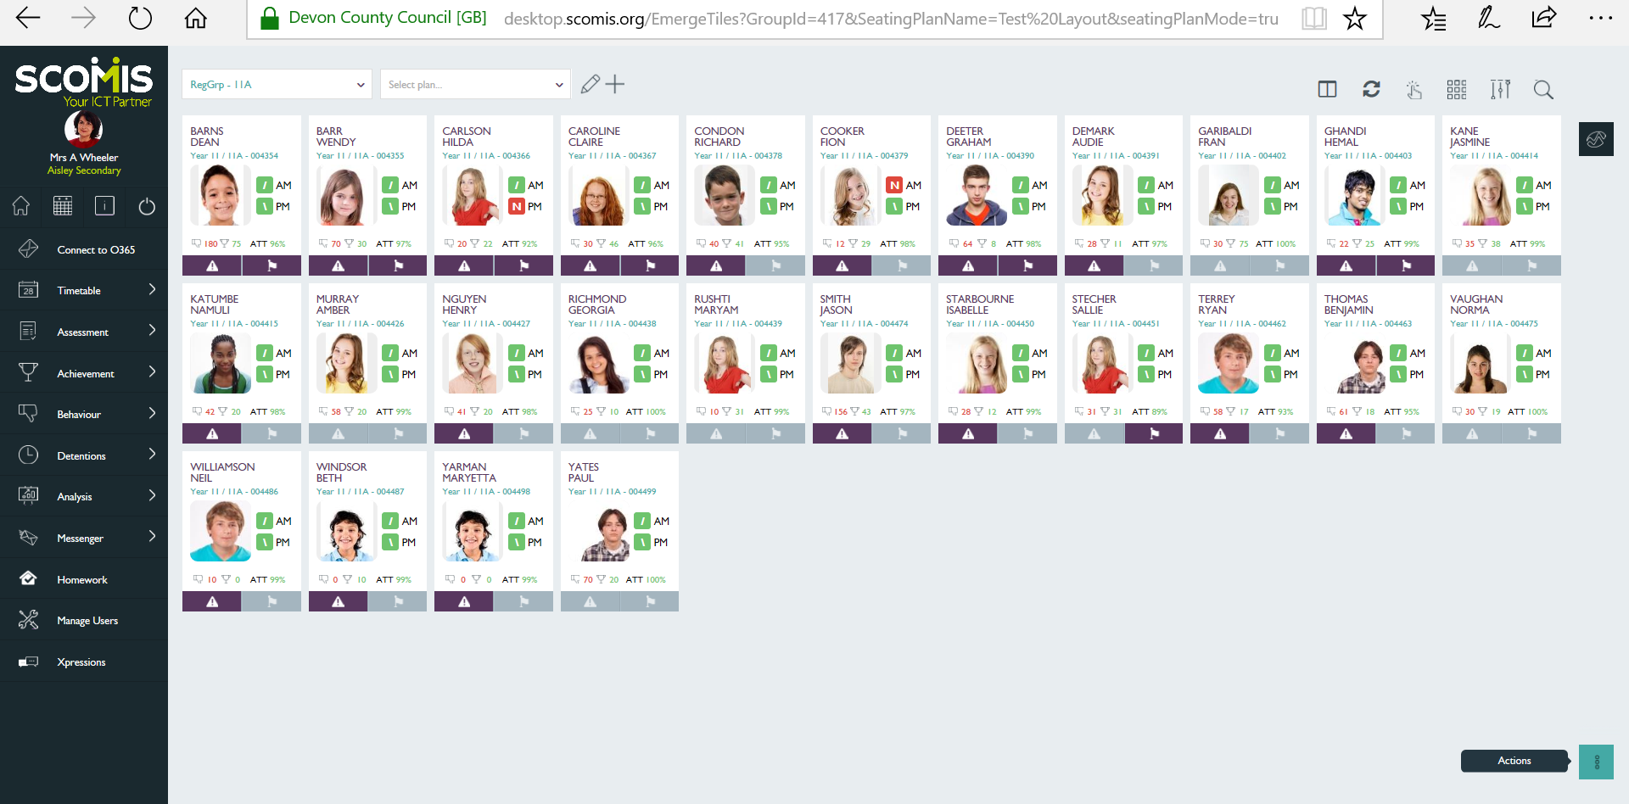

From the drop-down box select the relevant seating plan i.e. Test Layout

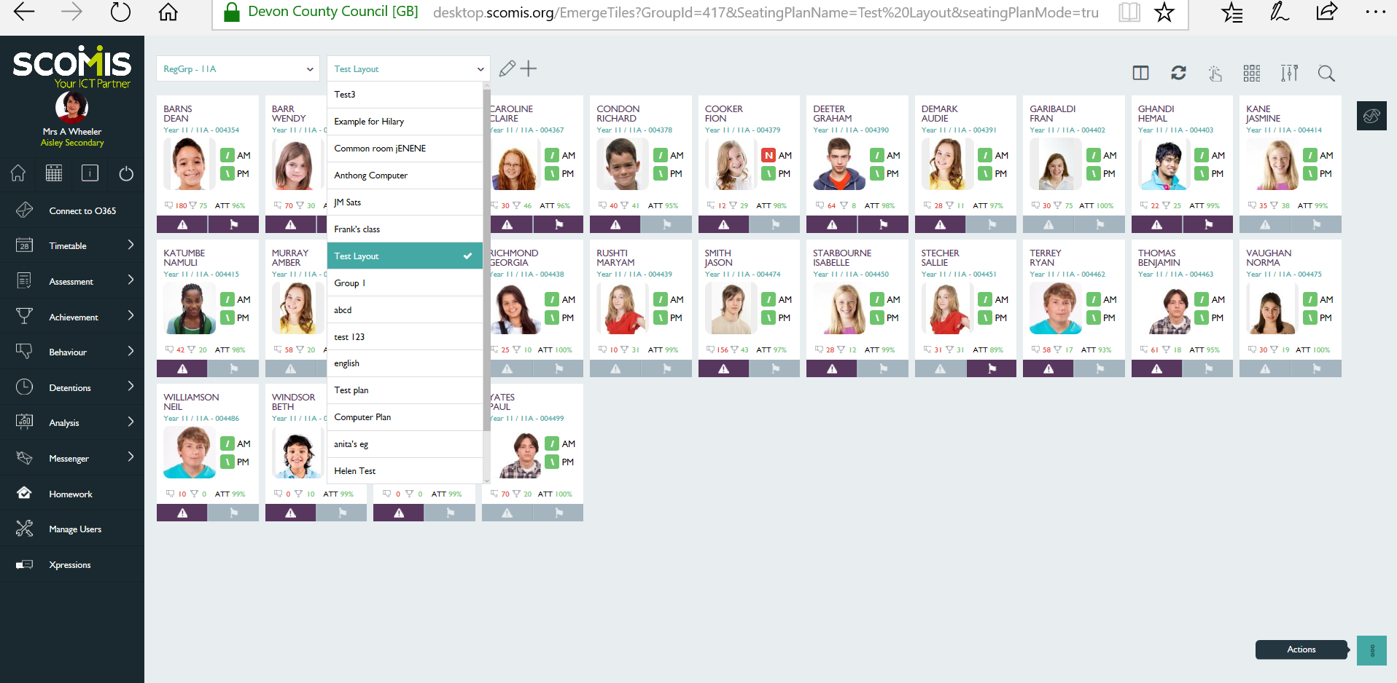

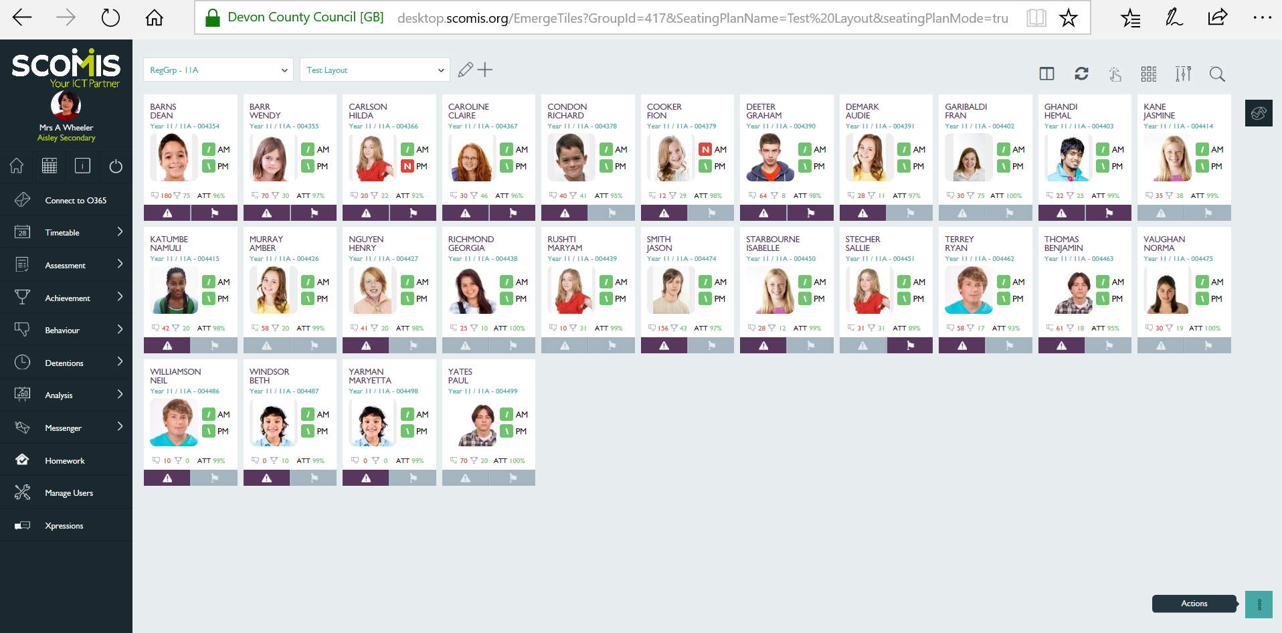

With the name of the seating plan selected, click on the pen

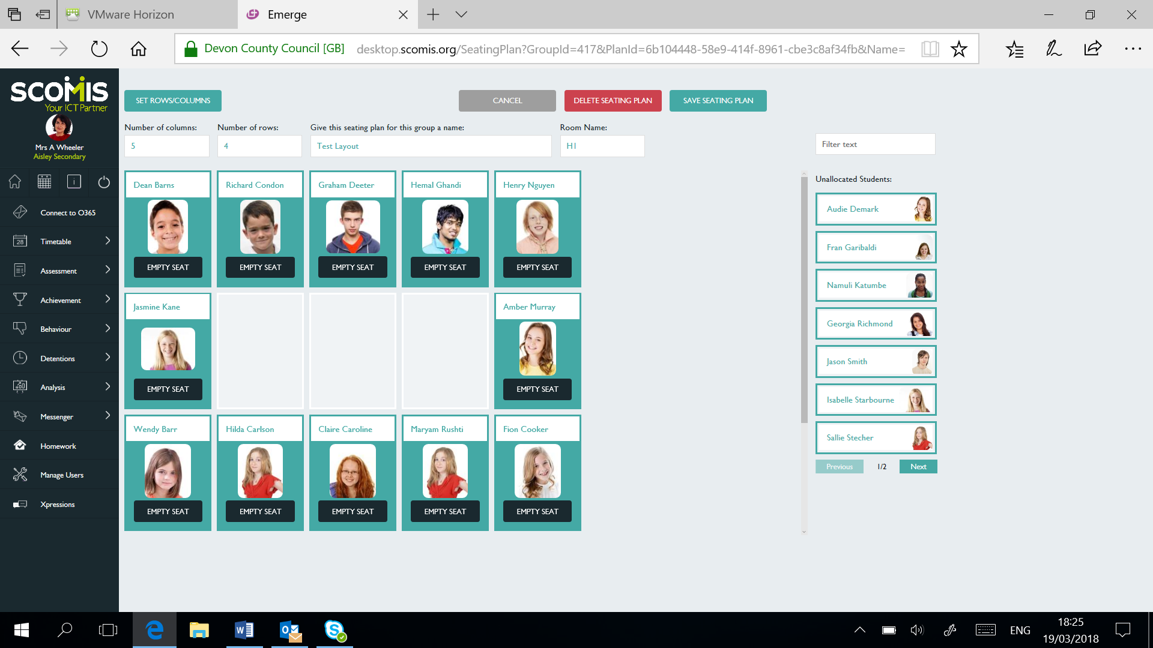

The seating plan can be edited, to remove a student – select ‘empty seat’
To delete a seating plan – select ‘delete seating plan’
Save the seating plan – to return to the home page

