Quick Achievement

New functionality for The Scomis Desktop allows the teacher/user to input behaviour and achievement via the student registration screen.

From the student registration screen select the ‘pointed finger’ (Mark)

Select the student(s)

NB.For this example I have selected Dean Barnes, Paul Yates and Fion Cooker. The student image becomes highlighted

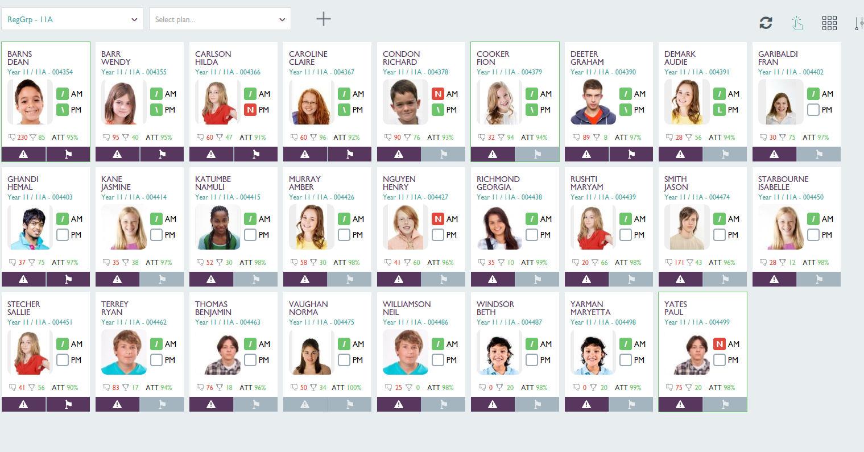

If you wish to de-select a student – click on the cell once again

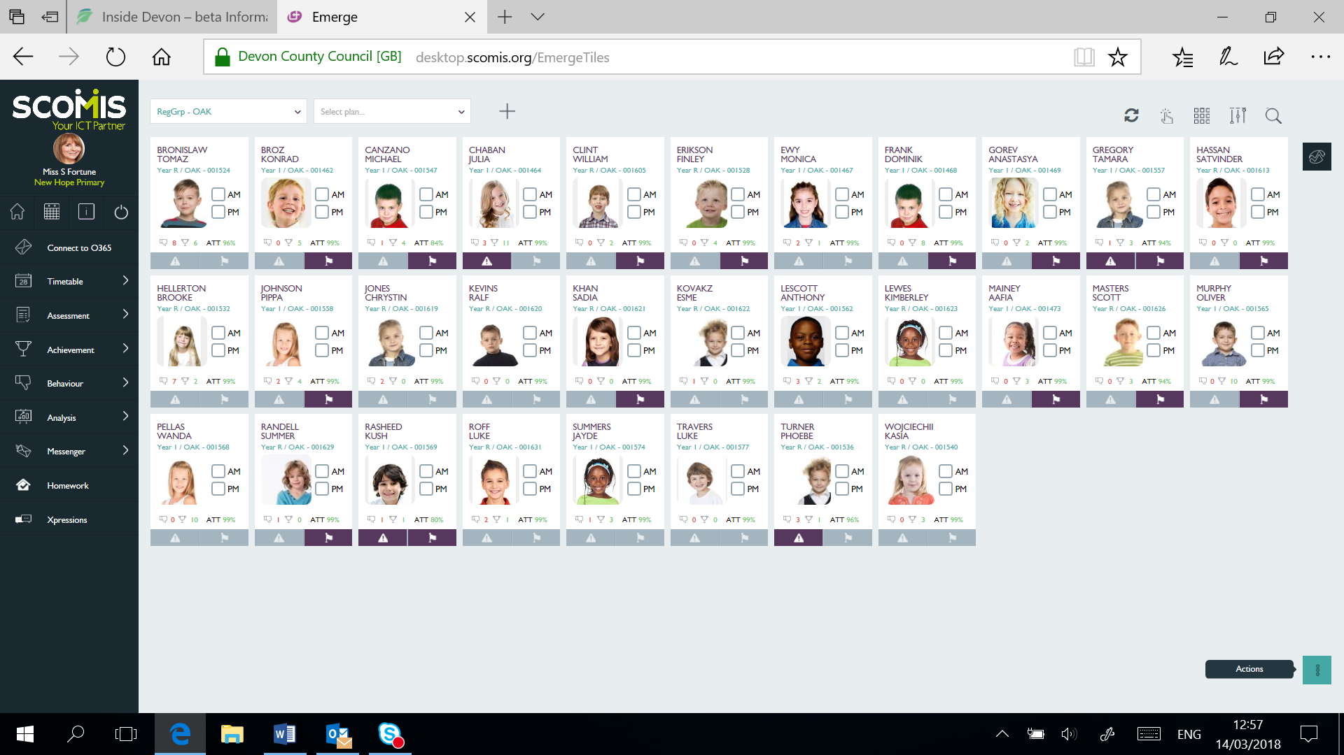

Select Actions

From the list select ‘Quick Achievement’

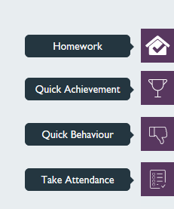

The following screen will appear

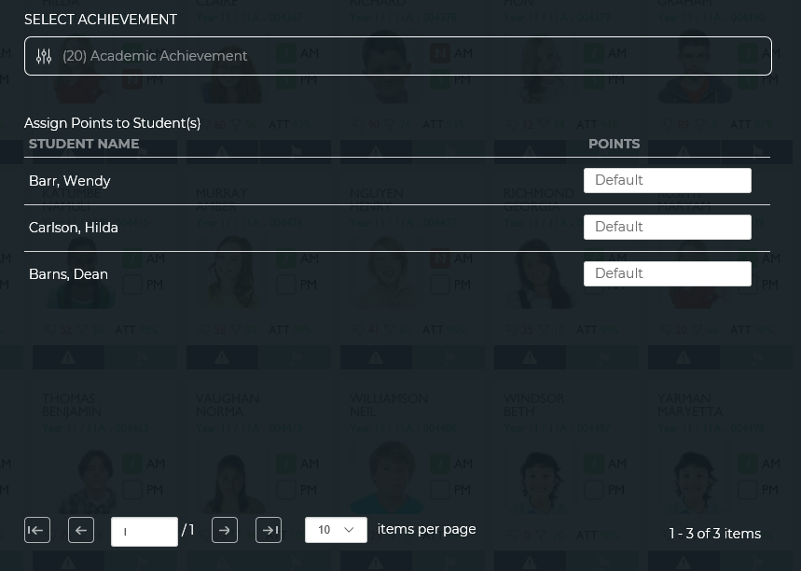

Screen displays with student(s) listed

Select the relevant achievement from the drop-down list. NB. for this example I have selected ‘Academic Achievement’.

Select ‘Next Step’

Complete the fields for Date (15/3/18), Staff Role (Class Teacher) and Activity/subject(English) as required from the drop-down boxes
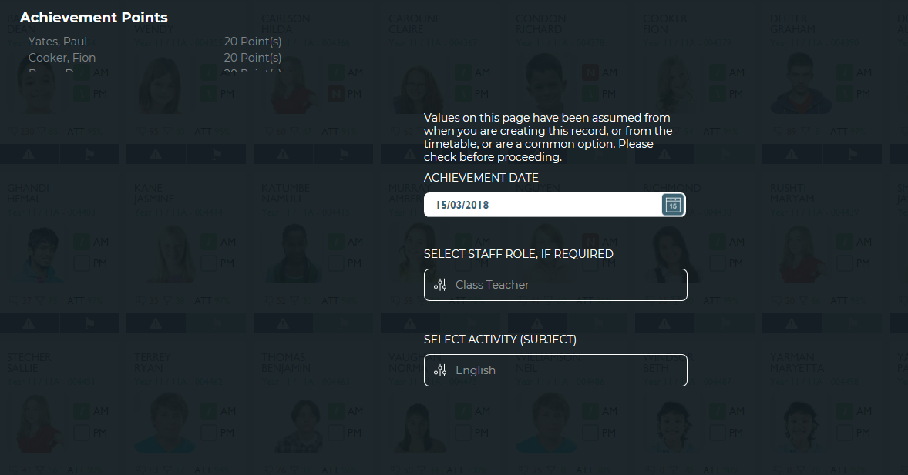

Select ‘Next Step’

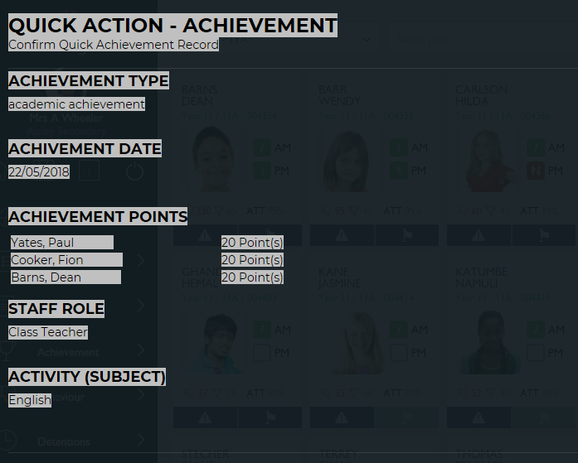

NB. At this point you have two options: back (if you wish to make a change) Or Send (to write data back to SIMS)

Select ‘x’ to get back to the Student registration screen

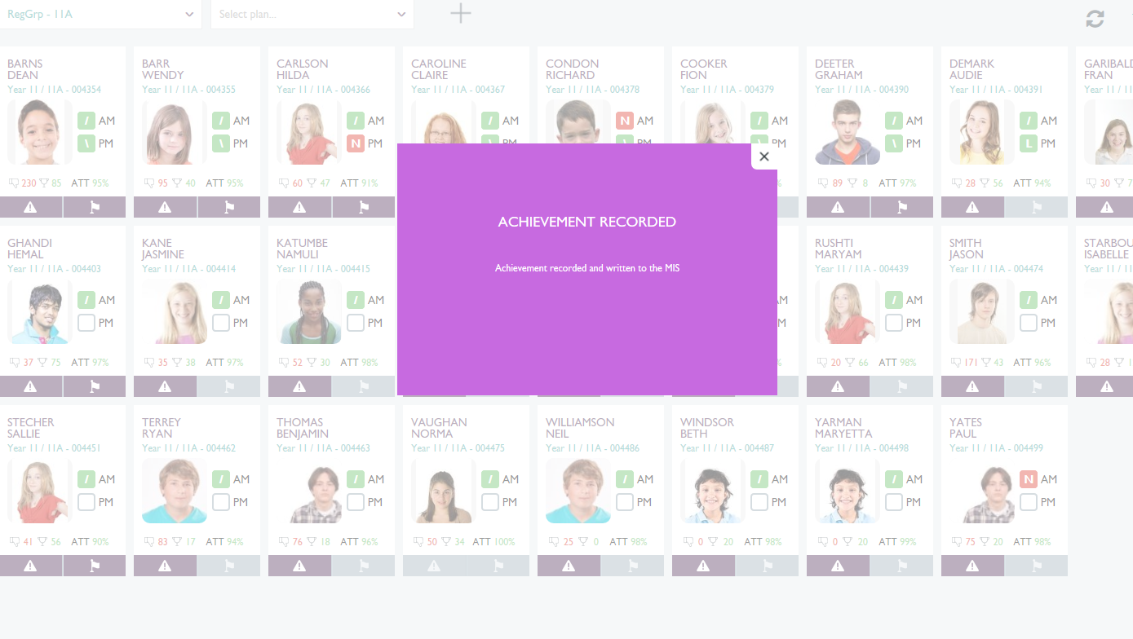

Double click on Dean Barnes from the Student registration screen

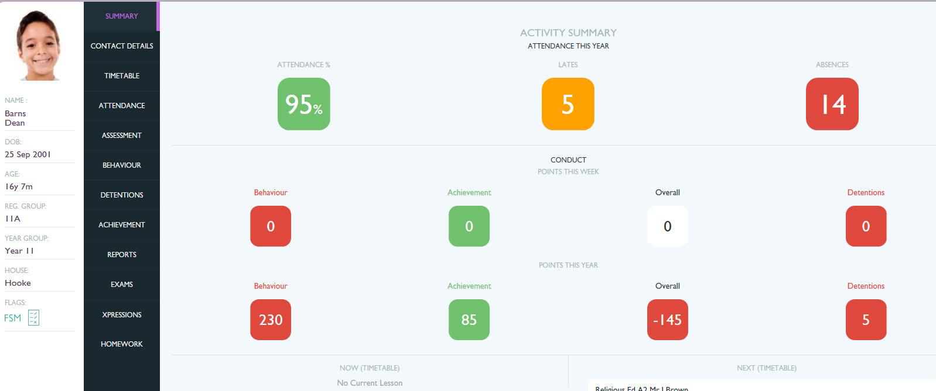

Select ‘Achievement’

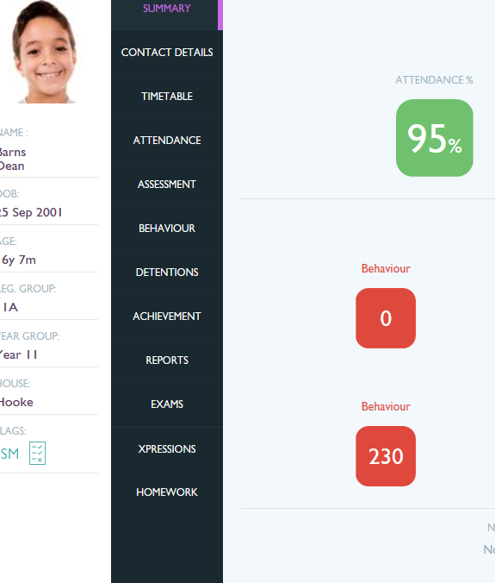

The Achievement Award for the 15th March 2018 is clearly displayed

