Quick Behaviour

New functionality for The Scomis Desktop allows the teacher/user to input behaviour and achievement via the student registration screen.

From the student registration screen select the ‘pointed finger’ icon

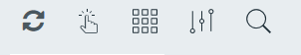
Select the student(s)

I have selected Dean Barnes, Paul Yates and Fion Cooker. The student image becomes highlighted

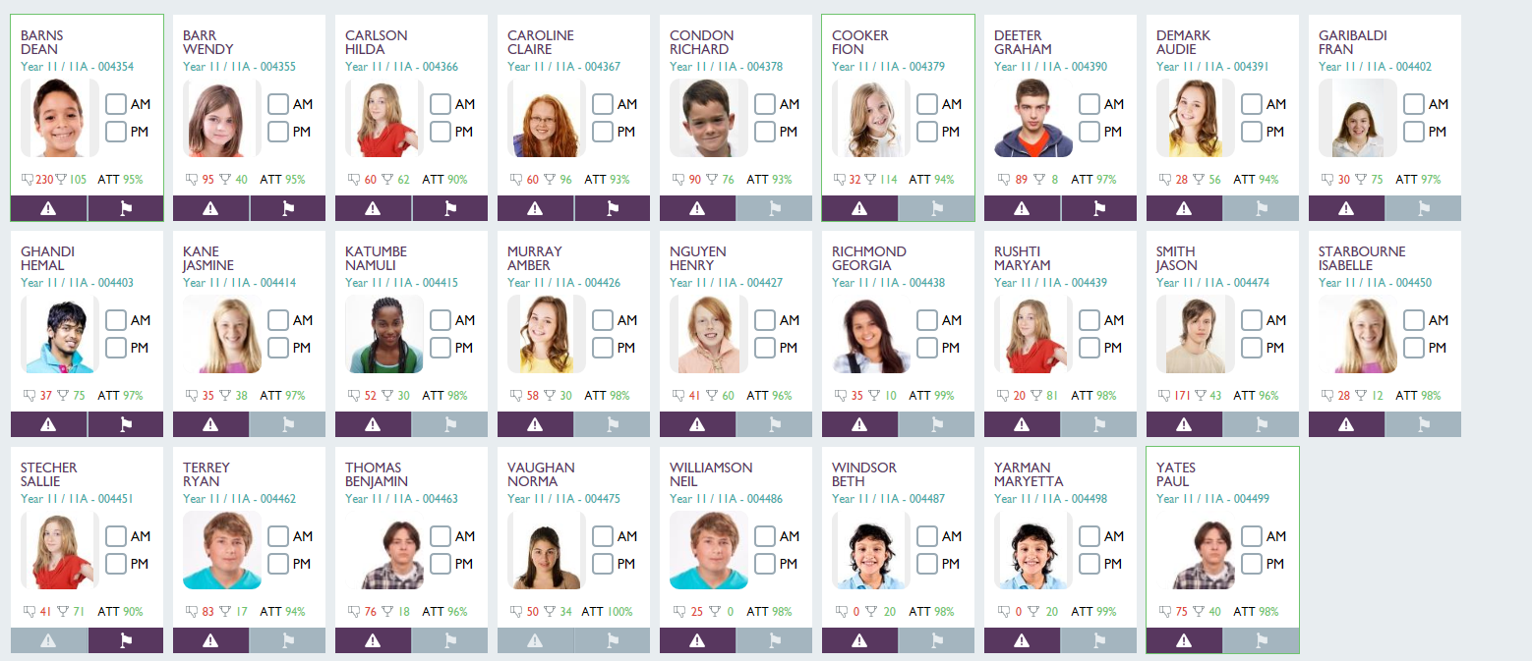

NB: For this example

If you wish to de-select a student – click on their name once again

Select Actions on the right of the screen

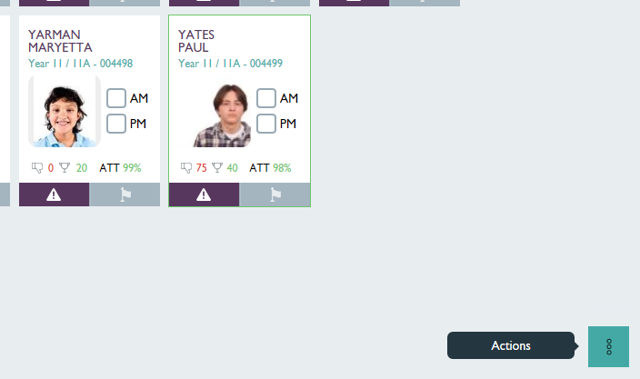

From the list select ‘Quick Behaviour’
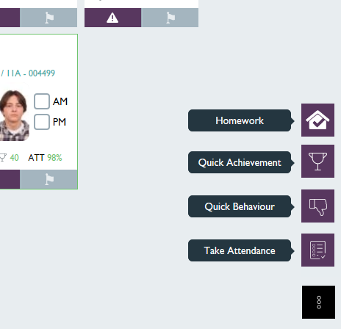

Screen displays with student(s) listed

Complete the fields for INCIDENT RECORD TYPE, INCIDENT RECORD STATUS STUDENT ROLE and ACTION TAKEN as required from the drop-down boxes:
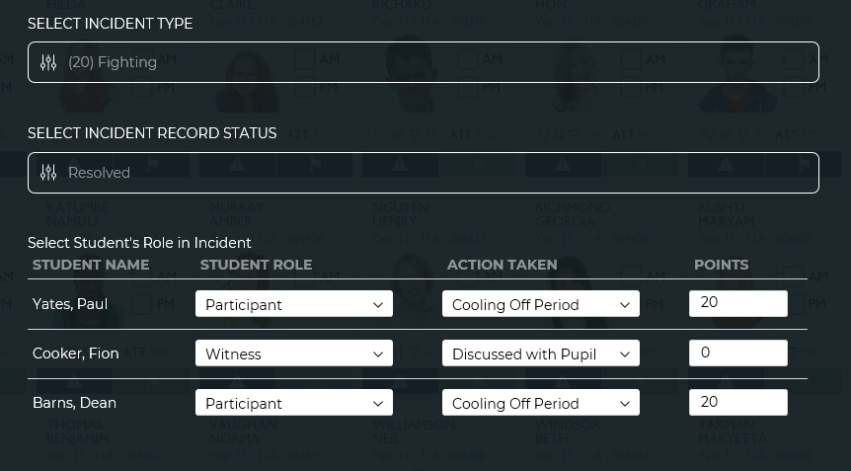

Select ‘Next Step’ at the bottom right

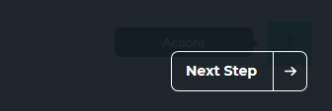

Fill in the Incident Date, Staff Role, Activity, Incident Location and Incident Time
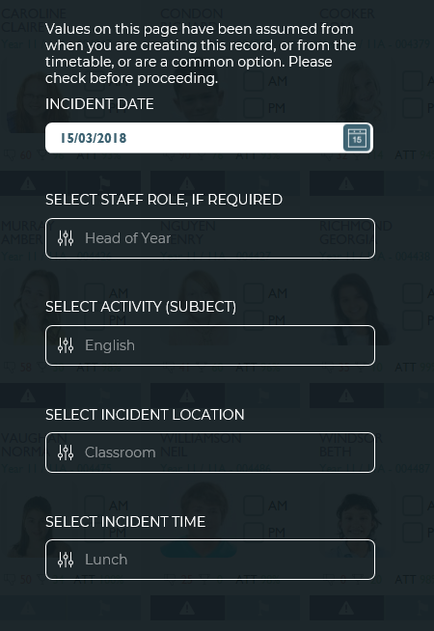

Select ‘Next Step’ at the bottom right

The Behaviour Incident then displays

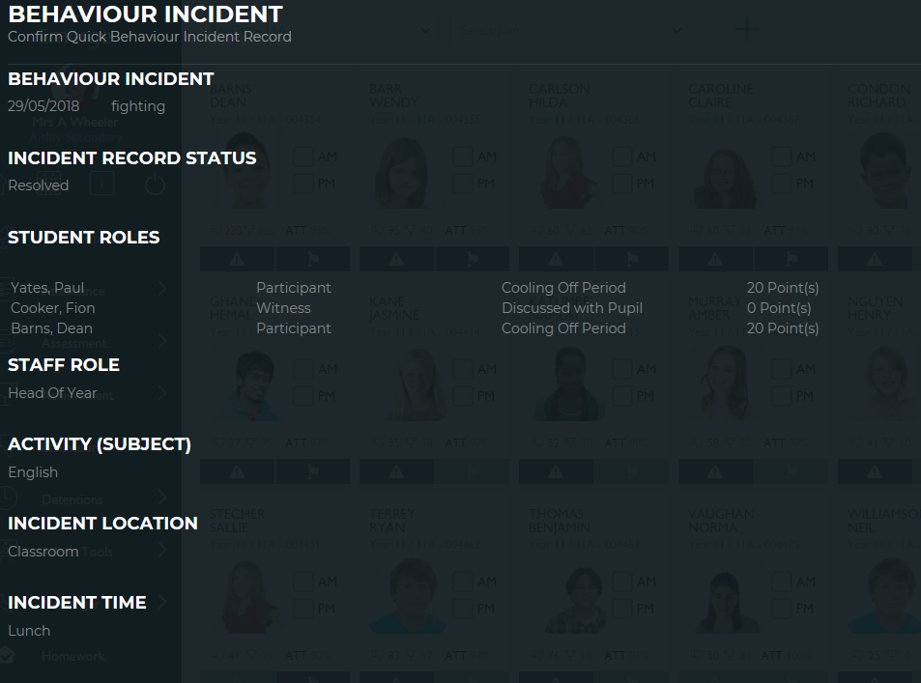

NB. At this point you have two options: Back (if you wish to make a change) or Send (to confirm and write data back to SIMS)

Select ‘x’ to get back to the Student registration screen

Double click on the Student Name in the registration screen, i.e. Dean Barnes

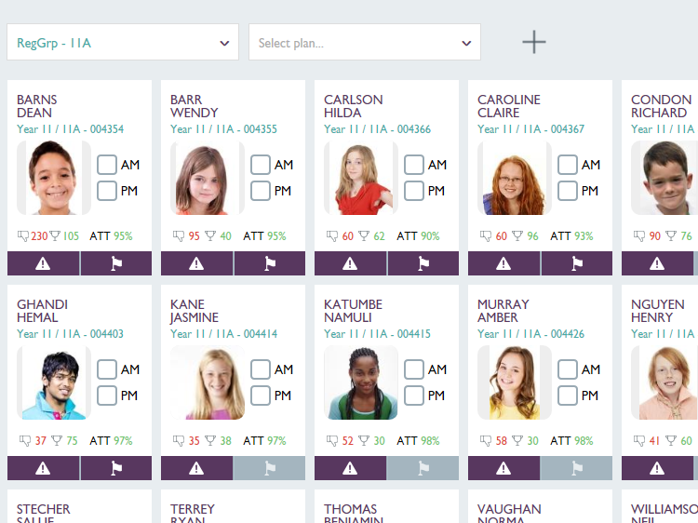

Select ‘Behaviour’
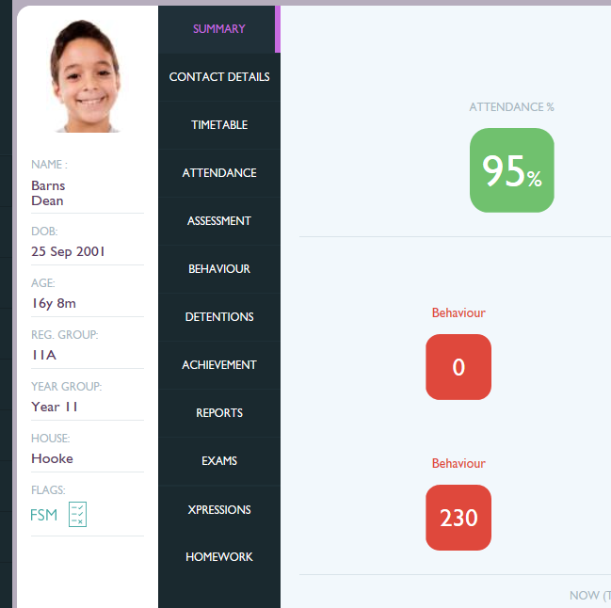

The Behaviour Incident for the 15th March 2018 is clearly displayed
Selecting the white arrow in the black box will provide more details

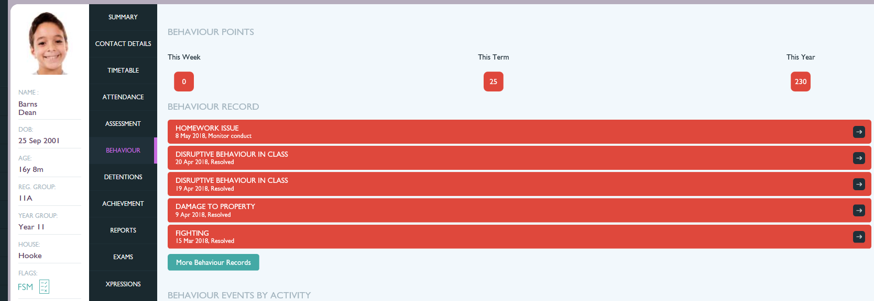

To view more information use the scroll down bar

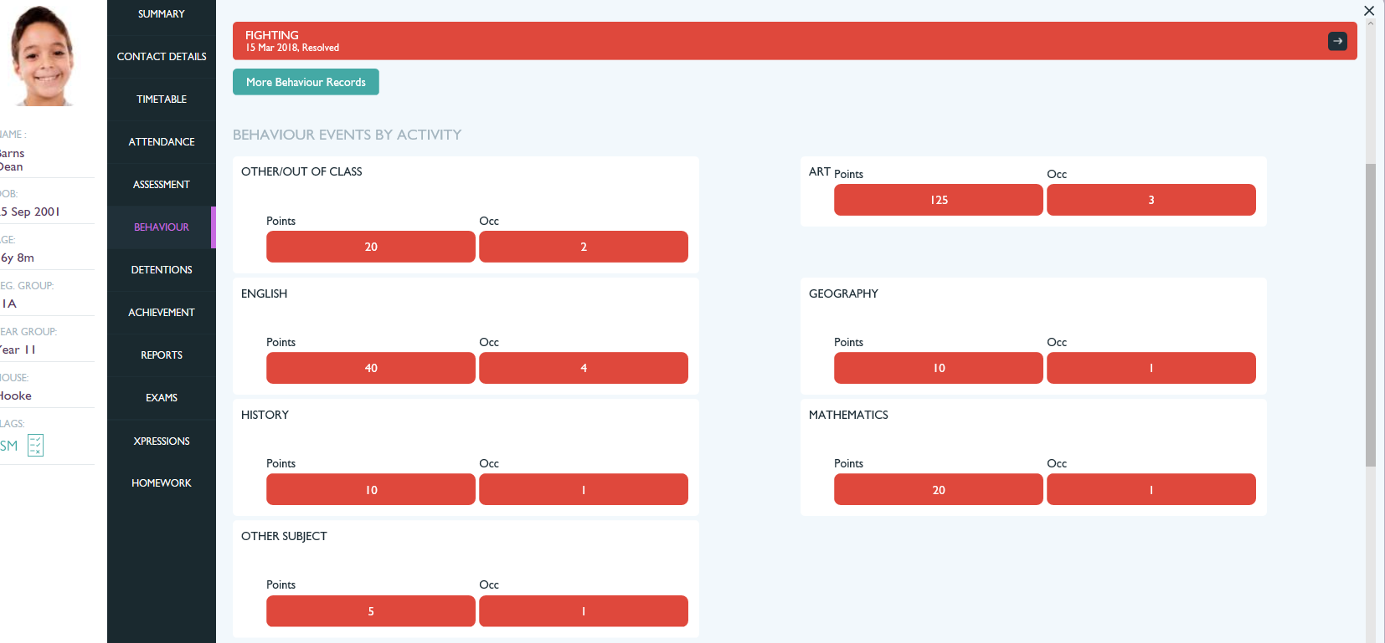

Use the X button to return to the Behaviour Summary record for Dean Barnes or select the Home icon to return you to the Student Registration screen

