To take registration via The Scomis Desktop

Registration
Once a teacher with a registration group has logged into The Scomis Desktop their class (registration group) will be displayed

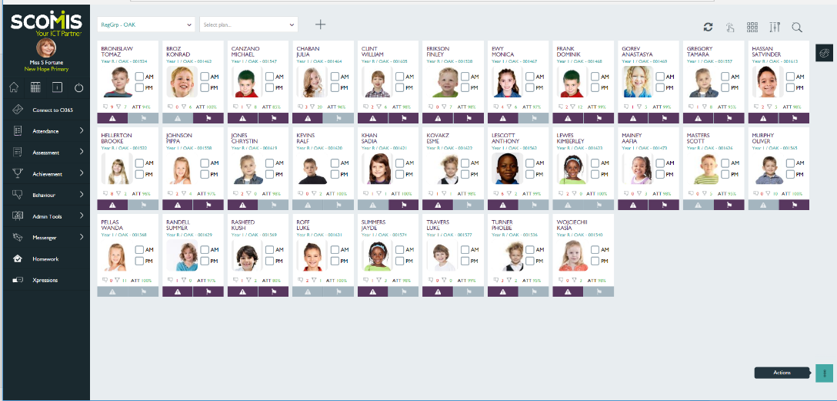

Selecting a ‘highlighted’ cell will provide further information about the student

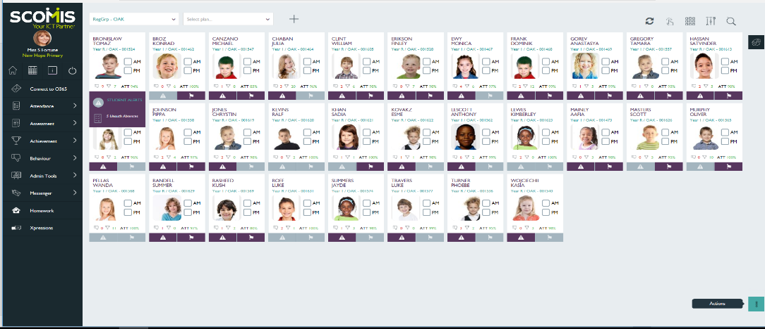

For example Tomaz has accumulated 5 unauthorised absences when the ‘Alerts’ cell is
selected. Selecting the ‘Student Flag’ for Konrad displays Medical and Pupil Premium information
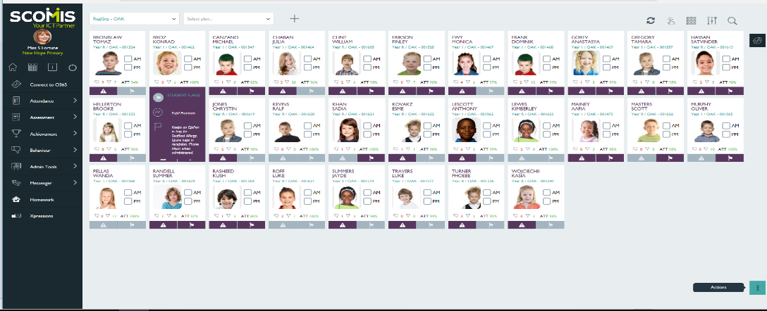
To take the register

Select Actions

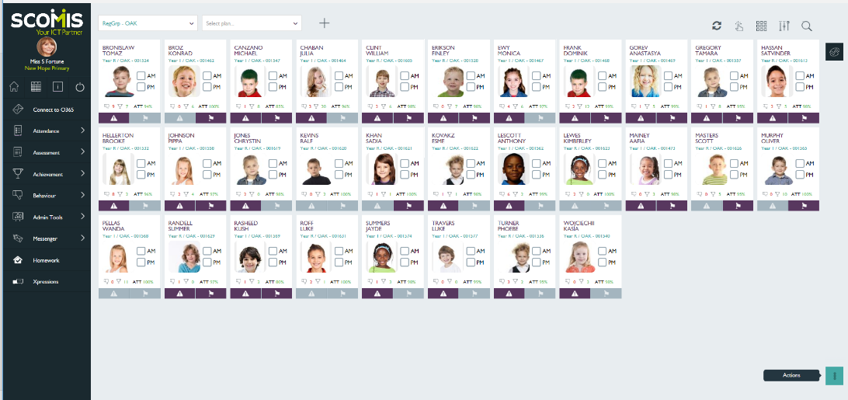

From the list select ‘Take Attendance’

Screen displays with students listed

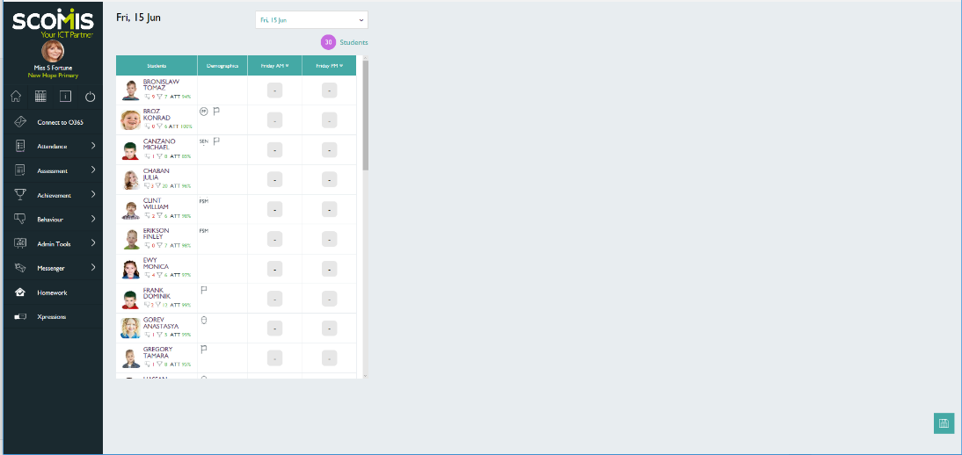

It is possible to take the register in two ways:

- Select the cell and use the / or \ keys or N for absent

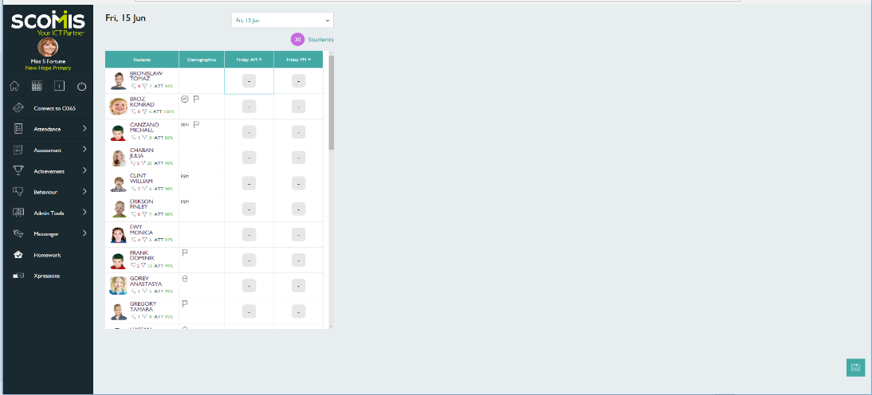

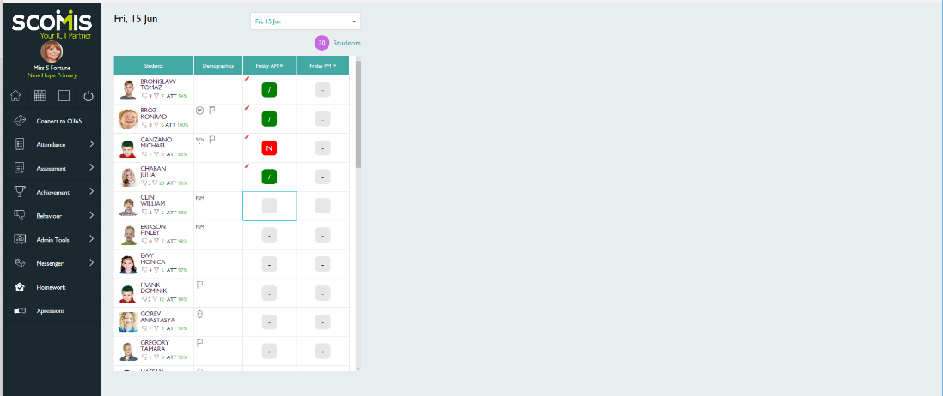
As soon as the student is marked ‘present / or absent N’ the cursor will move down to the next cell. A red pencil is displayed to indicate that the data has not been saved. Continue to complete the register for each student.

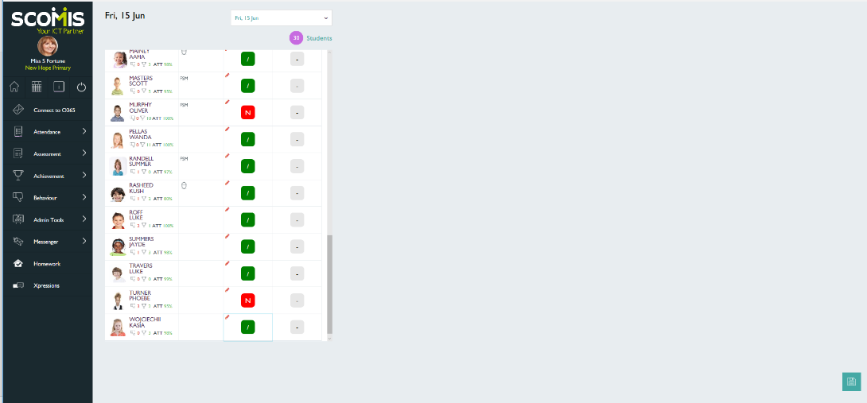

Once the register is completed for all students, select the ‘save’ icon at the bottom right of the screen
Select ‘Yes’ and the data will write back to SIMS

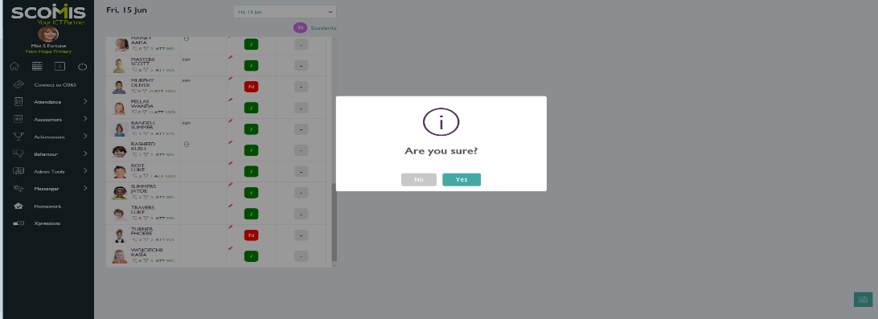e

Alternative method for taking the register
Select the two chevrons in the column heading

The following drop down box will appear
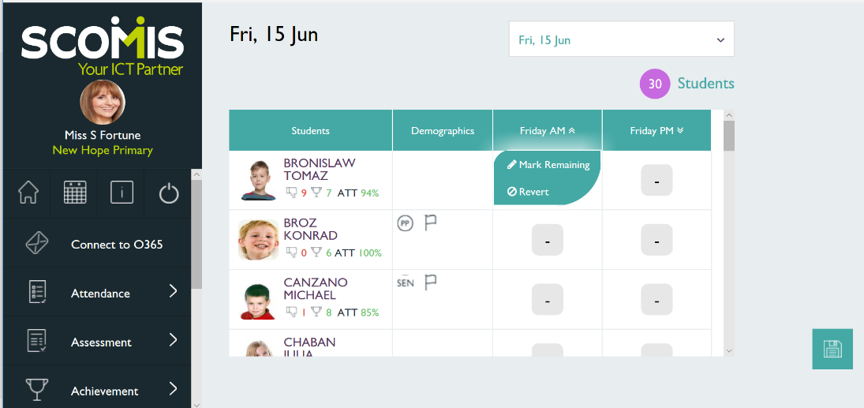

Select ‘Mark Remaining’. From the following screen select ‘Present
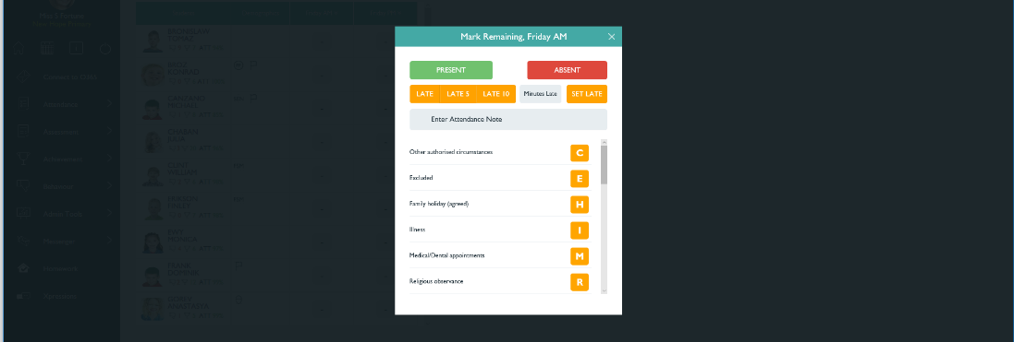
All students will be marked as present

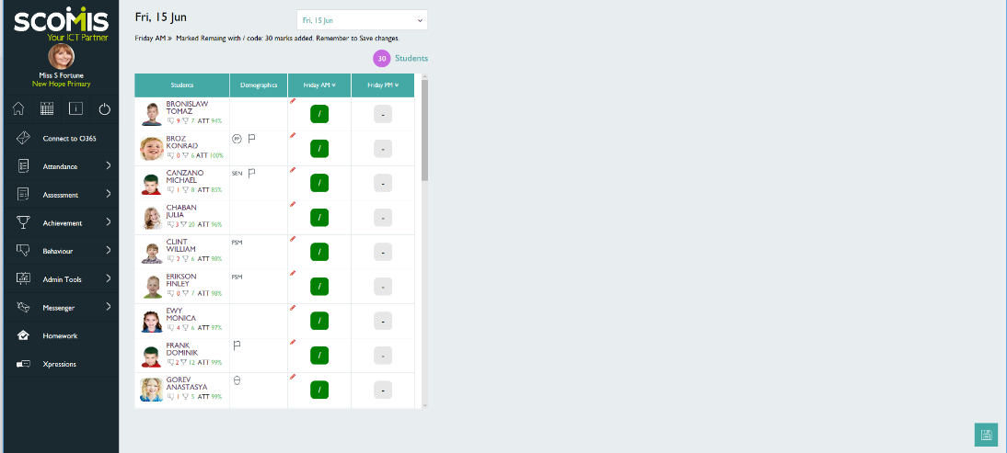

Mark students absent by selecting the relative cell i.e. Monica Ewy

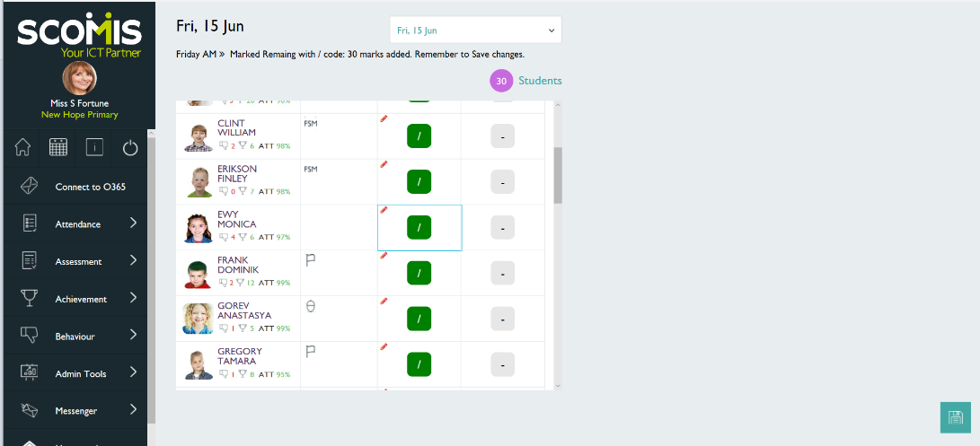

Select ‘Absent’

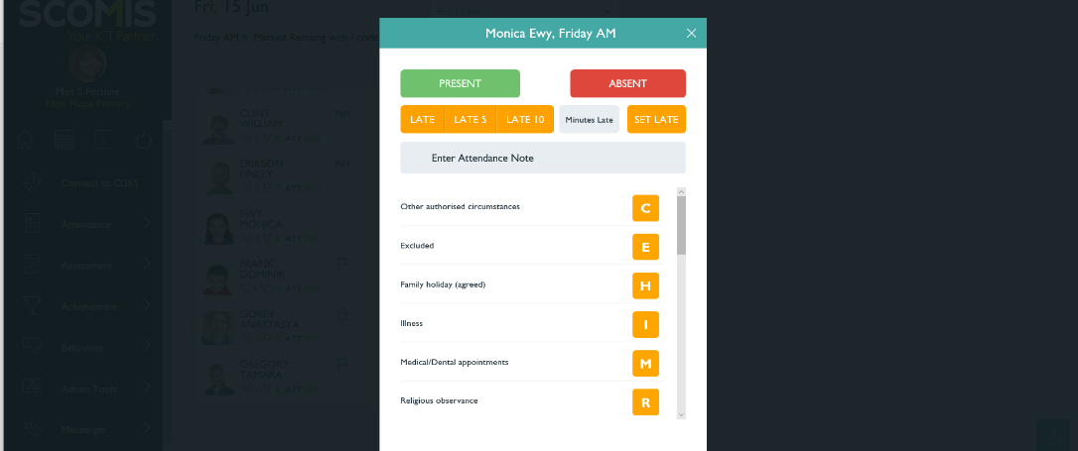

Repeat this step for the remaining students who are absent

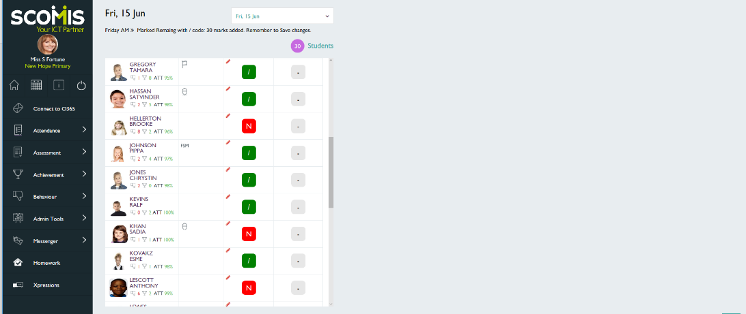

When the register is complete, select ‘Save’

Select ‘Yes’ and the data will write back to SIMS

