Uploading and Importing the Current QAN Catalogues

Courses need to have the correct QWS QAN code in the classification panel of the course in Course manager in order for the analysis reports to run correctly.

It is recommended that the following steps are undertaken to ensure the correct code is attached.

DOWNLOADING QWS QAN XML FILES

The DfE maintains this list and data is available for download from the following DfE QAN website:

<https://collectdata.education.gov.uk/qwsweb/(S(04xkip55sfip1g3rho3y4r45))/default.aspx>

*(Alternatively do a Google search entering DfE QAN Catalogue)*

Click the generic QAN data link. This will display a list of files.

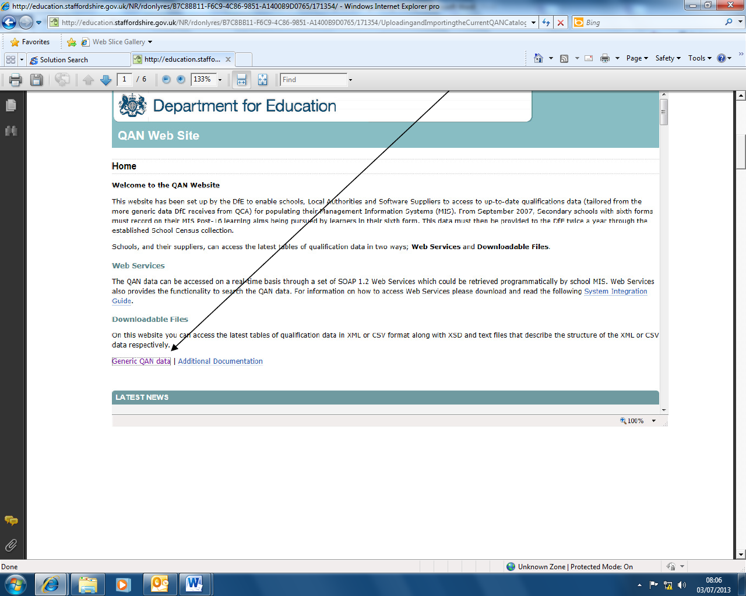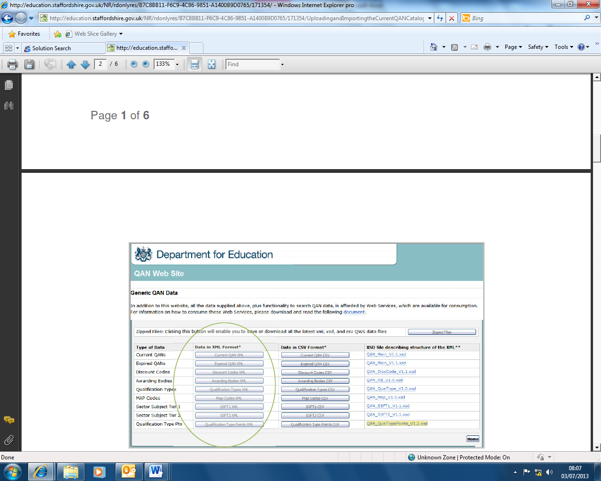

The following four files are needed from the **Generic QAN Data | Data in XML Format** area:

* Awarding bodies (QAN_AB_<version>.xml
* Discount codes (QAN_DiscCode_,version>.xml
* Qualification types (QAN_QualType_<version>.xml
* Current QAN (QAN_Current_<version>.xml

Click the applicable buttons to download the files, which should be stored on the local computer ready for Import (see below).

**DOWNLOADING THE REQUIRED FILES**

1. Create a new folder on an accessible drive or your desktop to hold the new QAN data.
2. Navigate to the **DfE QAN** website as above
3. Click the **Generic QAN Data** link
4. Click the **Awarding Bodies XML** button
5. Click the **Save** button and save the file to the folder you created
6. Repeat this for the other required files above.

**IMPORTING QANS AND DISCOUNT CODES INTO SIMS**

1. Within SIMS .net select **Tools | Examinations | Import Qualification Data**
2. A message dialog will appear asking for confirmation that you have downloaded the latest files from the DfE to a folder on your computer. Confirm by clicking on **OK.**
3. Click the browser button to the right of each of the files. Browse to the location of the files you downloaded from the DfE website.

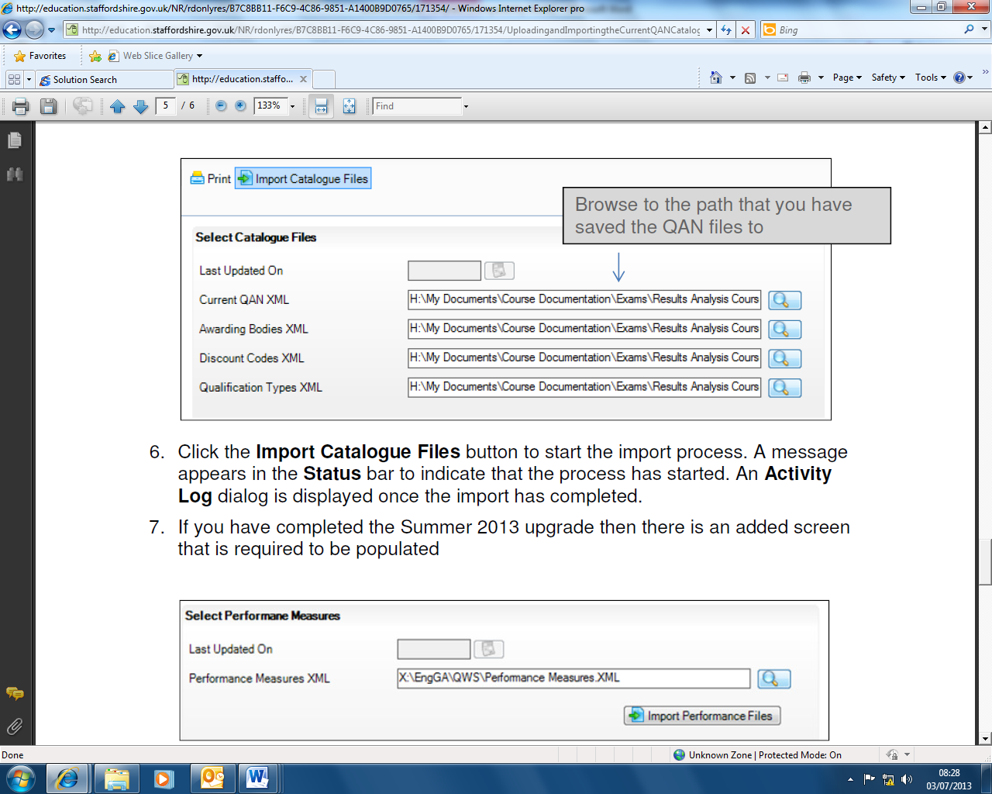

1. Click the **Import Catalogue Files** button to start the import process. A message appears in the **Status**  bar to Indicate that the process has started. An **Activity** **Log** dialogue is displayed once the import has completed.

**ACTIVATING QWS QAN AND DISCOUNT CODES IN COURSE MANAGER**

Even though the entire QWS QAN catalogue has been downloaded and imported, only a small selection of QWS QAN codes need to be present from within either the Edit PI Data screen or Course Manager. If a code is required within the Edit PI Data screen or Course Manager and it is not present, it is necessary to make it available for selection by activating the QWS QAN from the imported catalogue Into SIMS.

1. Select **Tools | Statutory Return Tools | Update QANS and Discount Codes for Course Manager**

A selection screen will be displayed supplying various filters.



The QAN catalogue contains thousands of records and clicking the **Search Title** button would load the entire list to be browsed and may take some time. Awarding body, level of the qualification and title contents can all be used in combination to narrow the search.

Enter **a subject** in the **Containing Title** field, then select from ther **Board** drop-down. Click **Search Title** button. A number of matching qualifications appear.

Select the qualifications required, then click the **Add** button to move the selection into the lower field and click the **Update Button.** This newly activated QWS QAN code can be attached to a new course.

