- Contents
01| Getting Started with Admissions 1
Introduction 1
What’s New in This Release? 2
Permissions for SIMS 2
Note for Primary Schools with Nursery Classes 3
Note for Schools with Sixth Form Intakes 3
Setting up Admissions 3
02| Adding Intake Groups and Admission Groups 5
Adding Intake Groups 5
Adding Admission Groups 6
Deleting Admission Groups 7
03| Importing Admissions Transfer Files, Accepting Applications and Admitting Applicants 9
Importing an Admissions Transfer File (ATF) 9
Transferring Admission Group Members 16
Finalising Offers for Sixth Form Classes 17
Accepting and Declining Applications 19
Withdrawing Applications 21
Admitting Applications 22
Re-admitting Pupil/Students 24
Deleting an Application 25
Running the Projected Pupil (or Student) Numbers Report 25
Index 33

Getting Started with Admissions
Introduction 1
What’s New in This Release? 2
Permissions for SIMS 2
Note for Primary Schools with Nursery Classes 3
Note for Schools with Sixth Form Intakes 3
Setting up Admissions 3

Introduction
The Admissions Code of Practice applies to the admissions process for maintained Primary and Secondary schools.
Under this system, parents submit an application form (the School Application Form) to their local LA, listing their preferred schools for their child’s education. Supporting reasons can be given to indicate why they feel their child’s attendance at a particular school would be more beneficial than their attendance elsewhere.
In co-operation with other Admission Authorities, the LA is responsible for processing all the submitted preferences and for ensuring that each applicant is issued with a single offer of a school place. Parents are then advised of this offer.
This handbook provides information on the steps necessary to record admissions in Non-Own Admissions Authority Schools in England.
These processes are applicable to Primary and Secondary schools in England. They are not applicable to schools with a Sixth Form, schools in Wales and schools in Northern Ireland.
The ADT, ASL and ATF files are compiled in XML format in accordance with the published requirements from the DfE.
IMPORTANT NOTES: Due to the sensitive nature of some of the data stored in SIMS, careful consideration should be given when specifying the location of any folder into which you save sensitive data, e.g. census returns, imported and exported CTFs, etc.
You should be mindful of your school’s responsibilities with respect to information security. Consider which users have access to the chosen folder, especially if the folder is shared on a Server. The DfE recommends ISO27001 as the standard for information security (http://www.itgovernance.co.uk/bs7799.aspx), a copy of which can be found at. If you are in any doubt, consult with your IT Security Officer before proceeding.
Please ensure that you use either CTF or ATF files to import pupil/students into SIMS. Using both methods may produce duplicate entries.

What’s New in This Release?

Updated ATF Version Number
Applicable to Maintained schools in England only
Routines | Admission | Import ATF File
It is now possible to import version 18.0 or 19.0 ATF files only.

More Information:
Importing an Admissions Transfer File (ATF) on page 9

Permissions for SIMS
When running SIMS, you should use the login name and password assigned to you by the System Manager. Your login details are set up using SIMS System Manager.
A set of default permissions is supplied with System Manager. This includes various user groups to which users can be assigned.
Users should be allocated membership to one or more of these groups to access and use the various areas of SIMS. The permissions available within these groups can be edited as required and it is also possible to add new groups to which a bespoke set of permissions can be added.
For more information on setting user permissions, please refer to the Managing SIMS Users, Groups and Databases handbook. All handbooks can be accessed from the Documentation Centre which is launched by clicking the Documentation button on the Home Page in SIMS. Once open, click the Handbooks button, select the required category, then click the required handbook from the Handbooks page.
An Excel spreadsheet describing the numerous permissions available in SIMS is available on the support portal (https://customer.support-ess.com/csm?id=kb_article_view&sysparm_article=KB0036819).

Note for Primary Schools with Nursery Classes
Schools that receive an ATF file may encounter applicants in the file who are already members of the school, e.g. they are enrolled in a Nursery class. These applicants can be imported as new applicants but prior to admitting them, the Admissions Officer is required to record these children as leavers from the Nursery class. For further information on recording leavers, please refer to the Managing Pupil/Students handbook.

Note for Schools with Sixth Form Intakes
Sixth Form intakes are not covered by the Codes of Practice in the same way as years Reception – Year 11. As a result, there are no Admissions Data Transfer (ADT) files available from the LA for these intakes.
Schools must first create intake and admission group combinations then enter applicants manually from any application forms that may have been received for these intakes. The Finalise Offers page can be used to offer places to these applicants.
When the applicants have accepted the offer of a place, they can be accepted and admitted in the usual way.

Setting up Admissions
Before starting the Admissions process in SIMS, it is important to set up the system defaults.
- Select Tools | Admissions | Defaults to display the Setup Details page.
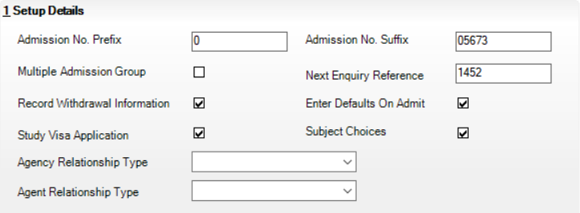
- Amend the Admission No. Prefix and Admission No. Suffix values, if required. The prefix can be either a letter or a number between 0-9 that enables you to identify a year’s admission intake easily. The prefix defaults to zero.
- Specify whether you use multiple admission groups by selecting the Multiple Admission Groups check box, if required. Selecting the check box enables you to organise admissions by splitting the intake groups across the terms of the academic year. Additional admission groups can be set up only if this check box is selected. If this check box is deselected, SIMS creates a single admission group and associates it with the newly created intake group.
The Next Enquiry Reference field is not relevant for Own Admission Authority Basic Licence users and should be ignored.
- Select the Record Withdrawal Information check box if you want to record when pupil/students, who have previously applied to attend your school but have subsequently gone elsewhere, withdraw their application.
- The Enter Defaults On Admit check box enables schools to save data on an applicant’s record without entering dates, e.g. Free School Meal period. When the applicant is finally admitted, SIMS generates the dates providing the Enter Defaults On Admit check box is selected.
- Select the Study Visa Application check box if you wish to record this information. Once this has been selected:
- a Study Visa Application record can be created and the CAS Reference (Confirmation of Acceptance for Studies) can be recorded on the Application page (via Focus | Admission | Application)
- Study Visa information can be recorded on the Enquiry page (via Focus | Admission | Enquiry).
Only schools that accept foreign nationals (requiring a VISA) as pupil/students need to manage these applications. This functionality assists schools in tracking this type of application. Schools can decide whether or not the fields associated with Study Visa applications are displayed.
- When prospective students apply to the school for Sixth form and GCSEs, they will normally apply for subjects. Select the Subject Choices check box if you want to record the subjects for which they are applying to enable further analysis. Once this check box is selected, the Subject Choices table is displayed in the Registration Details panel on the Application page.
- Select a default Agent Relationship Type and Agency Relationship Type from the drop-down lists.
The options available from these drop-down lists are controlled by lookups. The lookup values can be edited using the SEN Linked Adult Relation Type and Agency Student Relationship Type lookup tables respectively. It is recommended that you set up lookup values for any agent/agency relationship types that are required and ensure they are active.
- Click the Save button to save the details.

Additional Resources:
Recording Study Visa Application Information and Completing Registration Information in the Managing Applications to your School chapter of the Managing Pupil/Students handbook

Adding Intake Groups and Admission Groups
Adding Intake Groups 5
Adding Admission Groups 6

Adding Intake Groups
Before importing applicants, it is essential that intake and admission group combinations have been set up for the forthcoming academic year. For schools that will be importing ADT files, the creation of a new admission group or intake group into which these files can be imported is essential. Intake and admission groups can be set up in advance for future academic years.
- Select Routines | Admission | Admission Groups | Setup to display the Find Intake Group browser.
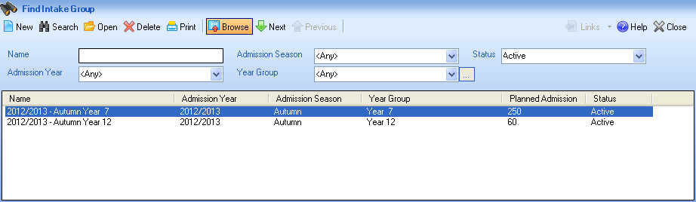
It is possible to search for the required intake group by selecting the Status from the drop-down list. This enables users to search for inactive intake groups as well as currently available groups. It is also possible to delete intake groups from the browser but it is only possible to delete groups where all the applications have already been dealt with. By setting an intake group as inactive rather than deleting the group, SIMS retains a history of the applications for a particular intake.
- After searching for an existing intake group to ensure that the details have not already been added, click the New button to display the Intake Group Details page.
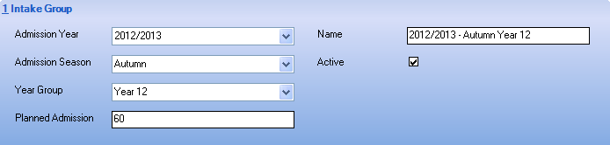
- In the Intake Group panel, select the Admission Year to which the intake group relates from the drop-down list. The admission year defaults to the current academic year but can be changed, if required.
- Select the Admission Season from the drop-down list, enabling you to associate a specific term with the intake group.
- Select the appropriate Year Group from the drop-down list. Many schools maintain several lists of applications for different year groups.
- Enter a numeric value for the Planned Admission. This represents the maximum number of new pupil/students who can be admitted for this intake group and is generally abbreviated to PAN (Planned Admission Number).
The Name field is created automatically from a combination of the admission year, admission season and the year group specified. The name can be changed by overtyping the default text.
The Active check box is selected by default, indicating that the intake group is available for use immediately. Once the applications for a particular intake group have been dealt with, schools can mark the intake group as inactive to prevent it from being displayed in the Find Intake Group browser.
- Click the Save button to save the intake group details.
SIMS validates that the name for the new intake group is unique and that an admission year, admission season, year group and PAN have been specified. Schools are required to set up additional admission groups only if the Multiple Admission Group check box is selected on the Setup Details page (via Tools | Admissions | Defaults). If this check box is not selected, SIMS creates a single admission group and associates it with the newly created intake group.

Adding Admission Groups
Schools are required to set up additional admission groups only if the Multiple Admission Group check box is selected on the Setup Details page (via Tools | Admissions | Defaults). If this check box is not selected, SIMS creates a single admission group and associates it with the newly created intake group. The following section is relevant only if you are recording multiple admission groups.
- Select Routines | Admission | Admission Groups | Setup to display the Find Intake Group browser.
- Enter all or part of the group Name or select the appropriate search criteria from the drop-down lists then click the Search button to display all intake groups that match the search criteria entered.
- Highlight the required intake group then click the Open button to display the Intake Group Details page.
- Click the New button in the Admission Groups panel to display the Add Admission Group dialog or highlight an existing admission group then click the Open button to display the Edit Admission Group dialog.
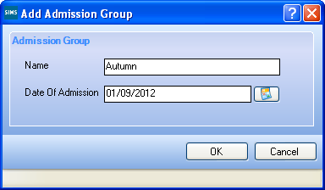
- Enter a unique Name for the admission group.
- Specify the Date Of Admission by clicking the Calendar button then selecting the required date. Admission groups are generally set up in advance of the expected intake for the forthcoming academic year. It is possible however, to specify the Date Of Admission as a date in the past. The date of admission specified must fall within the admissions year selected when the intake group was defined.
- Click the OK button to return to the Intake Group Details page.
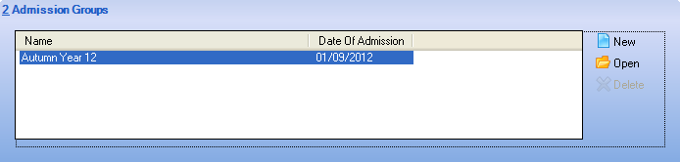

Deleting Admission Groups
The following section is relevant only if you are recording multiple admission groups.
- Select Routines | Admission | Admission Groups | Setup to display the Find Intake Group browser.
- Enter all or part of the group Name or select the appropriate search criteria from the drop-down lists then click the Search button to display all intake groups that match the search criteria entered.
- Highlight the required intake group then click the Open button to display the Intake Group Details page.
- In the Admission Groups panel, highlight the group you wish to delete then click the Delete button.
- Click the Save button.

Importing Admissions Transfer Files, Accepting Applications and Admitting Applicants
Importing an Admissions Transfer File (ATF) 9
Transferring Admission Group Members 16
Finalising Offers for Sixth Form Classes 17
Accepting and Declining Applications 19
Withdrawing Applications 21
Admitting Applications 22
Re-admitting Pupil/Students 24
Deleting an Application 25
Running the Projected Pupil (or Student) Numbers Report 25

Importing an Admissions Transfer File (ATF)
In March, schools receive an Admissions Transfer File (ATF) from their LA. This file contains the names of applicants who have been offered a place at your school for the following September, together with additional basic applicant information. Once the ATF has been imported into SIMS and applicants have been accepted, the curriculum planning process can be started.
NOTES: Before proceeding, please ensure that you have received an ATF from the LA and that it is stored in an accessible location.
An intake group and admission group combination must also have been defined, into which applicants can be imported.
- Select Routines | Admission | Import ATF File to display the Import ATF File wizard.
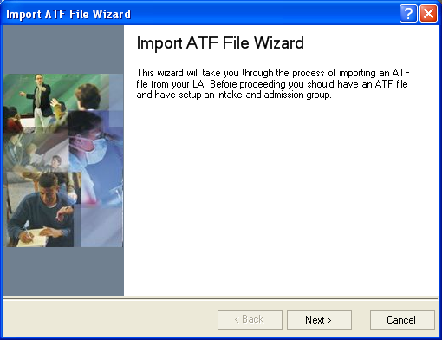
- Click the Next button to continue.
- Click the Browse button to display the Open dialog.
- Navigate to the location of the stored ATF, highlight it then click the Open button.
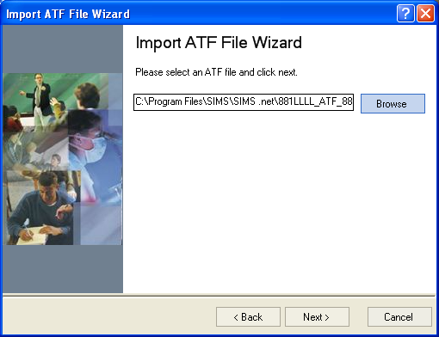
- Click the Next button to validate applicant addresses in the ATF.
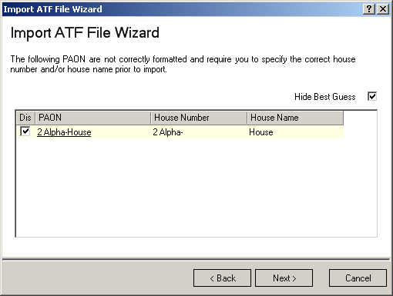
The House Number and House Name of an address are held in a single field of the XML file structure. This field is called a PAON (Primary Addressable Object Name).
This page is displayed only if the ATF contains addresses with incorrectly formatted PAON fields and enables you to correct the address details to prevent SIMS from rejecting the address.
The Hide Best Guess check box is selected by default.
Addresses that can be reconciled without user intervention are not displayed. The only addresses displayed in the lower section of the page are those that cannot be resolved automatically. These addresses can be corrected by clicking either the House Number or House Name field then entering the correct information manually. Alternatively, address details can be discarded and therefore not imported by selecting the Discard check box adjacent to the relevant entry.
If a large number of addresses require correction during import, you should request a correctly structured ATF from the LA.
- After correcting or discarding incorrect addresses, click the Next button to continue.
- Select the required Intake Group from the drop-down list.
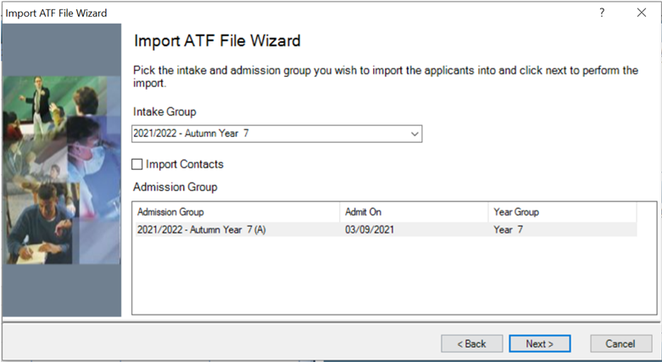
SIMS checks that the details contained in the ATF file header correspond with the details of the intake group into which the file is being imported. All admission groups associated with this intake group are displayed in the panel at the bottom of the wizard.
- To import applicants' contacts, select the Import Contacts check box.
- Highlight the required Admission Group then click the Next button to import the ATF. A progress bar is displayed.
Schools that have started to enter manually the details of next year’s applicants may encounter some duplicate applicants when importing the ATF. To reduce the risk of duplicate applicants, SIMS checks the information in the ATF against existing applicant details. Any details that match based on surname and forename are displayed.
NOTE: These details require investigation to determine whether they are new applicants or duplicates of existing, manually entered applications.
Application Reference Numbers (ARNs) play a key role in the matching of applications. Applicants who have been entered manually in SIMS are not issued with an ARN. ARNs are created as part of the LA process and applicants contained in the ATF have been given their own unique number, which is imported into SIMS with the rest of their details. These applicants are not displayed on this page.
- If an applicant in the ATF is a match for an existing applicant, select the Update Application check box. This updates the existing application and adds the applicant’s ARN to their current record.
- If an applicant in the ATF is a match for an existing applicant in SIMS, where their application was originally from another admissions year or they are currently an existing pupil in the Nursery year, select the New Application check box. For example, an applicant applied to join the school for the Nursery year in September 2020 but their application was unsuccessful, so they have now applied to join the Reception year in September 2021. These applicants are created as new applications.
- If an applicant in the ATF is a completely new applicant and is not the same as the individual found by SIMS, select the New person check box to record a new person and a new application.
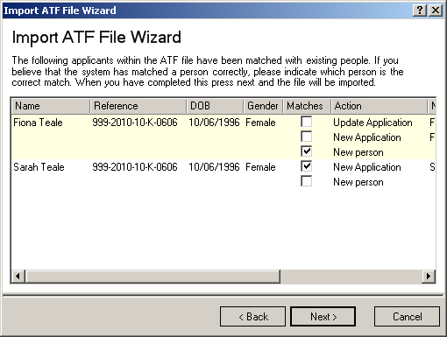
View all the fields in the panel using the scroll bar to move backwards and forwards across the page.
- Click the Next button to continue.
SIMS also checks for Contact matches, e.g. any applicant in the incoming ATF who shares a contact who is already present in the system.
- If any of the contacts listed on the following page of the wizard prove to be a match for an existing contact, select the Matches check box adjacent to the correct Name.
- If any of the contacts listed on the following page of the wizard prove to be a new contact, select the Matches check box adjacent to the New person record in the Name column.
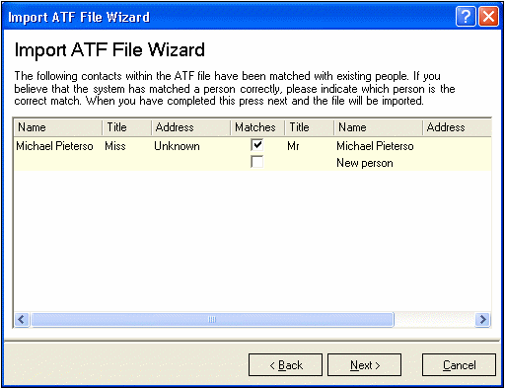
- Once you have dealt with each contact, click the Next button to continue.
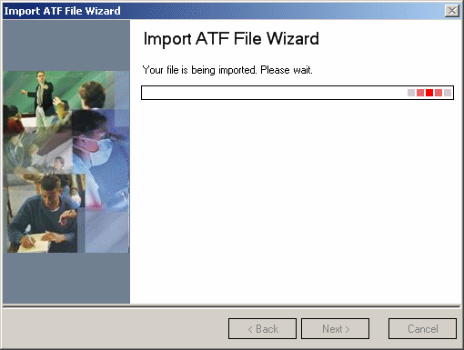
When the import is complete, the Number of applications in file, the Number of applications processed and the Number of new applications are displayed.
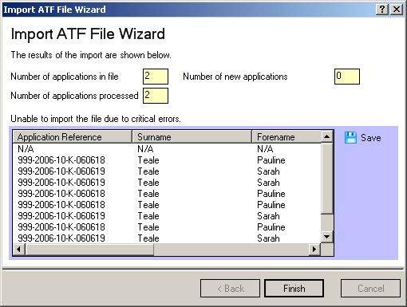
Applicants are imported with a status of Offered and their details can be viewed and updated by clicking the Application icon on the toolbar or via Focus | Admission | Application. Warnings or errors in the ATF import are listed, as shown in the previous graphic.
It is possible to Save or Print these details by clicking the appropriate button on the right-hand side of the page.
- To save the details of the ATF import, click the Save button to display the Save As dialog.
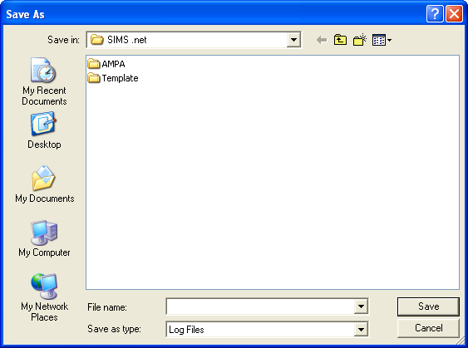
Navigate to or create a local folder in an appropriate location, enter a File name then click the Save button.
IMPORTANT NOTE: The log file may contain confidential information about the applicants so give careful consideration to where you store these files.
- To print the details of the ATF import, click the Print button to display the Run a Screen Based Report dialog.
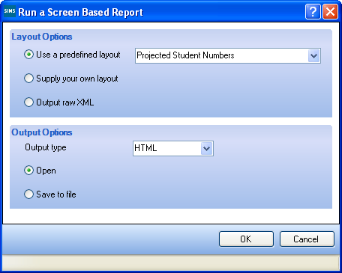
- Select the Output to a web browser check box then click the OK button to display the report in your web browser. The report can be printed by clicking the Print button.
Additional information about the applicants can be obtained by producing individual Data Collection Sheets and sending them to the applicant’s parent/guardians for completion and return. Data Collection Sheets can be produced via Reports | Run | Focus | Application or individually by clicking the Reports hyperlink in the Links panel.
- Click the Finish button to close the wizard.
NOTE: For schools that use the Enquiries functionality, when an ATF file that contains applicants who were originally recorded as enquirers is imported, the application is linked to the enquiry, and the enquiry is marked as complete and inactive. This enables you to produce accurate marketing and/or conversion reports.

Transferring Admission Group Members
All applications received by a school must be associated with an intake and admission group. The intake and admission groups define the intended date of admission and the year group for each individual application.
Occasionally, it may be necessary to associate applications with an alternative intake and/or admission group. This may be because of oversubscription to an intake and/or admission group, or because the application was originally placed in the wrong intake or admission group.
- Select Routines | Admission | Admission Groups | Transfer Applications to display the Transfer Admission Group Members page.
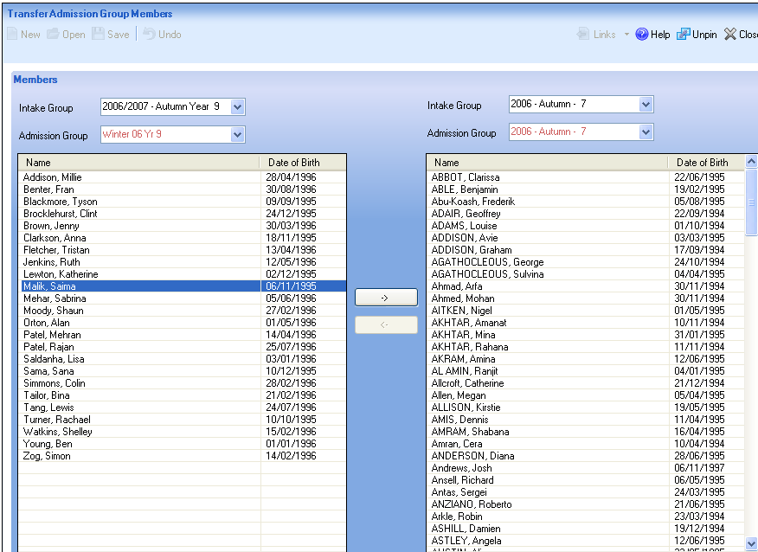
- On the left-hand side of the Members panel, select the Intake Group and Admission Group from which you want to transfer members from the drop-down lists. Only admission groups that have been associated with the selected intake group are available for selection.
All the applications that are currently associated with this intake/admission group combination are displayed in the panel on the left-hand side of the grid.
- On the right-hand side of the Members panel, select the Intake Group and Admission Group to which you want to transfer members from the drop-down lists. Only admission groups that have been associated with the selected intake group are available for selection.
All the applications that are currently associated with this intake/admission group combination are displayed in the panel on the right-hand side of the grid. If you have inadvertently selected the same intake/admission group combination on both sides of the screen, a warning message is displayed in the Status Bar advising that it is not possible to transfer members.
NOTE: If you would like to keep a record of the original allocations, click the Print button before continuing.
- Highlight the applications you wish to transfer then click the Forward and Backward buttons to move the applications. Applications can be selected individually or in multiples by using the Ctrl & Click or Shift & Click.
- Click the Save button to save the transferred applications.

Finalising Offers for Sixth Form Classes
The Finalise Offers page should be used for Sixth Form intakes to make offers to its applicants.
- Select Routines | Admission | Finalise Offers to display the Find Intake Group browser.
- Search for the required intake group, highlight it then click the Open button to display the Finalise Offers page.
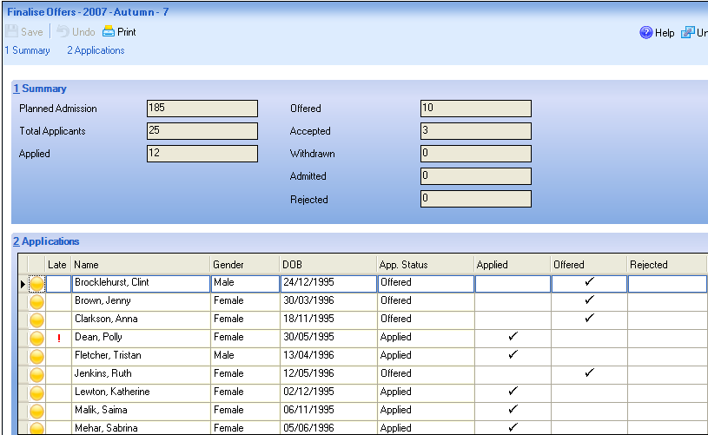
The Summary panel displays the current statistical information relating to the selected intake group.
- Planned Admission – indicates the original number of applications intended for this group (the PAN).
- Total Applicants – indicates the number of applications that have already been received and provisionally assigned to this intake group.
- Applied – indicates the number of applicants who have already applied for a place in this intake group.
- Offered – indicates the total number of places within this intake group that have already been offered to applicants.
- Accepted – indicates the number of applicants who have accepted their offered place.
- Withdrawn – indicates the number of applications that have been withdrawn from this intake group.
- Admitted – indicates the number of applicants who have already been admitted from this intake group.
- Rejected – indicates the number of applicants who have been rejected from this intake group.
The Applications panel displays the applications, together with the applicant Name, Gender, DOB and their current Application Status.
- Work through the list of applications, offering places and rejecting applicants where appropriate. The figures in the Offered and Rejected fields in the Summary panel are updated each time the information is saved.
The coloured markers on the far left-hand side of the grid indicate the following for each application.
- Green - that the applicant will be offered a place
- Orange - that the applicant could possibly be offered a place
- Red - that the applicant will not be offered a place.
- Click the Save button to save the allocations.
- Click the Print button to print the allocations.

Accepting and Declining Applications
When an acceptance notice is received from an applicant to whom you have offered a place, the application status should be updated. Only applications with a status of Accepted or Admitted are available when planning registers and detailed timetables.
- Select Routines | Admission | Accept Applications to display the Find Intake Group browser.
- Search for the required intake group, highlight it then click the Open button to display the Accept/Decline Applications page.
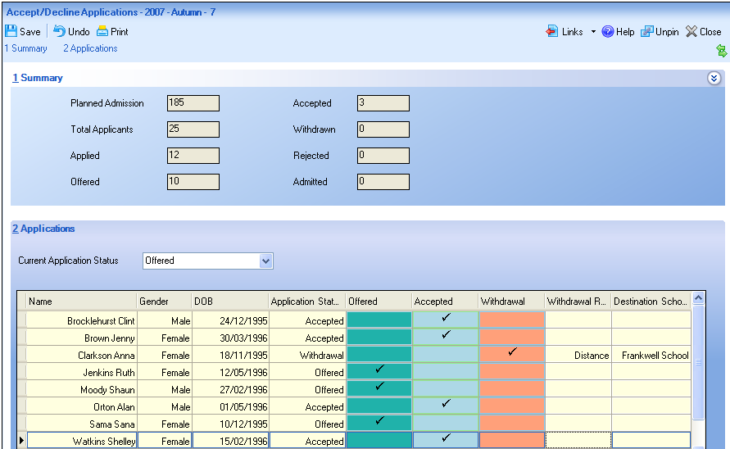
The Summary panel displays the current statistical information relating to the selected intake group.
- Planned Admission – indicates the original number of applications intended for this group (the PAN).
- Total Applicants – indicates the number of applications that have already been received and provisionally assigned to this intake group.
- Applied – indicates the number of applicants who have already applied for a place in this intake group.
- Offered – indicates the total number of places within this intake group that have already been offered to applicants.
- Accepted – indicates the number of applicants who have accepted their offered place.
- Withdrawn – indicates the number of applications that have been withdrawn from this intake group.
- Rejected – indicates the number of applicants who have been rejected from this intake group.
- Admitted – indicates the number of applicants who have already been admitted from this intake group.
Clicking the chevron button minimises the Summary panel, enabling more space on the screen for the Applications grid.
The Applications panel enables you to change the Current Application Status of the applications displayed in the grid. Select the required status from the drop-down list to change the selection of applications displayed.
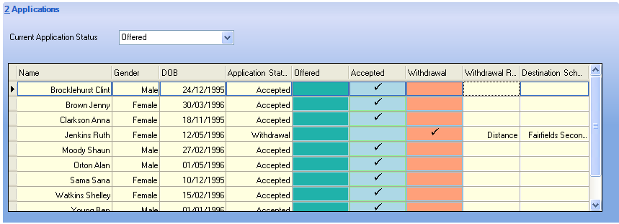
The grid displays the applications, together with the applicant Name, Sex (Gender), DOB and their current Application Status. It is possible to change the order in which the applicants are displayed in the grid by clicking any of the four column headings.
There are five additional columns, Offered, Accepted, Withdrawal, Withdrawal Reason and Destination School. The last two columns are available only if the Record Withdrawal Information check box is selected on the Setup Details page (via Tools | Admissions | Defaults).
Work through the list of applications, marking each applicant appropriately by clicking the relevant cell.
Any changes made to an applicant’s Current Application Status are updated only when you click the Save button. The figures in the Summary panel are updated each time the information is saved. SIMS validates that the total number of applicants who have been accepted or admitted from this intake group does not exceed the planned admission number (PAN) for the intake group.
- Click the Save button to save the changes.

Withdrawing Applications
It is possible to mark an applicant as Withdrawn if they eventually decide not to attend your school, perhaps because the family have moved out of the area. To ensure that your records are maintained correctly, it is advisable to remove these applicants as soon as the outcome of their application is known.
In addition to the following process, it is also possible to withdraw applicants individually via the application record (Focus | Admission | Application).
- Select Routines | Admission | Accept Applications to display the Find Intake Group browser.
- Search for the required intake group, highlight it then click the Open button to display the Accept/Decline Applications page.
All the applicants who have been allocated to this intake group are displayed in the Applications panel.
- Work through the list of applications, offering places and rejecting applicants where appropriate. The figures in the Summary panel are updated each time the information is saved.
- For each applicant who is marked as withdrawn, a Withdrawal Reason should be selected from the drop-down list to indicate why the applicant will not be attending your school.
- Click the Destination School cell then click the Browse button to display the Schools Browse dialog.
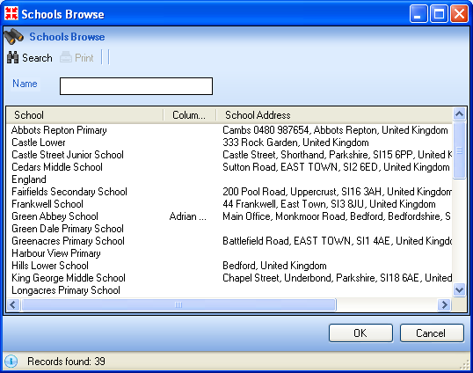
- Enter the required school Name then click the Search button to display a list of schools that match the search criteria entered.
- Highlight the required school then click the OK button to return to the Accept/Decline Applications page.
- Click the Save button to save the changes.

Admitting Applications
It is possible to admit applicants only when a place has been offered and the place has been accepted. Applicants should be admitted only when you are certain that they will be attending your school.
- Select Routines | Admission | Admit Applications to display the Find Intake Group browser.
- Enter all or part of the intake group Name or select the appropriate options from the drop-down lists then click the Search button to display all intake groups that match the search criteria entered. Alternatively, click the Search button without entering or selecting search criteria to display all intake groups.
- Highlight the required intake group then click the Open button to display the Admit Applicant Detail page.
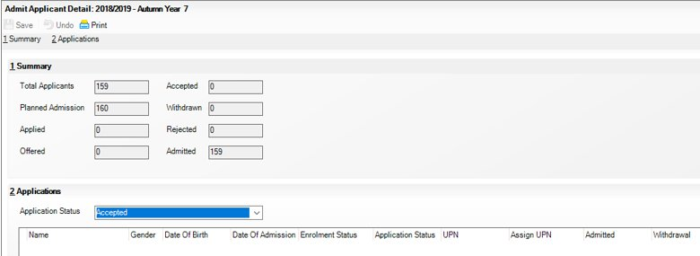
The Summary panel displays the current statistical information relating to the selected intake group.
- Total Applicants – indicates the number of applications that have already been received and provisionally assigned to this intake group.
- Planned Admission – indicates the original number of applications intended for this group (the PAN).
- Applied – indicates the number of applicants who have already applied for a place in this intake group.
- Offered – indicates the total number of places within this intake group that have already been offered to applicants.
- Accepted – indicates the number of applicants who have accepted their offered place.
- Withdrawn – indicates the number of applications that have been withdrawn from this intake group.
- Rejected – indicates the number of applicants who have been rejected from this intake group.
- Admitted – indicates the number of applicants who have already been admitted from this intake group.
Clicking the chevron button minimises the Summary panel, enabling more space on the screen for the Applications grid.
The Applications panel enables you to change the Application Status of the applications displayed in the grid. Select the required status from the drop-down list to change the selection of applications displayed.
The grid displays the applications, together with the applicant Name, Gender (Sex), Date Of Birth, Date of Admission, Enrolment Status, their current Application Status and their UPN.
The Assign UPN column can be edited. If an applicant does not have an existing UPN, click this cell, select the appropriate action from the drop-down list then click the Save button. Alternatively, click the Assign Permanent UPN button to assign UPNs to all the applicants in the grid. Permanent UPNs are issued to applicants only when it is believed that they have never been allocated a UPN, or to replace a temporary UPN.
There are several additional columns, including Admitted, Withdrawal, Withdrawal Reason and Destination School. The last two columns are available only if the Record Withdrawal Information check box is selected on the Setup Details page (via Tools | Admissions | Defaults).
Work through the list of applications, marking each applicant appropriately by clicking the relevant cell. Clicking the Admit All button selects the Admitted cell for each applicant in the Applications grid.
Any changes to an applicant’s current Application Status are updated when the record is saved. The figures in the Summary panel are updated each time the information is saved.
- Click the Save button to save the details and update the information in the Summary panel.

Re-admitting Pupil/Students
It is sometimes necessary to re-admit pupil/students because they have left, they have joined the school mid-term or they have disappeared from view because their Date of Admission was a date in the future.
- Select Focus | Pupil (or Student) | Pupil (or Student) Details to display the Find Student browser.
- Click the New button to display the Add Pupil (or Student) page. Enter any known details of the required pupil/student in the Basic Details panel to facilitate the search.
- Click the Continue button to display the Matched People panel, which displays all the people who match the search criteria entered.
- Highlight the required pupil/student then click the Open button to display the following warning message.
The selected pupil/student is a Leaver, do you want to re-admit the pupil/student?
- Click the Yes button if you are certain that this is the pupil/student who should be re-admitted to display the pupil/student’s details on the Pupil (or Student) Details page.
- Click the Save button to highlight the mandatory fields that must be completed before you can save the details. These include the Registration Group, Year Group, Year Taught In, Enrolment Status and Admission Date fields.
- Click the Save button when all the required information has been entered.

Deleting an Application
Schools may require the ability to delete one or more applications for a number of reasons.
- An application may have been entered in error.
- Applicants may have been offered a place but decided not to attend your school. Maintained schools may want to delete these applications in late September once it is clear that these applicants are not going to arrive at your school.
- Click the Application button on the toolbar or select Focus | Admission | Application to display the Find Application browser.

Application icon
- Enter the Surname or Forename for the applicant or select the Application Status, Intake Group, Admission Group or Tier from the drop-down lists. Alternatively, leave all the fields blank to search for all applicants.
- Click the Search button to display the applicants who match the search criteria entered.
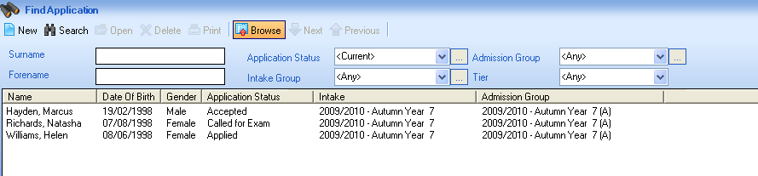
- After identifying the correct application to delete, click the Delete button to display the following warning message.
Deleting Applications will affect your annual statistics and is irreversible. Are you sure you wish to continue?
- Click the Yes button to delete the application and display the following message.
The application has successfully been deleted from the system.
- Click the OK button to complete the process.

Running the Projected Pupil (or Student) Numbers Report
The consolidated Projected Pupil (or Student) Numbers report enables schools to plan more effectively for the forthcoming admission intakes. The number of projected pupil/students can be reported on by Application Status or Application Status Category, and can be filtered on Gender, Boarder Status, House and Applicant Feeder.
The selection of a Comparison Date and Comparison Year enables you to compare projected pupil/student numbers on two dates, to facilitate the tracking of target pupil/student figures.
IMPORTANT NOTES: You are strongly advised to run the School Promotion routine (via Routines | School | Promotion) before generating the Projected Pupil (or Student) Numbers report to ensure accurate results in the report output.
You are also advised to ensure that any pupil/student leavers have been recorded.
- Select Reports | Admissions | Projected Pupil (or Student) Numbers to display the Projected Pupil (or Student) Numbers dialog.
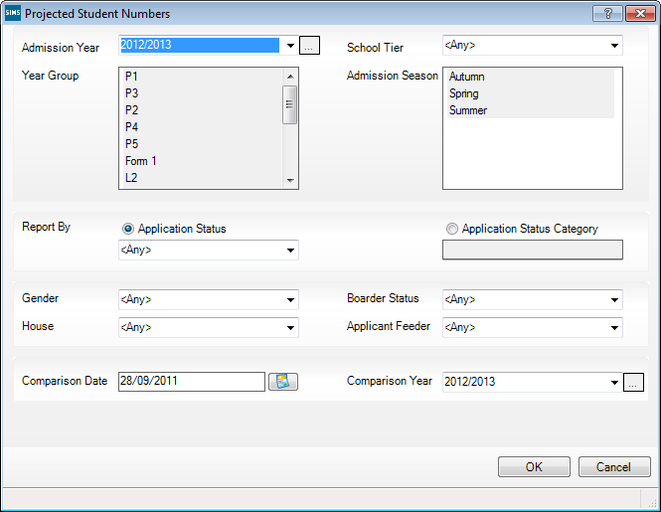
- Select the required Admission Year from the drop-down list. This relates to the year for which you want to run the report. Click the Inactive Items button to view any inactive admission years.
- Select the appropriate School Tier from the drop-down list.
- Highlight the Year Group(s) and Admission Season(s) you wish to include in the report.
- The Report By panel enables you to select the method of reporting for the last two sections of the report. Select the Application Status or Application Status Category radio button, then select the appropriate option from the respective drop-down list.
- Select the Application Status radio button, then select the appropriate status from the drop-down list if you want to report on all available application statuses or a single application status. This option is selected by default.
- Select the Application Status Category radio button, then select the appropriate category status from the drop-down list if you want to report on applications by category or a single category.
The items available in the drop-down lists are those that are marked as Active in the Application Status lookup record (via Tools | Lookups | Maintain). For example, to report only on application records with a status of Applied, select the Application Status radio button, then select Applied from the adjacent drop-down list. To report on all application records (i.e. all application records regardless of their status), select the Application Status radio button, then select <Any> from the adjacent drop-down list. The same rules apply if you elect to report by Application Status Category.
When the report is generated, the titles of the third and fourth sections vary depending on the options selected.
- Select the Gender (Sex), Boarder Status and House from the drop-down lists.
- Select the required Applicant Feeder from the drop-down list. This enables you to filter the report by Internal applicants, External applicants or <Any>. An internal applicant is somebody who is already at your establishment and is applying to enter the next tier at the establishment. An external applicant is somebody who is applying to enter the next tier of their education from another establishment.
- To enable the comparison of projected pupil/student numbers on two dates (i.e. a comparison between projected numbers on this date last year and today), as displayed in the Comparative Analysis by Application Status on <date> for <year> section of the report output:
- Enter a Comparison Date or select the date with which you wish to compare figures from the Calendar. The date defaults to exactly one year ago today but can be changed to any date in the past, up to and including yesterday's date.
- Select the Comparison Year from the drop-down list. This is either the current year (by default) or a future year. It is not possible to select a year earlier than that in which the Comparison Date lies.
The number of applications made on the Comparison Date (in its corresponding academic year) is compared with the number of applications made so far in the selected Comparison Year.
This functionality enables the tracking of progress towards target pupil numbers.
- Click the OK button to display the Run a Screen Based Report dialog.
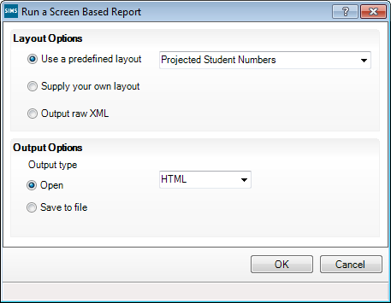
- After specifying the Layout Options and Output Options, click the OK button to produce the Projected Pupil (or Student) Numbers report.
The report can be output to Excel, an HTML browser or as XML data.
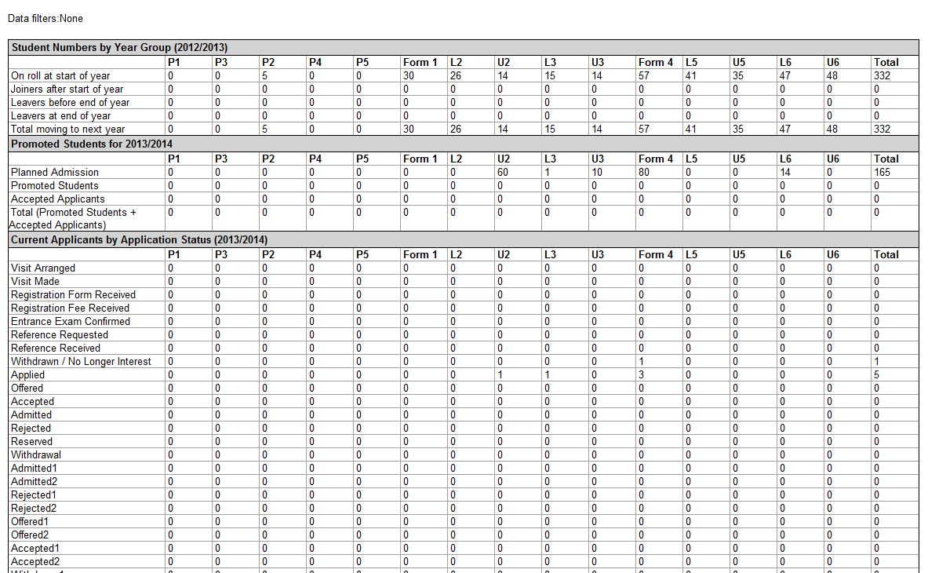
To assist with the identification of the report scope, if any of the following report filters have been applied, they are displayed as the report header:
- School Tier
- Gender (Sex)
- Boarder Status
- House
- Applicant Feeder
If no report filters have been set (i.e. all filters have been left as the default <Any>), Data filters: None is displayed as the report header (as it is displayed in the previous graphic).
The report is split into four sections:
- Pupil (or Student) Numbers by Year Group (<Academic Year>) (please see Pupil (or Student) Numbers by Year Group (<Academic Year>) on page 29)
- Promoted Pupil (or Student)s for <Next Academic Year> (please see Promoted Pupil (or Student)s for (<Next Academic Year>) on page 30)
- Current Applicants by Application Status (<Next Academic Year>) or the Current Applicants by Application Status Category (<Next Academic Year>), depending on the radio button selected in the Report By panel (please see Current Applicants by Application Status/Application Status Category (<Admission Year + 1>) on page 30).
- Comparative Analysis by Application Status on <Comparison Date> for <Comparison Year> or the Comparative Analysis by Application Status Category on <Comparison Date> for <Comparison Year>, depending on the radio button selected in the Report By panel (please see Comparative Analysis by Application Status/Application Status Category on <Comparison Date> for <Comparison Year> on page 31).
Each report row includes a Total column, enabling you to view whole school totals.

Additional Resources:
Importing and Maintaining Lookups in the Customising SIMS chapter of the Setting Up and Administering SIMS handbook

Pupil (or Student) Numbers by Year Group (<Academic Year>)
The Pupil (or Student) Numbers by Year Group (<Academic Year>) section of the report provides granular statistics on currently on-roll pupil/students.
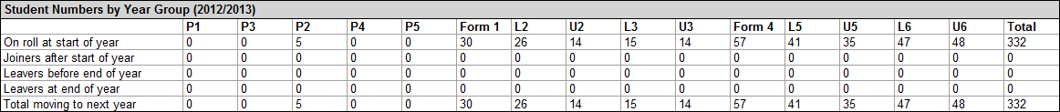
The following rows are displayed in this section:
- On roll at start of year
For each year group, the number of pupil/students on-roll at the start of the selected academic year group is displayed.
- Joiners after start of year
For each year group, the number of pupil/students who came on-roll after the start of the selected academic year is displayed.
- Leavers before end of year
For each year group, the number of pupil/students who left the school, or are due to leave the school, before the end of the selected academic year is displayed.
- Leavers at end of year
For each year group, the number of pupil/students who are due to leave the school at the end of the selected academic year is displayed.
- Total moving to next year
For each year group, this is calculated as follows: (On roll at start of year + Joiners after start of year) - (Leavers before end of year + Leavers at end of year). This also indicates the number of pupil/students who are scheduled to transfer into the next academic year.
IMPORTANT NOTE: If a pupil/student changes year group part way through the academic year, they will be included in the column associated with their current year group.

Promoted Pupil (or Student)s for (<Next Academic Year>)
The Promoted Pupil (or Student)s for <Next Academic Year> section of the report provides statistics regarding the number of pupil/students at your school who will be promoted next year and the number of applicants whose applications have been accepted.
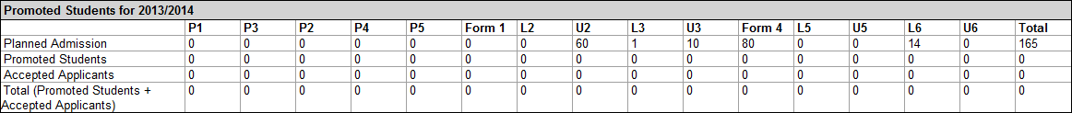
The following rows are displayed in this section:
- Planned Admission
This represents the maximum number of new pupil/students who can be admitted into an intake group (i.e. the Planned Admission Number, or PAN).
- Promoted Pupil/Students
This represents the number of pupil/students entering each year group from another year group in your school.
- Accepted Applicants
This represents the number of applicants whose applications have been accepted.
- Total (Promoted Pupil/Students + Accepted Applicants)
The total number of people who currently plan to attend your school, by year, in the next academic year.
NOTE: If you have not yet run Academic Promotion for the year into which you are moving, the figures in this table will not be accurate.

Current Applicants by Application Status/Application Status Category (<Admission Year + 1>)
The Current Applicants by Application Status <Admission Year + 1> section of the report provides granular statistics on the status of all applications, by year group, and the number of enquiries that have been made (Prospective Students) for the selected year of the report.
NOTE: This section will be named Current Applicants by Application Status Category (Admission Year +1) if you selected this radio button in the Report By panel on the Projected Student Numbers dialog.
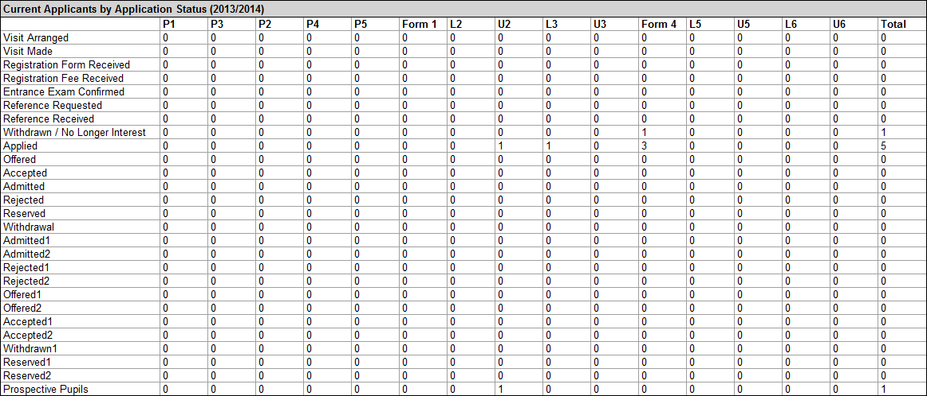
The number of rows displayed in this section of the report depends on the number of Active lookup values defined for the Application Status lookup table (via Tools | Lookups | Maintain). Additionally, the Prospective Pupils row will not be displayed if a report filter has been set in the Report By panel of the Projected Student Numbers dialog (please see Running the Projected Pupil (or Student) Numbers Report on page 25).
For an enquiry to be included in the Prospective Pupils (or Students) row of the report, all of the following rules must be met:
- The enquiry must not have a corresponding, current application.
- The proposed year of entry in the enquiry must match the Admission Year specified for the report.
- They proposed year group for the enquiry must be specified.
- The enquiry must be active.
- The prospective pupil must not be withdrawn.

Comparative Analysis by Application Status/Application Status Category on <Comparison Date> for <Comparison Year>
The Comparative Analysis by Application Status on <Comparison Date> for <Comparison Year> section of the report enables you to compare projected pupil/student numbers on two dates, to facilitate the tracking of target pupil/student figures, based on the options selected from the Comparison Date and Comparison Year drop-down lists on the Projected Student Numbers dialog (please see Running the Projected Pupil (or Student) Numbers Report on page 25).
NOTE: This section will be named Comparative Analysis by Application Status Category on <Comparison Date> for <Comparison Year> if you selected this radio button in the Report By panel on the Projected Student Numbers dialog.
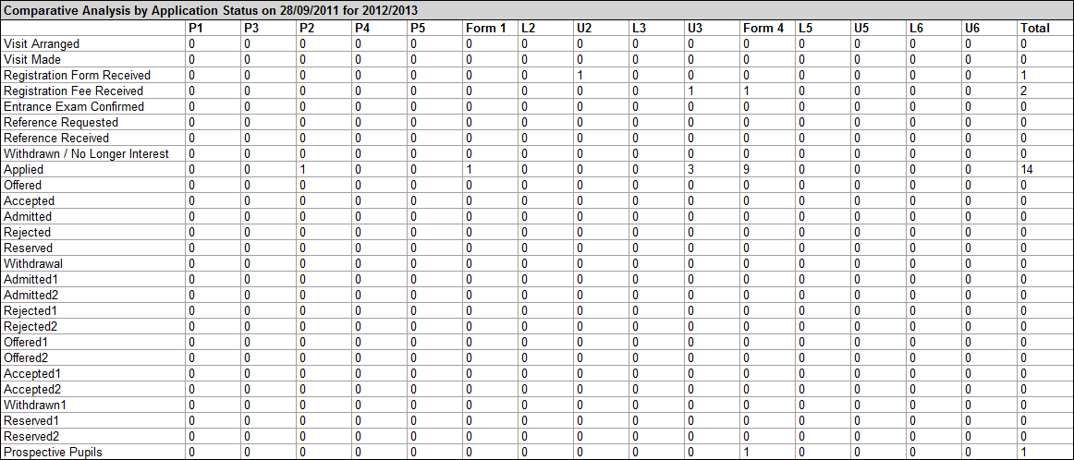
The number of rows displayed in this section of the report depends on the number of Active lookup values defined for the Application Status lookup table (via Tools | Lookups | Maintain). Additionally, the Prospective Pupils row will not be displayed if a report filter has been set in the Report By panel of the Projected Student Numbers dialog (please see Running the Projected Pupil (or Student) Numbers Report on page 25).
For an enquiry to be included in the Prospective Students row of the report, all of the following rules must be met:
- The enquiry must not have a corresponding, current application.
- The proposed year of entry in the enquiry must match the Comparison Year specified for the report.
- They proposed year group for the enquiry must be specified.
- The enquiry must be active.
- The prospective pupil must not be withdrawn.

Index
A
accepting
applicants 19
access rights 2
admission groups
creating 6
deleting 7
transferring members 16
admission number
prefix 3
suffix 3
admissions
defaults 3
admissions code of practice 1
admitting
applicants 22
applicants
accepting 19
admitting 22
applications
deleting 25
transferring to other group 16
withdrawing 21
ATF files
importing 9
C
creating
admission groups 6
intake groups 5
D
defaults
specifying 3
deleting
admission groups 7
applications 25
F
finalising offers 17
I
importing
ATF files 9
intake groups
creating 5
introduction 1
O
offers
finalising 17
P
permissions 2
prefix
admission number 3
projected pupil/student numbers report
running 25
R
reports
projected pupil/student numbers report 25
S
school application form 1
setting up
admissions 3
suffix
admission number 3
T
transferring
applications 16
W
withdrawing
applications 21

