IMPORTANT NOTE: Capita SIMS has made this document available in Microsoft® Word format to enable you to edit the information supplied herein. Capita SIMS cannot be held responsible for any changes, errors or omissions resulting from the subsequent editing of this supplied document.

School Census Autumn 2018 Preparation Check List
Use this check list to tick off each of the preparation tasks when they have been completed.

Complete | Description
 | Check with your System Administrator/Manager that you have the appropriate permissions to run the School Census and record associated data (please see Setting Permissions on page 2).
 | Upgrade to the SIMS 2018 Summer Release (SIMS 7.182) or later as soon as possible to enable dry runs to be carried out (please see What Version of SIMS is Required? on page 3).
 | Check with your System Administrator/Manager that the latest fileset version has been imported (please see Importing Revised Filesets for Validation and Reports on page 4).
 | Carry out a dry run to determine what information needs to be updated (please see Why Carry out a Dry Run? on page 9).
 | Check School Level information (please see Preparing School Level Information on page 17).
 | Check that leavers and re-admissions have been recorded (please see Recording Leavers and Re-Admissions on page 26).
 | Delete any student records that have been created in error (please see Deleting Student Records Entered in Error on page 30).
 | Check the students’ basic details (please see Checking Student Details on page 21).
 | Check the enrolment status, admission date and boarder status (please see Checking Enrolment Status, Admission Date and Boarder Status on page 39).
 | Check and correct UPNs (please see Checking Unique Pupil Numbers on page 40).
 | Check and correct unique learner numbers (please see Checking Unique Learner Numbers on page 43).
 | Check and correct part-time student information (please see Checking Student's Part-Time Details on page 44).
 | Check and correct the national curriculum year group (please see Checking National Curriculum Year Groups on page 30).
 | Check and correct each student home address (please see Checking Home Address Information on page 45).
 | Check free school meal eligibility information (please see Checking Free School Meals Eligibility on page 46).
 | Check ethnic and cultural information (please see Checking Ethnic and Cultural Information on page 48).
 | Check the Youth Support Services Agreement (YSSA) status (please see Checking Additional Information on page 49).
 | Check and correct special educational needs information (please see Checking Special Educational Needs Information on page 50).
 | Check exclusions information (please see Preparing Exclusions Information on page 53).
 | Check attendance data (please see Preparing Termly Attendance Information on page 60).
Check Post 16 information recorded in Course Manager (please see Preparing Post 16 Information in Course Manager on page 60) (applicable to Secondary schools with a Sixth Form only).
Refer to the Preparing Post 16 Data for the School Census Autumn 2018 guide, which is available on the My Account website (https://myaccount.capita-cs.co.uk) by using the search facility to find CENSUS18 documentation.

Notes

- Contents
01| Getting Started 1
Introduction 1
How has the School Census Autumn Return Changed since Last Year? 1
Setting Permissions 2
What Version of SIMS is Required? 3
Importing Revised Filesets for Validation and Reports 4
Before Importing the Revised Files 5
Importing the Revised Files 5
School Census Return Process Flow 7
02| Carrying out a Dry Run 9
Why Carry out a Dry Run? 9
The Dry Run Process 9
Resolving Validation Errors and Checking Queries 11
Producing Detail Reports 14
03| Preparing School Level Information 17
Checking Establishment Details 17
Information for Academies 18
Checking School Telephone and Email Information 19
04| Preparing Student Level Information 21
Checking Student Details 21
Updating Information Using the Bulk Update Routine 22
Bulk Updating Data with the Same Data Item then Editing the Exceptions 25
Bulk Updating Data for a Selection of Students 26
Recording Leavers and Re-Admissions 26
Recording a Leaver 26
Re-Admitting a Student 29
Deleting Student Records Entered in Error 30
Checking National Curriculum Year Groups 30
Checking the Student's Year Taught In Record 32
Checking the Year Taught In via the Pastoral Structure by Curriculum Year 32
Checking the Year Taught In via the Pastoral Structure for the Whole School 34
Checking a Student’s Basic Details 36
Recording a Student’s Change of Surname 37
Checking Registration Details 38
Checking Enrolment Status, Admission Date and Boarder Status 39
Checking Unique Pupil Numbers 41
Checking Unique Learner Numbers 43
Checking Student's Part-Time Details 44
Checking Home Address Information 45
Checking Free School Meals Eligibility 46
Checking Ethnic and Cultural Information 48
Checking Additional Information 49
Checking Special Educational Needs Information 50
Preparing Exclusions Information 53
Recording an Exclusion 53
Updating Students with Top-Up Funding 56
Updating Students Post Looked After Arrangements 57
Preparing Termly Attendance Information 60
Preparing Post 16 Information in Course Manager 60
05| What Next? 63
Where Can I Get More Information? 63
Index 65

Getting Started
Introduction 1
How has the School Census Autumn Return Changed since Last Year? 1
Setting Permissions 2
What Version of SIMS is Required? 3
Importing Revised Filesets for Validation and Reports 4
School Census Return Process Flow 7

Introduction
This preparation guide has been produced to help you to identify the most common tasks that need to be carried out before running the School Census Autumn 2018 Return.
The information in this guide applies to all LA maintained Secondary schools, Middle deemed Secondary schools, All-Through schools (secondary phase) and Pupil Referral Units (secondary phase). It also applies to Academies that cover the Secondary school phase and City Technology Colleges (CTCs) also, Service Children’s Education (Secondary schools) and on a voluntary basis.
For schools with a sixth form, an additional Preparation guide is available, which deals specifically with Post 16 data: Preparing Post 16 Data for the School Census Autumn 2018 Return guide.
Where the information relates to a specific school phase, it is indicated in red, e.g. Applicable to Middle deemed Secondary schools only.
NOTE: The content of the graphics (dates, names, etc.) are examples only of what you might expect to see when using SIMS to prepare for the forthcoming School Census Return.

How has the School Census Autumn Return Changed since Last Year?
Changes to the School Census Autumn Return include the following:

Key Dates for the School Census Autumn 2018 Return
- Census Date: 04/10/2018
- Termly attendance collected from 02/04/2018 to 31/07/2018
- Exclusions collected from 01/01/2018 to 01/04/2018
- Free School Meals collected from 18/05/2018 to 04/10/2018
- Learning Aims collected from 01/08/2017 to 04/10/2018.

Changes to Data Items Collected
The Service Children in Education indicator is now collected for all three School Census returns and is applicable to all students and school phases.
The DfE no longer require the following data items to be collected for any School Census return:
- Student Nationality
- Student Country of Birth.

More Information:
Checking Additional Information on page 49

Provider Status for Pupil Referral Units
Applicable to Pupil Referral Units only
Routines | Statutory Returns | School Census
Tools | Statutory Return Tools | Update Provider Status
A student's Provider Status can be changed via Routines | Student | Change Provider Status. Therefore, the following functionality has been removed from all school census returns:
- The Provider Status panel in the School Census area.
- The dedicated Update Provider Status menu route.

Alternative Provision Placement
The collection date range for pupil placements in Alternative Provisions (AP Placements) is now displayed in the Census Details panel.
A new detail report (AP Placements) is available from the Detail Report drop-down list.
There is no requirement from the DfE for this data to be collected or held. Should schools decide to collect, process or retain data on Alternative Provision Placements for their own purposes, a lawful basis for this processing must be identified by the school, as outlined in GDPR articles 6 and 9. More information on lawful bases for processing can be found on the ICO website (https://ico.org.uk/for-organisations/guide-to-the-general-data-protection-regulation-gdpr/lawful-basis-for-processing/#ib3).

Setting Permissions
The following permissions are applicable to users who deal with returns.

Producing the Return
To produce the return, you must be a member of the Returns Manager user group in System Manager.

Editing and Preparing Data
Users who edit and prepare data must have permissions to access additional areas of SIMS, e.g. student details, school details, etc. These users must be a member of any of the following user groups in System Manager:
- Administration Assistant
- Admissions Officer
- School Administrator.

Importing Revised Files
The Import Fileset functionality enables updates to the Validation Errors Summary and the Summary report (derived from files supplied by the Statutory Body), and detail reports (provided by SIMS), to be imported into SIMS between SIMS releases.
To use the Import Fileset functionality (via Tools | Setups | Import Fileset), you must be a member of any of the following user groups in System Manager:
- Returns Manager
- System Manager.
For more information about the Import Fileset functionality, please refer to the applicable preparation guide, available via the Documentation button on the SIMS Home Page or the My Account website (https://myaccount.capita-cs.co.uk).

Where to find More Information about Permissions
Please contact your System Administrator/Manager if you are not sure whether you have the required permissions. For more information, please refer to the Managing SIMS Users, Groups and Databases handbook.
An Excel spreadsheet describing the numerous permissions available in SIMS is available on the My Account website (https://myaccount.capita-cs.co.uk).
To find the spreadsheet, search for <sims version> sims permissions, e.g. 7.182 sims permissions.

What Version of SIMS is Required?
To run the return, you must have the SIMS 2018 Summer Release (7.182) or later installed.
To check which version of SIMS is installed, open SIMS and then select Help | About SIMS. A dialog similar to the one shown in the following graphic is displayed.
The version should read 7.182 or later.

Importing Revised Filesets for Validation and Reports
Applicable to the Personnel Officer, Returns Manager and System Manager
The Validation Errors Summary and the Summary report are derived from files supplied by the Statutory Body. In addition, SIMS provides detail reports to enable the checking of data used to generate the return. These report files are initially installed automatically during the SIMS release upgrade.
Occasionally, additions or corrections are made to these files, after a SIMS release, which are required for the forthcoming return. The Import Fileset functionality is provided to enable these files to be imported into SIMS (between releases) by the Personnel Officer, Returns Manager or System Manager.
NOTE: Use of the Import Fileset routine between releases is not always required. If updated files are available for import, a notification is displayed on My Account (https://myaccount.capita-cs.co.uk).
Revised files can be:
- downloaded from the My Account website (https://myaccount.capita-cs.co.uk) to a folder of your choice.
The files available for download from My Account are zipped. Once the ZIP file is downloaded it should be unzipped to a folder of your choice. The Import Fileset routine can then be run by a user at the school who has the appropriate permissions.
IMPORTANT NOTE: Ensure that the Document Management Server (DMS) is configured correctly before attempting to import the files.
- authorised and deployed to schools via SOLUS3. The Import Fileset routine can then be run by a user at the school who has the appropriate permissions.
IMPORTANT NOTE: In SOLUS3, administrators must ensure that the SIMS user details (SIMS username and password) and SIMS database are set up in Targets.
For more information, please refer to the SOLUS3 for Local Authorities handbook.
TIP: To check which version of the fileset is currently in use, select Routines | Statutory Returns | School Census to display the Census Return browser. The Validation Fileset ID is displayed in the browser header.

Before Importing the Revised Files
To enable the file(s) to be imported successfully, ensure that the DMS is configured correctly. This is achieved via Tools | Setups | Document Management Server. Click the Test server connection button to check if the specified DMS is available for use and functioning correctly.
If the connection is unsuccessful, check the following details:
- The Protocol field defaults to http and should not be edited.
- The Computer name should be the name/number of the PC on which the DMS is installed.
- The Port number is usually 8080. The number must be between 0 and 65535.
- The Active check box must be selected, indicating that the server is in use.
Click the Test server connection button again. If the DMS is now working correctly, click the Save button.

Additional Resources:
Setting up and Administering SIMS handbook

Importing the Revised Files
- In SIMS, select Tools | Setups | Import Fileset to display the Import Fileset page, where the current fileset number is displayed.
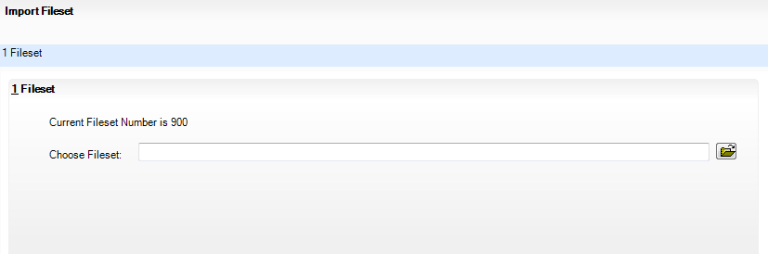
- Click the Browse button to display the Open dialog.
- Navigate to the location of the downloaded fileset. The file name is made up of the following data fields: <Fileset Number>-StatutoryReturns-<Term and Year>_Fileset.mfs.
IMPORTANT NOTE: If more than one MFS file is displayed in the Open dialog, care should be taken to select the correct file.
- Highlight the file then click the Open button. Alternatively, double-click the required MFS file to return to the Import Fileset page.
NOTE: The following graphics show example data only.
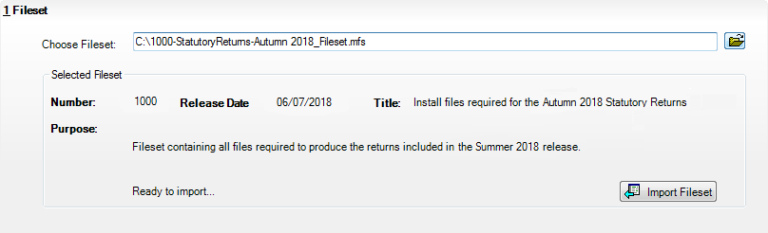
Details of the selected fileset are displayed, including the version Number of the fileset, the Release Date and the fileset description (Title).
- Click the Import Fileset button to import the fileset into the DMS.
When the import process is finished, Import successful is displayed at the bottom left-hand side of the Fileset panel and you are advised to restart SIMS. This ensures that the newly imported data will take effect.
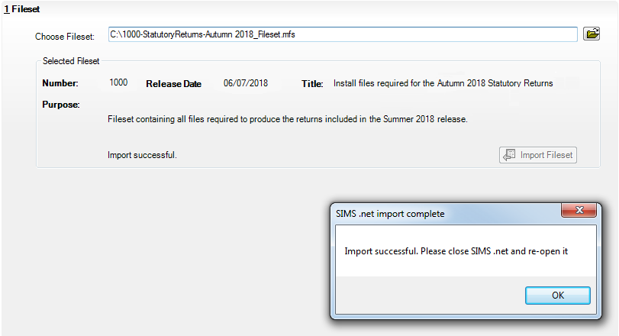
- Click the OK button then restart SIMS.
- Run the return in the usual way.

Completed

School Census Return Process Flow
The following provides a brief outline of the steps involved in producing the School Census Autumn 2018 Return. If data has been regularly and accurately maintained, many of the activities in this document are unnecessary. However, it is advisable to check to ensure that the information is up-to-date.
- Upgrade to the SIMS 2018 Summer Release (7.182) or later.
- Carry out one or more dry runs to identify any errors that may exist in your data.
- Ensure that the relevant student and school data exists in SIMS and that it is complete and correct. Use the Bulk Update routine (Routines | Student | Bulk Update) to add missing or correct invalid data, if required.
- Complete the information on the Census Return Details page.
- Create and validate the return.
- Resolve any validation errors/queries and then create and validate the return again.
Continue to resolve the validation failures then repeat the Create and Validate routine until you are satisfied that the content of the return is correct.
The detail reports and Summary report can be generated to assess the accuracy and completeness of the return.
- Provide the Head Teacher with the latest copy of the Summary report to enable them to check that all information is correct before they give approval for authorisation of the return.
The Summary report can be used in conjunction with the detail reports.
- Once approval has been given, authorise the return (Routines | Statutory Returns | School Census – Authorise button).
- Upload the return to the DfE COLLECT data collection website or submit it to your Local Authority, as applicable.

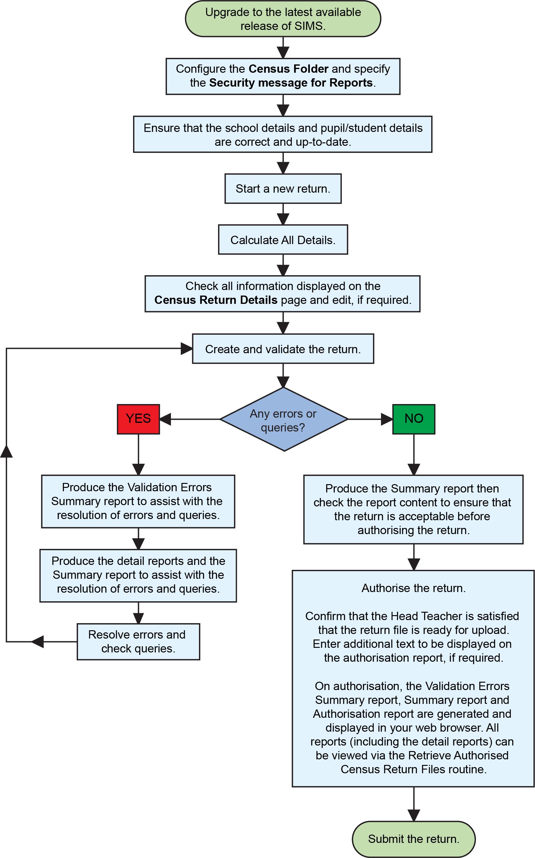

Carrying out a Dry Run
Why Carry out a Dry Run? 9
The Dry Run Process 9

Why Carry out a Dry Run?
When you have upgraded to the SIMS 2018 Summer Release (7.182), you can carry out one or more dry runs of the return.
The purpose of a dry run is to produce the Validation Errors Summary, which provides details about any corrections that need to be made to your data to make it acceptable for inclusion in the return. To ensure that you are aware of potential issues, it is advisable to do this as early as possible, even if you know that your data has not yet been fully prepared or checked.
Whilst a significant number of errors may be generated, many of the errors that relate to students, e.g. language, can be fixed quickly using the Bulk Update routine (please see Updating Information Using the Bulk Update Routine on page 22).

The Dry Run Process
- Select Routines | Statutory Returns | School Census to display the Census Return for Autumn Term browser.
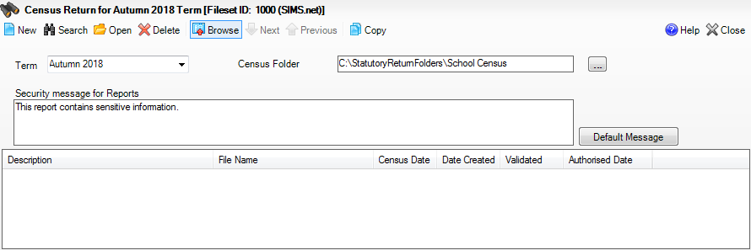
- Select an existing School Census Folder or enter a new location in which the School Census files will be stored. You may wish to make this a temporary folder for the purposes of producing a dry run.
IMPORTANT NOTE: Due to the sensitive nature of some of the data stored in SIMS, careful consideration should be given when specifying the location of any folder into which you save sensitive data, e.g. census returns, imported and exported CTFs, etc. You should be mindful of your school's responsibilities with respect to information security.
Consider which users have access to the chosen folder, especially if the folder is shared on a server. Please refer to the government website for more information about securing your information (https://www.gov.uk/service-manual/technology/securing-your-information). If you are in any doubt, you should consult with your IT Security Officer before proceeding.
- Click the New button to display the Census Return Details page.
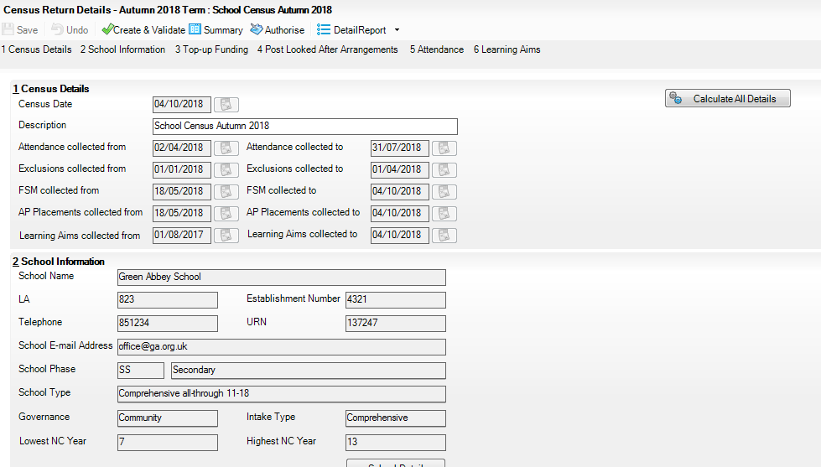
- By default, the return Description is displayed as School Census Autumn 2018. Edit the Description to any name that will clearly distinguish this dry run from the actual return, which will be generated later, e.g. Autumn18Test.
- In the Census Details panel, click the Calculate All Details button to extract the required information from the SIMS database and display the results in the various panels of the Census Return Details page.
- If there is any missing or invalid data, an error message is displayed on the Status Bar. This data must be added or corrected before the return can be created and validated.
- Click the Create & Validate button to start the validation process. This may take some time. Any missing or invalid data is listed in the Validation Errors Summary panel, located at the bottom of the page.

Additional Resources:
Detailed information about completing the individual panels on the Census Return Details page is available in the Producing the School Census Autumn 2018 Return (English Secondary/Middle deemed Secondary Schools).

Resolving Validation Errors and Checking Queries
After creating the return file and validating the data, any errors and queries found are listed in the Validation Errors Summary panel at the bottom of the Census Return Details page.
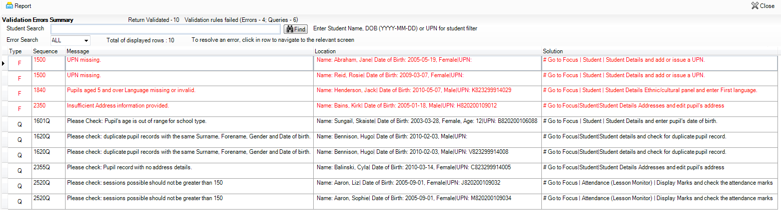
The number of errors and queries found during the Create and Validate process is displayed in the header of the Validation Errors Summary panel.
Details about each of the errors and queries found are displayed in the columns as described in the following table.

Column | Description
Type | Displays the type of validation rule:  Failure (F displayed in red) indicates an error, which must be corrected.  Query (Q displayed in black) indicates that there are unusual data conditions. These should be considered and corrected, if necessary.
Sequence | Shows the error or query number.
Message | Displays the text of the error or query message.
Location | Lists the specific record containing the error or query.
Solution | Provides a suggestion on how the error can be corrected or the query checked. Many solutions have a hyperlink (indicated by a #) to the appropriate area of SIMS.
To assist in the resolution of any errors and queries:
- When the mouse pointer is hovered over a Message, Location or Solution cell, hover help displays the entire content of that cell.
- When the mouse pointer is hovered over an error or query row, it changes to a hand if a hyperlink is available to the area of SIMS where the issue can be checked.
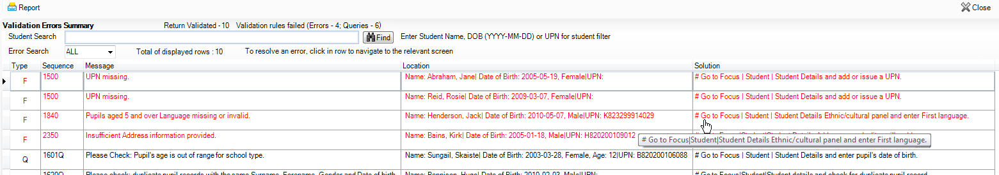
NOTE: A hyperlink is also indicated by a hash symbol (#) preceding the Solution text.
Click the appropriate hyperlink to display the specific SIMS area where the record(s) can be checked or corrected.
- The Student Search functionality can be used to display all errors and queries relating to a particular student. Enter all or part of a UPN, student's surname or date of birth in the Student Search field then select the required record from the Student Search drop-down list to populate the Student Search field. Click the Find button to display the applicable validation records.
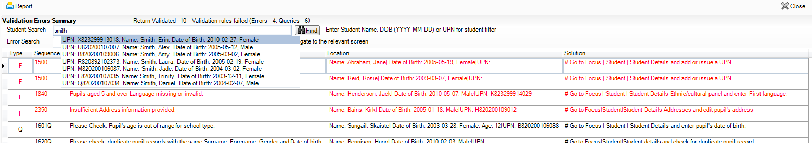
- Click a Solution hyperlink to display the area of SIMS where the associated issue can be checked and/or corrected. When you return to the Validation Errors Summary panel, the details of the applicable student are displayed in the Student Search field. Click the Find button to display all errors and queries relating to that student.
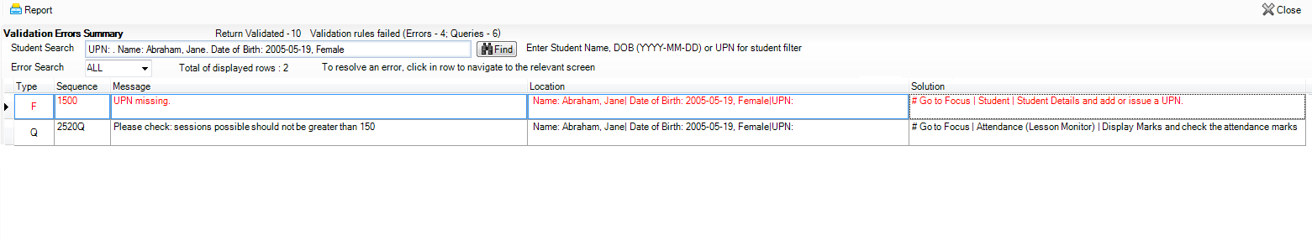
- Use the Errors Search to display the required error or query you want to view. Select ALL, ERRORS, QUERIES or the required number from the drop-down list. The total number of rows that relate to the selected validation is displayed adjacent to the Error Search field.
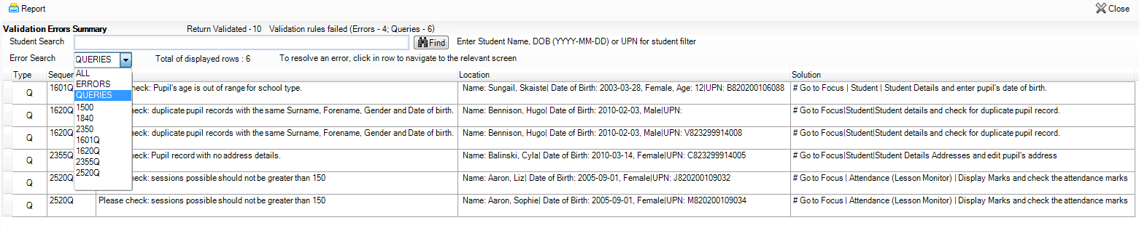
- By default, when ALL is selected from the Errors Search drop-down list, the errors are displayed at the top of the list.
The order of the items in the list can be changed by clicking the appropriate column heading.
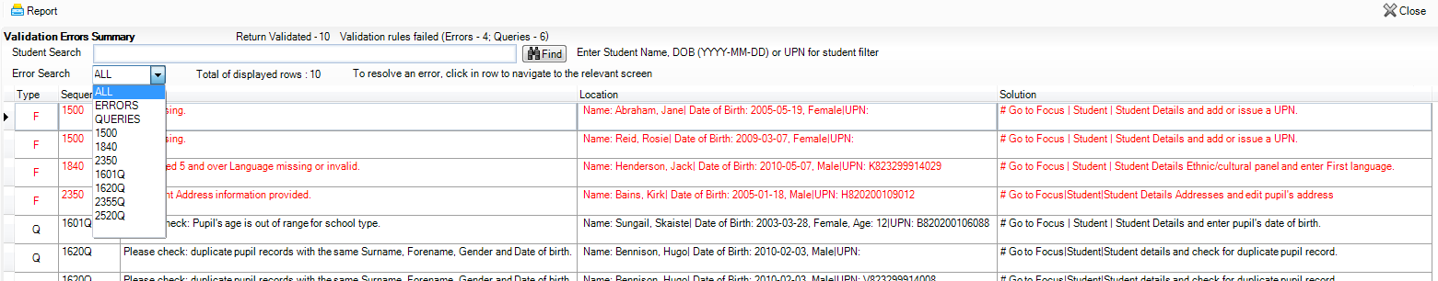
The width of the columns can be changed by dragging the dividing line between the column headings until the required size is achieved.
- View a summary of validation failures, which is particularly useful if there are a large number of errors/queries, by clicking the Report button (located at the left-hand side and directly above the Validation Errors Summary panel). The report is displayed in your web browser, e.g. Internet Explorer®, where it can be printed or transferred to another application, if required.
The report (Validation Errors Summary.HTML) is saved automatically in the Census Folder, which was specified previously in the Census Return for <season> <year> Term browser. The original report, which was generated when the Create & Validate button was clicked (e.g. <LACode><SchoolNumber>_<SurveyType>_ <LACode><LL><Year>_<SerialNumber>_ ValidationErrorsSummary.HTML), is also stored in this folder.
For guidance on navigating to files on your local workstation when you are working in a Hosted environment, please contact your System Manager or Local Support Unit.
Resolve as many errors and check as many queries as possible then revalidate the return details. Continue to resolve failures and revalidate the return as many times as necessary.
NOTE: All errors must be resolved and all queries must be investigated.
If at any point you wish to hide the list of error and queries, click the Close button located at the top right-hand side of the Validation Errors Summary panel. The list is displayed again when the Create and Validate process is run.
Many of the errors generated can be fixed quickly using bulk update functionality (via Routines | Student | Bulk Update). For more information, please refer to the Managing Pupil/Students handbook.
In addition to the Validation Errors Summary, an Errors and Resolutions document containing a list of all errors/queries that can be generated is being produced. Explanations and information on how to resolve the errors or whether the queries can be ignored are also included. The document can help to identify the order in which errors should be corrected. For example, if a UPN is missing, several UPN related errors might be generated. Therefore, adding missing UPNs can remove several errors.

Producing Detail Reports
Detail Reports can be used to check the data stored in SIMS that has been used to create the return. The reports can be produced as soon as the return has been validated.
The following reports are currently available:
- On Roll Basic Details Report
- Leavers Basic Details Report
- Exclusions Report
- Attendance Report (1st half term)
- Attendance Report (2nd half term)
- Absentees Report
- SEN Report
- Address Detail Report
- Free School Meal Eligibility Report
- AP Placements Report
- On Roll Learning Aims Report
- Leavers Learning Aims Report
- Learning Aims by Status Report
- Post-16 Programmes of Study report
- Prior Attainment report
- Top-up Funding Report
- Post Looked After Arrangements Report.
To select a single detail report:
Select the required report from the Detail Report drop-down list, located at the top of the Census Return Details page. The selected report is generated automatically and displayed in your web browser.
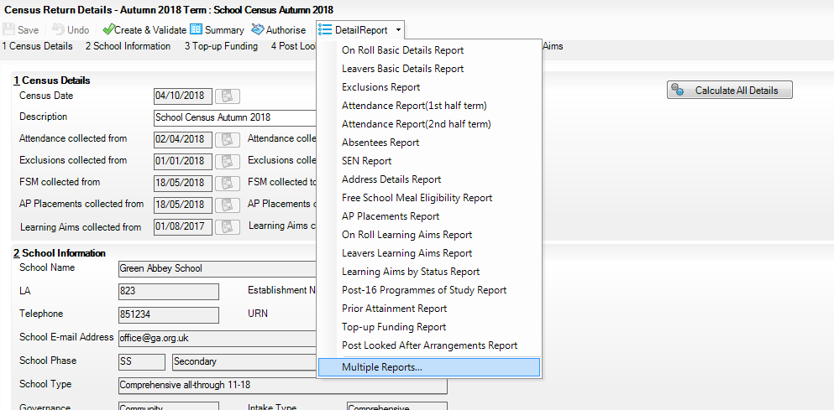
To select multiple detail reports:
- Select Multiple Reports from the bottom of the Detail Report drop-down list to display the Detail Reports dialog. By default, all detail reports are selected.
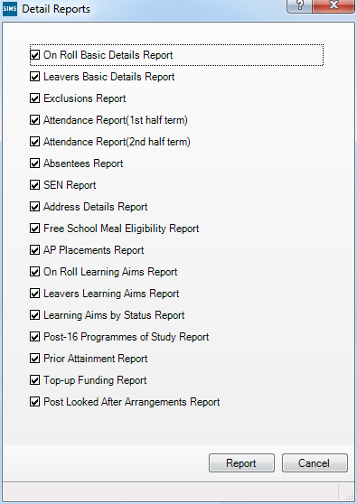
- If any reports are not required, deselect the associated check boxes.
- Click the Report button to generate the selected reports, which are displayed in your web browser.
The reports are saved automatically in the folder specified in the Census Return for Autumn Term browser, e.g. S:\SCHOOL CENSUS. For guidance on navigating to files on your local workstation when you are working in a Hosted environment, please contact your System Manager or Local Support Unit.
TIP: If required, the report can be transferred to a spreadsheet application, which enables the data to be sorted and the column order to be changed, etc. In your web browser, right-click the report then select the required option, e.g. Export to Microsoft Excel, from the drop-down list.

Completed

Preparing School Level Information
Checking Establishment Details 17
Checking School Telephone and Email Information 19

Checking Establishment Details
The following establishment details are required for the return and therefore need to be checked to ensure that they are recorded correctly in SIMS:
- Unique Reference Number (URN)
- School Type
- School Governance
- Intake Type.
The following read-only items are also collected. Please contact your Local Support Unit if the information displayed in SIMS is incorrect.
- School Name
- LA number
- Establishment Number
- School Phase
- Curriculum Years (highest and lowest national curriculum year group).
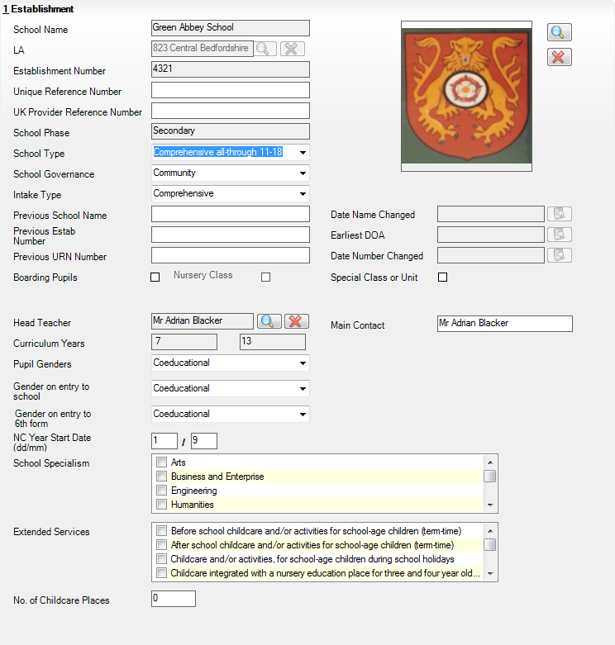
- Select Focus | School | School Details to display the School Details page.
- Check that the details displayed in the Establishment panel are correct.
- Ensure that the School Type, School Governance and Intake Type are displayed correctly. Select the correct value from the drop-down lists, if required.
NOTE: The School Name, LA number, Establishment Number and School Phase were set up when SIMS was installed. If these details are incorrect, please contact your Local Support Unit for assistance.
- Ensure that the establishment's six digit Unique Reference Number (URN) is entered. The number is available via the Get information about schools website (https://get-information-schools.service.gov.uk/), which is a register of schools and colleges in England.
- If you have edited any information in the Establishment panel, click the Save button.

Completed

Information for Academies
Academies should also ensure that the following information is recorded, if applicable:
- The School Type and School Governance.
Select Academies from the applicable drop-down lists.
- The Previous Name and Date Name Changed.
- The Previous Estab Number and Earliest DOA (date of admission).
This information is used by School Census. If the establishment number (DfE number) has changed for sponsor-led Academies, historical information is not collected and the earliest date of admission is reported in the School Census.
- The Previous URN Number (used by other census returns) and Date Number Changed.
This information is used by the School Workforce Census. For all types of Academies opened in the collection period, the date that the establishment’s URN changed is used to determine when the academy was formed. Historical information is not collected from before the date the URN changed.

Checking School Telephone and Email Information
The following school contact details are collected for the return and therefore need to be checked to ensure that they are up-to-date and correctly recorded in SIMS:
- School Email Address
- School Telephone Number.
- Select Focus | School | School Details to display the School Details page.
- Click the Contact Details hyperlink to display the Contact Details panel.
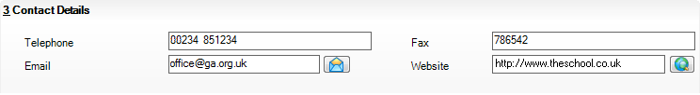
- Ensure that a Telephone number has been recorded (including the STD code).
- Ensure that the school’s official communications Email address has been recorded correctly (it must include the @ character together with a minimum of one full stop).
The email address must be the account used on a regular basis. It must also be accessible to the Head Teacher as it might be used for future DfE correspondence.
- Click the Save button, if changes have been made.

Completed

Preparing Student Level Information
Checking Student Details 21
Updating Information Using the Bulk Update Routine 22
Recording Leavers and Re-Admissions 26
Deleting Student Records Entered in Error 30
Checking National Curriculum Year Groups 30
Checking a Student’s Basic Details 36
Checking Registration Details 38
Checking Home Address Information 45
Checking Free School Meals Eligibility 46
Checking Ethnic and Cultural Information 48
Checking Additional Information 49
Checking Special Educational Needs Information 50
Preparing Exclusions Information 53
Updating Students with Top-Up Funding 56
Updating Students Post Looked After Arrangements 57
Preparing Termly Attendance Information 60
Preparing Post 16 Information in Course Manager 60

Checking Student Details
Before starting the School Census return, check that all on-roll students are recorded in SIMS and that as far as possible the information is up-to-date and accurate. Ensure that:
- new students records have been added (for more information, please refer to the Recording a New Pupil/Student section in the Managing Pupil/Student handbook).
- any leavers have been recorded as such (please see Recording Leavers and Re-Admissions on page 26).
NOTE: Ensure that a student’s first language and boarder status are entered before they are recorded as a leaver.
- any duplicate student records have been deleted (please see Deleting Student Records Entered in Error on page 30).
- part-time details have been checked/updated.
- student details have been updated where required.
The following sections in this guide provide additional information and specific instructions on checking and editing student level data. Some of this data can be checked/updated using the Bulk Update routine (please see Updating Information Using the Bulk Update Routine on page 22).
When you have upgraded to the SIMS 2018 Summer Release (7.182), you are strongly advised to carry out one or more dry runs in order to identify any validation errors and queries that must be resolved before the return is submitted (please see Why Carry out a Dry Run? on page 9).

Updating Information Using the Bulk Update Routine
To prevent validation errors from occurring, it is advisable to check your SIMS data for accuracy before the return is created and validated.
Many items can be checked using the Bulk Update routine. This functionality enables you to search for missing or invalid data then update in bulk. For example, it is possible to search for all students who do not have a First Language recorded against their name. From the students found, a value can be assigned to all or several students. This prevents the need to enter/change values manually for individual students.
- Select Routines | Student | Bulk Update to display the Bulk update Student browser.
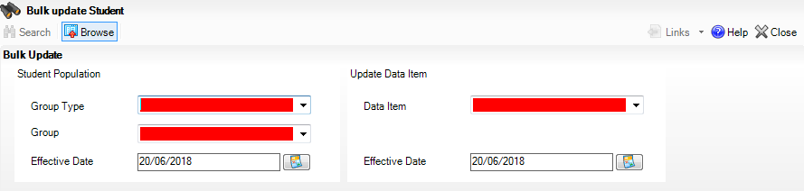
- In the Bulk Update panel, select the required Group Type and Group from the drop-down lists.
The Group Type indicates the type of group to list while the Group enables the specific group of students to be listed. For example, selecting a Group Type of Year Group enables a specific year to be selected from the Group drop-down list, such as Year 8.
If searching for missing information, select the particular data field from the Group Type drop-down list, such as First Language, and then select a specific Group, such as <NONE>.
It is also possible to use this functionality to review the data entered for all the students in the school. This is achieved by selecting Year Group from the Group Type drop-down list and <ANY> from the Group drop-down list and then selecting the required Data Item.
The following table provides some examples of the searches that can be carried out to identify missing data.

Group Type | Group | Data Item | Comment
First Language | <NONE> | First Language | Identifies students who do not have a First Language recorded. Can also be used to change existing values as required.
SEN Status | Education, Health and Care Plan | SEN Provision Type | Lists students with a SEN Status of E enabling the SEN Provision to be selected.
Year Group | Year 8 (and above) | Boarder Status | Searches for all students in Year Group 8 and then displays the boarder status recorded against each student's name.
- Select the required Data Item from the drop-down list, e.g. First Language.
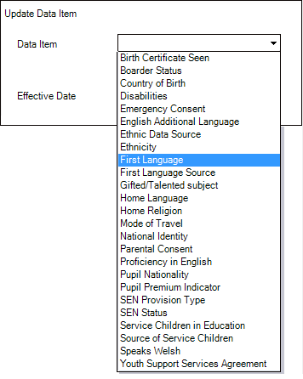
- The Effective Date is the date on which the membership of the group is based and defaults to today’s date. In most circumstances, it is advisable to change this date to the start of the academic year because most data recorded is applicable from the start of the academic year.
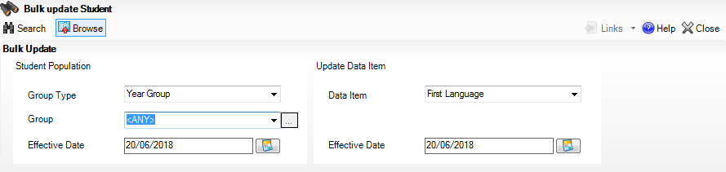
- Click the Search button to display the Members panel, which displays a list of students matching the chosen criteria and the choice of First Language types.
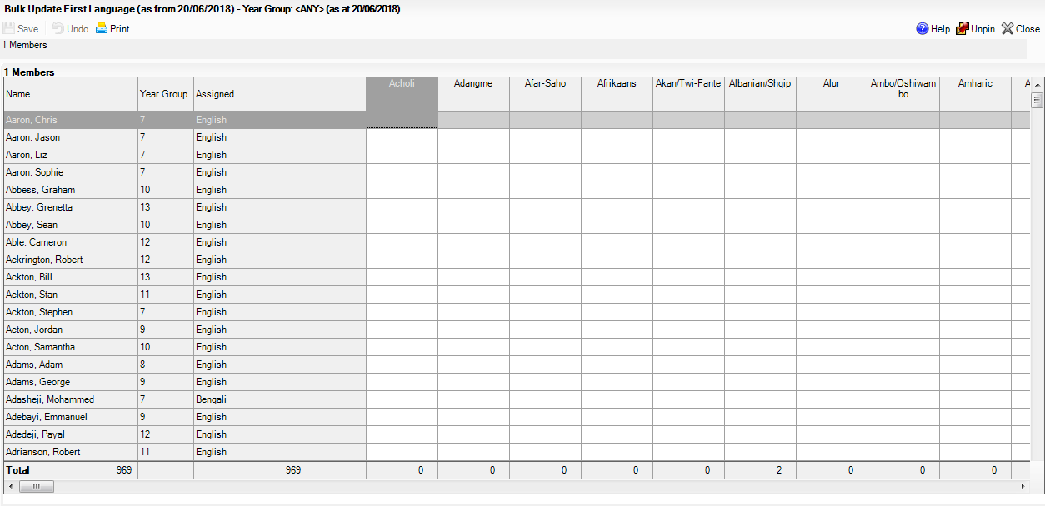
TIPS: Use the horizontal and vertical scroll bars to view additional columns or rows as required. To increase the number of columns visible on the page, right-click any column heading then select Narrow Columns from the pop-up menu.

Bulk Updating Data with the Same Data Item then Editing the Exceptions
Often, the most effective way of populating missing data is to fill all the rows with the same data item and then edit the exceptions (for example, depending on the ethnic range within your school).
The following example illustrates how to set the ethnicity of all students as English then edit the exceptions.
- Right-click the English data entry column header (hover over the heading to see the full title, if required) then select Check All from the pop-up menu.
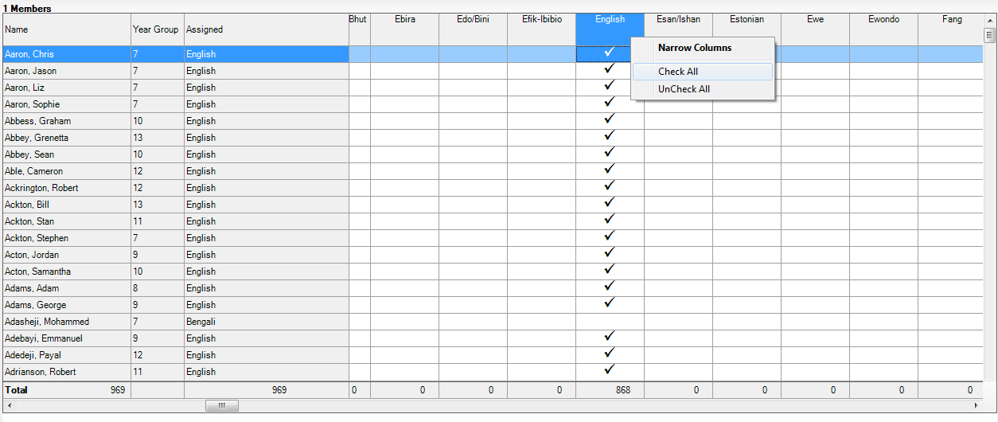
All the cells within that column are populated with ticks.
- Edit the exceptions by clicking in the cell associated with the individual student and their status, e.g. the first language of Cameron Able is Estonian.
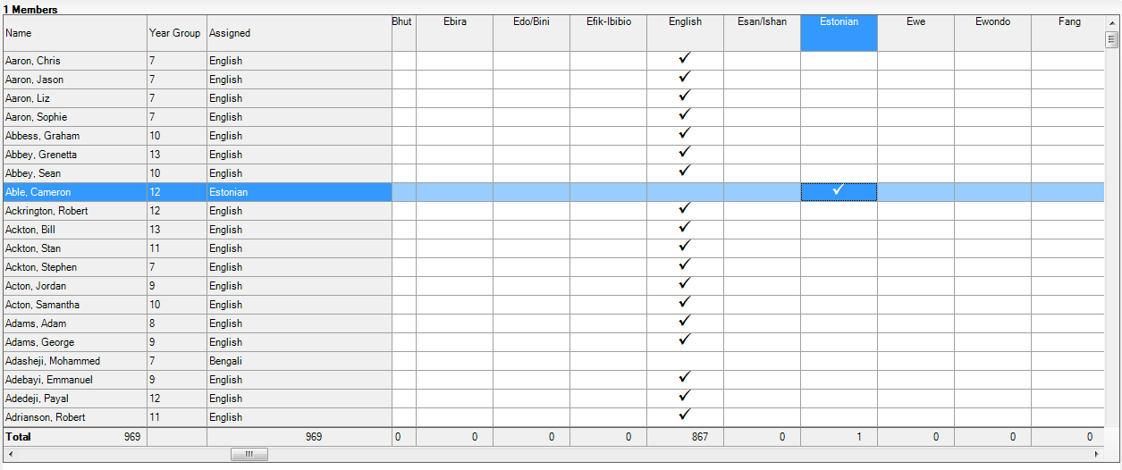
- Once you have made all the required changes, click the Save button to bulk update the records.

Bulk Updating Data for a Selection of Students
There are two methods for selecting a number of students.
Entering a Value for a Selection of Students
- Highlight the first student you wish to select then hold down the Ctrl key and highlight the other required students.
- Release the Ctrl key and then click one of the highlighted cells in the required data item column.
A tick indicates that the student has been assigned that value.
Entering a Value for Sequentially Listed Students
This method can be used for assigning a value to a group of sequentially listed students. For example, clicking the Assigned column heading displays all unassigned student at the top of the list.
- Highlight the first student in the group, hold down the Shift key then click the last student in the group (alternatively, hold down the Shift key and press the Down Arrow key).
- Release the Shift key then click one of the highlighted cells in the required data item column.
A tick indicates that the student has been assigned that value.

Recording Leavers and Re-Admissions
Ensure that all your leavers are taken off-roll and any returning students are re-admitted.
The accuracy of student numbers can be checked by running the Population Analysis (Dated) report (Reports | Run Report – Focus – Student). This is a predefined report that gives a breakdown of the number of students (including numbers by gender) for each registration group in each year, together with a grand total.

Recording a Leaver
The Date of Leaving is collected for all schools with the exception of Nursery schools.
- Select Routines | Student | Leavers to display the Find Pupil(s) or Find Student(s) browser.
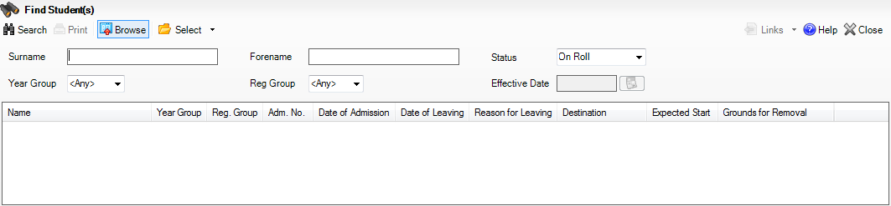
- Ensure that the Status of On Roll is selected.
- Click the Search button to display a list of all on-roll students.
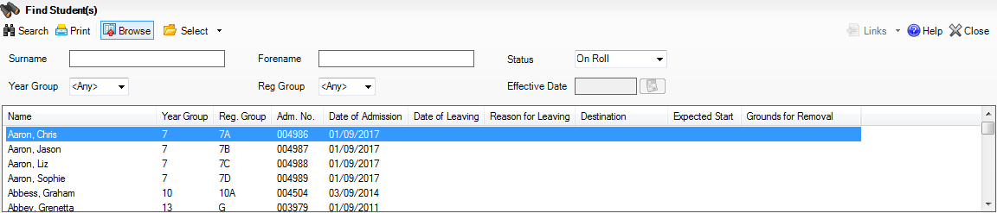
- Highlight the students you wish to record as leavers, then click the Select button. The selected students are displayed in the Students panel.
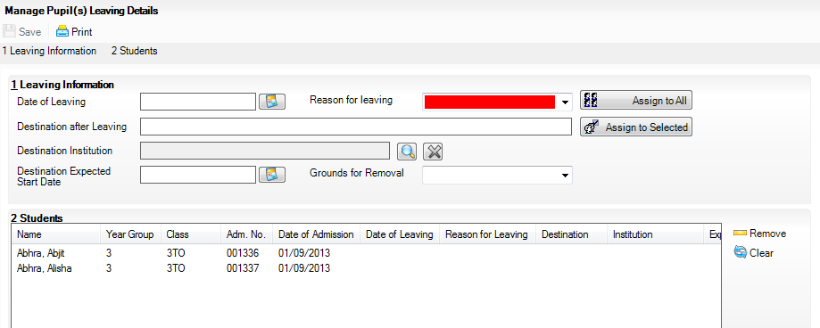
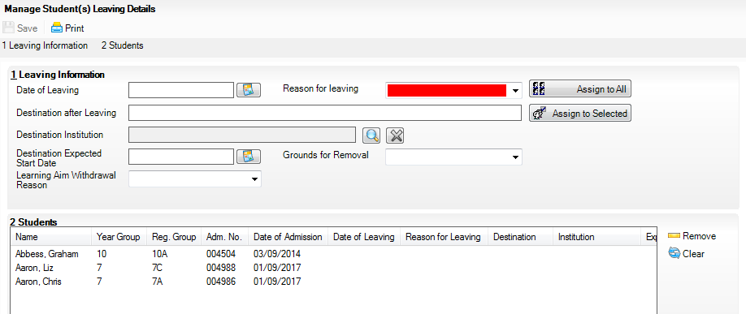
- In the Leaving Information panel, enter the Date of Leaving or click the Calendar button and select the required date.
The date of leaving should be the date that the student is actually leaving the school, unless they are transferring from Junior/Primary phase to Secondary phase because Local Authorities normally specify the dates to be used for school transfers so that they match. For example, some authorities prefer not to have any gaps between dates and may suggest a date of leaving the old school of 4 September and the date of admission into the new school (destination expected start date) of 5 September. If you are in any doubt, please contact your Local Authority for advice.
IMPORTANT NOTE: It is recommended that Year 11 students are not given a Date of Leaving until it is confirmed that they will actually be leaving the school at the end of the Summer term and are not returning to Year 12.
For students who stay on for Year 12, without a gap in learning from Year 11, the DfE expects their Date of Admission to be the same as it was when the student was in Year 11. It is also expected that no date of leaving was recorded for the end of Year 11.
- Select the Reason for Leaving from the drop-down list, e.g. Elective Home Education, then either:
- highlight the students to whom this information applies (for multiple selection, use the Ctrl or Shift functionality) and then click the Assign to Selected button; or
- if the information applies to all the students in the list, click the Assign to All button.
- Enter the Destination after Leaving, if known, then use the Assign to All or Assign to Selected options, as required.
- Specify the Destination Institution, if known.
- Click the Browse button (adjacent to the Destination Institution field) to display the School Browse dialog.
- Search for and then select the relevant institution. Alternatively, click the New button to add a new institution.
- Click the OK button(s) to return to the Leaving Information panel.
- Use the Assign to All or Assign to Selected options, as required.
- Enter the Destination Expected Start Date (or select the relevant date from the Calendar), then use the Assign to All or Assign to Selected options, as required.
- If the student is a child deemed missing in education, select the Grounds for Removal from the drop-down list, e.g. E - Distance, then use the Assign to All or Assign to Selected options, as applicable.
IMPORTANT NOTE: To comply with the Children Missing in Education legislation, schools are required to record this information for all students on leaving the school.
- Select the Learning Aim Withdrawal Reason from the drop-down list, e.g. Personal, (applicable to Secondary, All-Through and Pupil Referral Units only).
The reason for withdrawing from a Learning Aim is collected in the Autumn Return for any Learning Aim with the status of Withdrawn.
- Click the Assign to All button or Assign to Selected button, as applicable.
- Click the Save button.
TIPS: To remove a student from the Students list, highlight their record, then click the Remove button.
To correct details enter in error, highlight the applicable student, then click the Clear button. This remove the details drawn from the Leaving Information panel for the selected student only. Re-enter the information as required.
The Learning Aim Reason column remains populated after clicking the Clear button. However, the data is updated automatically if a different reason is selected and assigned.

Completed

Re-Admitting a Student
Any student who leaves the school and subsequently decides to return must be re-admitted.
NOTES: Do not remove the leaving date, as the student’s period of absence from the school will not be recorded.
However, if a student is intending to leave but subsequently changes their mind and decides not to leave, the date of leaving can be removed, as continuous attendance has been maintained.
- Select Focus | Student | Student Details to display the Find Student browser.
- Click the New button to display the Add Student page. It is necessary to enter limited information here as you know that the person already exists.
- Click the Continue button to display a list of Matched People, based on the criteria entered on the Add Student page.
- Highlight the required student then click the Open button. The following warning message is displayed:
The selected student is a leaver. Do you want to re-admit the student?
- Click the Yes button if you are certain that this is the student who should be re-admitted. Their details are displayed on the Student Details page.
- Complete the mandatory fields (Date of birth, Gender, Year Group, Enrolment Status, Year Taught In and Admission Date) and check any other details that may have changed since they were last on-roll, such as their address.
- Check that the original UPN is displayed.
If it did not previously exist, generate a new UPN by clicking the button adjacent to the UPN field to display the Issue UPN dialog.
Select either the Issue Permanent or Issue Temporary UPN radio button then click the OK button to return to the Registration panel.
The temporary/permanent UPN is issued on save.
- Click the Save button to re-admit the student.
NOTE: If the student’s registration status has changed from when they were previously on-roll, their enrolment status should be changed via Routines | Student | Change Enrolment Status.

Completed

Deleting Student Records Entered in Error
If there are student records that have been entered in error (such as those resulting in duplicates), ensure that the record is deleted, so that it is not included in the return. This is achieved via Routines | Student | Delete Student.
After selecting the required student, you have the opportunity to review and print their details before deciding to delete their record permanently.
WARNING: The deletion is irreversible; therefore a student's record must only be deleted if they have been entered in error.

Completed

Checking National Curriculum Year Groups
The National Curriculum Year Group (Year Taught In) is the year group in which the student is taught for the majority of the time, regardless of their chronological age. In most cases, this will be the same as the Year Group. However, some children are taught in the year above or below the expected year (based on their age), perhaps because they are academically advanced or behind. It is very important that the correct Year Taught In has been recorded in SIMS.
For the School Census Autumn 2018 Return, the collection of attendance data uses the Age at Date as at 31/08/2017. All other data uses 31/08/2018.
The following table shows the Curriculum Year that students in England are expected to be taught in (Year Taught In), according to their date of birth (during the academic year 2018/2019). This table is provided for reference only.
Year Taught In | Date of Birth Range | Age Range
 | After 31/08/2016 | 1 and under
N1 | 01/09/2015 to 31/08/2016 | 2 – 3
N2 | 01/09/2014 to 31/08/2015 | 3 – 4
R | 01/09/2013 to 31/08/2014 | 4 – 5
1 | 01/09/2012 to 31/08/2013 | 5 – 6
2 | 01/09/2011 to 31/08/2012 | 6 – 7
3 | 01/09/2010 to 31/08/2011 | 7 – 8
4 | 01/09/2009 to 31/08/2010 | 8 – 9
5 | 01/09/2008 to 31/08/2009 | 9 – 10
6 | 01/09/2007 to 31/08/2008 | 10 – 11
7 | 01/09/2006 to 31/08/2007 | 11 – 12
8 | 01/09/2005 to 31/08/2006 | 12 – 13
9 | 01/09/2004 to 31/08/2005 | 13 – 14
10 | 01/09/2003 to 31/08/2004 | 14 – 15
11 | 01/09/2002 to 31/08/2003 | 15 – 16
12 | 01/09/2001 to 31/08/2002 | 16 – 17
13 | 01/09/2000 to 31/08/2001 | 17 – 18
 | Before 31/08/2000 | 19+
There are three ways to check a student’s curriculum year and date of birth in SIMS:
- Via individual student records (Focus | Student | Student Details).
- Via the pastoral structure by curriculum year (Focus | School | Pastoral Structure | Current Structure).
- Via the pastoral structure for the whole school (Focus | School | Pastoral Structure | Current Structure).

Additional Resources:
Managing Pupil/Students handbook
Setting up and Administering SIMS handbook

Checking the Student's Year Taught In Record
Year Taught In is mandatory information in SIMS.
- Select Focus | Student | Student Details to display the Find Student browser.
- Search for then double-click the name of the required student to display the Student Details page.
- Click the Registration hyperlink to display the Registration panel.
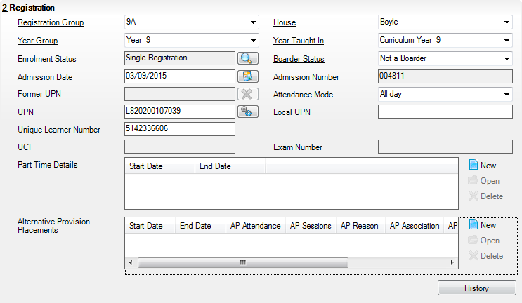
- Ensure that the Year Taught In field displays the actual National Curriculum year in which the student is taught the majority of the time. Select a different year from the drop-down list, if required.
NOTE: Any change made in the Registration panel is effective from today’s date. If the Year Taught In change was applicable from an earlier date, click the History button and apply the change from the actual date the change is required.

Checking the Year Taught In via the Pastoral Structure by Curriculum Year
- Select Focus | School | Pastoral Structure | Current Structure to display the Current Academic Year Pastoral Structure page.
- Click the Go button.
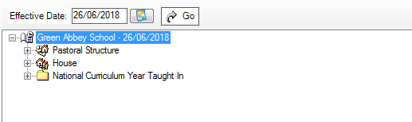
- Expand the National Curriculum Year Taught In folder by clicking the + icon or double-clicking the folder name. The curriculum years are displayed.
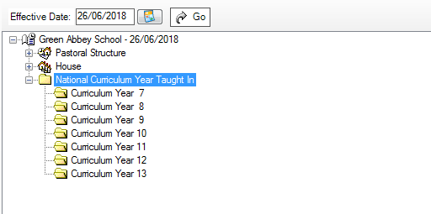
- Right-click the required curriculum year folder and then select Members from the pop-up menu.
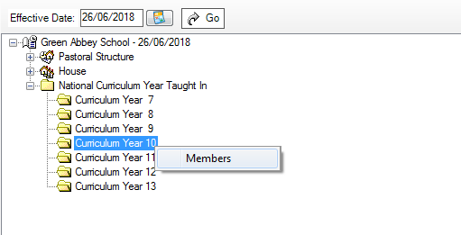
The Allocate Students/Applicants dialog is displayed.
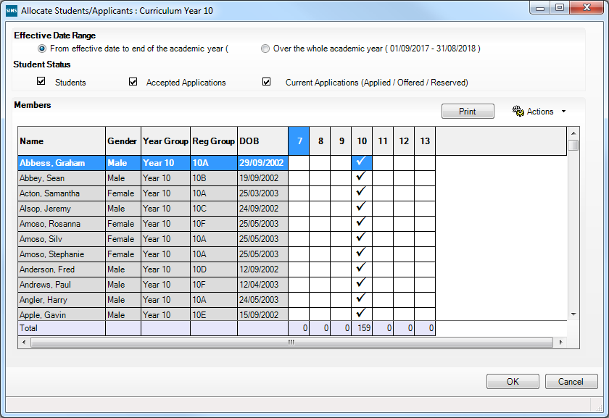
- Ensure that the Effective Date Range is changed to Over the whole academic year by selecting the radio button.
- To change a student's memberships of the National Curriculum Year Taught In, click the applicable cell in the grid.
By default, the records are displayed in alphabetical surname order. To sort the student names in date of birth order, right-click the DOB column heading then select Sort By from the pop-up menu
The following graphic shows that one Year 10 student is taught in Year 11.
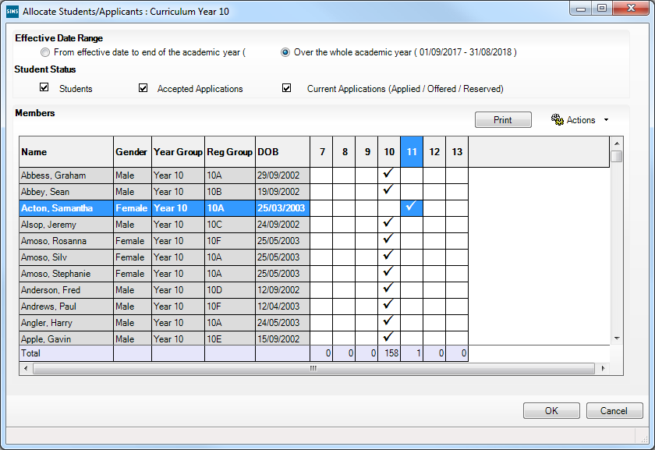
- Ensure that all students are allocated membership to the correct National Curriculum Year Taught In and then click the OK button to return to the Current Academic Year Pastoral Structure page.
- Repeat for the other curriculum years, where applicable.
- Click Save button.

Checking the Year Taught In via the Pastoral Structure for the Whole School
- Select Focus | School | Pastoral Structure | Current Structure to display the Current Academic Year Pastoral Structure page.
- Click the Go button.
- Right-click the National Curriculum Year Taught In folder and then select Members from the pop-up menu.
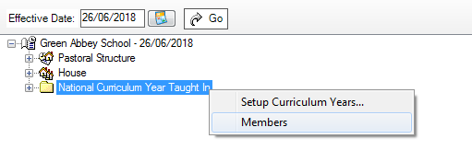
The Allocate Students/Applicants dialog is displayed.
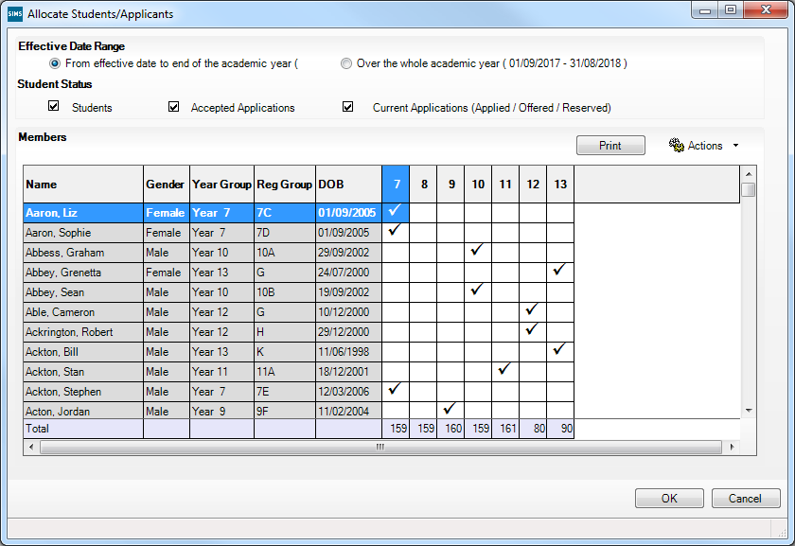
- Ensure that the Effective Date Range is changed to Over the whole academic year by selecting the radio button.
By default, the records are displayed in alphabetical surname order. Sorting the names in year group order assists in locating students who do not have a Year Taught In selected.
- Right-click the Year Group heading then select Sort By from the pop-up menu. Any students who have not been allocated a year taught in are displayed at the top of the list.
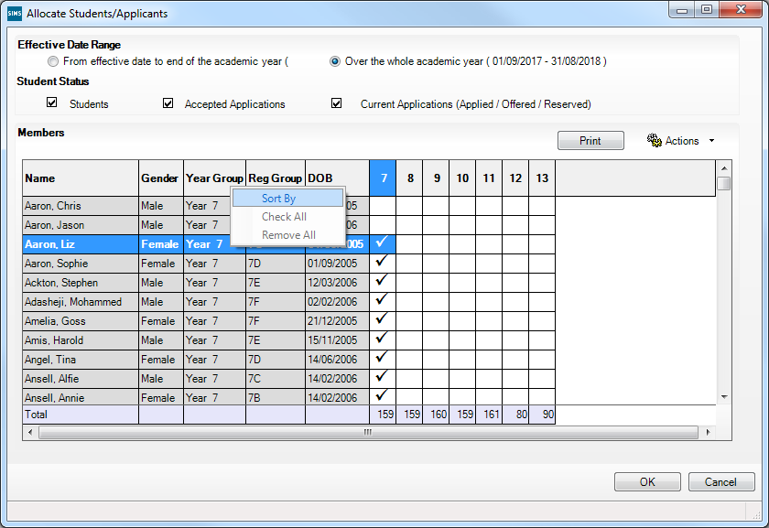
- Indicate which year the students with missing years are taught in by clicking the applicable cell in the grid.
- Make any required changes for the other students.
- Click the OK button then click the Save button.

Completed

Checking a Student’s Basic Details
Ensure that basic details for all students are up-to-date and correct. It may be necessary to make changes for a number of reasons, e.g. to correct inaccurately entered information, legal adoption, change of legal surname, etc.
The following information is collected in the return:
- Legal Forename (mandatory information in SIMS)
- Middle Names
- Legal Surname (mandatory information in SIMS)
- Former Surname
- Preferred Surname (mandatory information in SIMS)
- Gender (mandatory information in SIMS)
- Date of Birth (mandatory information in SIMS).
- Select Focus | Student | Student Details to display the Find Student browser.
- Search for then double-click the name of the required student to display the Student Details page.
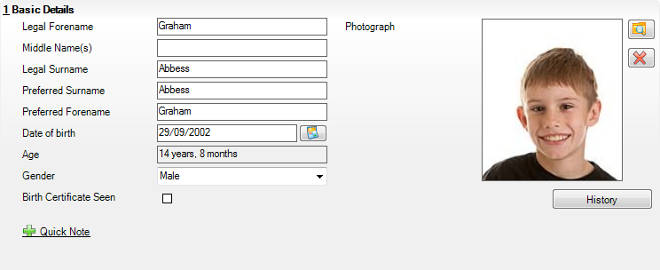
- Check that all the details displayed in the Basic Details panel are up-to-date and correct, paying particular attention to the data collected in the return (listed previously).
If a legal change (rather than a correction) is made to the Legal Forename, Middle Name(s) or Legal Surname, a Reason and Date of Change must be recorded.
- If you have made any changes, click the Save button.

Completed

More Information:
Recording a Student’s Change of Surname on page 37

Recording a Student’s Change of Surname
It is a requirement of the return that a history of students’ previous surname(s) is recorded.
- In the Basic Details panel, edit the student’s Legal Surname.
- Click the Save button. The following message is displayed:
Is this a correction to the name or a legal change to the student’s name? If it is a legal change, please select Yes.
- Click the Yes button to display the Reason For Change dialog.
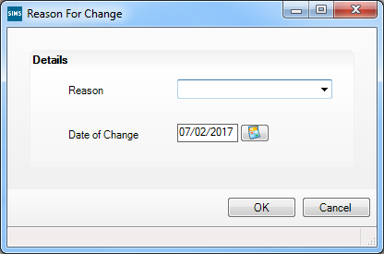
- Select the applicable Reason for change from the drop-down list. This entry is optional but is recommended to maintain a complete history of name changes.
- The Date of Change defaults to today's date but can be amended by clicking the Calendar button and selecting an alternative date, if required.
- Click the OK button to return to the Basic Details panel.
- Click the Save button.
- To view a list of the student’s previous names, click the History button to display the Previous Names for dialog.
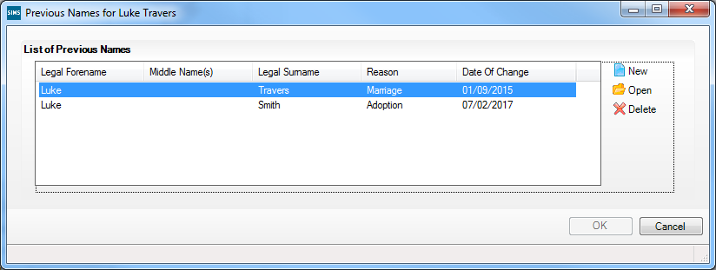
- Click the Cancel button to return to the Basic Details panel.

Completed

Checking Registration Details
The following registration information is collected in the return and should therefore be checked and corrected, if necessary:
- Enrolment Status (mandatory information in SIMS).
The Student area of SIMS displays read-only enrolment status information only. A student's enrolment status can be changed via Routines | Pupil | Change Enrolment Status.
- Admission Date (mandatory information in SIMS)
- Year Taught In, i.e. National Curriculum Year Group (mandatory information in SIMS)
- Boarder Status
- UPN
- Former UPN (this is a read-only field, which is populated automatically if the UPN is changed)
- Unique Learner Number
- Part-Time Details
- Alternative Provision Placement.

Checking Enrolment Status, Admission Date and Boarder Status
The following information is collected in the return and should therefore be checked and corrected if necessary:
- Enrolment Status (mandatory information in SIMS)
NOTE: SIMS uses the information in the enrolment status change log to determine enrolment on census day.
From the SIMS 2018 Summer Release, changing of Enrolment Status is available via Routines | Student | Change Enrolment Status only. PRUs can select FE College and Other Provider, in addition to the Enrolments Statuses available to non-PRU establishments.
- Admission Date (mandatory information in SIMS)
- Boarder Status.
- Select Focus | Student | Student Details to display the Find Student browser.
- Search for then double-click the name of the required student to display the Student Details page.
- Click the Registration hyperlink to display the Registration panel.
- Check the student’s Enrolment Status. A history of the Enrolment Status Changes can be viewed by clicking the adjacent Search button. SIMS uses the information in the enrolment status change log to determine enrolment on census day.
To change a student's Enrolment Status, select Routines | Student | Change Enrolment Status (please see Changing an Enrolment Status on page 40).
- Ensure that the Admission Date is correct. Edit the date or click the Calendar button and select a different date, if required.
- Check the Boarder Status. Select the correct boarder status from the drop-down list, if required.
- Click the Save button.

Completed

Changing an Enrolment Status
A student Enrolment Status defaults to Single Registration but can be changed, if required.
The following enrolment statuses are available:
- Single Registration - this status represents a normal, full-time student who is only registered as on-roll at your school.
- Guest Pupil - this status represents a student who is on-roll at another school, but attends your school for certain lessons. There is no need to register them as on-roll at your school.
- Main-Dual Registration - this status indicates that the student is registered at another school for some of their timetable, but the majority of their time is spent at your school. This status carries legal and financial implications and should only be used after agreement with the other school involved.
- Subsidiary-Dual Registration - this status indicates that the student is registered at another school for the majority of their timetable and only a minority of their time is spent at your school. This status carries legal and financial implications and should only be used after agreement with the other school involved.
- FE College (applicable to Pupil Referral Units in England only) - this status indicates that the student is registered at an Further Education College and only a minority of their time is spent at your school.
- Other Provider (applicable to Pupil Referral Units in England only) - this status indicates that the student is registered at another provider and only a minority of their time is spent at your school.
NOTE: SIMS uses the information in the enrolment status change log to determine enrolment on census day.
- Select Routines | Student | Change Enrolment Status to display the Find Student browser.
- Search for, then double-click the name of the required student to display the Change Enrolment Status page.
The student's basic details are displayed for information only. Edits to basic details can be made via Focus | Student | Basic Details.
- In the Registration panel, select the applicable Enrolment Status from the drop-down list.
- If the student's enrolment status has been changed before, a history of the Enrolment Status Changes can be viewed by clicking the adjacent Search button.
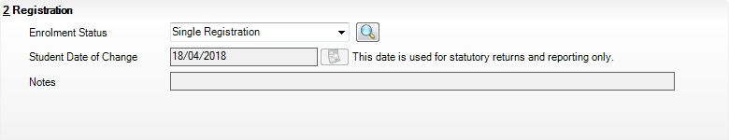
- The Student Date of Change defaults to today's date but can be edited by selecting the required date from the adjacent Calendar. This date is for information only and does not impact any other part of SIMS.
- Enter any associated Notes.
- Click the Save button.
If the student's enrolment status is changed from Guest Student to Single Registration, Main Dual Registration or Subsidiary Dual Registration, a message dialog is displayed.
Click the Yes button to allocate a new admission number to the student.
NOTE: You might need to check/correct the applicable attendance marks, if the enrolment status change has taken place during the academic year.

Completed

Checking Unique Pupil Numbers
The following information is collected in the return:
- UPN
- Former UPN (this is a read-only field, which is automatically populated if the UPN is changed).
Ensure that all students have a UPN recorded and that all UPNs are in the correct format. A temporary UPN is acceptable in some circumstances.
- Select Focus | Student | Student Details to display the Find Student browser.
- Search for then double-click the name of the required student to display the Student Details page.
- Click the Registration hyperlink to display the Registration panel.
UPNs should be entered in the UPN field. Ensure that the format is valid (the field will turn red if invalid).
- Permanent UPNs are issued to a new student only when it is believed that they have never previously been allocated a UPN or to replace a temporary UPN.
- Temporary UPNs are issued to a student when the permanent UPN is not known to the school, e.g. awaiting transfer file/applicant’s information. A temporary UPN can be recognised by the letter after the UPN number, e.g. H82020010701A.
- If necessary, issue a new UPN by clicking the Generate UPN button adjacent to the UPN field to display the Issue UPN dialog.
Generate UPN button
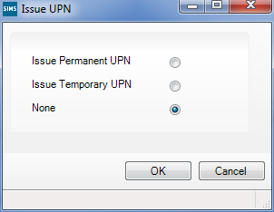
- Select either the Issue Permanent UPN or Issue Temporary UPN radio button.
- Click the OK button to return to the Registration panel.
The UPN is generated automatically when the record is saved and the previous UPN is displayed in the Former UPN field, if applicable.
- Click the Save button.
NOTE: A student who is adopted after being allocated a UPN is often issued with a new permanent UPN. However, the exact process may vary depending on the circumstances and the guidance issued by your LA/DfE.
For information about issuing a new UPN for an adopted child, please seek advice from your LA, if applicable.
DfE guidance is also available on the GOV.UK website (https://www.gov.uk/government/publications/unique-pupil-numbers).

Completed

Checking Unique Learner Numbers
Applicable to Secondary/middle deemed Secondary, All-Through and Special schools, and Pupil Referral Units that have a Secondary phase
A Unique Learner Number (ULN) is a 10-digit identifier that is retained and stays with the student’s learning record throughout their lives. Currently, this applies to students over the age of 14 involved in UK education or training.
Learning Records Service (previously known as the Managing Information Across Partners Programme) issues and maintains a ULN record for applicable students. ULNs can be obtained in one or more of the following ways:
- The DfE ULN service to upload a CTF file via a web page on the S2S website (http://www.education.gov.uk/researchandstatistics/datatdatam/s2s/a0064650/school-to-school-s2s).
- The Learner Registration Service Web Portal to obtain individual ULNs (https://www.gov.uk/government/collections/learning-records-service).
- The Key to Success website (https://www.keytosuccess.education.gov.uk/).
If available, enter a ULN for each student over the age of 14.
- Select Focus | Student | Student Details to display the Find Student browser.
- Search for then double-click the name of the required student to display the Student Details page.
- Click the Registration hyperlink to display the Registration panel.
- Check the content of the Unique Learner Number field. Enter the 10-digit identifier, if not currently displayed.
NOTE: The UCI (Unique Candidate Identifier) and Exam Number information is read only. The fields are populated with data held in Examinations Organiser.
- Click the Save button to save any changes, if applicable.

Completed

Checking Student's Part-Time Details
Part-time details apply mostly to Nursery schools (or schools with nursery age children) and Primary schools with Reception years. However, any student can be marked as part-time if their attendance is anything less than 10 sessions per week.
For dual registered students, time in other schools should be taken into account. For example, three full days in one school and two full days in another school should not be classified by either school as part-time.
- Select Focus | Student | Student Details to display the Find Student browser.
- Search for then double-click the name of the required student to display the Student Details page.
- Click the Registration hyperlink to display the Registration panel.
- Check the details displayed in the Part Time Details section. A minimum of a Start Date must be displayed for each record.
- Part-time details can be added by clicking the New button to display the Add Part-time Attendance dialog.
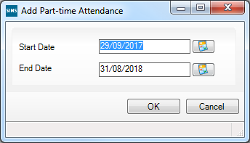
- Enter a minimum of the Start Date then click the OK button to return to the Registration panel.
- Click the Save button.
IMPORTANT NOTE: It is equally important to edit the details of any students who are no longer part-time. This is achieved by highlighting the student’s Part Time Details record then clicking the Open button to display the Add Part-time Attendance dialog. Enter the correct End Date then click the OK button to return to the Registration panel.

Completed

Checking Home Address Information
A student’s current home address is required for the return. Where a student has multiple current addresses, details of all addresses should be recorded.
All aspects of the address are collected and therefore all address details should be recorded in order to avoid validation errors. It is particularly important to check that a House Name or House Number and a Post Code are entered in the correct fields.
Post codes must be entered in the correct format. A validation error is generated if a post code has not been entered (although it is understood that in some instances, such as Traveller children, a post code is not available).
The Unique Property Reference Number (UPRN) is a unique identifier that links together related address records across different software programmes. This enables organisations to collate and share information based on a common reference number.
- Select Focus | Student | Student Details to display the Find Student browser.
- Search for, then double-click the name of the required student to display the Student Details page.
- Click the Addresses hyperlink to display the Addresses panel.
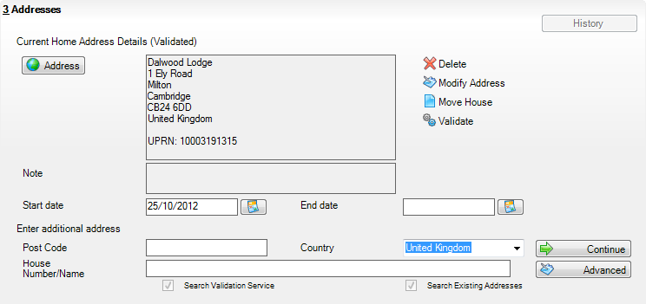
- Check that the Post Code and House Number/Name exist and that they are valid. If you have Internet Explorer®, these details can be checked by clicking the Address button to display the address location on a map.
NOTE: British Forces Post Office numbers can be added as post codes.
- If the Unique Property Reference Number (UPRN) is not displayed below the Current Home Address Details,
- Click the Validate button to display the Find Matching Addresses dialog.
- Highlight the required address then click the OK button to return to the Addresses panel, where the UPRN is displayed below the address.
- If you have edited the address, click the Save button.
- If the student has an additional current address, i.e. a Second Home, enter the additional address then click the Continue button (adjacent to the address) to display the New Address Details panel.
- Enter the remaining address details and the Address Type then click the Save button to refresh the display.

Completed

Checking Free School Meals Eligibility
Only students who have been approved by the LA to receive a free school meal should be recorded in SIMS as being eligible. It is advisable to check that all eligible students are recorded.
Free school meal guidance for schools and Local Authorities is available from the GOV.UK website (https://www.gov.uk/government/publications/free-school-meals-guidance-for-schools-and-local-authorities).
The following free school meal eligibility related data is collected in for the return:
- Start Date
- End Date (if known)
- UK Country in which the eligibility applies.
Meal Patterns are not required for the return but can be recorded for information purposes only. It is perfectly acceptable, for example, for a student to be eligible for free school meals, but to bring sandwiches (PL (packed lunch)) or to go home (HO (home)).
- Select Focus | Student | Student Details to display the Find Student browser.
- Search for, then double-click the required student to display the Student Details page.
- Click the Dietary hyperlink to display the Dietary panel.
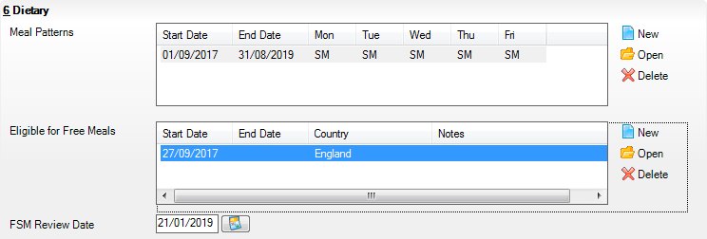
- Ensure the minimum of a Start Date and Country are displayed in the Eligible for Free Meals panel. If you need to edit the data, highlight the required record then click the Open button.
If a new record is required, click the adjacent New button to display the Add Student Free Meals Details dialog.
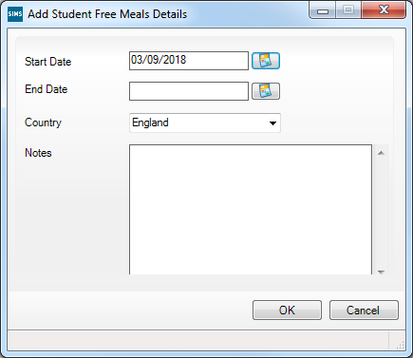
- Enter the Start Date (and End Date if available) for the free meal period, as supplied by your Local Authority.
- Ensure that the UK Country in which the eligibility applies is correct. Select from the drop-down list, if required.
- Notes can be entered, if required.
- Click the OK button to return to the Dietary panel, where the new information is displayed.
- Click the Save button.
Ensure that this information is checked/amended on a regular basis.

Completed

Checking Ethnic and Cultural Information
The following ethnic and cultural information is collected in the return:
First Language
- A First Language other than English should be recorded where a student was exposed to the language during early development and continues to be exposed to this language at home or in the community.
- If the child was exposed to more than one language (which may include English) during early development, the language other than English should be recorded, irrespective of the student’s proficiency in English.
- Select Focus | Student | Student Details to display the Find Student browser.
- Search for, then double-click the required student to display the Student Details page.
- Click the Ethnic/Cultural hyperlink to display the Ethnic/Cultural panel.
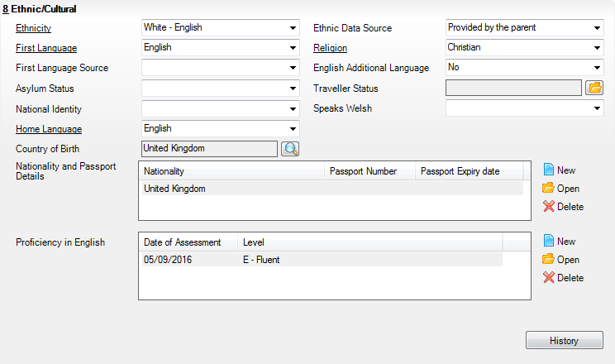
- Select the student’s First Language from the drop-down list.
- Click the Save button.
TIPS:
It is possible to bulk update First Language for a selected group of students by selecting the relevant option from the Data Item drop-down list via Routines | Student | Bulk Update.
Home language is no longer collected in the School Census. Users with School Administrator permissions can remove the Home Language field from the Student Details and Application pages, if required. This is achieved by selecting the Hide Home Language check box in the School Options panel via Tools | Setups | School Options.
Home language is always included in CTF imports, CTF exports and the Reporting Dictionary, even if it is not displayed on the Student Details and Application pages.

Completed

Checking Additional Information
Ensure that the following additional information is recorded in SIMS:
- Youth Support Services Agreement (YSSA) status
The YSSA applies to students between age 12 and 25 with special educational needs and students between age 12 and 20 with no special educational needs.
- Service Children in Education information.
The Bulk Update routine can be used to assign and edit these values for a specific selection of students at the same time, if required (please see Updating Information Using the Bulk Update Routine on page 22).
- Select Focus | Student | Student Details to display the Find Student browser.
- Search for, then double-click the required student to display the Student Details page.
- Click the Additional Information hyperlink to display the Additional Information panel.
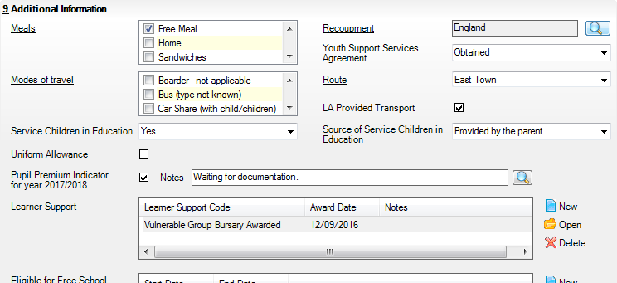
NOTE: The Meals section will be removed in a future release because the meal information is now entered via the Dietary panel.
- Select the applicable Youth Support Services Agreement (YSSA) status from the drop-down list.
- If the student is the child of a parent(s) in the armed forces, ensure that the correct value is selected from the Service Children in Education drop-down list.
- Select how the school was notified about the Service Children in Education information by selecting from the Source of Service Children in Education drop-down list.
- Ensure that the Pupil Premium Indicator for year 2017/2018 check box is selected, if applicable. To enter a note related to the applicable year, click the Search button adjacent to the Notes field.
Although Pupil Premium information is not collected in the return, it is important for schools that are in receipt of this funding, which is allocated to children from low-income families, to be able to give a full account of its use. The national school performance tables now include information about the progress of students in receipt of Pupil Premium and information is required to be sent to parents about how it has been used and what impact it has had on student progress.

Completed

Checking Special Educational Needs Information
The following Special Educational Needs (SEN) items are collected in the return:
- SEN Status (SEN Provision)
- E – Education, Health and Care Plan (EHCP) – the LA has reviewed the student and a plan has been issued.
- N – No Special Educational Need - No special educational need has been identified.
- K – SEN Support – actions have been put in place or will be put in place to support the student with their need, once a SEN need or potential SEN need has been identified.
- S – Statement – the LA has reviewed the student and a statement has been issued (collected for exclusions only).
IMPORTANT NOTE: SEN Provisions/Statuses A and P are no longer valid.
- Provision Type (not applicable to Pupil Referral Units or Special schools)
- Time in SEN Unit - member of SEN Unit
- Resourced Provision
- Select Focus | Student | Special Educational Needs to display the Find SEN Student browser.
- Select the required SEN Status from the drop-down list. Additional search criteria can be selected, if required, e.g. Year Group.
- Click the Search button to display a list of students who match the criteria.
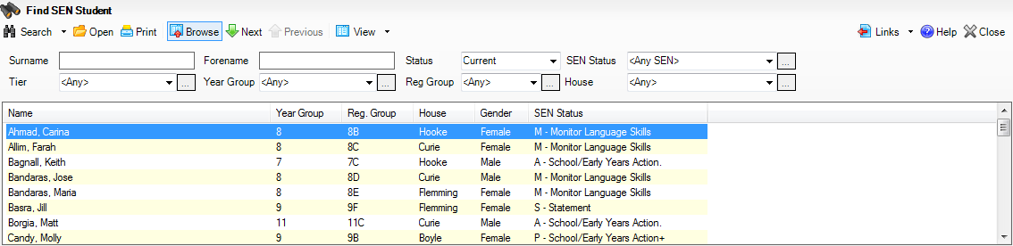
- Double-click the name of the required student to display the Student SEN details page.
- Click the Basic SEN Details hyperlink to display the Basic SEN Details panel.
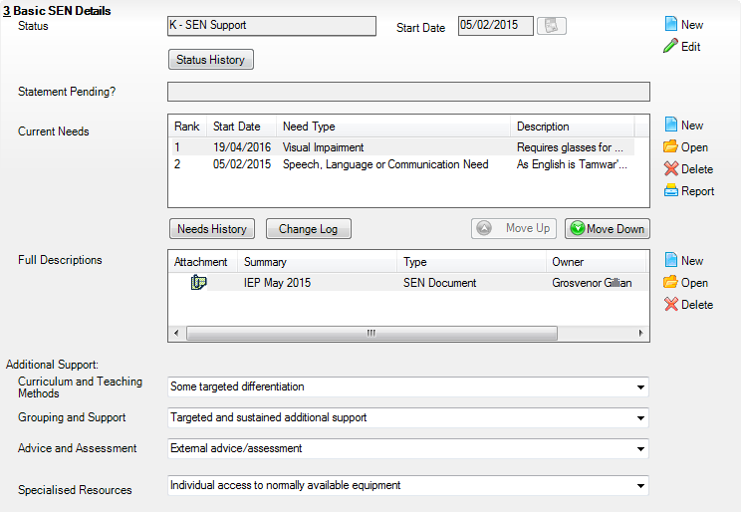
- Ensure that the SEN Status and Start Date are correct.
To amend an error in the current Status or Start Date, click the Edit button. Select the required Status from the drop-down list and edit the Start Date, if required.
Alternatively, click the New button. This removes the original Status and the Start Date defaults to today's date. Select the applicable Status and change the Start Date, if required.
NOTE: At least one Special Educational Need, e.g. Visual Impairment, must be recorded for all students with a SEN Status of E – Education, Health and Care Plan (EHCP), K – SEN Support and S - Statement.
To view changes that have taken place to the student's SEN Status, click the Status History button to display the Status History page.
- Click the Provisions hyperlink to display the Provisions panel.
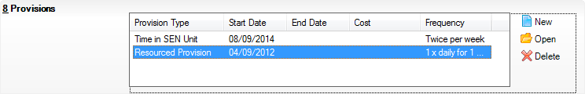
- Ensure that records with a Provision Type of Time in Unit or Resourced Provision are recorded correctly. To edit an existing record, highlight the required record and then click the Open button.
Alternatively, to create a new record, click the New button to display the Add/Edit SEN Provision dialog.
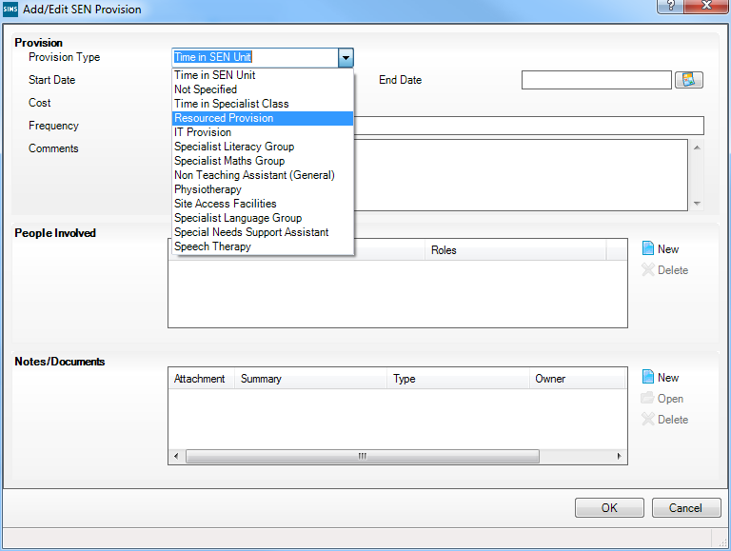
- Ensure that the details are entered correctly, paying particular attention to the Provision Type.
- Click the OK button to return to the Provisions panel.
- Update the other information on the Student SEN details page, if required and then click the Save button.
The DfE website (http://www.gov.uk/schools-colleges/special-educational-needs) provides more information about Special Educational Needs, if required.

Completed

Preparing Exclusions Information
Exclusions information is required for students who were subject to any exclusion with a start date during the period 01/01/2018 to 01/04/2018 inclusive. Exclusions should not be counted if the Head Teacher withdrew them, or if the student was re-instated by the Discipline Committee or an independent Appeal Panel.
The following exclusion related data items are collected for the return:
- Exclusion Type (category, e.g. fixed period, lunchtime or permanent).
- Exclusion Reason (select one code to provide the main reason).
- Exclusion Start Date.
- Actual number of sessions (Length) - required for fixed period and lunchtime exclusions.
- SEN Provision (please see Checking Special Educational Needs Information on page 50).
IMPORTANT NOTE about Permanent Exclusions: Any permanently excluded students should be marked as leavers as soon as the exclusion has been confirmed by the LA. Before making them a leaver, ensure that you have recorded the following information:
▪ SEN Status (if applicable)
▪ Ethnicity
▪ Ethnic Source
▪ Part-time indicator (if applicable)
▪ Date of Admission.

Recording an Exclusion
- Select Focus | Student | Exclusions to display the Find Exclusions Student browser.
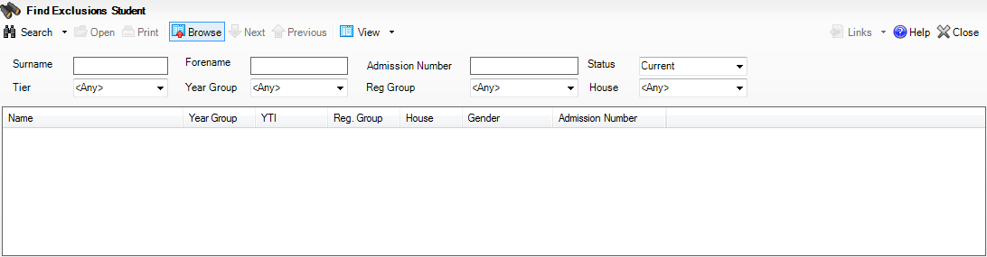
- Search for, then double-click the required student to display the Exclusion Details page.
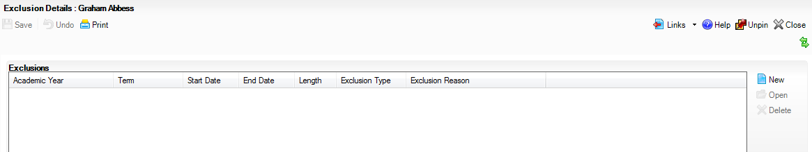
- Click the New button adjacent to the Exclusions panel to display the Add Exclusion dialog.
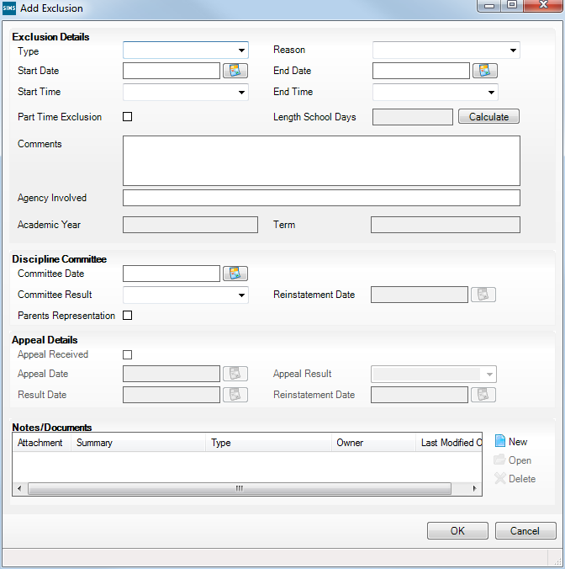
- Select the exclusion Type and the Reason for the exclusion from the respective drop-down lists.
- Enter the exclusion Start Date and End Date or click the appropriate Calendar button then select the required date.
- Select a Start Time and End Time (i.e. AM or PM) from the associated drop-down list.
- Click the Calculate button to populate the Length School Days field automatically.
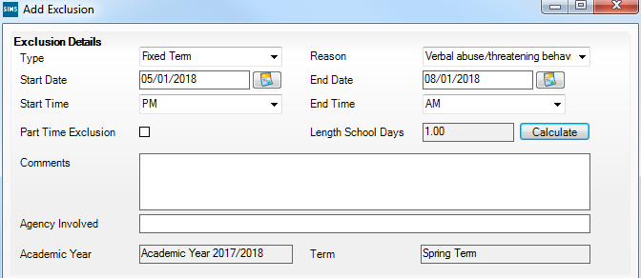
- Click the OK button to save the exclusion details and return to the Exclusion Details page, where a summary of the new exclusion is displayed.
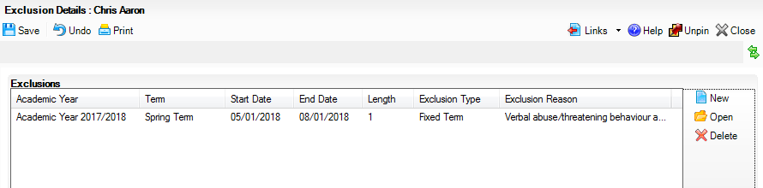
The Academic Year and the total number of exclusion days in that year are displayed at the bottom of the page.
- Click the Save button to save the exclusion.
For more information about exclusions, please refer to the DfE website (http://www.education.gov.uk/schools/pupilsupport/behaviour/exclusion).

Completed

Updating Students with Top-Up Funding
Top-up funding is supplied to schools, in most cases by the Local Authority, to meet the additional costs of support for high needs students.
- Select Tools | Statutory Return Tools | Update Top-Up Funding to display the Update Students with Top-up Funding page.
Any students currently recorded as having top-up funding are displayed in the Top-up Funding list (located in the bottom half of the page).
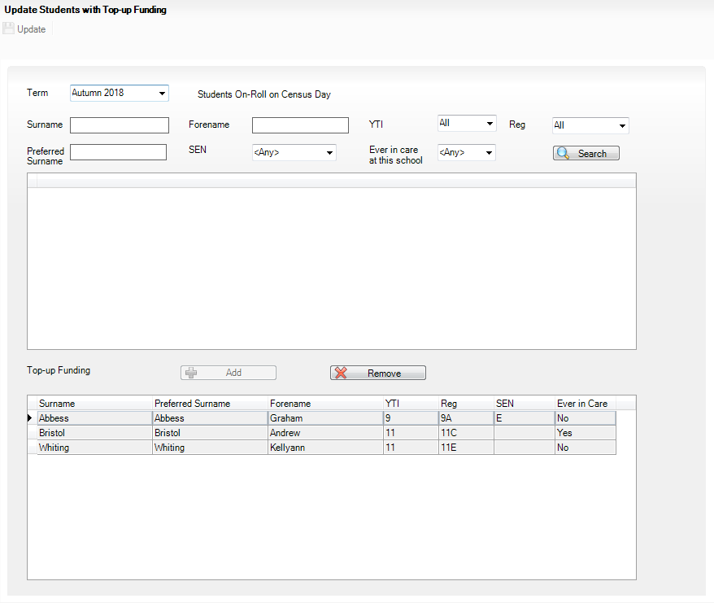
- Use the Students On-Roll on Census Day search criteria to locate the additional students you wish to record as having top-up funding then highlight their details.
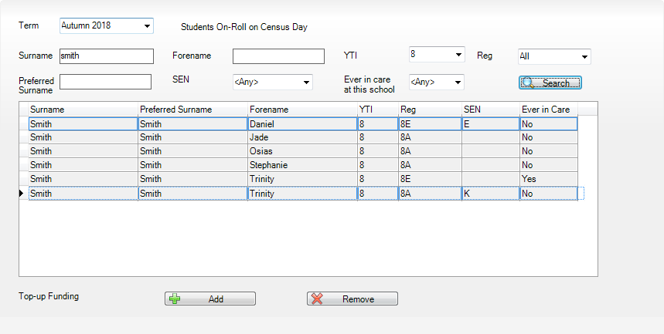
- Click the Add button to move the highlighted student(s) to the Top-up Funding list.
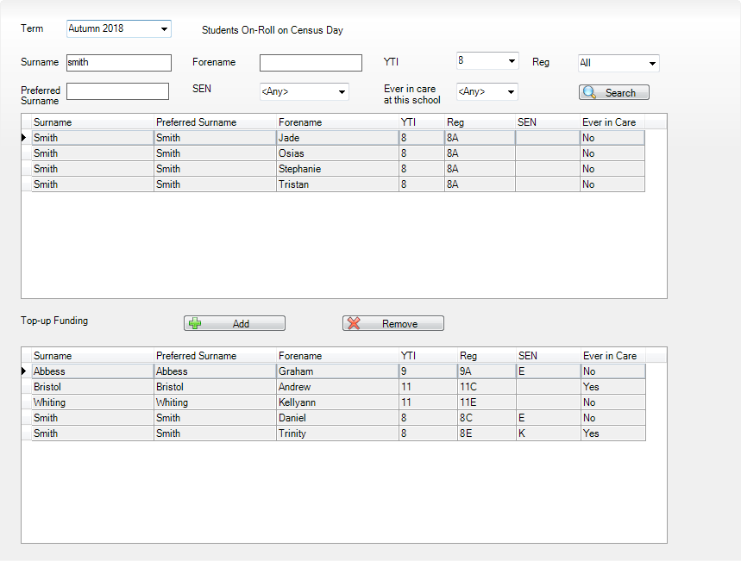
- To remove a student from the Top-up Funding list, highlight the required student then click the Remove button. The student's record is moved to the Students On-Roll on Census Day list, from where it can be reselected, if required.
- Click the Update button to save the data and arrange the list of students in Surname order.

Completed

Updating Students Post Looked After Arrangements
Post Looked After Arrangements (previously named Adopted from Care) is collected for students who are on-roll on census day and the information is then used for funding purposes.
The values available for selection enable schools to indicated which students were looked after immediately before adoption or prior to being the subject of a residence or special guardianship order. However, those who have parental responsibility are not obliged to provide this information to the school.
- Select Tools | Statutory Return Tools | Update Post Looked After Arrangements to display the Update Students Post Looked After Arrangements page.
Any students currently recorded as having post looked after arrangements are displayed in the Post Looked After Arrangements list (located in the bottom half of the page).
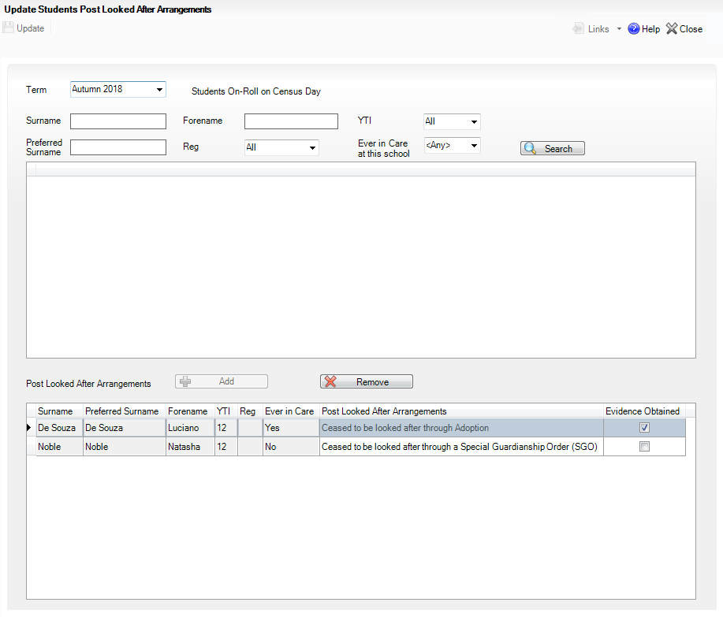
- Use the Students On-Roll on Census Day search criteria to locate the students you want to record as having PLAA.
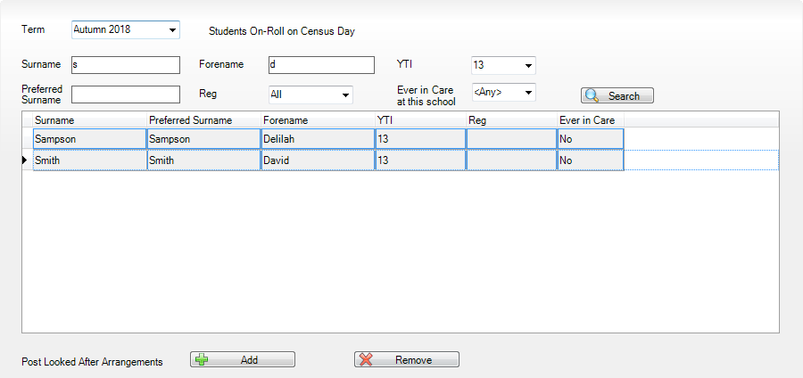
- Highlight the required students, then click the Add button to move the selected students to the Post Looked After Arrangements list.
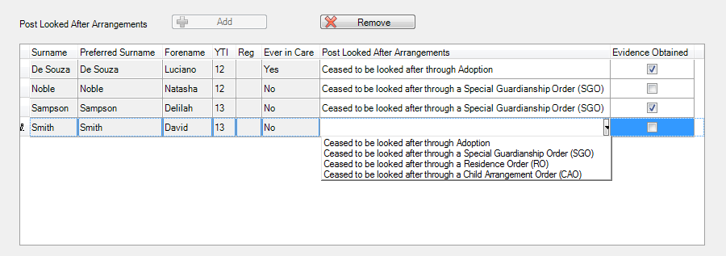
- Ensure that the correct post looked after arrangement is displayed for each student by clicking the applicable PLAA cell then selecting the applicable status from the drop-down list:
- Ceased to be looked after through Adoption
- Ceased to be looked after through a Special Guardianship Order (SGO)
- Ceased to be looked after through a Residence Order (RO)
- Ceased to be looked after through a Child Arrangement Order (CAO).
- Select the Evidence Obtained check box, if documents have been obtained that provide evidence of the post looked after arrangements.
NOTE: Evidence Obtained is not collected in the School Census return but should be recorded as prove of DfE/Ofsted compliance.
- To remove a student from the Post Looked After Arrangements list, highlight the required student then click the Remove button. The student's record is automatically moved to the Students On-Roll on Census Day list, from where it can be reselected, if required.
- Click the Update button to save the information and arrange the names in surname order.
If you have indicated that evidence has been obtained, you are reminded to ensure that the necessary documents are stored securely outside of SIMS or within the Document Management Server.

Completed

Preparing Termly Attendance Information
Termly attendance data (including attendance codes and the number of sessions missed) should be provided for non-boarder students and leavers aged four to 15 inclusive on 31/08/2017, who were on-roll for at least one session during the collection period from 02/04/2018 to 31/07/2018.
The attendance data collected in this return includes:
- Attendance Codes (i.e. the reasons for absence)
- Number of Sessions Missed.
If you use SIMS Attendance or SIMS Lesson Monitor, attendance data is entered in the return automatically, provided there are no missing marks.
IMPORTANT NOTE: If you use SIMS Attendance or SIMS Lesson Monitor, ensure that all missing marks and unexplained absences for the previous term have been dealt with before commencing the School Census Return.
If you do not use SIMS Attendance or SIMS Lesson Monitor and you do not use a software package that writes back to the SIMS database, or if you have not converted to the code of practice for attendance codes, you need to calculate and enter the following information manually on the Census Details page (via Routines | Statutory Returns | School Census):
- Possible Sessions
- Sessions Missed due to Authorised Absence
- Sessions Missed due to Unauthorised Absence.
For information and advice about school attendance, please refer to the DfE website (http://www.education.gov.uk/schools/pupilsupport/behaviour/attendance).

Additional Resources:
Producing the School Census Autumn 2018 Return handbook
Managing Pupil/Student Attendance handbook (SIMS Attendance users)
Monitoring Session and Lesson Attendance handbook (SIMS Lesson Monitor users)

Completed

Preparing Post 16 Information in Course Manager
Applicable to schools with a Sixth Form only
Learning Aims data is collected from English maintained Secondary/middle deemed Secondary and All-Through schools, Pupil Referral Units, CTCs and Academies that have sixth form students.
The Post 16 Learning Aims are collected only once a year (in the School Census Autumn Return) for students who were/are in National Curriculum Year Group (Year Taught In) 12 or above during the period from 01/08/2017 to 04/10/2018.
IMPORTANT NOTES:
Learning Aims are collected for students for whom the school wishes to claim Post 16 funding from the Education and Skills Funding Agency (ESFA). These students must be/have been in National Curriculum Year Group (Year Taught In) 12 or above during the previous/current academic year as stated previously.
Learners are expected to be in National Curriculum Year 12 and above if the majority of their learning is at level 3 or above.
Students in Actual National Curriculum Year Group 11 (or below) with the majority of their learning at level 2 are no longer included in the return.
It is important to ensure that the information entered in Course Manager is up-to-date and accurate before starting the return.
When creating the School Census Autumn 2018 Return, the Learning Aims panel is provided to deal with the Post 16 information required for the return. Detailed information about the functionality provided in this panel is available in the Producing the School Census Autumn 2018 Return (English Secondary and Middle deemed Secondary) handbook.
A document dedicated to the preparation of Post 16 data (Preparing Post 16 Data for the School Census Autumn 2018 Return guide) can be accessed from the SIMS Documentation Centre (via the Documentation button on the top right-hand side of the SIMS Home Page) or from the My Account website (https://myaccount.capita-cs.co.uk) by using the search facility to find CENSUS18.

Completed

What Next?
After carrying out the preparation routines documented in this guide, ensure that any subsequent changes at your school (e.g. student basic detail changes, SEN provisions changes, leavers and admissions/re-admissions, etc.) are recorded accurately in SIMS.
The SIMS 2018 Summer Release (7.182) must be installed before completing the School Census Autumn 2018 Return. However, it is advisable to check whether a later version of SIMS is available and then upgrade to the current release, if necessary, as it may include updates applicable to the forthcoming return.
You should now be ready to produce the final School Census Autumn 2018 Return.

Where Can I Get More Information?
In addition to this preparation guide, the following information is also available:
- Producing the School Census Autumn 2018 Return (English Secondary/Middle deemed Secondary Schools) handbook
This handbook outlines the School Census process in SIMS for Secondary and Middle deemed Secondary schools.
- Producing the School Census Autumn 2018 Return (English All-Through Schools) handbook
This handbook outlines the School Census process in SIMS for All-Through schools.
- Producing the School Census Autumn 2018 Return (English Pupil Referral Units) handbook
This handbook outlines the School Census process in SIMS for Pupil Referral Units.
- School Census Academic Year 2017/2018 Validation Errors and Resolutions document
This guide provides suggestions on how to resolve any validation errors or queries.
- Preparing Post 16 Data for the School Census Autumn 2018 Return guide
This guide deals specifically with preparing Post 16 data for the School Census Return.
- Managing Pupil/Students handbook
This handbook provides details about the processes that relate to the management of student data in SIMS.
Guidance about data protection and how student data is shared is available from the GOV.UK website (https://www.gov.uk/guidance/data-protection-how-we-collect-and-share-research-data).
Online help can be accessed by pressing F1 or clicking the applicable Help button in SIMS.
A wide range of documentation is available from the SIMS Documentation Centre, including handbooks, quick reference sheets and tutorials. Click the Documentation button (located on the top right-hand side of the SIMS Home Page), select the required category and then select the document you require. Alternatively, use the Search facility to locate the required document.
Documentation is also available from the My Account website (https://myaccount.capita-cs.co.uk).
- Enter the required text in the Search field to display a list of documents that match the search criteria.
- To refine the search further, click Documents and then select the required Document type, File type and/or Date range (click Show more to view additional options, if required).
Alternatively, click SIMS Publications (located in the Popular Searches list) to display a list of all SIMS publications.
The search results are displayed automatically.

Tips for using the My Account Search Facility
Here are some key tips for using the search facility in My Account. For additional explanations, please refer to the My Account website.
NOTE: You no longer need to use + / - / "" when searching.
- Cut down on the amount of words that you type in the search field and only use key words, e.g. instead of typing student showing as a contact search for the word contact.
- Use the Product Type filter to refine results further.
- Use the advanced filters located on the left-hand side of the Search results page.

Problem Solving using My Account
The My Account website also includes:
- Notification (the latest news to keep you up to date and informed)
- Hot Topics (a collection of articles from our Knowledge Base and other resources surrounding popular topical subjects such as preparing for the new school year)
- The Knowledge Base (a library of helpful articles produced by our customer service desks).
IMPORTANT NOTE: If you receive support from a local authority or third party support team, check with them before using any of the solutions.

Index
A
access rights 2
admission date 39
attendance data 60
B
basic details (student) 21, 36
boarder status 39
bulk update process
examples 22
using 22
C
Course Manager
preparing post 16 information 60
D
deleting
student records 30
detail reports
generating 14
dry run
create and validate 11
detail reports 14
process 9
reasons for a dry run 9
E
enrolment status 39
changing 39, 40
establishment details 17
telephone and email address 19
ethnic and cultural information 48
exclusions
adding a record 53
overview 53
F
fileset
importing 4
permissions 3
first language 22
former UPN 41
free school meals eligibility 46
H
home address (student) 45
L
learner support code 49
learning aims
updating 60
leavers
learning aim withdrawal reason 26
recording leavers as off-roll students 26
N
national curriculum year group 30
P
part-time student information 44
permissions 2
post 16 information
Course Manager 60
post looked after arrangements 57
preparation
minimum version of SIMS 3
permissions 2
printing
validation errors summary 11
process flowchart 7
R
re-admitting students 26, 29
registration details 38
reports
generating detail reports 14
population analysis (dated) report 26
printing summary report 11
revised fileset 3, 4
S
school information
establishment details 17
telephone and email 19
school meals 46
service children in care 49
special educational needs 50
student level information 36
student’s basic detail 21, 36
surname
recording a change 37
T
telephone and email address (school) 19
top-up funding 56
U
unique learner number 43
updating
learning aims 60
post looked after arrangements 57
UPN
former UPN 41
permanent/temporary 41
V
validation errors
resolving 11
Y
year taught in
checking individual records 32
checking via pastoral structure
by curriculum year 32
by whole school 34
date of birth/age ranges 30
youth support services agreement 49

