Running a Manual Upgrade
First download the zip files for SIMS/FMS/Discover as applicable for your school.
Unzip the files. The zip files are password protected.
Once unzipped, you will have an .iso file. This can be burnt to a disk, mounted as a virtual disk or further unzipped (using a program such as 7zip) to reveal all the files.
The structure of the .iso file is as below:
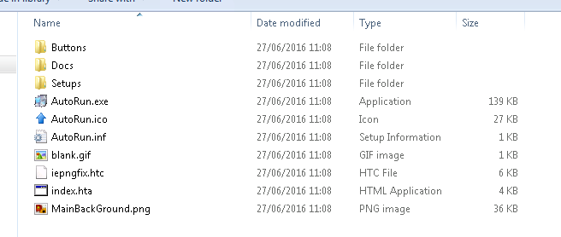
Double click the “AutoRun.exe” application to run it and you will be presented with the following screen:
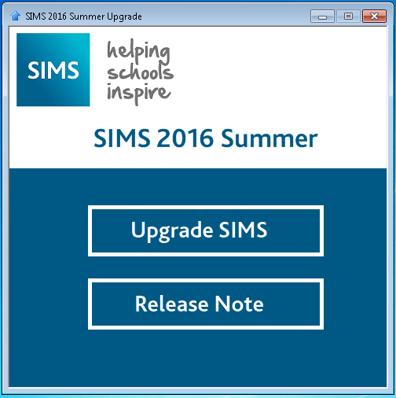
Check the “Release Note” so you are aware of the changes that are about to be made. Then click “Upgrade SIMS”.
Click “Next”
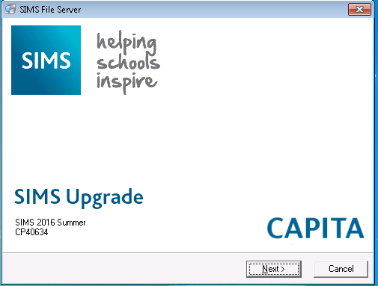

Check the location of your SIMS Setups is correct, amend if necessary and then click “Next”
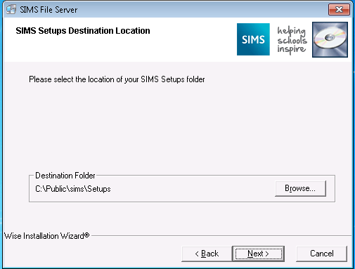

Click “Next” to begin the upgrade
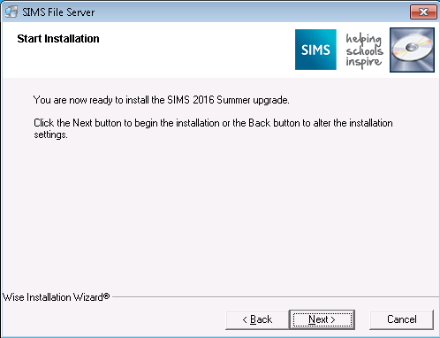

Your setups folder will be updated with the latest files
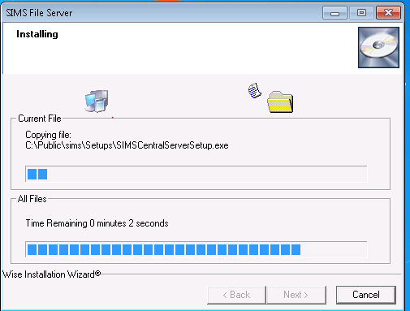

You will be presented with the dbupgrade window – enter the requested details (if unsure of the server and database names, you can get them from the connect.ini file located in your SIMS directory) and click “Login”
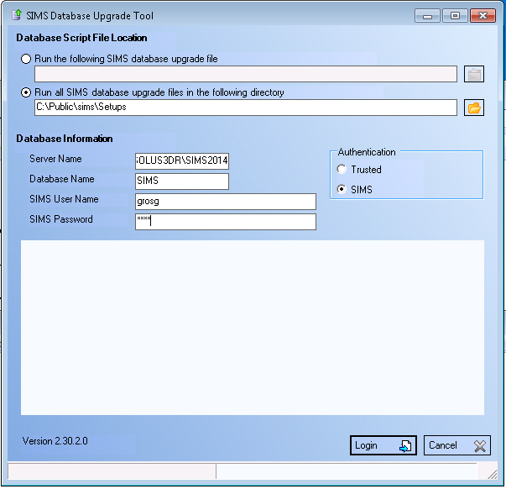
There will be upgrades to apply – press “Install” to continue
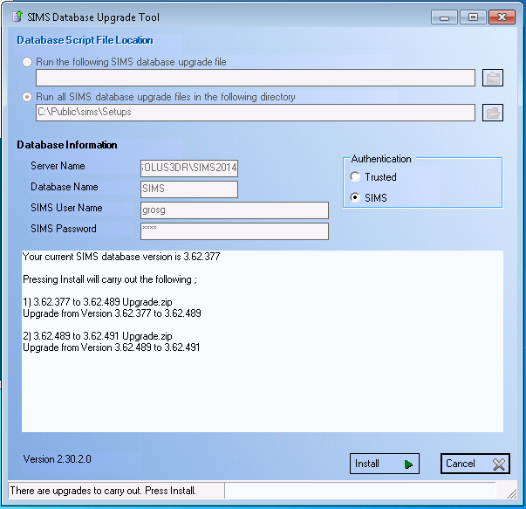
A backup of the database will be taken and then it will be upgraded.
You will be notified once the process has finished – click “OK”
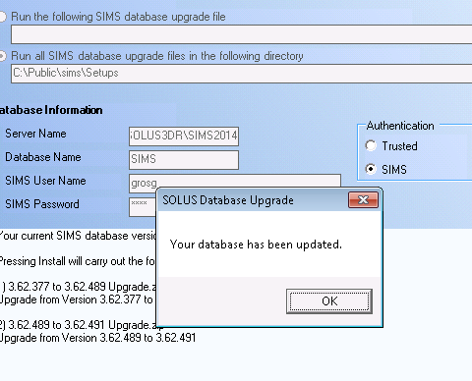
Click “Finish” on the final screen
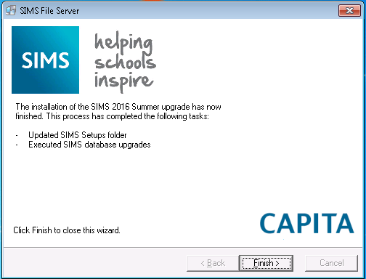
When you next run SIMS .Net, the program files will automatically be updated and you will be able to login to SIMS.

Upgrading FMS is a very similar process – Download, Extract, Run, and follow the onscreen prompts. Take care to enter the correct FMS Database names in the Database Upgrade Tool.

Upgrading Discover is slightly different. Download and extract the file as before, again on the server, run “AutoRun.exe” and see the below:
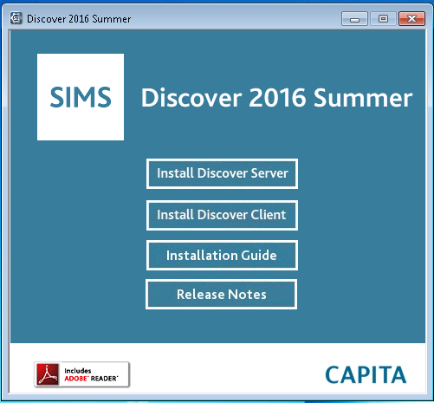
First, click “Install Discover Server” and click “Next” at the welcome screen
Then click “Upgrade Installation”
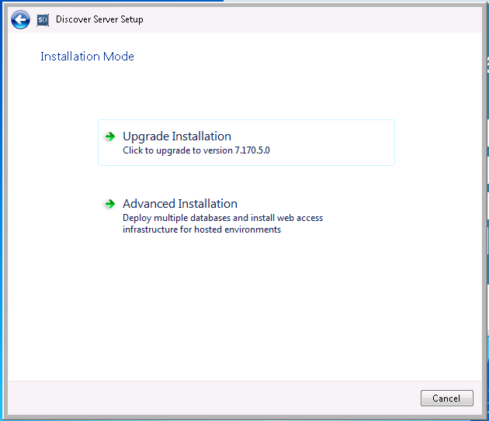

Change it to SQL Server Authentication and enter your SQL SA details (the SQL Server and Database fields should be pre configured, if not enter the details) and click “Next”
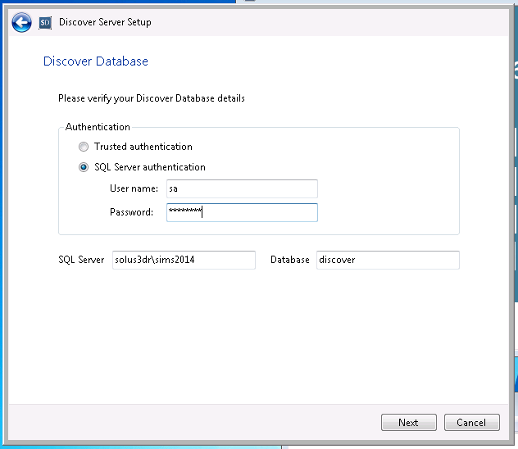
You will be given a confirmation box, click “OK”
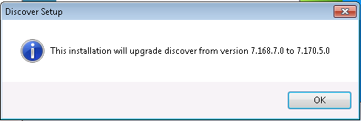
Click “Install” on the “Verify Ready” page.
The Discover Server components will then be upgraded – click “Finish” on the “Completed” screen.

Back on the Index page, Click “Install Discover Client”
Click “Next” at the “Welcome” screen and then “Upgrade” on the next
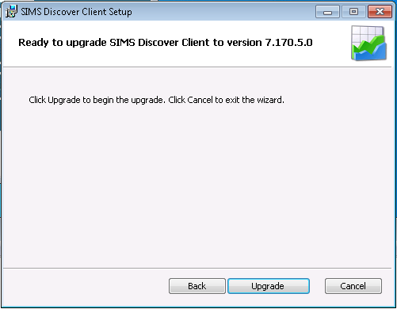
The Discover Client software will then be upgraded. Click “Finish” on the “Completed” screen.
Close the Discover upgrade index page. The Discover Client Upgrade will need to be run on any workstation that is using Discover.

