Course Code – DINMON-1-05
Version 12.0
Dinner Money
Microsoft® and Windows® are either registered trademarks or trademarks of
Microsoft Corporation in the United States and/or other countries.
© Capita Business Services Ltd 2018. All rights reserved.
No part of this publication may be reproduced, photocopied, stored on a retrieval system, translated or transmitted without the express written consent of the publisher.
Capita SIMS, Franklin Court,
Priory Business Park, Cardington, Bedford, MK44 3JZ
Tel: 01234 838080 Fax: 01234 832082 http://www.capita–sims.co.uk
Where appropriate for data entry purposes, the graphics used in this document match the training data recommended for use on the course. Where the graphic is an example of what might be expected when using certain areas of the software, the training data may not be an exact match.
Revision History
Version | Change Description | Date
7.176 – 11.0 | Updated for new academic year | 26/07/2017
7.180 – 12.0 | Updated for new academic year | 18/06/2018
This booklet is designed for use with SIMS software version 7.180
Mimeo Print code: DINMON-1-v12.0

Dinner Money
Contents
Introduction 1
Introduction 1
Pupil Data 1
Course Objectives 1
Overview 1
Course Requirements 2
- Setting up Dinner Money 3
Chapter Introduction 3
Accessing Dinner Money 3
Permissions 3
Step by Step – Permissions 4
Step by Step – Adding Banking Codes 5
For Schools Not Intending to Use Other Sales 6
Step by Step – Adding/Editing VAT Codes 6
Activity – Adding a Change in the VAT Rate 6
Step by Step – Completing the Dinner Money Setup and Default Banking/VAT Codes 6
Activity – Personalising Setup 9
Setting the Meal types and Charge Definitions for the School 9
Setting up Meal Types 9
Step by Step – To View, Add or Edit Meal Types 9
Step by Step – Personalising Meal Types 11
Step by Step – Adding/Editing Pupil Meal Definitions 11
Activity – Personalising Meal Definitions 12
Activity – Changing the Charge for a Meal Type 13
Step by Step – Manually Adding/Editing Pupil Opening Balances 13
Producing the Opening Balances Report 14
Step by Step – Setting Pupil Default Meal Patterns 14
Activity – Checking Meal Patterns 16
Adding/Editing Free School Meal Eligibility 16
Activity – Adding Free School Meal Eligibility 16
Adding/Editing Dietary Preferences (Optional) 16
Adding/Editing Dietary Needs 17
Activity – Adding a Dietary Preference 17
- Recording Pupil Meals for Schools not using the Attendance Links 19
Chapter Introduction 19
Step by Step – Turning the Attendance Link Off 19
Step by Step – Completing the Dinner Register before Attendance is Recorded 20
Step by Step – Entering Meals 20
Entering a Comment 21
Flood Filling all Pupils with a Default Meal Pattern 21
Activity – Completing Dinner Register 21
Step by Step – Setting Up and Recording Special Meals 21
Step by Step – Completing the Dinner Register After Attendance is Recorded 22
- Recording Pupil Meals for Schools Using the Attendance Links 23
Chapter Introduction 23
Step by Step – Activating the Attendance Links 23
Step by Step – Recording Pupil Meals for Schools who have Entered Attendance Method 1: Take Register 23
Step by Step – Recording Pupil Meals for Schools who have entered Attendance Method 2: Record Pupil Meals 24
Activity – Using Attendance to Assist with Completing Dinner Register 24
Step by Step – Editing Dinner List after Attendance 24
Step by Step – The Kitchen Statistics Report 26
Step by Step – The Supervisors List 27
- Recording Pupil Payments 29
Chapter Introduction 29
Step by Step – Cash or Cheque Payments 29
Activity – Checking Balances 30
Saving Pupils Payments 30
Activity – Recording Payments 30
Step by Step – Recording Split Payments 31
Activity – Entering Split Payments 31
Recording Additional Payment Details (where necessary) 31
Step by Step – Pupil Additional Transactions 31
Step by Step – Reversing a Payment 32
Recording a Returned Payment 33
Recording a Refund 33
Step by Step – Recording a Balance Transfer 33
Recording a Write Off 33
Activity – Reversing a Payment 34
Activity – Refunding a Payment 34
Activity – Transferring a Payment 34
Step by Step – Recording Electronic Payments 34
Step by Step – Viewing an Individual Pupil’s Transactions in Pupil Details 35
- Staff Meals (if Required) 37
Chapter Introduction 37
Step by Step – To View, Add, Edit Meal Types and to Map Values 37
Adding/Editing Staff Meal Definitions 38
Staff Opening Balances 38
Recording Staff Meals 38
Recording Staff Payments 38
Recording Additional Transactions for Staff 38
- Adhoc Meals (Optional) 39
Chapter Introduction 39
Step by Step – Adding/Editing Adhoc Meal Definitions 39
Activity – Adding an Adhoc Meal Definition 39
Step by Step – Recording Adhoc Meals 39
Step by Step – Recording Additional Adhoc Meals 40
- Other Sales (Optional) 41
Chapter Introduction 41
Step by Step – Add/Edit Other Sales Definitions 41
Step by Step – Recording Other Sales 41
- Banking Dinner Money Payments 43
Chapter Introduction 43
Step by Step – Running Unauthorised Banking 44
Step by Step – Running Authorised Banking 44
Viewing Previous Banking Returns 45
- The Catering Return 47
Chapter Introduction 47
The Catering Return 47
Step by Step – Running the Catering Return 47
- Running Dinner Money Reports 51
Chapter Introduction 51
The Manual Dinner Money Register 51
Step by Step – Printing the Manual Dinner Money Register 51
Step by Step – The Kitchen Statistics Report 53
Dinner Numbers by Week Report 53
Yearly Statistics Report 53
Split Payments List 54
Cheque and Payment Detail List 54
Transaction List by Type 54
Transaction List by Number 54
Pupil Balances Report 54
Staff Balances Report 54
Step by Step – Pupil Detailed Statement of Account 55
Staff Detailed Statement of Account 56
Producing the Audit Log Report 56
Cost/Income Summary Report 57
- Dinner Money Letters 59
Chapter Introduction 59
Step by Step – Producing Dinner Money Letters 59
Editing the Dinner Money Letters 59
Step by Step – Personalising an Existing Template 60
Step by Step – Producing Dinner Money Letters 61
Appendix A – Backdating Meal Processing 63
Step by Step – Backdating Meal Processing 63
Step by Step – Unlock Meal Processing 64
Appendix B – Links to Other SIMS Modules 65
Links to Other SIMS Modules 65
School Census 65
InTouch 65
Agora 66
Step by Step – The SIMS Teacher App and the Dinner Register 67
Step by Step – Adding/editing Dinner Register Comments 67

I | Introduction

This chapter contains:
Introduction 1
Course Objectives 1
Overview 1
Course Requirements 2

Introduction
Dinner Money is an approved auditable financial package that enables meal arrangements and payments to be recorded. All transactions can be tracked using the extensive selection of available reports.
Meal arrangements can be recorded directly into SIMS by teachers in the classroom or transferred from paper registers by someone in the school office.
The software automatically reduces the charge to zero for pupils in Reception, Year 1 and Year 2 to support Universal Infant Free School Meals.

Pupil Data
Pupil details are automatically available in Dinner Money without the need to run any other procedures. Parents’ names and addresses are also available for inclusion in letters.

Course Objectives
By the end of the course you will be able to:
- record all types of pupil, staff and visitor meal arrangements including special meals such as theme meals
- record all types of pupil, staff and visitor payments including electronic payments
- produce a variety of reports for different requirements such as registers, the kitchen, mid–day supervisors, pupil and staff statements
- complete the regular financial transactions
- produce a weekly catering return
- produce mail merge letters to parents.

Overview
This course is an introduction to using SIMS for recording Dinner and Dinner Money information. It covers the setting up of the software, personalisation of the settings to meet the school’s own requirements, the recording of opening balances, daily meal arrangements and payments and how to run the banking routine and produce various reports and letters to parents.

Course Requirements
An understanding of how SIMS is used to maintain and update pupil information is desirable but not essential.

Setting up Dinner Money

This chapter contains:
Chapter Introduction 3
Step by Step – Permissions 4
Step by Step – Adding Banking Codes 5
Step by Step – Adding/Editing VAT Codes 6
Activity – Adding a Change in the VAT Rate 6
Step by Step – Completing the Dinner Money Setup and Default Banking/VAT Codes 6
Activity – Personalising Setup 9
Step by Step – To View, Add or Edit Meal Types 9
Step by Step – Personalising Meal Types 11
Step by Step – Adding/Editing Pupil Meal Definitions 11
Activity – Personalising Meal Definitions 12
Activity – Changing the Charge for a Meal Type 13
Step by Step – Manually Adding/Editing Pupil Opening Balances 13
Step by Step – Setting Pupil Default Meal Patterns 14
Activity – Checking Meal Patterns 16
Activity – Adding Free School Meal Eligibility 16
Activity – Adding a Dietary Preference 17

Chapter Introduction
NOTE: For the purposes of this training course many settings have already been created but may be edited.

NOTE: Following the installation of Dinner Money on a school system, all settings will need to be created or personalised. VAT codes will exist but should be checked to ensure they are the current rate.

Accessing Dinner Money
Dinner Money is part of SIMS, but cannot be accessed until an activation patch has been run.
Once this has been done, new routes will appear in:
- Focus | Dinner Money
- Reports | Dinner Money
- Routines | Dinner Money
- Tools | Dinner Money.
The actual routes available will depend on the permissions assigned to individuals.

Permissions
Default permission groups exist, allowing schools to quickly assign permissions. Two principal groups exist to allow users to run and control Dinner Money:
- Bursar
- Receipts Clerk.
In addition a number of groups exist to allow users to record or view the meals required by pupils.
- Class Teacher
- Registration Tutor
- Administration Assistant
- School Administrator
- Attendance Manager (View Only)
- Attendance Operator (View Only)
- Pastoral Manager (View Only)
- SEN Co-ordinator (View Only)
- Senior Management Team (View Only)
Further details of the permission group can be found in the SIMS Permission spreadsheet, accessed via the documentation link on the Homepage. If these are not, appropriate schools can create their own groups.

Step by Step – Permissions
- Log in to SIMS: Waters Edge using the following details (not case sensitive):
User Name | GROSG
Password | ABCD
- Open System Manager via Focus | System Manager | Manage Groups.
- Type bursar in the Description, and then click Search.
- Select and open the bursar group from the search results.
- Go to panel 2: Members and notice Grosvenor, Gillian already appears in the panel.
- To assign permissions for a staff member; click Add to the right–hand side of the panel.
- Search for a staff member, select the name required and click OK.
- Click Save and then close System Manager.
If the user is already is logged in they will need to log out and log back in again to access the new permission.

Step by Step – Adding Banking Codes
These codes are used in the banking reports. They can be the default codes (as in the following table) or based on local requirements.
Bank Code | Description | Cost Code | Detail
MS1 | Pupil Meals | 01 | PM
MS2 | Adult Meals | 02 | SM
MS3 | Other Sales – Type A | 03 | OSA
MS4 | Other Sales – Type B | 04 | OSB
MS5 | Other Sales – Type C | 05 | OSC
- Select Tools | Dinner Money | Banking Codes, and then click Search to display any current entries.
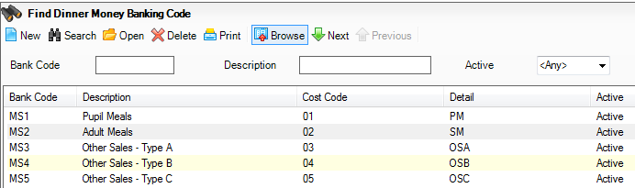
- Click New to add a new entry or double click the existing entry to check the details.
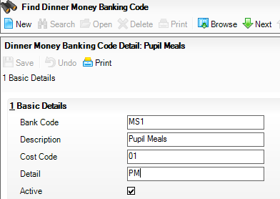
If you no longer wish to use a code, mark it as Inactive. Banking codes that have not been used may be deleted from the browse list by highlighting them and clicking Delete.
NOTE: You will need to create these codes for the Banking Report to display correctly.
It is recommend, unless local needs require otherwise, to use the default codes in preceding table.

For Schools Not Intending to Use Other Sales
At school do not add MS3, MS4 and MS5.
On this course deselect the Active check box for each of those three codes.

Step by Step – Adding/Editing VAT Codes
Standard VAT codes have been provided.
- Select Tools | Dinner Money | VAT Codes.
- Click Search to see the existing codes.
Code | Description | Current Rate %
E | Exempt | 0.00
S | Standard | 20.00
Z | Zero | 0.00
- To edit a code either double–click it, or click on it once, and then click Open.

Activity – Adding a Change in the VAT Rate
- Open the Standard VAT rate.
- Click New to the right and add a new rate of 25% with a Start Date of 03/01/2019.
- As this is an exercise close the screen without saving.
NOTE: VAT is only applicable to adult meals. Further information on charging VAT can be obtained from your local authority (LA) or an accountant.

Step by Step – Completing the Dinner Money Setup and Default Banking/VAT Codes
In school the setup page needs to be completed before using Dinner Money, but this has already been completed for today’s course.
Panel 8: Letter Templates will be dealt with in Chapter 11.
- Select Tools | Dinner Money | Setup.
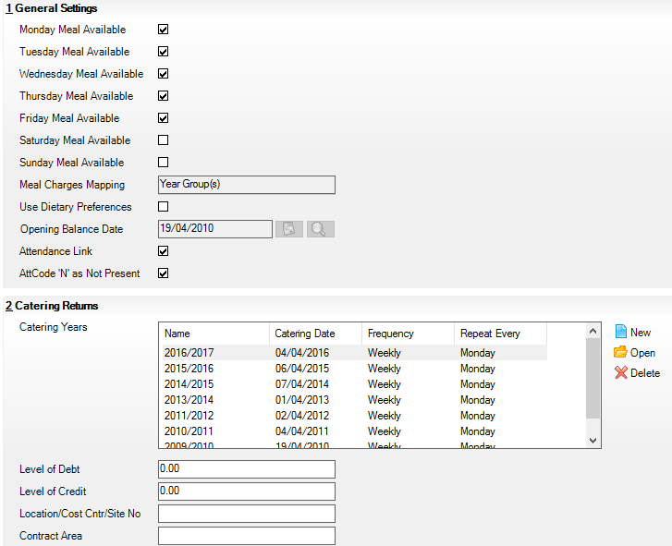
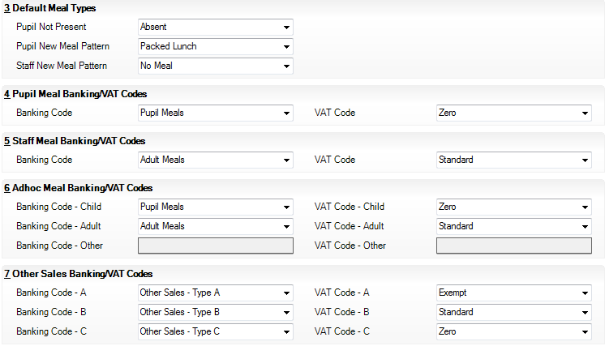
- In General Settings select the check boxes to indicate the days of the week meals are provided.
- Select how the meal charges will be mapped, according to year groups, registration groups or tiers.
NOTE: Once saved, the meal charges mapping cannot be altered, see Adding/Editing Pupil Meal Definitions later in this chapter for more details.
If you are uncertain, it is recommended that you select year groups as the most flexible option.
- Only select Use Dietary Preferences if you intend to use them.
- Opening Balance Date – It is possible to record an initial balance. This enables schools to move from an existing dinner solution to Dinner Money, recording the final balances from the previous system as opening balance for Dinner Money. The date should be the date the school starts recording dinners taken in SIMS.
NOTE: Opening balances can only be edited in the academic year in which the opening balance date falls.
- Attendance Link – If checked pupils attendance is used to populate the dinner register. By default pupils marked present in will receive their default meal and absent students will not be provided with a meal. The defaults can be manually changed once entered. For the link to work efficiently the attendance register is recorded in SIMS prior to the time the dinner register being needed, usually in the classroom and pupils have default meals setup. For the purposes of today’s course do not select it yet.
NOTE: This should not be ticked until the school is ready to start using Dinner Money as it will populate students’ dinner register.
- AttCode "N" as Not Present – determines, if the Attendance Link is also ticked, how SIMS interprets the attendance "N" code (No reason yet provided for absence) in Dinner Money. If ticked, recording an N in the attendance register will record the pupil as not present in the dinner register.
NOTE: Chapters 2 and 3 of the course cover the use of these ticks and how they relate to the functionality of the module.
- The Catering Years aid the reporting of Dinner information for the kitchen. The year can be defined in the way best to support the school and the caterers and is created every year. Usually it follows the financial year, but may be any date range such academic year.
- Click New to create a new catering year
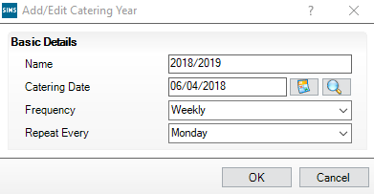
- Enter a unique Name for the catering year.
- Enter the start date (Catering Date) of the catering year.
- Select the Frequency.
- Select Repeat Every for subsequent returns, either a day of the week or a day of the month
- Click OK to return to the main panel.
- The Level of Debt and Level of Credit fields set the default values for reports, this can be set to zero. The value can be changed when the report is run.
- The Location/Cost Centre/Site No and Contract Area fields are optional.
- Default Meal Types – this panel enables you to set the default entries for times when a pupil is absent and what meal pattern will be displayed when pupils or staff are given an initial meal pattern. The patterns can be left blank if preferred.
- Pupil Not Present – select the entry to be displayed, for example, Absent; if a pupil has been marked on the attendance register with a pupil not present code.
- Pupil New Meal Pattern – the selection made here will be displayed for all initial pupil patterns entered in SIMS but may be edited individually, if necessary. It can be left blank.
- Staff New Meal Pattern – the selection made here will be displayed for all initial staff patterns entered in SIMS but may be edited individually, if necessary.
- Panels 4 to 7 define how the banking codes are linked to the VAT codes and need to be set. Schools should seek advice from their LA or accountant for the required settings. For the purpose of this course use the existing settings. It is a good idea to complete the adhoc meal panel even if you do not intend to use at present. If you marked the other sales codes as Inactive when setting up banking codes, they will be greyed out here.
- Letter Templates will be covered in Chapter 11.
- When all the entries on this screen are complete click Save and then Close.
- For the purposes of this training course it we will not restart SIMS at this point.

Activity – Personalising Setup
- Use the Dinner Money setup screen to replicate the situation in the school.

Setting the Meal types and Charge Definitions for the School
For Dinner Money to be used effectively a school must define the types of meal offered and define how much is to be charged. The software automatically applies a zero charge to pupils eligible for free school meals (either deprivation or universal infant meals).

Setting up Meal Types
The standard set of meal types provided is:
- student meal type
- staff meal type
- adhoc meal type
- other sales type.
These can be configured to represent the meal types actually provided by a school. They should be mapped to an appropriate meal category to enable effective reporting.

Step by Step – To View, Add or Edit Meal Types
- Select Tools | Lookups | Maintain.
- Select Dinner Money from the Data Area drop–down list, and then click Search. The four standard types are displayed.
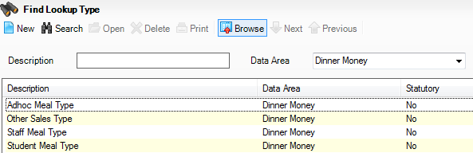
- Open Student Meal Type.
The values listed as Active will be shown as the available options when marking the dinner register. It is important that the list is correct for the school and contains every type of meal the school will offer – plus Packed Lunch, Home and Absent.
NOTE: Do not add a deprivation free meal type, as it is important that you record all relevant pupils as taking a normal school meal and let SIMS remove any charges for the pupils with free meal entitlements.
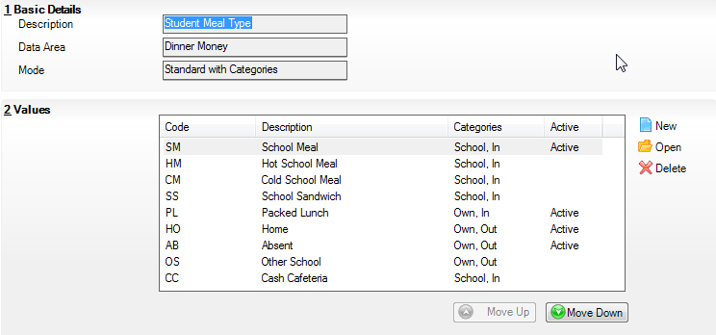
- To check the details double–click each value in turn.
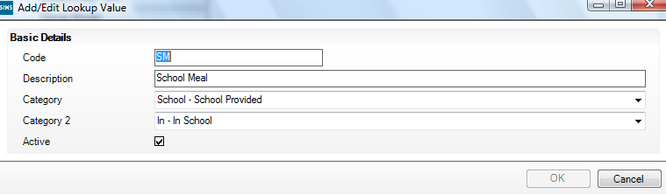
- Select Student Meal Type.
- Category: indicate who provides the meal by selecting from the drop–down list.
NOTE: Funding for universal infant free school meals is allocated to schools using information submitted through the school census. The census can count infant pupils who take a meal type with category of School – School Provided as having a school meal.
- Category 2: indicate whether the meal is taken in or out of school.
- Delete or mark as Inactive any meal types that are not currently in use.
Ensure the list is in the best order for the school as it is helpful to have the most frequently used at the top.
- Select Staff Meal Type (if required).
- Category: select the role of the person.
- Category 2: select whether a charge is made.
- Select Adhoc Meal Type (if required).
- Category: select the type of person.
- Category 2: select whether a charge is made.
- Select Other Sales Type (if required).
- Category: select the type of item for sale.
- Category 2: select which VAT this item relates to.
- Mark any inappropriate types as Inactive.

Step by Step – Personalising Meal Types
Check the existing meal types and make sure that only those required by the school are marked as Active. Every active meal type will be offered as a choice for selection on the register. Ensure the Description and order are correct. Note the number of meal types showing as Active.
In addition to the standard meal types, the school wishes to offer pupils a vegetarian option in the Student Meal Type lookup.
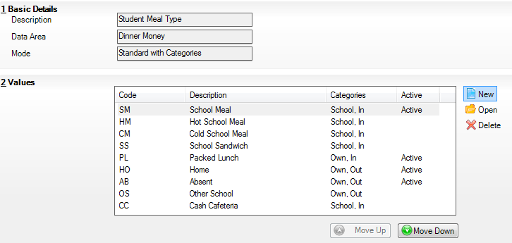
1. Click on New located to the right of the Values panel.
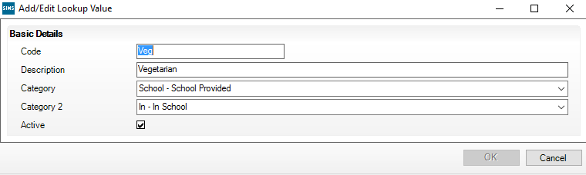
- Type a Code of Veg and a Description of Vegetarian. The meal will be provided by the school and eaten in the school.
- Reorder the list as required.
- Click Save. A message will be displayed informing you that SIMS must be closed and restarted before the changes take effect.
- Restart SIMS using the following details:
User Name | GROSG
Password | ABCD

Step by Step – Adding/Editing Pupil Meal Definitions
In addition to creating a meal type the school must also define how much will be charged. Different meal definitions can be created for each group for the same meal type. Only one meal type/group combination can be valid at any one time.
Meal definitions can be added manually or provided by other organisations, for example to be imported from the LA.
NOTE: It is a very good idea to set a meal definition for all meal type/group combinations. Whilst it is possible to save a pupil’s meal if the meal type is not covered by a definition, it will prevent many further activities and reporting within Dinner Money, for example, Pupil Payments.
- Select Tools | Dinner Money | Pupil Meal Definition.
- Click Search to view the existing definitions or click New to create a new one.
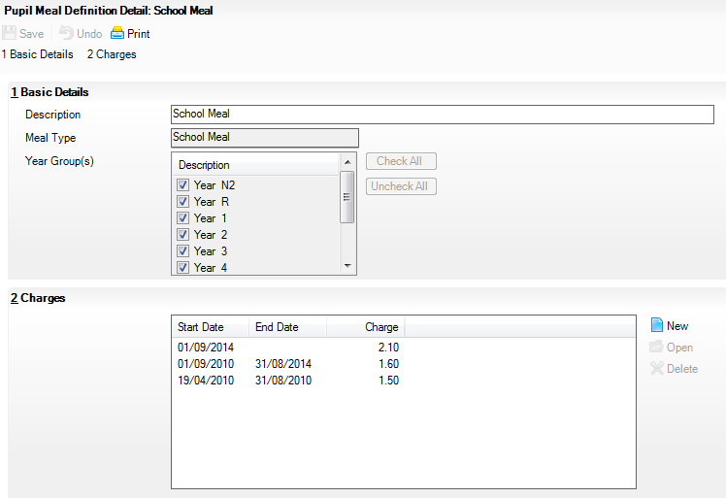
- Enter a Description for the meal and select the Meal Type from the Meal Type drop–down list.
- Tick the Year Group(s) that will charge the amount set for this definition.
NOTE: The Group Type is defined during setup and cannot be changed (Tools |Dinner Money |Setup | Meal Charging Maps).
- In the Charges panel either highlight an existing charge, and then click Open or click New to add a new charge.

Activity – Personalising Meal Definitions
- Add the Vegetarian option so that it can be recorded against pupils. Enter the Description Vegetarian and choose the Vegetarian Meal Type. Check all Year Group(s) and set a charge of £2.10 with a Start Date of 01/09/2017.
NOTE: To support Universal Infant Free School Meals (UIFSM), Dinner Money will automatically charge Reception, Year 1 and Year 2 pupils £0.00 regardless of the definitions charge. Similarly pupils eligible for Free School Meals will also not be charged.
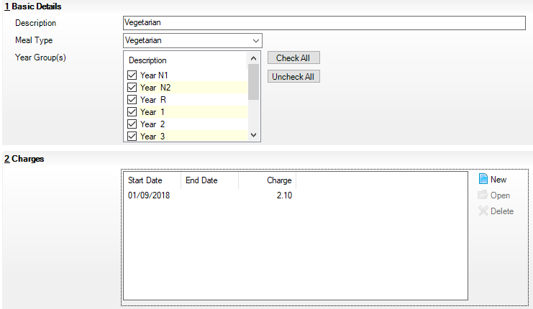
- Browse and Search to refresh the listed definitions.
- Check that you have created a meal definition for every Meal Type shown on your drop–down list.

Activity – Changing the Charge for a Meal Type
From next Monday the school wishes to adjust the price of a school meal.
- Open the Pupil Meal Definition for School Meal. In panel 2: Charges, click New, located on the right. Set the Start Date to next Monday and the Charge to £2.50 and Save.
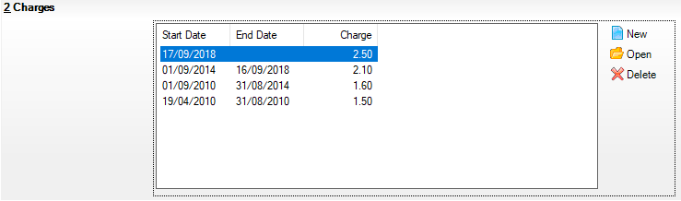
- The new charge will be applied from the start date, it is preferred to enter new charges with a start date in the future, if the start date for the charge has already passed it will be necessary to Backdate Meals Processed, as described in Appendix A.

Step by Step – Manually Adding/Editing Pupil Opening Balances
Opening Balances allow schools to record any balances the pupils may already have when the school starts using Dinner Money.
They can only be edited until the end of the academic year during which Dinner Money was first used unless the opening balance date in Tools | Dinner Money | Setups is altered.
On this course, the opening balances cannot be edited as Dinner Money has been in use for more than a year.
- Select Focus | Dinner Money | Pupil Opening Balances to display the browser. Either click Search to view the whole school or select a specific group.
- Click any column heading to sort by that column.
- Click in the appropriate cell to add or edit the opening balance, making sure you include a minus sign for a negative balance, for example, -£2.50.
- Click Save if any changes have been made.
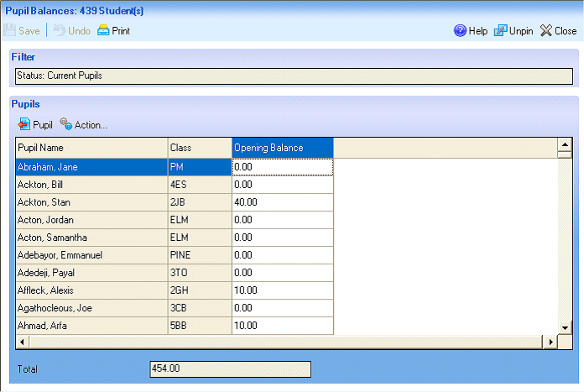

Producing the Opening Balances Report
This report lists the opening balances of each pupil and member of staff.
- Select Reports | Dinner Money | Finance | Opening Balances.
- Select to run the report for Pupils, Staff or both (All)

Step by Step – Setting Pupil Default Meal Patterns
If pupils take a particular meal on a particular day they can be assigned a meal pattern. Assigning a meal pattern allows Dinner Money to automatically assign a meal type based on attendance. These can be edited on the day if the pupil makes a different choice. They can be left blank for any pupil who does not have a regular pattern.
Meal patterns can be set either individually or on a group bases.
- Meal Patterns can be set individually in panel 6: Dietary of the Pupil Details screen.
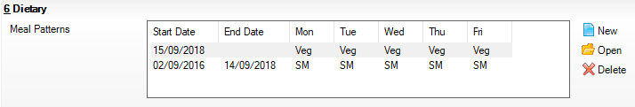
- To add a new pattern, click New.
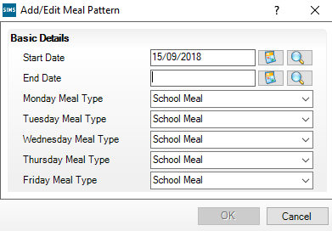
- The Start Date can only be today or a date in the future. The End Date may be left blank. Adding a new meal pattern automatically assigns an end date to any existing pattern. Click Save.
- Alternatively they can be set for individuals or groups by selecting Focus | Dinner Money | Pupil Default Meal Patterns. Changes made in either route are reflected in the other.
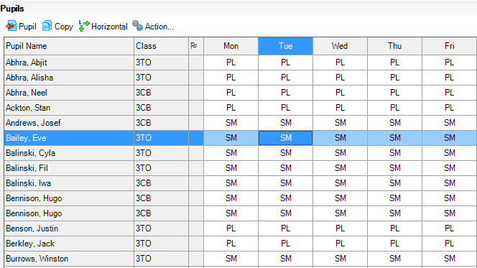
- Columns can be sorted by clicking the column heading – any empty cells appear at the top.
- To add or change a meal pattern, right–click in the appropriate cell or click Action to display a drop–down list.
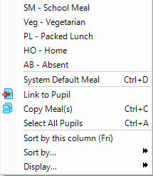
- If the same meal type needs to be assigned to the rest of the week click Copy or press Ctrl and C.
Multiple pupils can be selected in the usual way by holding Ctrl and clicking with the mouse or alternatively pressing shift and clicking the first and last name.
- To assign the same meal type to everyone in the selected group; select the day, press Ctrl and A or click Action and select Select All Pupils, and then right–click in any cell to display the drop–down list. Those codes can be copied to other days.
An entry in the flag column indicates prior settings:
- F – Indicates there is a future meal pattern for the pupil already defined and any changes made here will only apply until the new start date.
- E – Indicates there is already an end date for the current meal pattern so changes will only apply until that date.
- L – Indicates a date of leaving (DOL) has been set and any changes made here will only apply until that date.

Activity – Checking Meal Patterns
- Dinner Money does not appear to display correctly for Lexi Mitch. She is entitled to free meals and takes a school meal every day. If necessary edit the pattern to reflect this.

Adding/Editing Free School Meal Eligibility
These are recorded in panel 6: Dietary of the Pupil Details. Enter a Start Date, choose a Country and an End Date, if known. During the period that a pupil is eligible for free meals, they can be assigned a meal type of School Meal but there will be no charge. There is no need to create a meal type of free meal.
NOTE: This should only be used to record pupils eligible for deprivation free meals, not pupils entitled under universal infant free school meals.

NOTE: When a pupil’s entitlement to free meals ends open Eligible for Free Meals and enter the end date. Do not delete the eligibility as this will affect the school’s and the pupil’s future school's ability to report on Free School Meal history including eligibility over the last 1 and 6 years.

Activity – Adding Free School Meal Eligibility
- The school has received notification that Evia Caster in Year 3 has been approved for free meals from next Monday. His mother says he will have a school meal every day. Edit his record accordingly.

Adding/Editing Dietary Preferences (Optional)
If you indicated on the Setup page that you wish to use Dietary Preferences then an additional section will be added to panel 6: Dietary of the Pupil Details screen.
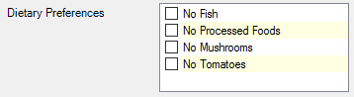
This table can be personalised by selecting Tools | Lookups | Maintain | Dietary Preferences.
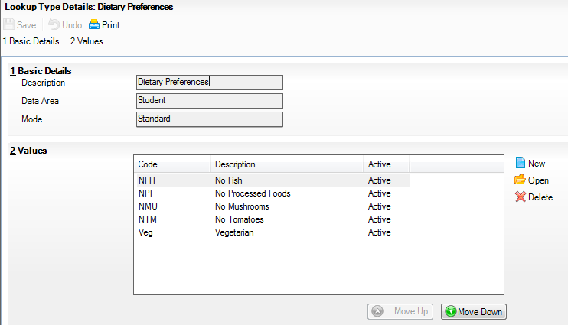

Adding/Editing Dietary Needs
These are found in panel 7: Medical of the Pupil Details screen.
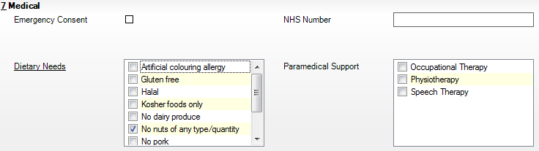
These can also be personalised by selecting Tools | Lookups | Maintain | Dietary Needs.
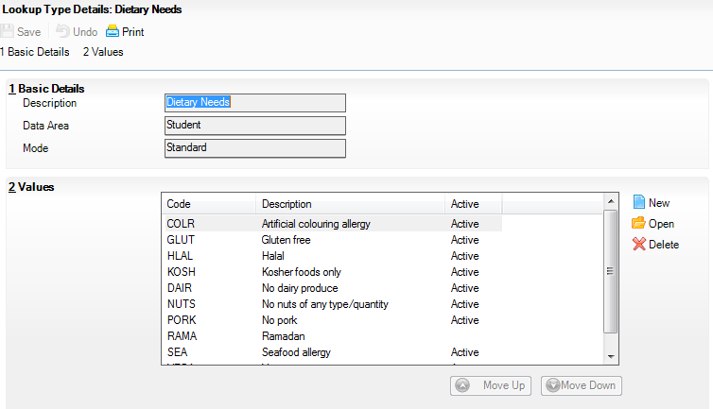

Activity – Adding a Dietary Preference
- The school wishes to record which students are vegetarian using the dietary preference area.
- Add vegetarian to the Dietary Preference lookup.
- Check Dietary Preference is ticked in Dinner Money setup.
- Restart SIMS.
User Name | GROSG
Password | ABCD
- Open a pupil record and record them as vegetarian in the dietary preference in panel 6.
- Adjust their meal pattern so they have the vegetarian meal from today.
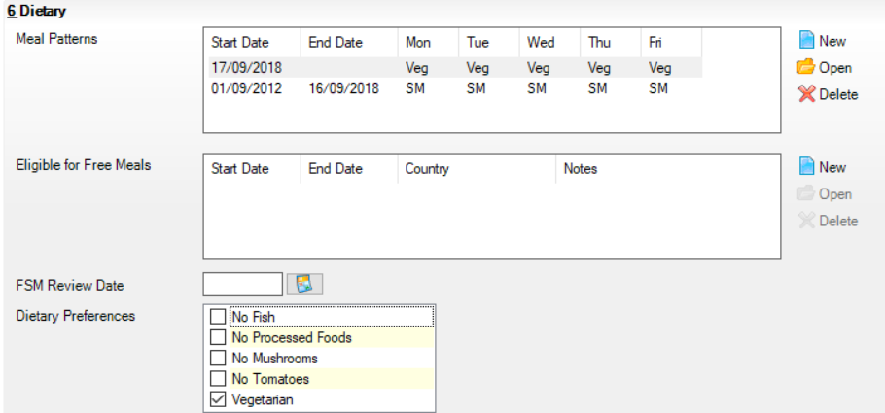

Recording Pupil Meals for Schools not using the Attendance Links

This chapter contains:
Chapter Introduction 19
Step by Step – Turning the Attendance Link Off 19
Step by Step – Completing the Dinner Register before Attendance is Recorded 20
Step by Step – Entering Meals 20
Activity – Completing Dinner Register 21
Step by Step – Setting Up and Recording Special Meals 21
Step by Step – Completing the Dinner Register After Attendance is Recorded 22

Chapter Introduction
There are various ways of recording meals and these depend on whether you record attendance marks on a daily basis.
In some schools the pupils do not have a default meal pattern but choose each day which meal is to be taken. If so no link can be made between a child’s attendance at school and the meal taken.
Many schools still transfer attendance marks from their attendance register to SIMS at the end of the day/week so the population of Dinner Money from Attendance is not applicable. However, daily meals can be populated with the default meal pattern which can then be manually edited, if necessary.
NOTE: The Focus| Attendance| Take Register and Focus| Dinner Money| Record Pupil Meals routes should not be used if you do not enter the Attendance marks daily. If you do use these routes, saving the dinner register results in all pupils being given an N on the attendance register (and will be regarded as absent).
When meals have been recorded, a report for the kitchen can be created by selecting Reports | Dinner Money | Statistics | Kitchen Statistics. It shows the number of meals required for pupils, staff, visitors and any special meal requirements together with the total number of pupils having a packed lunch. Details for this report are given in Chapter 10.

Step by Step – Turning the Attendance Link Off
- Ensure that the Attendance link is turned off. Go to Tools | Dinner Money | Setup.
- Remove the tick from the Attendance Link box.
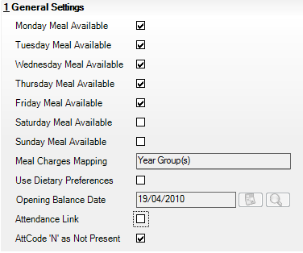
- Save and Close the screen.

Step by Step – Completing the Dinner Register before Attendance is Recorded
- In SIMS go to Focus | Dinner Money | Edit Pupil Meals. All the classes are shown in the browser. Click Select All, and then click Open.
- The dinner register is displayed for the first class. When it is completed and saved, click Next to move to the next class. Alternatively, double–click the class to be worked on.
Next
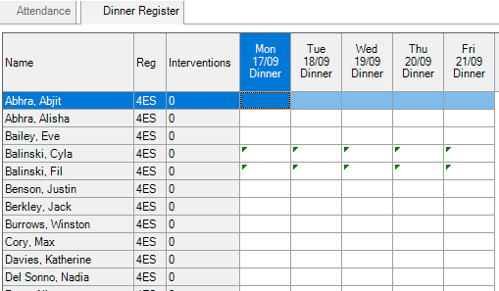
The green triangles indicate pupils with current free meal entitlements.

Step by Step – Entering Meals
Meals can be added using any of the following methods:
- Right–click the cell of the first pupil and select the appropriate Meal Type from the drop–down list (which contains the meal types marked as Active in the set up).
- The meal type is placed in that cell and the drop–down list automatically moves to the next pupil.
- Press Ctrl and click all the pupils having a school meal.
- Right–click one of their cells and select School Meal from the drop–down list.
- If you want to enter the default meal for the whole class, select the appropriate column and press Ctrl and D. Edit as necessary.
- To enter the default meal for a single pupil, select the cell and press Ctrl and D or right–click and select Default Meal.
- Make sure the first pupil’s cell for the right day is selected and click Codes to display the Codes dialog.
- Double–click the correct Meal Type for each pupil in turn. Click Close when you have reached the last pupil.
- If an incorrect meal type has been selected use the Clear Meal option.
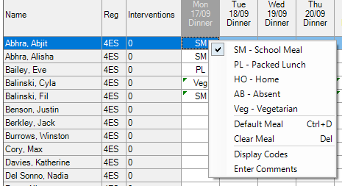
- If you need to change a meal after it has been saved; click Preserve to change it to Overwrite. Make the change, and then click Overwrite to display Preserve before clicking Save.
Preserve
Overwrite

Entering a Comment
A comment may be entered on any cell by right–clicking and selecting Enter Comment. This can also be done on the attendance register.

Flood Filling all Pupils with a Default Meal Pattern
This option may be time saving if you like to have all the default meals showing on the dinner register, but do not have any attendance data entered yet.
Select Routines | Dinner Money | Autofill Default Meals, ensure the correct date and appropriate roles have been selected. Click Save.
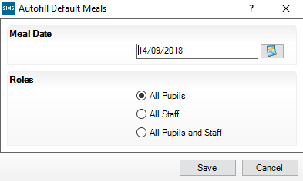

Activity – Completing Dinner Register
- Using Focus | Dinner Money | Edit Pupil Meals select 4ES and complete the dinner register for today, finding the best method of entry for the school.

Step by Step – Setting Up and Recording Special Meals
Schools may need to record meals that are only taken at certain times of the year such as:
- religious festivals e.g. Christmas lunch – there may be a different charge for the meal on a certain day
- Theme meal – perhaps a special meal to tie in with the curriculum but with a different price.
- Ensure the Meal Type has been created in Tools | Lookups | Maintain | Student Meal Type and that it is set to Active. If you have had to make a change to the setting you will need to close and reopen SIMS for it to take effect.
- Create a Meal Definition for the new Meal Type by selecting Tools | Dinner Money | Pupil Meal Definitions. Search to ensure that meal does not already exist, and then click New.
- Type a name and link it to the appropriate meal type. Select the year groups who will take this meal.
- Add a meal Charge with an appropriate Start Date and End Date.
- Record the meal as normal, the special meal will now be displayed in the codes available.
- After the event you can return to Tools | Lookups | Maintain | Student Meal and mark it Inactive to prevent it being selected by mistake.
- Next time you need to use that meal type:
- Meal Type – mark it as Active
- Meal Definition – add a new Charge with the new Start Date, End Date and Price.

Step by Step – Completing the Dinner Register After Attendance is Recorded
The dinner register can be taken after, or at the same time as the attendance register.
- In SIMS go to Focus | Dinner Money | Record Pupil Meals.
- Double click on the session in the time line.
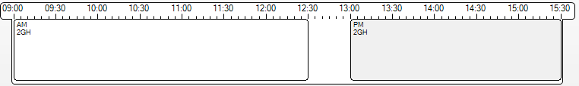
- Enter the required meals.
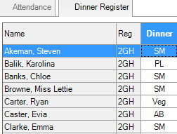
- Hover over a Dinner column for a pupil’s attendance to be revealed.
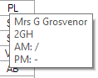
- Or view all the attendance by click on the Attendance tab.
- Return to the Dinner Register by clicking on the tab.
- Click Save.

Recording Pupil Meals for Schools Using the Attendance Links

This chapter contains:
Chapter Introduction 23
Step by Step – Activating the Attendance Links 23
Step by Step – Recording Pupil Meals for Schools who have Entered Attendance Method 1: Take Register 24
Step by Step – Recording Pupil Meals for Schools who have entered Attendance Method 2: Record Pupil Meals 24
Activity – Using Attendance to Assist with Completing Dinner Register 24
Step by Step – Editing Dinner List after Attendance 25
Step by Step – The Kitchen Statistics Report 26
Step by Step – The Supervisors List 27

Chapter Introduction
Dinner Money has been designed to take today’s attendance marks from SIMS and transfer them to Dinner Money therefore saving double entry. This happens as long as the Attendance Link has been selected and the default meal patterns have been set up. Present and late marks will convert to the appropriate meal pattern for that day and all types of absence marks will populate Dinner Money with absent.
When meals have been recorded, a report for the kitchen can be created by selecting Reports | Dinner Money | Statistics | Kitchen Statistics. It shows the number of meals required for pupils, staff, visitors and any special meal requirements plus the total number of pupils having a packed lunch. Details for this report are given in Chapter 10.

Step by Step – Activating the Attendance Links
- Select Tools | Dinner Money | Setup.
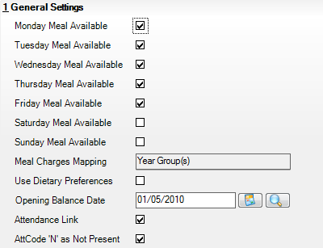
- Ensure the last two check boxes in panel 1: General Settings are selected and save.

Step by Step – Recording Pupil Meals for Schools who have Entered Attendance Method 1: Take Register
The take register route has been designed to record both attendance and meals directly into SIMS in the classroom.
- Select Focus | Attendance | Take Register and select the appropriate class. Take Register can also be used.
- The attendance register for the current day will be displayed with the dinner register on the second tab.
- As soon as the attendance register has been completed, all pupils with a not present code will be populated with AB on the dinner register screen. All others have been populated with their default meal pattern (if they exist) for that day. Hovering over the cell on the Dinner Register tab will display the attendance code.
These can then be manually edited, if necessary, by right–clicking in the appropriate cell.

Step by Step – Recording Pupil Meals for Schools who have entered Attendance Method 2: Record Pupil Meals
If the attendance marks for the day have already been entered, the meals can also be recorded or checked.
- Select Focus | Dinner Money | Record Pupil Meals.
- Any pupils marked as not present on the attendance register will show with AB on the dinner register and default meals will show where they exist. As with the other method, hovering over the meal type of a pupil will display their attendance code.
Comments can be added for any pupil by right–clicking in the appropriate cell and selecting Enter Comments.
NOTE: If the attendance mark is subsequently altered after it has been saved, the dinner register is not automatically updated.

Activity – Using Attendance to Assist with Completing Dinner Register
Using Focus | Attendance | Take Register or Focus | Attendance | Edit Marks select any class and enter attendance marks for today.
- Open a register for Mrs Boswell (2JB) in Focus | Attendance | Take Register. By default it opens the registers for the classes supervised by the staff member. Change the teacher by clicking on the binoculars to the right of the teacher.
- Search for and double click Mrs Boswells AM session to open the register.
- Enter some attendance marks. Right-click to see the codes. Mark some Present, Absent and N code for Not Yet Known.
- Click Save.
- View the results on the Dinner Register tab.
- Amend some attendance results (if you saved them you will need to click Preserve to change it to Overwrite mode) and observe the effect.

Step by Step – Editing Dinner List after Attendance
Once the register has been saved it is possible to view or edit the meals recorded. The dinner register is populated by attendance mark at first saving. If the attendance mark is subsequently changes the dinner register will also need to be amended, for example, when a student arrives late and the attendance is updated the dinner register will also need to be changed to the pupil’s choice of meal.
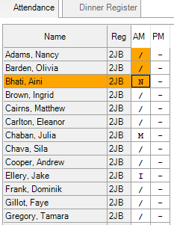
- Record attendance for class and click Save.
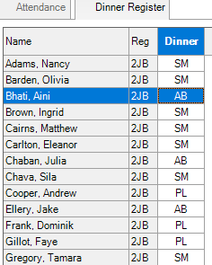
- Ensure that the register is setup to Overwrite and change a pupil from N to L (Late). Click Save.
- Switch to the Dinner Register tab.
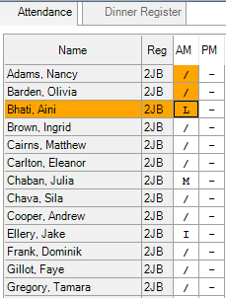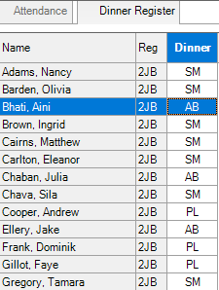
- Manually change the pupil to the required meal, it is possible to right-click and choose the default meal.
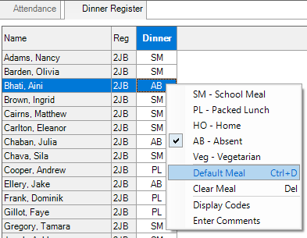
- Save the amended dinner register.
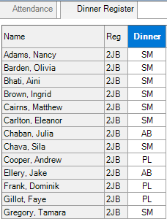
The two most common reports run are the Kitchen Statistics to provide information on overall number of meals required that day and the Supervisor List to ensure pupils receive their requested meal.

Step by Step – The Kitchen Statistics Report
Usually this report is run on a daily basis to inform the kitchen of the number of meals required. The report displays the meal numbers for pupils, staff and adhoc meals within a given date range (normally the current day). It can also display the special meal requirements for pupils and staff. A section is provided for manual entry of any special requirement for adhoc meals.
- Select Reports | Dinner Money | Statistics | Kitchen Statistics.
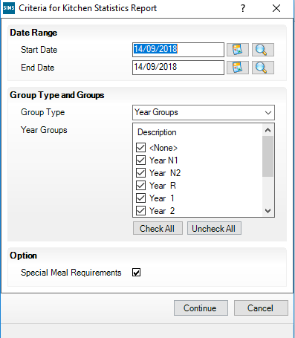
- The date defaults to today’s date but can be changed.
- Accept and select the Group Types and Year Groups.
- The check box for the Special Meal Requirements is selected by default but can be deselected.
- Click Continue and then click OK to produce the report.
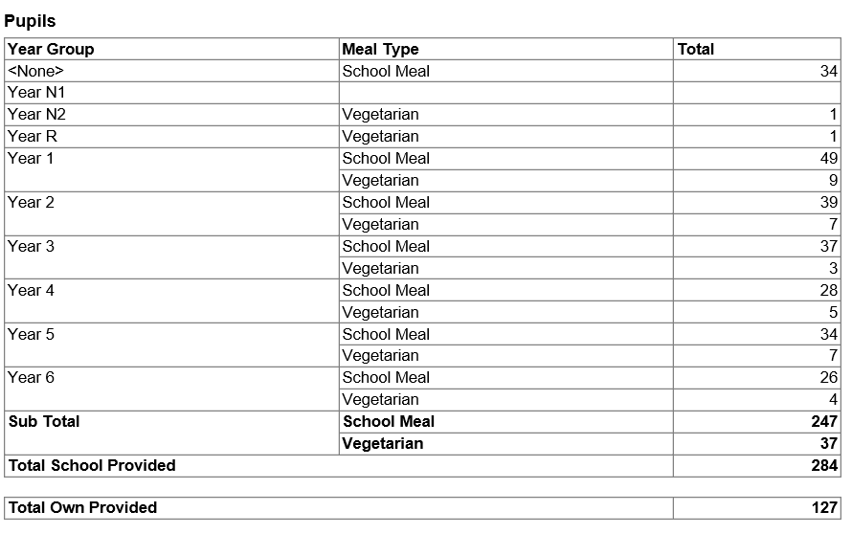
Alternatively instead of printing a report it can be saved and emailed to the kitchen.
- On the Run a Screen Based Report menu choose output to file. Set the file path and filename.
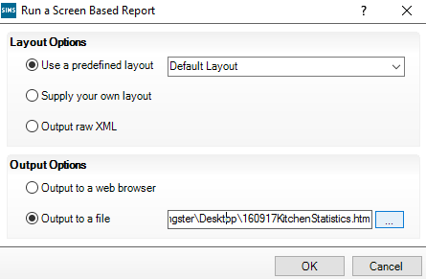
- Click Ok.

Step by Step – The Supervisors List
This report can be printed and given to the person supervising the meal time to ensure that pupils receive the requested meals.
- Select Report | Dinner Money | Listing | Supervisors List.
- Set the required date (defaults to today) and the required groups.
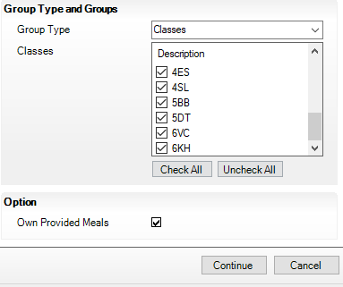
- Click Continue.
- Use the Default Layout.
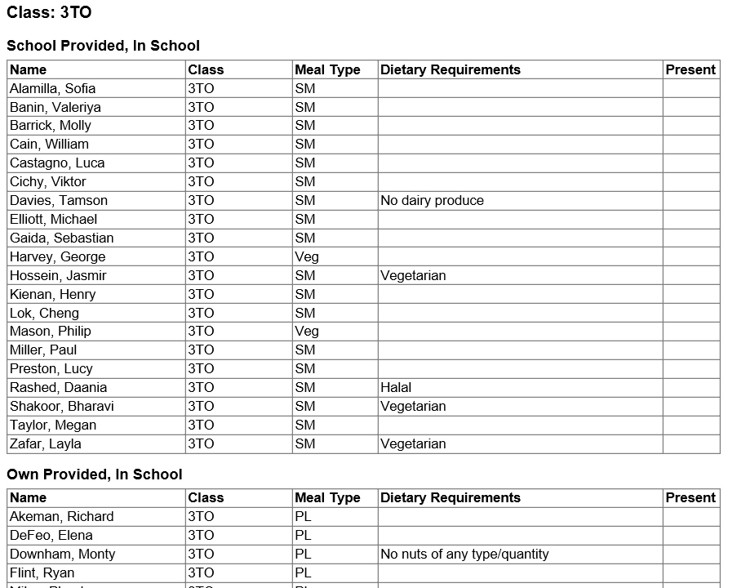

Recording Pupil Payments

This chapter contains:
Chapter Introduction 29
Step by Step – Cash or Cheque Payments 29
Activity – Checking Balances 30
Activity – Recording Payments 30
Step by Step – Recording Split Payments 31
Activity – Entering Split Payments 31
Step by Step – Pupil Additional Transactions 32
Step by Step – Reversing a Payment 33
Step by Step – Recording a Balance Transfer 33
Activity – Reversing a Payment 34
Activity – Refunding a Payment 34
Activity – Transferring a Payment 34
Step by Step – Recording Electronic Payments 34
Step by Step – Viewing an Individual Pupil’s Transactions in Pupil Details 36

Chapter Introduction
This process will enable you to record payments for pupil meals by cash, cheque and electronic methods card or internet transactions.

Step by Step – Cash or Cheque Payments
- Select Focus | Dinner Money | Pupil Payments and select Bankable Payment Type. The date defaults to today but may be changed to one in the past. Click OK.
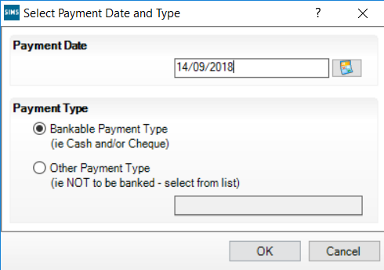
- Select the pupils by class or by the grouping you prefer. The current balance is displayed as well as any previous payments that have not yet been banked (the Dinner Money banking has not been run since these payments were made).
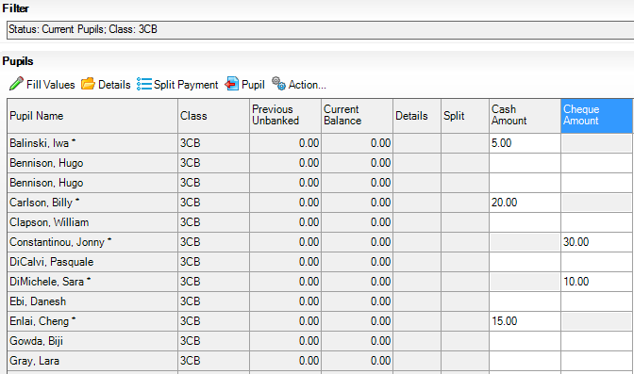
- Enter the payments in the appropriate column. The total of each column is displayed at the bottom of the screen.
- Fill Values enables you to flood fill every pupil with the same amount. Highlight the column, and then click Fill Values. However, if you use this routine for cash you will not be able to enter any cheque payments without saving and closing then re–opening the screen and vice versa.

Activity – Checking Balances
- Open the Payment screen for class 6KH.
- Check Eleanor Murray current balance. Is she in credit or debt?
- Close the screen without saving.

Saving Pupils Payments
When all the payments on that screen are completed, clicking Save displays the following screen, as shown in the graphic below.
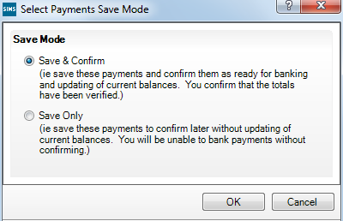
If you are sure that the payment details are correct select Save & Confirm which will update the balances and record the payments in the audit log. Any changes would have to be made by other means, such as a reversal.
However, if you wish to close the screen temporarily to check on a payment, for example, select Save Only. This will not update the balances and will enable you to make changes. The payment screen could be closed, if wished, but when re–opened and completed, the Save & Confirm should be selected.

Activity – Recording Payments
- Open class 6VC and make the following payments:
 | Cash | Cheque
Sonya Astoni (FSM) | 5.00
Anabel Clarke |  | 40.00
Ben Davies | 10.00
Carl jackson | 7.50
Andrew Mead |  | 20.00
Christian Simons |  | 7.50
- You then re–examine the payment envelope and realise that Christian Simons could be Cheryl Smyth. Select Save Only while you investigate. Close the screen.
- Re–open class 6VC and change the £7.50 to Cheryl Smyth. Select Save & Confirm.
- What happened to a pupil receiving free school meals?

Step by Step – Recording Split Payments
You may need to record a split payment where one pupil makes the payment, usually a cheque, for themselves and another pupil or pupil(s).
- Enter the full amount for the first pupil and click Split Payment.
- The screen will display the first pupil and other siblings. Other pupils can be added by clicking Add Pupil.
- Allocate the payment accordingly. Click OK.
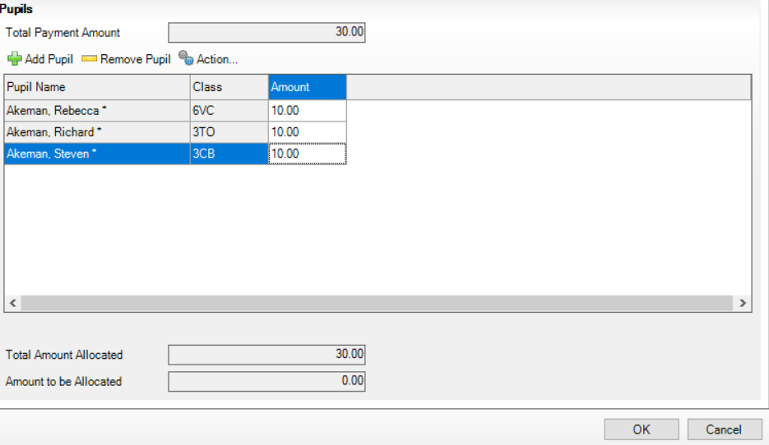
NOTE: The whole amount is still displayed against the first pupil at this point but the individual balances will show the correct amounts once the screen has been saved and confirmed.

Activity – Entering Split Payments
- Rebecca Akeman in class 6VC has brought in a cheque for £30.00 for herself and her siblings. Record the payment apportioning the amounts as you wish.
- Save and then confirm the payment.
- Review the unbanked balances.

Recording Additional Payment Details (where necessary)
It is possible to enter additional information about a payment, if necessary – perhaps in the case of a damaged cheque which may be returned by the bank.
When a payment has been entered for a pupil click Details and enter as much information as required.

Step by Step – Pupil Additional Transactions
This route can be used to see all opening balances, the current balance and current transactions for a pupil without the need for printing a statement.
It is also used if it is necessary to amend payments that have been confirmed. Additional transactions can take the form of a:
- reversal, for example, to amend a duplicate payment, incorrect type or amount of payment. This cancels the original payment
- returned payment (returned by the bank), for example, a bounced cheque
- refund
- write–off
- balance transfer between pupils.
NOTE: Advice about the use of these may have to be sought from the LA or an accountant.
- Select Focus | Dinner Money | Pupil Additional Transactions and then the appropriate pupil.
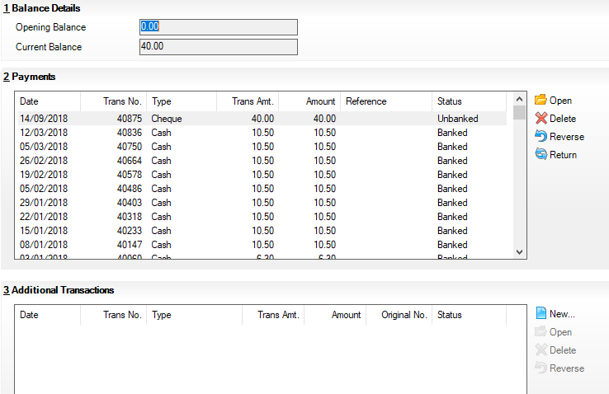
- The current position is shown. Highlight the payment to be altered.
- Click Open to view details of the payment.

Step by Step – Reversing a Payment
NOTE: Only unbanked payments can be reversed. Banked payments will need to be transferred.
- Highlight the payment to be reversed and then click Reverse.
- All the fields are read–only except the reason which needs to be completed. Click OK. The transaction is displayed in the lower field.
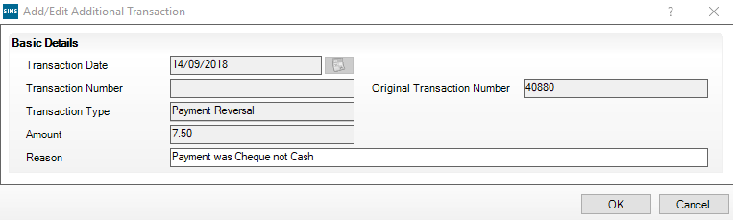
- Click Save when you are satisfied the record is now correct. Make the correct payment via the Pupil Payment screen.
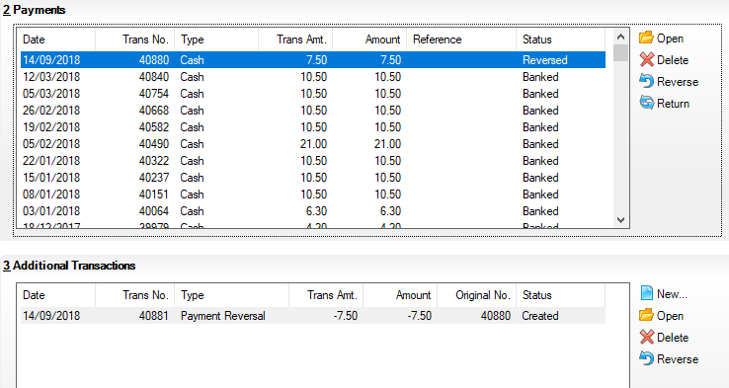

Recording a Returned Payment
This procedure is for recording a cheque that has been returned by the bank – a bounced cheque. It would not be used until the payment has been banked.
Select the appropriate pupil and payment then click Return.

Recording a Refund
If the school permits, a pupil with a positive balance can obtain a refund (for full or part of the balance).
Select the appropriate pupil and click New in the Additional Transactions panel, then select refund and complete the details, selecting cash refund or external refund as appropriate.

Step by Step – Recording a Balance Transfer
This could be used to transfer an amount between pupils either to correct an error or to transfer between pupils at the request of parents.
- Select the appropriate pupil and click New in the Additional Transactions panel.
- Select Balance Transfer.
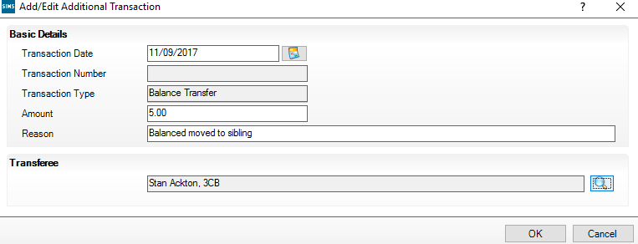
- Enter the amount to transfer and the reason, and then click the magnifying glass icon to select the pupil who will receive the amount.

Recording a Write Off
This will enable you to write off all or part of a negative balance. The date defaults to today, but can be backdated to any date in the current or previous academic year.
Select the appropriate pupil, then click New in the Additional Transactions panel, then select Write Off and complete the details.
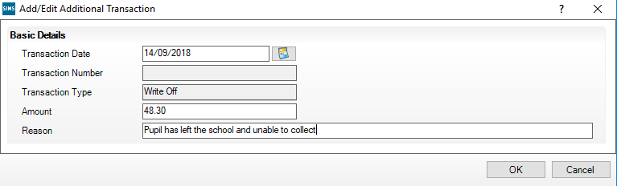

Activity – Reversing a Payment
- Sonya Astoni receives free school meals and doesn’t need to pay for meals. Reverse the payment and return the money.

Activity – Refunding a Payment
- Ben Davies’ mum has requested a refund as Ben has decided not to have school meals. Check his current balance and refund the money.

Activity – Transferring a Payment
- Despite the best efforts to unravel the earlier confusion with the payment of £7.50 by Cheryl Smyth, you now discover that the payment should have been recorded against Christian Simons. Use the Transfer procedure to correct this.

Step by Step – Recording Electronic Payments
Schools can record payments made via electronic methods such as Debit/Credit Card or Internet. Payments made through Agora will automatically update the balance in Dinner Money.
- Select the Other Payment Type radio button and select the appropriate type from the drop–down list.
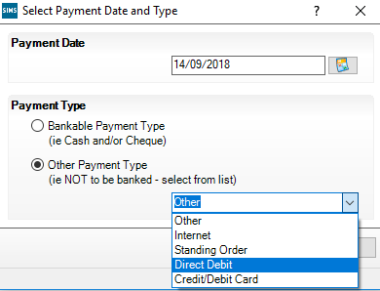
- Select a class or an individual pupil. The Payment screen displays with only one payment column.
- Enter some payment amounts in the Amount column.
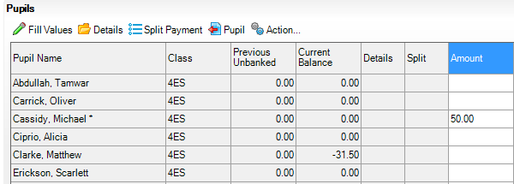
- Click Save.
- When the payment is saved there is no option to Save Only. Click OK.
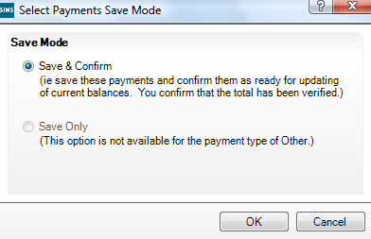
- After saving, the payment shows in the Current Balance column. The Payment screen displays with only one payment column.
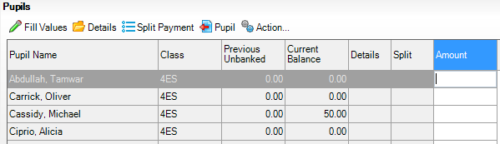
The money entered through the other payments appear in the catering return as Non-bankable Receipts. An extract from the catering return:
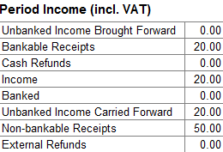

Step by Step – Viewing an Individual Pupil’s Transactions in Pupil Details
Balances, payments and other transactions may be viewed.
- Select Focus | Pupil | Pupil Details to display the Pupil Details screen.
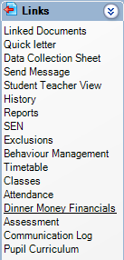
- Search and open Elizabeth Harvey’s record.
- On the Links panel to the right select Dinner Money Financials.

Staff Meals (if Required)

This chapter contains:
Chapter Introduction 37
Step by Step – To View, Add, Edit Meal Types and to Map Values 37

Chapter Introduction
Staff meal types are personalised and defined in a similar way to those of pupils.
It is not expected that every member of staff will take a meal so meals can be recorded for individuals or all staff.

Step by Step – To View, Add, Edit Meal Types and to Map Values
- Select Tools | Lookups | Maintain.
- Select Dinner Money from the Data Area drop–down list, and then click Search.
- Select Staff Meal Types.
- The values listed as Active will be shown as the available options when marking the dinner register. It is important that the active list is correct and contains every type of meal the school will offer to staff.
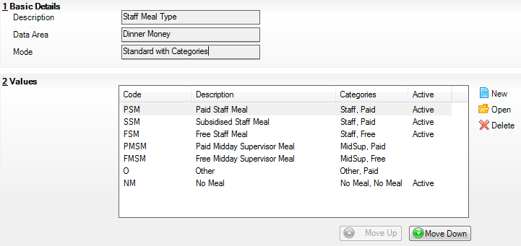
- Open each type of meal in turn to check the Description and Categories fields.
- Category: select the role of the person.
- Category 2: select whether a charge is made.
- Mark any meal types that will not be offered as Inactive, or delete them if they have not been used.
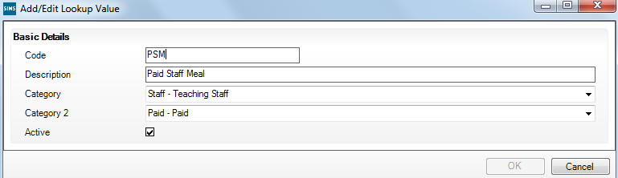
- Click Move Up and Move Down to order the list for the school.
- Click Search to see the edited list and note the number of Active meal types.

Adding/Editing Staff Meal Definitions
Meals and charges should be defined for each meal type you have set up. They need a start date, but not necessarily an end date unless it is for a fixed period. Meal definitions can be added manually or provided by other organisations, for example, the LA to be imported.
NOTE: It is essential that you define at least one meal definition for every entry available in the meal type drop–down list (which you will have already personalised).
The definitions can be managed through Tools | Dinner Money | Staff Meal Definitions.
A staff meal should be defined for every meal type listed on the drop–down list and the number of staff meals defined should agree with the number of meal types noted earlier.

Staff Opening Balances
These are entered by selecting Focus | Dinner Money | Staff Opening Balances.

Recording Staff Meals
These are recorded by selecting Focus | Dinner Money | Record Staff Meals.
If there are many adults in the school it may be easier to sort them by clicking the column headings.

Recording Staff Payments
These are recorded by selecting Focus | Dinner Money | Staff Payments.

Recording Additional Transactions for Staff
These are recorded by selecting Focus | Dinner Money | Staff Additional Transactions.

Adhoc Meals (Optional)

This chapter contains:
Chapter Introduction 39
Step by Step – Adding/Editing Adhoc Meal Definitions 39
Activity – Adding an Adhoc Meal Definition 39
Step by Step – Recording Adhoc Meals 39
Step by Step – Recording Additional Adhoc Meals 40

Chapter Introduction
Adhoc meals are used to record meals for visitors who do not exist in SIMS. They can be adult or pupil and free or paid. They can be entered for the current day, in the past or future.
The creation of adhoc meal types was covered in Chapter 1. Note the number of types.

Step by Step – Adding/Editing Adhoc Meal Definitions
- Select Tools | Dinner Money | Adhoc Meal Definitions.
- Click on New to create a new Adhoc Meal Definition.
- Enter a Description.
- Select the required Adhoc Meal Type.
- Enter the appropriate Charge and click Save.
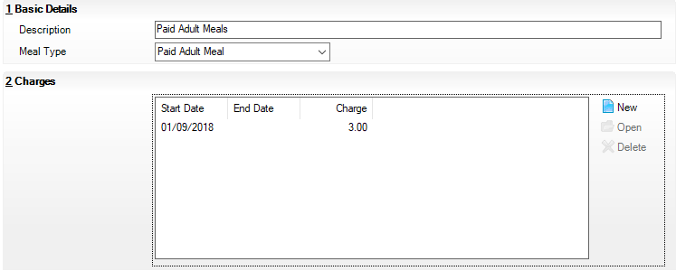

Activity – Adding an Adhoc Meal Definition
- Setup a Charge of £3.00 from today for Paid Adult Meals.

Step by Step – Recording Adhoc Meals
- Select Focus | Dinner Money | Adhoc Meals.
- Select the appropriate date, and then click OK.
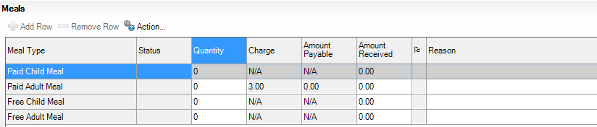
Each active adhoc meal type is listed but those for which a meal definition has not been created will show as N/A.
The Status column displays details of any previously entered meals and whether the money has been banked.
- Enter the number of meals for the relevant date in the Quantity column.
The Amount Payable column is calculated automatically.
- Enter money received.
NOTE: Once money for these meals has been banked it will not be possible to edit the amount.
Summary totals are displayed at the bottom of the screen.
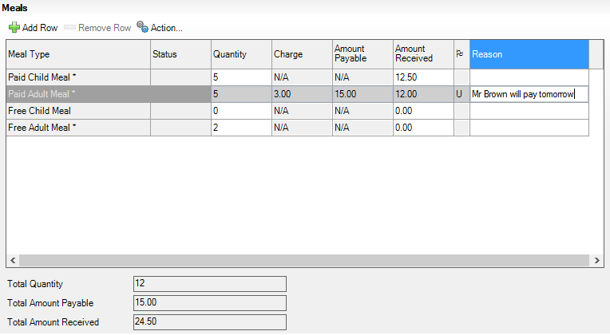
If there is a discrepancy between the Amount Payable and the Amount Received, a flag is displayed – U for underpayment and O for overpayment. The value of the difference is displayed by hovering the mouse over the flag.
Any comment can be typed in the Reason column.

Step by Step – Recording Additional Adhoc Meals
There may be separate reasons for recording the same type of meal on a particular date – perhaps different types of visitors – and this can be done by adding an additional row.
- Enter the first category.
- Click out of that line and back into it to activate Add Row.
- Click Add Row to create a new line and enter the extra category there.
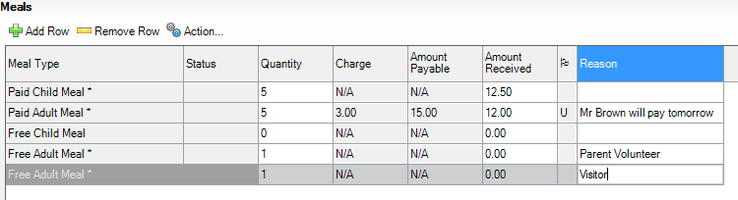
The additional row could also be used if a part payment has been received and banked then the balance paid later. In this case the additional row would show the quantity as zero but the amount of money subsequently paid.

Other Sales (Optional)

This chapter contains:
Chapter Introduction 41
Step by Step – Add/Edit Other Sales Definitions 41
Step by Step – Recording Other Sales 41

Chapter Introduction
Other sales can be used to record income received for particular items which are not considered to be meals such as milk, fruit and refreshments for meetings. The items are not recorded against individuals and will not affect the pupil’s balance.
The creation of other sales types was covered in Chapter 1.

Step by Step – Add/Edit Other Sales Definitions
- Select Tools | Dinner Money | Other Sales Definitions.
- Click New to add Other Sales as required and specify the charge.

Step by Step – Recording Other Sales
- Select Focus | Dinner Money | Other Sales. The Sales Type column will display the active other sales types. The rows showing N/A contain types which are active but have not been defined.
- Enter the number of items sold in the quantity column. The amount payable is automatically calculated.
- Enter the Amount Received.
If there is a discrepancy between the Amount Payable and the amount received a flag is displayed – U for Underpayment and O for Overpayment. The value of the difference is displayed by hovering the mouse over the flag.
Summary totals are displayed at the bottom of the page.
Values can be entered and edited until the banking return is authorised. When this has been completed, the grid is cleared of previous entries.
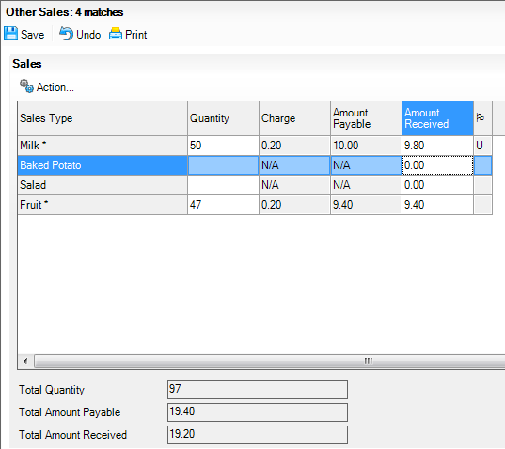

Banking Dinner Money Payments

This chapter contains:
Chapter Introduction 43
Step by Step – Running Unauthorised Banking 44
Step by Step – Running Authorised Banking 44

Chapter Introduction
The banking procedures in Dinner Money are very important. The process should be seen as finalising all the payments. Often schools link it to physical action of going to the bank, but doesn’t necessarily need to be so.
NOTE: If banking returns are not run regularly, much of the reporting functionality of Dinner Money will be lost.
There are two types of banking procedures – Unauthorised and Authorised.
- The Unauthorised routine enables you to check the amount of money and cheques you have taken since the last authorised banking. It can be run as often as required and does not require saving.
- The Authorised banking routine is run when money is physically handed over either to a bank or another member of staff. The accompanying report has a space for a signature. On saving, the status of all bankable transactions is changed to Banked and every payment will show the banking number and date.
The authorised banking return should be run regularly, however, the frequency depends on how the school operates. In a school where dinner money is collected daily, but someone only visits the bank once a week, the authorised banking routine needs to be run before each visit only.
In a school where the person recording dinner money data does not actually ever go to the bank, but hands the money to the finance officer every day, the authorised banking routine would be run daily.
Running the authorised banking return finalises all payments since the last return and includes them in the return.
Reports from either procedure can be printed and include amounts received for the cash and cheques paid in by classes and staff, adhoc meals and any other sales. Payments made electronically will not appear on this return as they will not physically be passed over.

Step by Step – Running Unauthorised Banking
- Select Focus | Dinner Money | Banking Return or Reports | Dinner Money | Banking Return, and then click New to display the Banking Return Details screen.
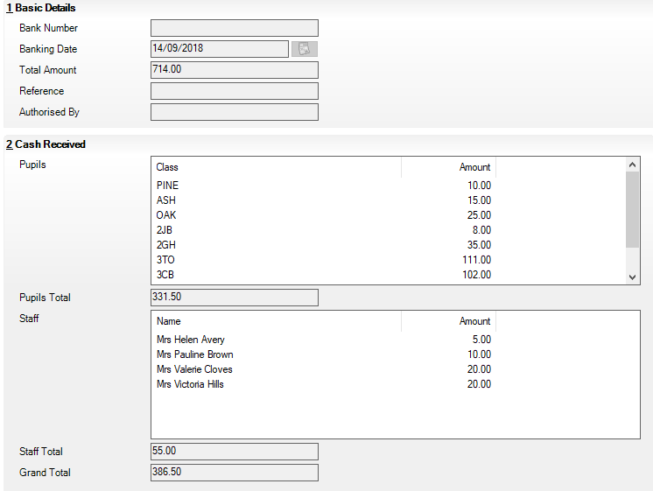
The screen displays any unbanked and confirmed transactions recorded up to and including today.
- Click Print if required.
- Click Close to close the screen without saving.

Step by Step – Running Authorised Banking
NOTE: Once the banking return has been authorised, no further changes or refunds can be included.
- When you are ready to physically pass the money elsewhere select Focus | Dinner Money | Banking Return or Reports | Dinner Money | Banking Return, then click New to display the Banking Return Details screen. This may be the same as the unauthorised return but will have changed if subsequent transactions have taken place.
- Click Save, you will be asked to confirm the authorisation.
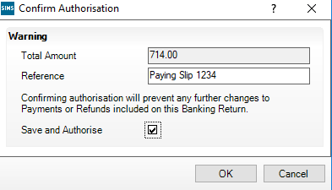
- The Total Amount is read–only. Enter a Reference, if required. OK is greyed out until the Save and Authorise check box has been selected. Click OK and the next bank number will be assigned to this transaction.
- Click Print for a copy of the report.
- The Basic Details panel displays the system generated bank number and shows who authorised the return.
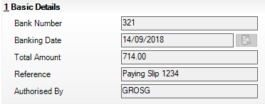

Viewing Previous Banking Returns
Select Focus | Dinner Money | Banking Return, and then click Search. Select and open the appropriate return to view the details. The report can be printed if required.

The Catering Return

This chapter contains:
Chapter Introduction 47
Step by Step – Running the Catering Return 47

Chapter Introduction

The Catering Return
The Catering Return reports on the number of paid, universal infant free school meals and free meals taken on a weekly or monthly basis, depending on the setup. The number of packed lunches is also shown. The following financial information is also included:
- VAT total
- additional catering income banked
- amounts banked for pupil and adult meals and dates of banking.

Step by Step – Running the Catering Return
- Select Focus | Dinner Money | Catering Return or Reports | Dinner Money | Catering Return and either search for existing returns or click New.
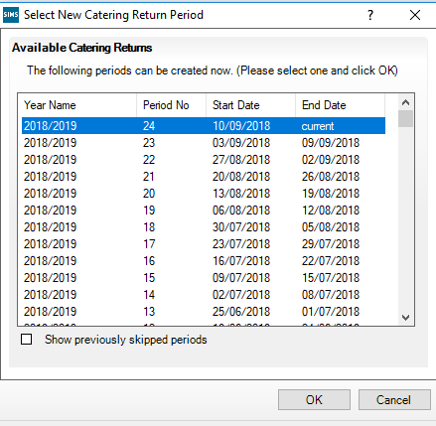
- Select the appropriate period, and then click OK.
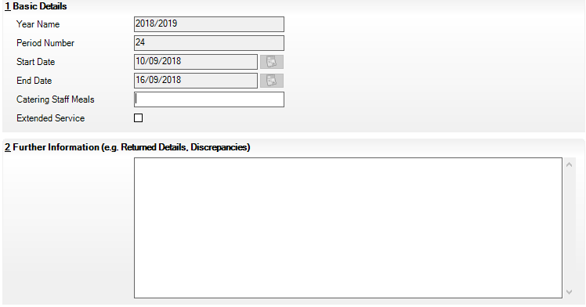
- All the fields in the first panel are read–only except Catering Staff Meals which can be completed, if required. If the catering staff have provided an additional catering service select the Extended Service check box.
- Panel 2: Further Information enables further information to be recorded, if required.
- Click Save and then Print.
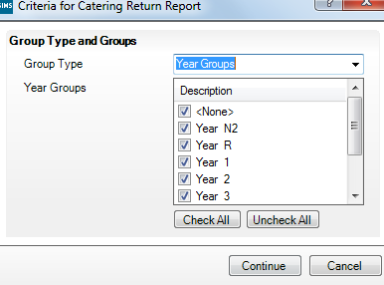
- Accept and select the Group Type and Groups required. Click Continue.
- Click OK on the Run a Screen Based Report screen. Once on screen the report can be printed or saved by selecting File | Save As.
Below is an example of a Catering Return, detailing the number of child and adult meals and monies received and banked.
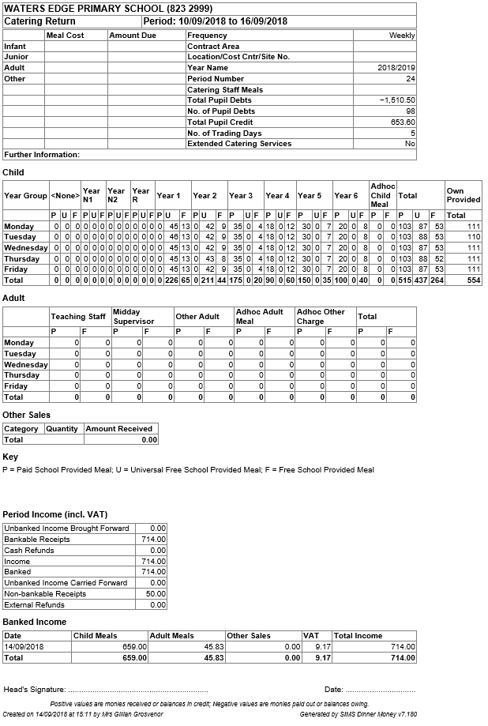

Running Dinner Money Reports

This chapter contains:
Chapter Introduction 51
Step by Step – Printing the Manual Dinner Money Register 51
Step by Step – The Kitchen Statistics Report 53
Step by Step – Pupil Detailed Statement of Account 55

Chapter Introduction
A range of reports can be run on the information recorded in Dinner Money on meals taken and payments made.
The Manual Dinner Money Register
This has three purposes and can be used:
- In place of a traditional book type dinner register for schools whose teachers do not have access to SIMS in the classroom for direct entry. It can display the default meal pattern or have blank columns.
- As a means of checking pupils’ default meal patterns, in which case only the option to include the default meal pattern should be selected.
- As a supervisor’s check list in which case only the option to include existing meals should be selected.

Step by Step – Printing the Manual Dinner Money Register
- Dinner registers may be printed by selecting Reports | Dinner Money | Listings | Manual Entry Dinner Register.
By default today’s date and the Group Type of Classes is selected but these may be changed as the classes are selected along with the option to display existing meals.
- Ensure the Default Meal Pattern check box is selected if you want them to be printed. If you want to print registers for the next week, select next Monday as the Start Date and the End Date.
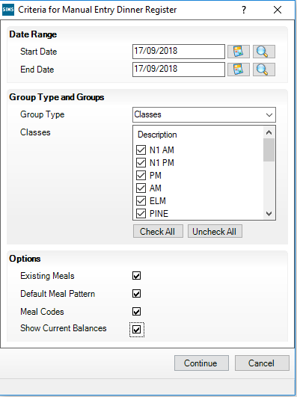
- Select the Classes required. If you want the default meal pattern displayed select the Default Meal Patterns check box. Likewise the Meal Codes and Show Current Balances can also be shown.
- Click Continue to display the Run a Screen Based Report dialog.
- Accept the settings, and then click OK.
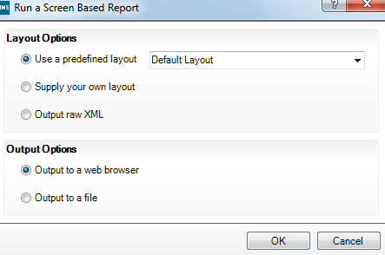
The report may display full screen or may appear as a button at the bottom of the screen, it will look similar to the graphic below.
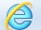
- Click it to display full size.
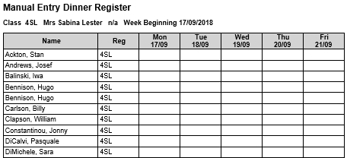
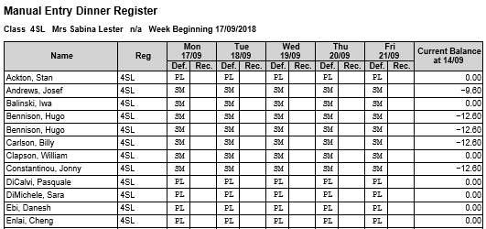

Step by Step – The Kitchen Statistics Report
Usually this report is run on a daily basis to inform the kitchen of the number of meals required. The report displays the meal numbers recorded for pupils, staff and adhoc meals within a given date rang. It can also display the special meal requirements for pupils and staff. A section is provided for manual entry of any special requirements for adhoc meals.
- Select Reports | Dinner Money | Statistics | Kitchen Statistics.
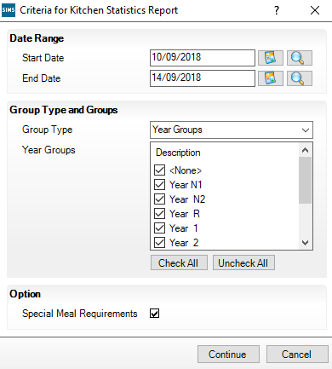
- The dates default to today’s date but can be changed.
- Accept and select the Group Types and Year Groups.
- The check box for Special Meal Requirements is selected by default but can be deselected.
- Click Continue, and then click OK to produce the report.

Dinner Numbers by Week Report
This report provides the numbers of pupil paid, UIFSM and free meals and those bringing in their own packed lunch. It also reports numbers of paid and free staff meals and adhoc meals.
Select Reports | Dinner Money | Statistics | Dinner Numbers by Week.
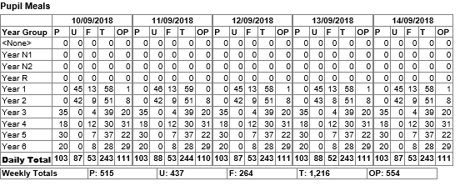
P = Paid, U = Universal Infant Free Meal, F = Free School Meal, T = Total school Provided, OP = Own Provided.

Yearly Statistics Report
This provides totals of meals recorded for pupils in this school year or for any period this year. Select Reports | Dinner Money | Statistics | Yearly Statistics.

Split Payments List
This displays payments that have been made by one pupil for themselves and other pupils or for staff who are also paying for other staff. Select Reports | Dinner Money | Listings | Split Payments.

Cheque and Payment Detail List
This provides the means of listing all payments or just cheque payments for pupils, staff, adhoc meals and other sales within a specified date range. Select Reports | Dinner Money | Finance | Cheque and Payment Detail List.

Transaction List by Type
This provides a list of all transactions for pupils, staff, adhoc meals and other sales within a date range. A summary amount for each of these categories is also shown. Select Reports | Dinner Money | Finance | Transaction List by Type.

Transaction List by Number
This provides a report in transaction number order of transactions for pupils, staff, adhoc meals and other sales. Select Reports | Dinner Money | Finance | Transaction List by Number.

Pupil Balances Report
This enables you to create a list of pupil balances at the start and end of a date range. It also displays the total amount spent on meals taken and payments made. The Balance type can be set to any to list all pupils in a group or just for those who have debit and credit.
Select Reports | Dinner Money | Finance | Pupil Balances.
NOTE: The level of Debt or Credit is filled in with the value set in Dinner Money Setup. It can be amended on this screen and the report will only list people with Debt or Credit over the amount.
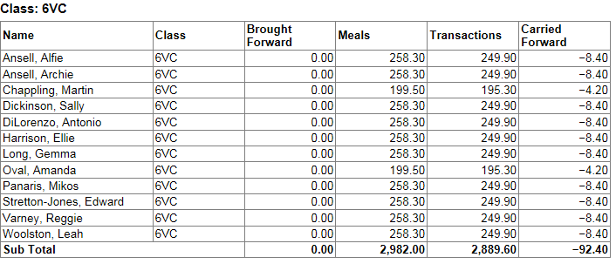

Staff Balances Report
Similar to pupil balance report but for staff. It produces a list of staff balances at the start and end of a date range. It also displays the cost of meals taken and payments made and can be for all staff or only those in debt or credit.
Select Reports | Dinner Money | Finance | Staff Balances.

Step by Step – Pupil Detailed Statement of Account
This report details, for the selected date range, which meals were taken on which days, how much was charged for the meal and all the payments made. Whilst it is possible to produce the report for whole groups of students it is generally only created for individual students when queries arise.
- Select Reports | Dinner Money | Finance | Pupil Detailed Statement of Account.
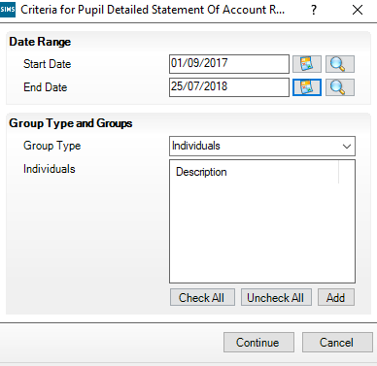
- As this will often be required for an individual pupil, select Individuals from the Group Type drop–down list, and then click Add.
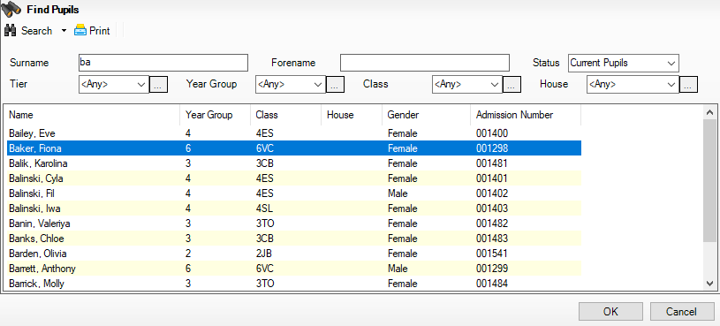
- Type all or part of the pupil’s name, and then click Search. More than one name can be selected if required.
- Click Continue to run the report.
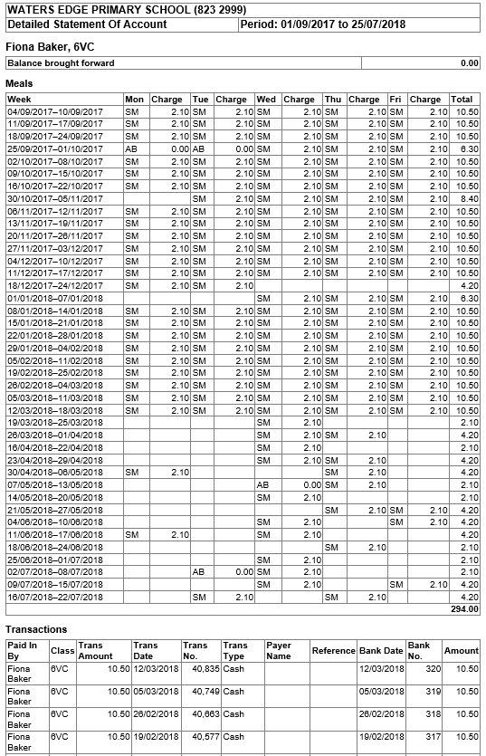

Staff Detailed Statement of Account
Select Reports | Dinner Money | Finance | Staff Detailed Statement of Account.

Producing the Audit Log Report
This has been provided for internal or external auditing of Dinner Money transactions. Various criteria are available for selection.
Select Reports | Dinner Money | Audit | Audit Log.
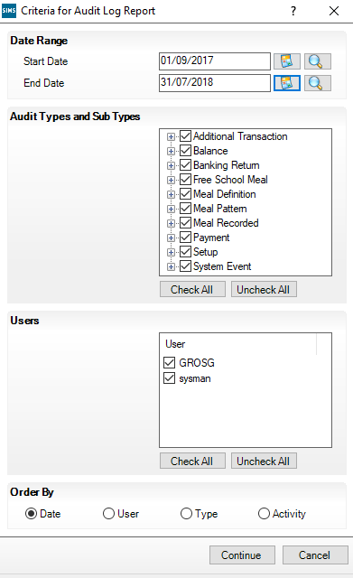

Cost/Income Summary Report
This enables you to produce a summary of the cost, income and cost/income difference of meals.
Select Reports | Dinner Money | Audit | Cost/Income Summary.

Dinner Money Letters

This chapter contains:
Chapter Introduction 59
Step by Step – Producing Dinner Money Letters 59
Step by Step – Personalising an Existing Template 60
Step by Step – Producing Dinner Money Letters 61

Chapter Introduction
Dinner Money enables you to generate letters to parents which merge details held in SIMS, for example, pupil’s name, parent’s name, home address and data relating to meals taken and payments made.
The following default letter templates are supplied:
- free school meal expiry
- debtor
- creditor
- summary statement
- charge forecast.
These can be used as they are or can be personalised.

Step by Step – Producing Dinner Money Letters
- Select Reports | Dinner Money | Letters, then select the appropriate letter.
- Enter the appropriate criteria for the selected letter. The Free Meal Expiry letter asks for a Date Range so it can generate letters for every pupil whose expiry date falls between those dates. The other letters ask for a Group Type so that letters will be generated for either everyone in that group (as in the Summary statement letter) or just the pupils in that group but who also fulfil other criteria; for example, they owe money for the Debtor Letter.
- Click Continue.
- Select the required print criteria, and then click OK to produce the letter(s).
A message is displayed if SIMS cannot find any relevant pupils or for the charge forecast letter, if it finds pupils with incomplete or missing meal patterns.

Editing the Dinner Money Letters
The templates can be copied so you can personalise them, or you can create a new template from scratch.

Step by Step – Personalising an Existing Template
In the following example the Debtor Letter is used but the instructions are the same for all letters.
- Select Tools | Dinner Money | Setup and move to panel 8: Letter Templates.
- Click Copy in the Debtor area of the panel to display the Add/Edit Debtor Letter Template dialog.
- Type a name for this version of the letter.
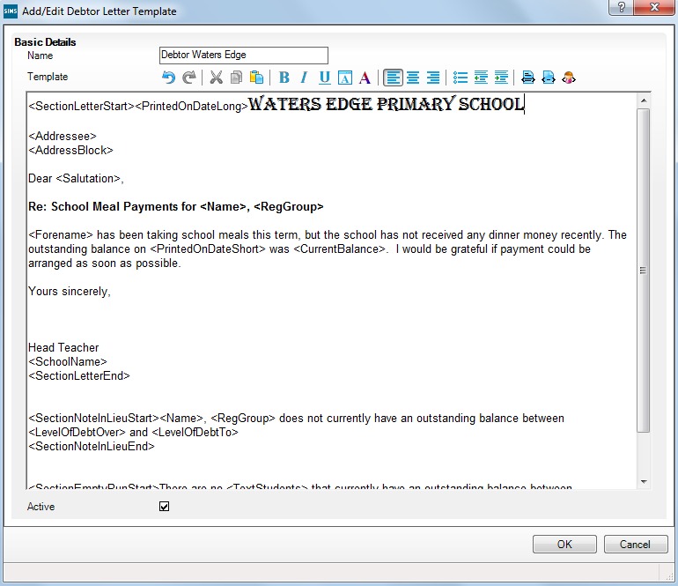
If the only change you wish to make is to insert the school letter heading you can copy and paste from another Word document. The last button on the toolbar is the Pupil tag button which enables the actual merge fields from SIMS to be selected. The other buttons provide similar tools to those in Microsoft Word.
You should type any inserts within the tags <SectionLetterStart> and <SectionLetterEnd>.
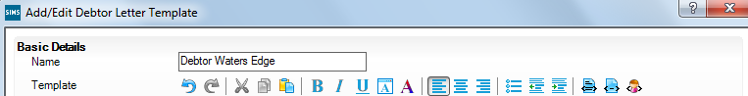
Pupil tags

Letter tags
Section tags

If you wish to design letters from scratch you will need to use tag to insert the relevant tags. More information about these can be found in the Dinner Money Handbook.
- Ensure the template is Active, and then click OK to save the new template.
- On the Setup screen click Move Up or Move Down to put the templates in order of use, the top report is the default report.
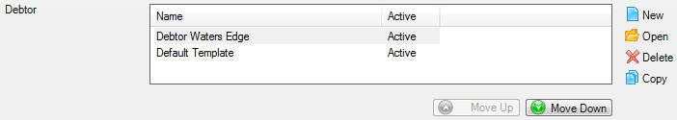
Unwanted templates may be deleted by highlighting the relevant template and clicking Delete. The default templates cannot be deleted.

Step by Step – Producing Dinner Money Letters
- Select Reports | Dinner Money | Letters then the appropriate letter.
- Select the Group Type from which the relevant pupils will be selected or leave the selection as all classes and let SIMS work out the relevant pupils from the whole school.
- Enter the Level of Debt Over and Level of Debt To to determine the pupils for whom a letter will be produced.
- Click Continue.
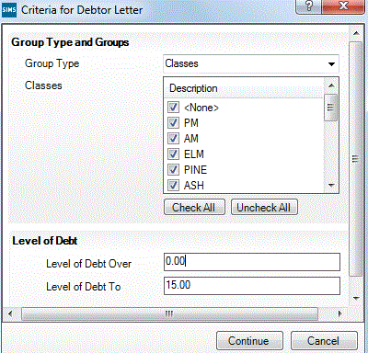
- On the Run an RTF Based Letter screen, the letter you placed at the top of the list shows by default, or alternative letters may be selected from the drop–down list.
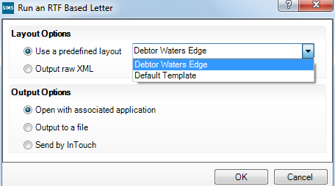
- Click OK to generate the letters.
If the parents’ names are missing from the address block and after the greeting “Dear”, it means the data is missing from Family/Home section of the Pupil Details screen.

 |  | A | Appendix A – Backdating Meal Processing
 | This chapter contains:
Step by Step – Backdating Meal Processing 63
Step by Step – Unlock Meal Processing 64

Step by Step – Backdating Meal Processing
The Backdate Meal process enables you to retrospectively edit meal definitions and prices within a specified date range for new and existing year groups or classes.
NOTE: All Dinner Money menu routes and reports must be closed before selecting the Backdate Meals process, with the exception of Record Pupil Meals, Edit Pupil Meals and Record Staff Meals.
- Select Tools | Dinner Money | BackDate Meals Processed to display the Backdate Meals Processed dialog.
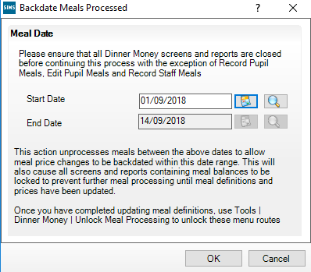
- Enter the date range over which you wish to lock the meal definitions and prices in the Start Date and End Date fields. Dates can be selected by clicking Calendar or Search and selecting the required date, or entering manually.
- Click OK. All meal records marked as processed within the dates selected will be updated to the status of unprocessed.
NOTE: Any menu routes and reports that contain meal balances will remain locked until meal definitions and/or prices have been updated and then unlocked via Tools | Dinner Money | Unlock Meal Processing.

Step by Step – Unlock Meal Processing
To unlock the meal definitions and prices:
- Select Tools | Dinner Money | Unlock Meal Processing to display the Unlock Meal Processing dialog.
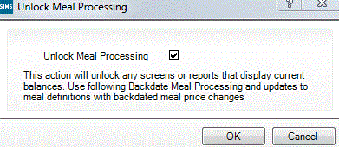
- Select the Unlock Meal Processing check box, and then click OK.

B | Appendix B – Links to Other SIMS Modules

This chapter contains:
Step by Step – The SIMS Teacher App and the Dinner Register 67
Step by Step – Adding/editing Dinner Register Comments 67

Links to Other SIMS Modules
Much of the data used in Dinner Money is already in SIMS e.g. Pupil Names, Group Membership, Eligibility for Free School Meals etc. Information recorded in Dinner Money can be used to support the production of the school census. In addition Dinner Money can be linked to the InTouch and Agora modules.

School Census
Schools are required to report on the number of pupils who receive a universal infant free school meal on census day. Clicking on Calculate From Dinner Money ticks the School Dinner Taken column for pupils who have a school provided meal (as defined in the pupil meal type) on the reference date.
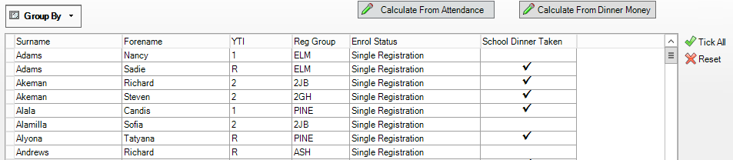

InTouch
InTouch allows schools to communicate via text and email to pupils, parents and staff including emailing dinner money letters to parents.
When running the Dinner Money letters it is possible to set the output options to send by InTouch. By choosing the InTouch Contact will attach the letter to an email sent the parents.
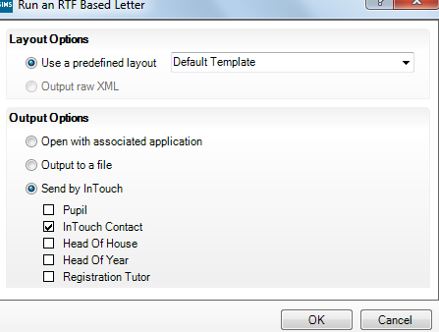
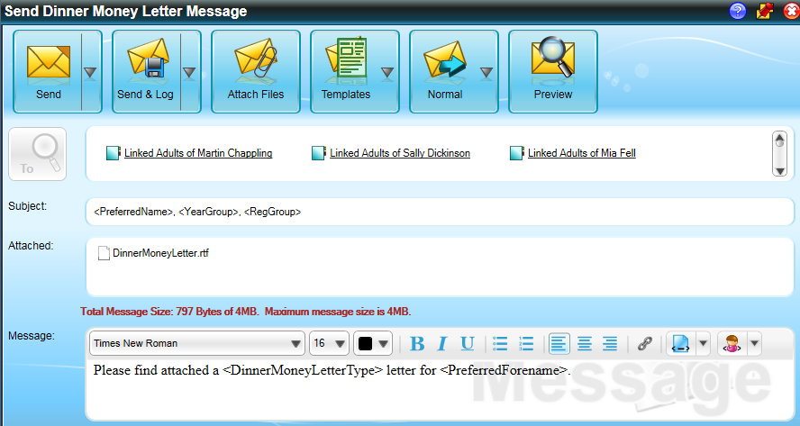
The template of the email message is defined by the school but can be amended as required.

Agora
SIMS Agora allows parents to use a secure internet payment system to purchase a wide range products e.g. School uniform, trips etc. Parent can add funds to the pupil’s account which is then used to pay for meals recorded in Dinner Money. Parents adding funds in Agora updates the balance in Dinner Money and meals taken in Dinner Money adjusts the balance in Agora.
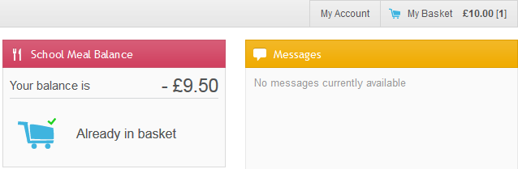
It is also possible to create menus, allowing parents to select their child(ren)’s dinner choices. The school can create menu choices to reflect what is being delivered in school. The menus can be set up on a regularly pattern, for example the meals are on a 3 week cycle or edited for individual days. Parents are able to log in and make the menu choices, with these feeding directly into Dinner Money.
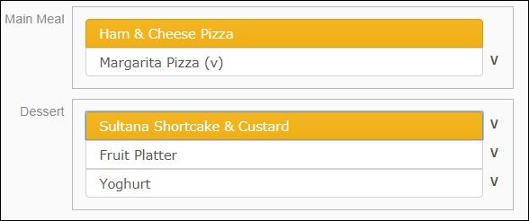
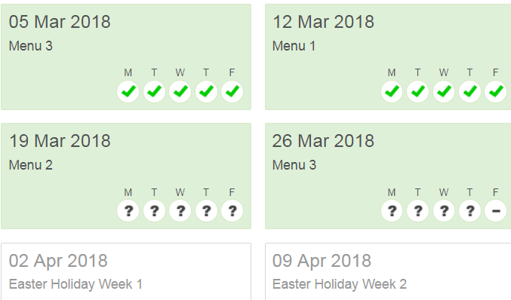

Step by Step – The SIMS Teacher App and the Dinner Register
When you log into the SIMS Teacher app, your timetable is displayed. If you access the app whilst teaching a lesson or during a registration session, the app will display pictures of the pupil/students in the class.
- To access Attendance, either swipe right on the page or tap Menu.
- Tap Attendance. It is recommended that you take the Attendance Register first and Save before tapping
- Tap Go To Dinner Register in the left-hand column.
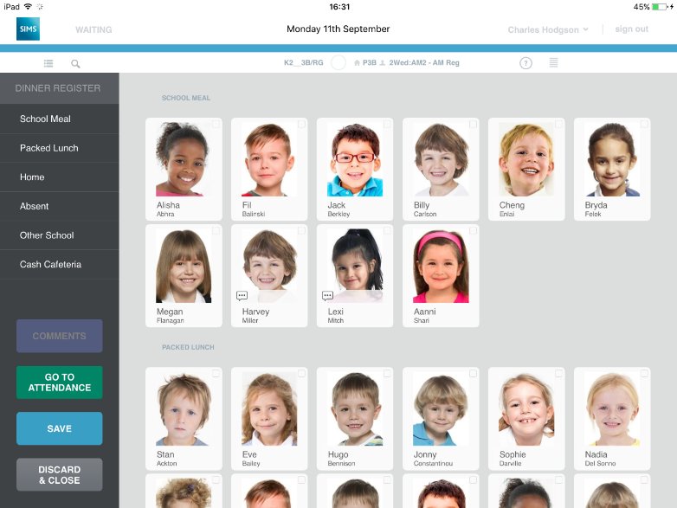
Pupils are grouped by their meal pattern. Any pupils recorded as absent in Attendance will be grouped into an Absent group.
- To change the pupil's meal, tap the pupil(s) to select them and then tap the meal choice in the left-hand column, e.g. School Meal.
Pupils will be re-sorted into the appropriate group.
- Comments can be added or edited, as required.
NOTE: Attendance comments cannot be edited within the Dinner Money register and vice versa.
- Tap Save to record the changes to the Dinner Register.

Step by Step – Adding/editing Dinner Register Comments
You can view, record and edit a comment for an individual student within the Dinner Register.
NOTE: Attendance comments cannot be edited within the Dinner register and vice versa.
- To add, view or edit a comment, tap on a pupil/student and tap Comment.
NOTE: Comments can be added to individual pupil/students only. The Comment option is disabled if multiple pupil/students are selected.
- Enter or edit the comment in the Comment panel and then tap Apply to return to the register.

