IMPORTANT NOTE: Capita SIMS has made this document available in Microsoft® Word format to enable you to edit the information supplied herein. Capita SIMS cannot be held responsible for any changes, errors or omissions resulting from the subsequent editing of this supplied document.

- Contents
01| How Does SIMS ID Work? 1
Purpose of this Document 1
Overview 2
02| Installing SIMS ID Using SIMS Services Manager 3
Prerequisites 3
Tasks for your School's IT Contact 3
Connecting your SIMS Server to SIMS ID 7
Tasks for the IT Contact 7
Adding a School 11
Logging in to SIMS ID 12
Logging in for the First Time 12
Setting your Security Questions and Answers 13
Changing your Password 13
Managing Users as a SIMS ID Site Administrator 14
Granting Access to an Application 14
Setting Up a User in Office 365 15
Troubleshooting 16
Help Centre 16

How Does SIMS ID Work?
Purpose of this Document 1
Overview 2

Purpose of this Document
This document is intended for use by the SIMS ID Administrator and the IT contact in the school and it provides step-by-step instructions for the installation of the SIMS ID service.
This document explains how to install an automated link between your SIMS database and SIMS ID so that user and timetable data can be synchronised. If you are not a SIMS school and instead use an alternative MIS, you can continue to manage users manually using the SIMS ID Administration website or via a CSV file. For information on how to import CSV files, please refer to the SIMS ID Support website (https://id.sims.co.uk/support).
If you have purchased SIMS ID Standard, use SIMS in school and plan for SIMS ID to directly manage your Google and/or Office 365 users, you should follow the instructions in this guide. All SIMS ID Standard schools will also have a local installation completed by a Capita engineer for the technology that manages your local Active Directory. To make full use of SIMS ID Standard, both installations are required.
If you have purchased SIMS ID Standard and are not a SIMS school, or if you have purchased SIMS ID Standard and are a SIMS school but you want to manage only local Active Directory accounts, you do not need to follow this guide or set up SIMS Services manager.
The following table can be used to identify your scenario and the guide you should follow to complete the installation successfully.
 | SSM Installation (this guide) | Local SIMS ID Standard Install
SIMS ID Light – SIMS school | Yes | No
SIMS ID Light – Non-SIMS school | No | No
SIMS ID Standard – SIMS school | Yes | Yes
SIMS ID Standard – Non-SIMS school | No | Yes
SIMS ID Standard – Google/Office 365 not Managed by SIMS ID | No | Yes
Once the SIMS ID service installation has completed successfully, you are strongly advised to refer to the SIMS ID Support website (https://id.sims.co.uk/support).
The SIMS ID Help Centre is accessed by clicking the Help button on the bottom right-hand side of each screen in SIMS ID. Over time, additional resources (including video tutorials) will be made available from the SIMS ID Help Centre.

Overview
SIMS ID enables a single login point for multiple pieces of software. It works by synchronising key user data between SIMS and SIMS ID, enabling a Single Sign On (SSO) experience for pupil/students, staff and parents.
Accounts, groups and timetable data are synchronised between SIMS and SIMS ID, with both administrators and users accessing SIMS ID as their go to point entry for local and online services.
SIMS ID Light manages users in Cloud Services such as Office 365 and Google.
SIMS ID Standard manages users in Local Services such as Active Directory, as well as Cloud Services where required.
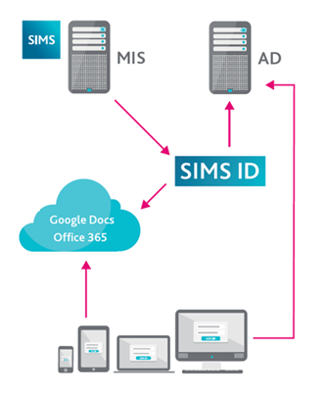

Installing SIMS ID Using SIMS Services Manager
Prerequisites 3
Connecting your SIMS Server to SIMS ID 7
Adding a School 11
Logging in to SIMS ID 12
Troubleshooting 16
Help Centre 16

Prerequisites
Please ensure that all of the following prerequisites have been completed or understood before attempting to install SIMS ID.
An additional column (Complete?) is available on the right-hand side of the following table. This can be used on a printed copy of this guide, to mark as complete once the task has been completed successfully.
TIP: You are strongly advised to forward this document to your school's IT contact because they will have to carry out the majority of the tasks.

Tasks for your School's IT Contact

Steps to be carried out by your school's IT contact
Step | Action | Complete?
Minimum technical requirements | The minimum technical requirements for schools and end users are detailed in the Minimum System Requirements document, which is available from the My Account website (https://myaccount.capita-cs.co.uk/hot-topics/sims-tech-resources/) or on request.
Internet connection | SIMS ID is a web-based service that requires an internet connection to operate.  Please ensure you are connected to the internet when installing and using SIMS ID.
SIMS compatibility | The school must be on the SIMS 2016 Spring Release or later. Please ensure this upgrade has taken place before attempting to install SIMS ID.
SIMS ID browser compatibility | Ensure that you upgrade to one of the following web browsers:  ▪ Latest Chrome  ▪ Latest Firefox  ▪ Latest Safari  ▪ Latest IE (11)  ▪ Latest Edge
Firewalls | Many schools and their internet providers often use firewalls and proxy servers for security.  The following sites must be unblocked to enable SIMS ID to run. You may need to contact your Internet Service Provider or Local Authority to arrange this.  For users within the school environment:  ▪ *.sims-ID.co.uk  ▪ *.sims.co.uk  ▪ *.sims-labsmanagement.co.uk  ▪ simspublications.com  For the machine with SIMS Services Manager installed:  ▪ *.sims.co.uk  ▪ *.sims-labsmanagement.co.uk  ▪ simslabspeople.blob.core.windows  .net
Email junk folder | Please add noreply@sims.co.uk to your email whitelist to ensure that the automatically-generated system invite does not go into your junk folder.
SIMS Services Manager | SIMS Services Manager (SSM) is a product that manages the link between SIMS and cloud-based products, such as the SIMS Teacher App, SIMS Pay and InTouch. It has been designed with the intention that it will replace older methods of data exchange (such as using VPNs) and unify them into a single technology. To remove the need for schools to install and set up SSM, the SIMS 2014 Autumn Release installs it on the SIMS SQL Server automatically as part of the upgrade.  By default, SSM updates itself automatically every night. It will continue to do so unless the automatic update has been switched off.  You must upgrade to at least version 1.4.6.4 of SSM. Please ensure that SSM has upgraded successfully before attempting to install SIMS ID.  The SSM web user interface is available on the server via the desktop shortcut that was created as part of the installation process or via a URL (http://localhost:50000).  SIMS Services Manager will operate on the following browsers:  ▪ Latest Chrome  ▪ Latest Firefox  ▪ Latest Safari  ▪ Latest IE (11)  ▪ Latest Edge  Please note that if your SIMS server is hosted or managed by your LA or support unit, this step will need to be carried out by them.
SIMS database patches | Part of the installation process requires the school to apply three SQL patches to the SIMS database via dbUpgrade. These patches will have been attached to the Welcome email sent to the main SIMS ID Administrator.  Before applying any patches, all users will need to be logged out of SIMS. Please ensure that this SIMS downtime has been planned in before beginning the installation process.  Please note that if your SIMS server is hosted or managed by your LA or support unit, this part of the installation process will need to be carried out by them.
Your SIMS data | ▪ Any members of staff who are required to use the system will need to be listed as a current member of staff in SIMS.  ▪ Ensure the staff member's date of birth is correctly recorded in the school’s SIMS system before setting them up in SIMS ID. Their date of birth will be required when the member of staff activates their account.  ▪ Ensure that email addresses of parents have not been saved as the pupil’s email address in SIMS. Parent email addresses should be linked only to the parent and not to the pupil.  ▪ Ensure that duplicate parent records do not exist in your SIMS database. If you are unsure whether duplicate parent records exist, please contact your SIMS support unit for advice.  You are strongly advised to ensure that all of these points have been checked and actioned before installing SIMS ID.

Connecting your SIMS Server to SIMS ID

Tasks for the IT Contact
WARNING: You will receive an email from your SIMS ID engineer. The email will contain a link to three patches that must be applied to your school's main SIMS database.
You are strongly advised to take a backup of your SIMS database before applying any new patches.
- Download the files to a suitable location on the school's server.
IMPORTANT NOTE: Do not unzip the content of the zip file.
- From the desktop, select Start | All Programs | SIMS Applications | dbUpgrade to display the SIMS Database Upgrade Tool.
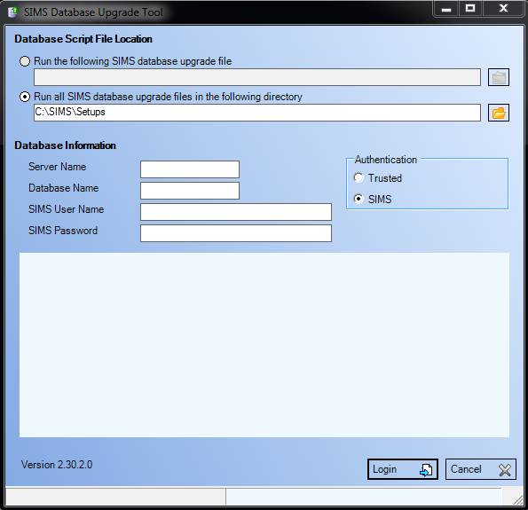
- Select the Run the following SIMS database upgrade file radio button if the patches are to be run separately or select the Run all SIMS database upgrade files in the following directory radio button if the files have been saved away from other files and will be run together.
- Click the Browse button adjacent to the selected radio button and navigate to the location of the stored email attachments.
- Select the Trusted radio button and complete the Server Name and Database Name fields.
If these fields do not complete automatically, the Server Name and Database Name can be found in the connect.ini file in the SIMS folder on the SIMS server.
- Click the Login button to display a message that confirms the upgrade you are about to perform.
- Click the Install button to continue.
- If the patch installation is successful, the Your database has been updated message is displayed.
Installing the SIMS Online Services Client
IMPORTANT NOTES: The patches must be uploaded before running the SIMS Online Services Client with SIMS Services Manager because the patches contain the licences required to allow the package to be installed.
Once SIMS Services Manager has been upgraded to the most recent version, the SIMS Online Services Client can be installed.
- Open the school's SIMS Services Manager by selecting Start | All Programs | SIMS Applications | SIMS Services Manager.
- Click the Manage Packages button to display the Manage Packages page. Your packages should now be displayed.
If your packages are not displayed, this can be caused by SIMS Services Manager not being able to access your school's SIMS database. If this is the case, please follow the advice in the following topic (please see Adding a School on page 11).
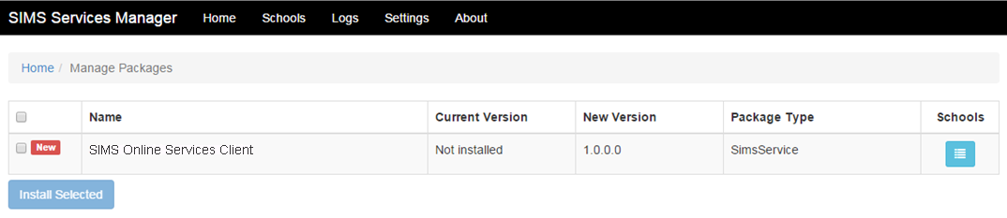
- Select the required package by selecting the check box and clicking the Install Selected button. A notice will be displayed regarding Applying Choices.
- Select the SIMS Online Services Client package by selecting its check box. Other packages might be listed but SIMS ID requires only the SIMS Online Services Client package to be installed.
- Click the Install Selected button. A notice is displayed regarding Applying Choices.
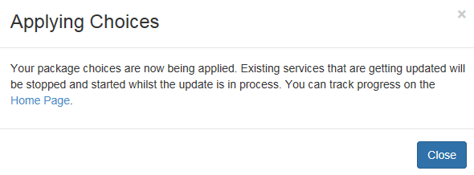
- Return to the Home page to view whether the package has been applied. If the package is not displayed, continue to refresh. The Status will show as Transitioning if the page is not refreshed.
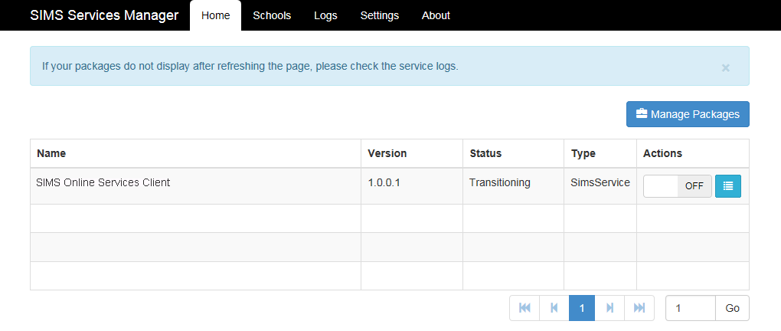
NOTE: If you are experiencing problems with the installation, we may ask you to check the logs. These are located along the SIMS Services Manager toolbar.
- Open SIMS Services Manager and click the menu icon in the Actions column for the SIMS Online Services Client package.
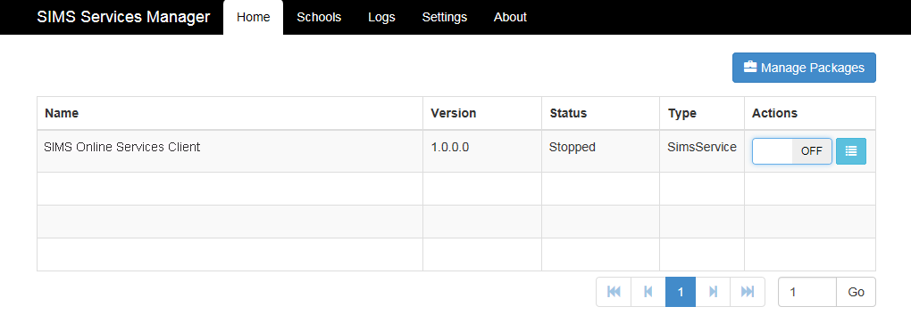
This shows the schools that are licensed for this product.
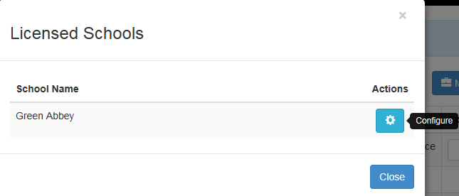
- Click the Configure icon to display the Configuration dialog.
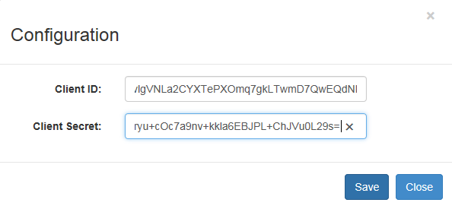
- You will have received an email from the SIMS ID engineer, containing a Client ID and Client Secret. Copy the codes from this email into the fields in SIMS Services Manager and click the Save button.
The data transfer will now take place.
IMPORTANT NOTE: It can take several minutes to complete the data transfer between SIMS and SIMS ID.

Adding a School
The Schools page displays a list of schools that have a SIMS database (School Name). From here, school details can be added.
- Open the Schools page.
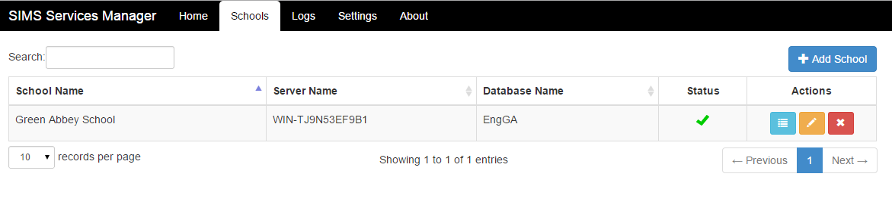
- Click the Add School button to display the Update School dialog.
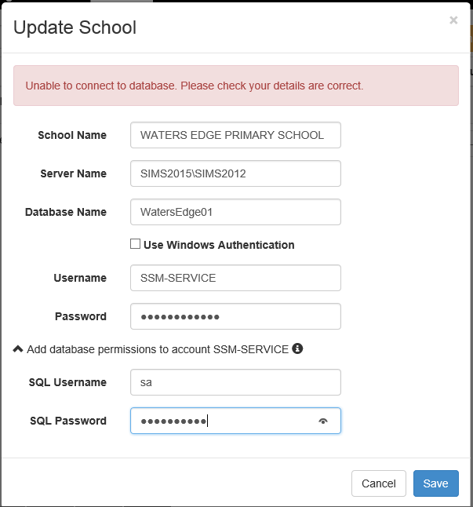
- Enter the School Name, Server Name and Database Name.
- Select the check box if you want to Use Windows Authentication and the default Windows account running SSM. Optionally if you want to connect to the SIMS database with a SQL account, enter the Username and Password.
NOTES: This cannot be a SIMS account.
If you specify a SQL username, you must also provide a SQL account with SA (or equivalent) permission to grant the right to the SQL account. Please note that this should be completed only if the account does not already have the sims service role. The UI will prompt you for this.
- Click the Save button to return to the Schools page.
- Click the Refresh Services button on the toolbar to apply the changes.

Logging in to SIMS ID
You will be provided with SIMS ID Site Administration login details during the installation process.
NOTE: If you have upgraded from OPENHIVE, it is possible to use the OPENHIVE site administration login details to access SIMS ID.

Logging in for the First Time
Before you can login, your SIMS ID Site Administrator must provide your new username and password.
Once you have been provided with your login credentials, navigate to the SIMS ID site (https://id.sims.co.uk).

Setting your Security Questions and Answers
On the first login to SIMS ID, you will be asked to add some security questions. This is necessary in case you need to reset your password in the future (e.g. if you forget your password).
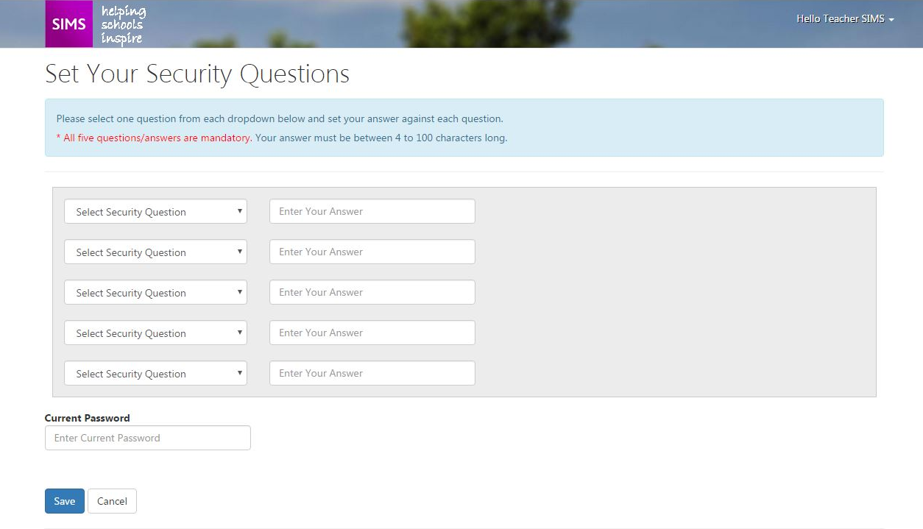
Please note the following:
- All questions must be answered.
- Answers must have four or more characters.
- You must enter your current password before clicking the Save button.
- On saving, you are returned to the Launcher page.

Changing your Password
After setting up your security questions and answers, the Launcher page is displayed.
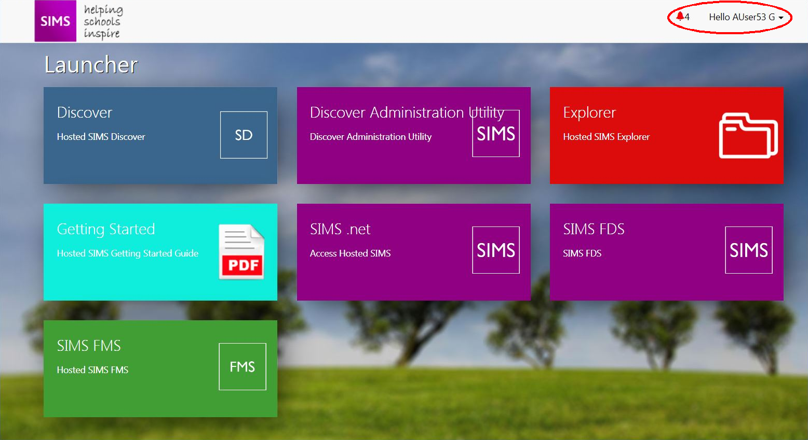
The next important step is to click the drop-down arrow on the top right-hand side of the page and select Change Password to display the Change Your Password page.
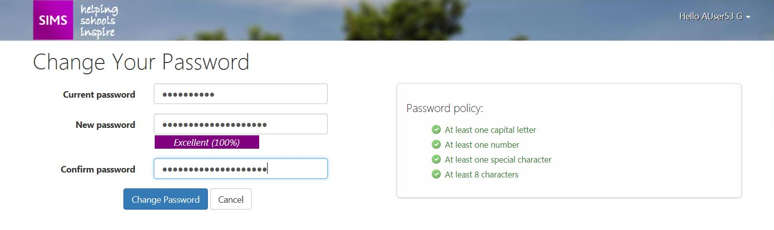
Enter your Current password, New password, and then Confirm password.
As you enter the new password, hints are provided to enable you to comply with the password policy.

Managing Users as a SIMS ID Site Administrator
A Site Administrator is a nominated member of staff who can manage aspects of other users' SIMS ID accounts.
Site Administrators can:
- create new users.
- grant users access to applications (by default, users do not have access to any applications).
- Reset the passwords of other users, should they not be able to carry out the self-service Forgotten Password service.

Granting Access to an Application
After logging into the SIMS ID site (https://id.sims.co.uk) as a SIMS ID Site Administrator, click the Users icon to display the Manage page.

Setting Up a User in Office 365
If you are a SIMS Support Unit or a Multi Academy Trust, you will be asked to select the school for the users you wish to manage.
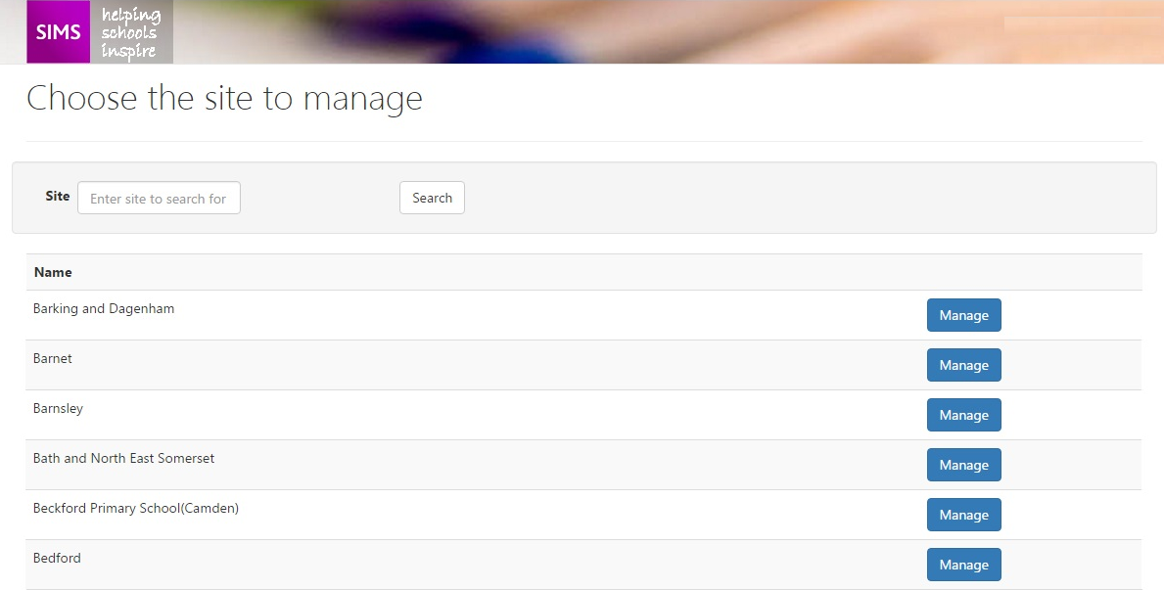
When SIMS and SIMS ID are synchronising successfully, a list of your users for the school is displayed.
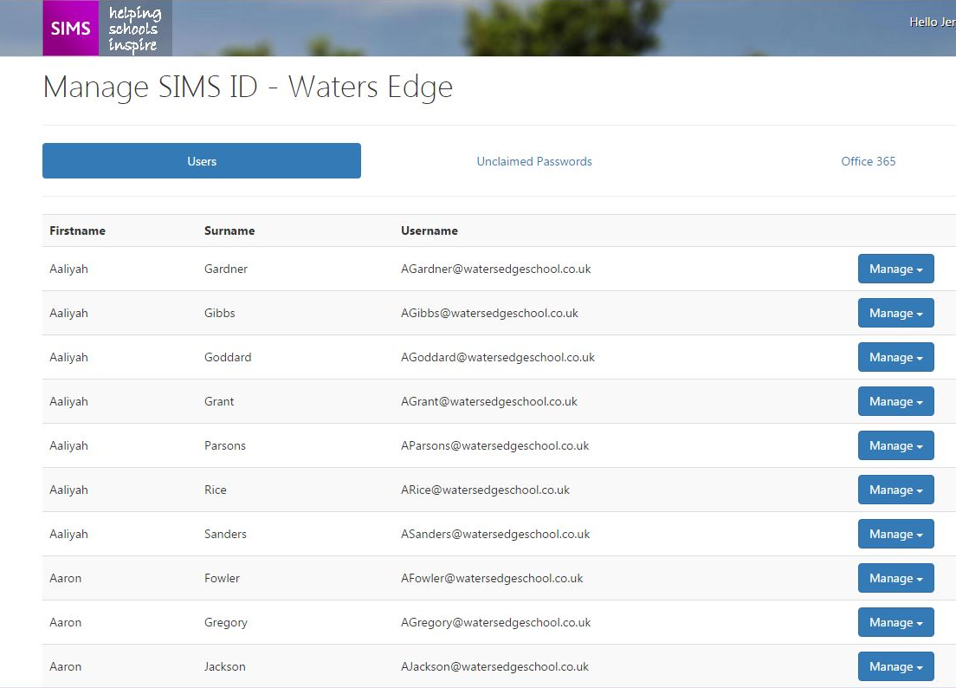
At this point, your Capita engineer will be ready to complete the SIMS ID configuration with you.

Troubleshooting

Installation related issues
Issue | Resolution
An error occurs when applying the SIMS Activities patches using dbUpgrade.  What should I do? | ▪ Ensure that the SIMS database patches were run alongside the correct signature files.  ▪ If you received the patches via email, check whether the patches were sent as a zipped file. If they were sent unzipped, it is likely that they have become corrupted. Please log a support case and request the patches be sent in zipped folders.
The SIMS Online Services Client does not install properly on SIMS Services Manager.  or  The configuration page on SIMS Services Manager is not working as expected.  What should I do? | Ensure that SIMS Services Manager has been upgraded to the most up-to-date release.  If your SIMS Services Manager is installed at the correct version and you still encounter issues, please log a support case.
Data between SIMS and SIMS Activities has not synchronised during installation.  What should I do? | ▪ Ensure that the SIMS Secret and Client ID are entered correctly in SIMS Services Manager.  ▪ Ensure that all firewalls have been unblocked.  ▪ Check if the SIMS Services Manager server is working and has not been turned off.  If all of these suggestions have been checked and you still encounter issues, then there could be an issue with your data. Please log a support case.

Help Centre
The SIMS ID Help Centre is accessed by clicking the Help button on the bottom right-hand side of each screen in SIMS ID. Over time, additional resources (including video tutorials) will be made available.
A complete online help system is available from within the SIMS ID Help Centre. The online help system provides step-by-step instructions for all key tasks. These instructions are not included in this guide.
Staff can also access SIMS ID using their unique Facebook or Twitter account.

