Creating Lookup Tables
In This Chapter
Introduction 111
Creating the Lookup Table 112

Introduction
The Qualifications and Curriculum Authority (QCA) provides Age Standardised Scores, which you can use to measure a pupil/student’s mark or grade against the national average for their age.
Standardised scores take into account a child’s age in years and months, giving an indication of how each child is performing relative to other children of the same age. Age standardised scores do not affect the child’s test levels.
To measure a pupil/student’s mark or grade in this way, you first need to create the Lookup Table from the QCA data. You can then define the template, to include a Data Review column that contains the Lookup formula, and then a marksheet to enter, calculate and display the results.

More Information:
Inserting a Lookup Formula on page 158
Entering and Reviewing Data using Marksheets on page 5

Data Format
The Age Standardized Scores are provided as an Excel spreadsheet.
- The first row of the table consists of the Age, either in years and months or in months only, and the first column of the table consists of the Score.
- The standardised scores are defined in the cells of the table.
The standardised scores use a mean of 100.
You can either copy the data from this spreadsheet to create the lookup table in SIMS Assessment, or you can create one yourself, typing in your own data.

Creating the Lookup Table
To create the Lookup Table:
- Select Focus | Assessment | Lookup Tables to display the Lookup Tables browser.
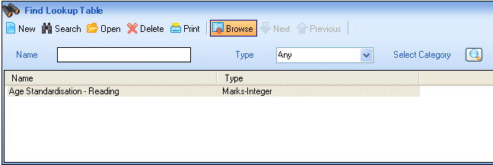
- Click the New button to create a new table. The Lookup Table Details page is displayed.
New button
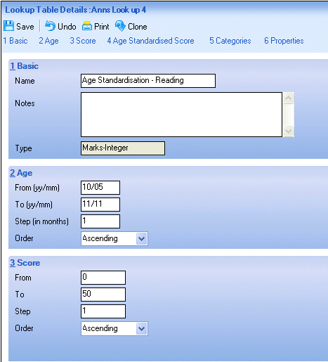
- Enter a Name for the Lookup Table (maximum 25 characters).
- Enter any notes that you wish, to describe the table.
- Specify the Type of aspect that will display the resulting data.
- Enter the Age range as yy/mm of the pupil/students whose data you wish to compare.
- State how the ages in the table are to be stepped. (For example, monthly would be 1, bi-monthly would be 2, etc.)
- From the drop-down box select the Order of the Age columns as ascending or descending.
- Enter the Score range.
- State how the Scores in the table are to be stepped (for example, in increments of 1, 5, 10 etc.).
- From the drop-down box select the Order of the Score rows as ascending or descending.

Copying Data from the Spreadsheet
- Open the Excel spreadsheet containing the Age Standardised Scores.
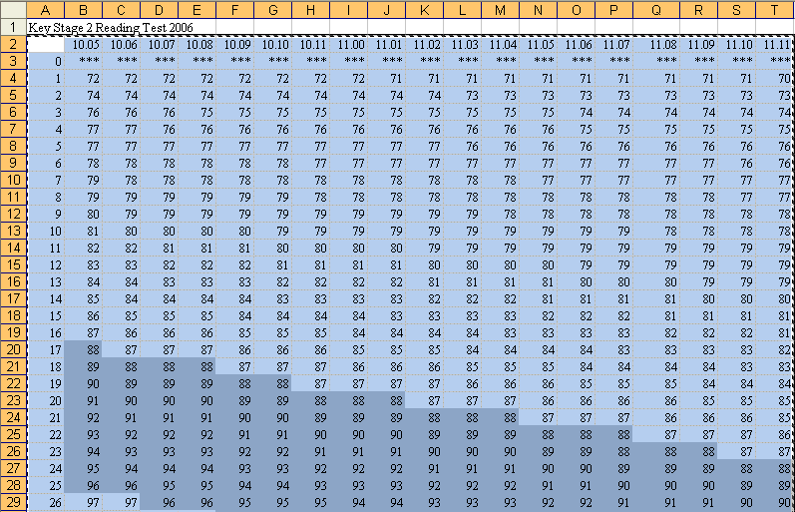
- Select the cells containing the score data (including the row and column descriptors) and copy them (Ctrl+C).
- Return to SIMS Assessment and click the Paste button to paste the data into the Lookup Table.
Paste button
- The Lookup Table is populated with the data from the spreadsheet. The Age must be in the format yy/mm. If not, you cannot save the table.
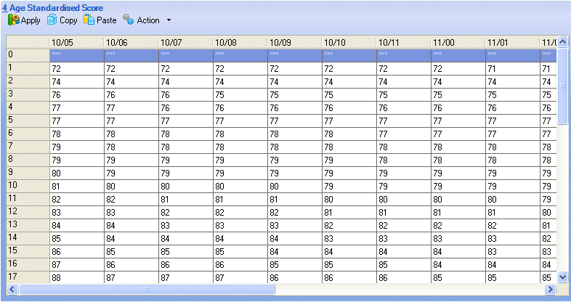

Entering Data Manually
To enter data into the Lookup Table manually:
- Click the Apply button to populate the grid with the stepped Ages and Scores that you have already defined.
Apply button
The Ages show as column headings and the stepped Scores will display down the side, one per row.
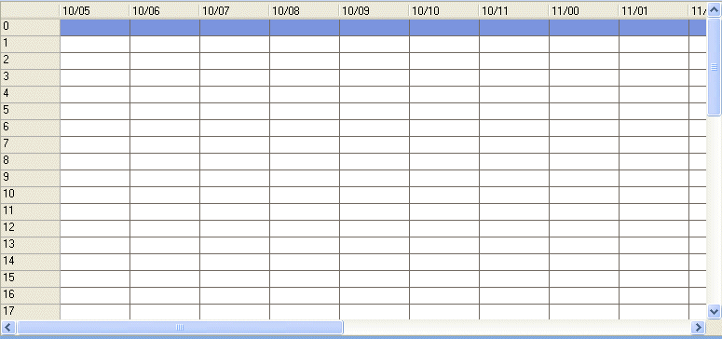
- You can then enter the required standardised scores into each cell of the grid.
- To add, edit or delete a column or row, right-click anywhere in the grid to display a pop-up menu. Select the required option. Rows are always added at the bottom and columns are always added at the far right.
Selecting Edit Row or Edit Column from the pop-up menu enables you to edit the column or row heading only. To edit the content, just click in the appropriate cell and type the changes.
- To move rows up or down, click in the required row and click the Up or Down button, adjacent to the Lookup Table.
Up button
Down button

Associating the Lookup Table with a Category
A Lookup Table can be associated with one or more previously defined Categories. This enables the subsequent view of Lookup Tables to be filtered by Category e.g. only show Maths Lookup Tables, only show Reading Age Lookup Tables, etc.
To assign a Lookup Table to one or more Categories:
- Scroll down or click the Categories hyperlink to display the Categories panel.
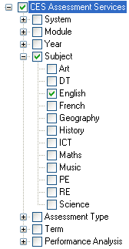
- Click the + or – symbols to expand or contract the Category Types as necessary.
- Choose the required Category or Categories by selecting the adjacent check box(es).
- Click the Save button to save the Category associations.

More Information:
Creating and Maintaining Categories on page 85

