SIMS .net Assessment

Key Stage Wizard 2019

Key Stage 1

Version 1.1

REVISION HISTORY

Version | Change Description | Date
1.0 | Updated to 7.186 | 15/04/2019
1.1 | Amendments from Babcock | 26/04/2019
1.1 | Added permissions required for Sims | 27/06/2019

Key Stage 1 Statutory Teacher Assessment Data Collection 2019 – Change for Academic Year 2018/2019

There are no significant changes to KS1 test administration from previous years. However, there is a change with Pre-Key Stage Teacher Assessment Standards and P-scales.

Previously, P-Scales of P1i,P1ii,P2i,P2ii,P3i,P3ii,P4,P5,P6,P7,P8 were used. This year P-Scales of P1i,P1ii,P2i,P2ii,P3i,P3ii,P4 are to be used. The code selected depends on whether the Teacher is going to give an overall code (eg for English) or if the Teacher is going to break it down into components (eg reading).

Pre-Key Stage - Previously, Teachers selected PKF, now Teachers have to pick between PK1, PK2, PK3 or PK4.

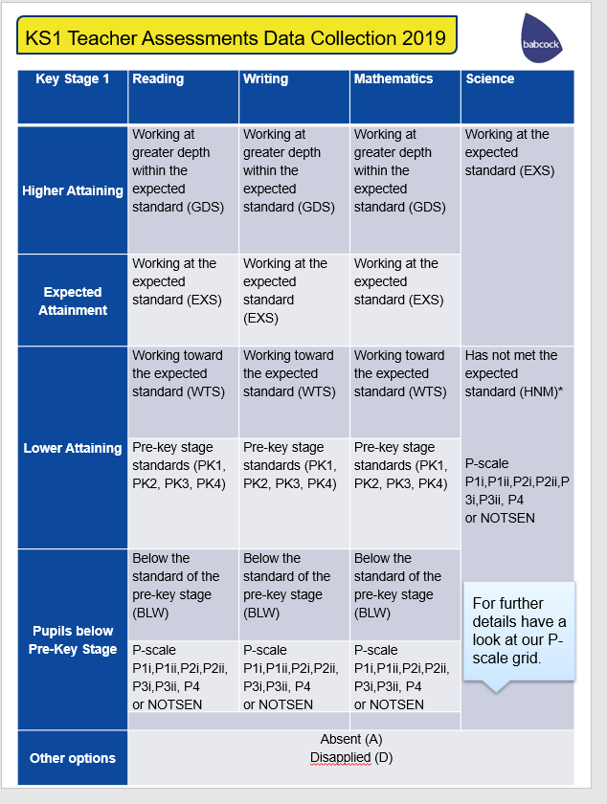

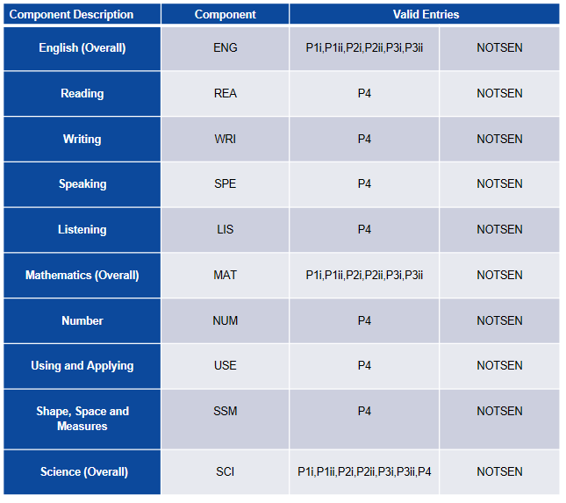

An error will occur if you try to add both a overall subject P-scale (eg English) and a subject component P-scale (eg Reading).

When NOTSEN is submitted as a valid result for a P scale, it indicates that the pupil is not on the SEN register but not yet working at PK1 standard. English as a second language is the most common reason for this.

Introduction

SIMS.net's Key Stage Wizards allow schools to easily manage their End of Key Stage results including:

- Recording each pupil’s attainment at the end of each Key Stage
- Producing reports for each pupil showing their Key Stage results
- Exporting results to the LA and other schools via a CTF
- Using the results as part of a tracking system within SIMS .net Assessment

The Wizards are automatically placed in an AMPA folder on each school’s computer as part of the upgrade process. They can be found in the following locations:-

- Hosted Schools:
F:\Public\AMPA\England Primary (and Middle Deemed Primary)\Assessment Manager
- Non-Hosted Schools:
C:\Program Files\SIMS\SIMS.net\AMPA\ England Primary (and Middle Deemed Primary)\Assessment Manager

As these Teacher Assessments form part of the CTF that accompanies children if they transfer between schools, it is a statutory requirement that where you are using alternative software for collection of assessment results, the data is also imported into SIMS.

Please refer to your software supplier for guidance and instructions on how to do this.

Permissions required:

Please note, to carry out the Key Stage process, users will need access to Class Teacher/Registration Tutor (to enter their own results) but to have access to enter all the results users will need Assessment Co-Ordinator or Assessment Operator.

Step 1 – Check SIMS .net Version
In order to use the 2019 Wizards you must be using the Spring 2019 Main Release version of SIMS .net or later. To check:

- Go to Help | About SIMS .net
- Check that the version of SIMS .net is 7.186 or higher.

Step 2 – Identify the KS1 Pupils
- If all pupils being assessed are in Year 2 continue to Step 3.
- If pupils outside of the year are being included in the Key Stage 1 assessment, or some of the Year 2 pupils are not being assessed – please refer to the notes for Creating a User Defined Group by clicking on the link below.
http://faq.scomis.org/kb15030/

Step 3 - Import the Wizard for Key Stage 1 for 2019

- Select Routines | Data In | Assessment | Import.
- If you get a message at this point advising you that there are some new or updated resources to import, you are advised to click Yes and import everything available
- Select the file to import from by clicking on the browser (magnifying glass) and then navigate to the folder
- Hosted Schools:
F:\Public\AMPA\\England Primary (and Middle Deemed Primary)\ Assessment Manager
- Non-Hosted Schools:
C:\Program Files\SIMS\SIMS.net\AMPA\ England Primary (and Middle Deemed Primary)\ Assessment Manager
- Highlight the 'Key Stage 1 Wizard England 2019'.
- Click Open.
- Click Finish and then Yes when asked Do you want to proceed?
- After a short pause you will then get an Activity Log that shows what has been imported. Click Close.

Step 4 - Enter Results
- Go to Tools | Performance | Assessment | Wizard Manager.

- Leave the filter on Incomplete and highlight Key Stage 1 Wizard England 2019.

- Click Next.

- Click the browser (magnifying glass).

- The Group Selector appears. Click the + next to 'Year Group' and choose Year 2 or the user defined group that you created earlier and then click Apply. This places this group in the box.

- Click Next. At the Marksheet window highlight the marksheet you wish to use and click on the Pencil icon on the right hand side to enter results.

There are 4 marksheets to choose from:

KS1 A. Teacher Assessments 2019
This marksheet can be used to store the outcome for the KS1 Reading, Writing, Mathematics and Science Performance Descriptor of the new curriculum (Assessment without Levels) from 2019 onwards.
Save
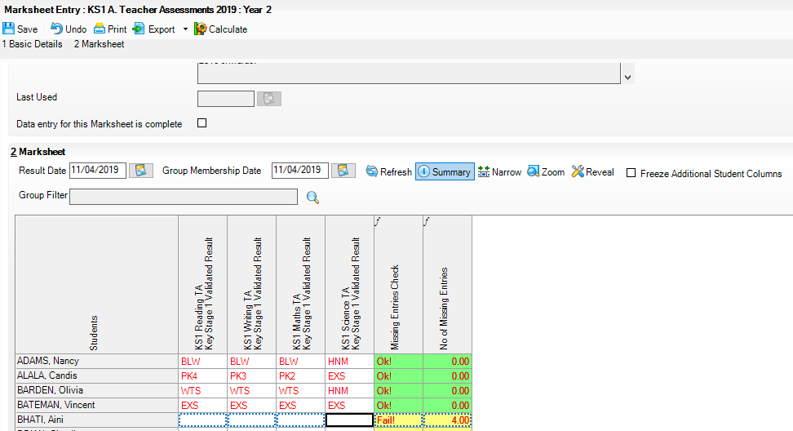
Calculate

NOTE: To amend a result that has already been saved, right click on the cell that contains the result, select View/Edit Result History, click on the result under the Result Column and type the amended result. Click on the Close button. Click Calculate and click Save.
Click the Calculate button. The final two columns alert you to any missing results. Continue entering results until completed.

Click the Save button.
Enter the result for English Reading and Writing, Mathematics and Science.

Hint: You can just type in the result or right click in the first empty cell and Select Grade for Cell. Double clicking on the appropriate result will populate the cell and move you to the next one. Click close when finished and click SAVE in the top left hand corner.

Once all results are entered click the Save button and close the marksheet to return to the Wizard and the list of marksheets.

8
If you enter BLW for a Teacher Assessment – a P Scale is required. Please see next page).

KS1 B. P Scale Data Entry 2019
This marksheet enables you to enter a P Scale assessment for pupils at Key Stage 1 who are working below the standard of the Pre Key Stage (BLW) in Reading, Writing or Mathematics. For those pupils who have not met the expected standard (HNM) in Science and are also SEN a P Scale must be recorded. To help identify these pupils, existing TA entries are displayed in read-only columns.

IMPORTANT NOTE:
The D grade should be used to signify a Disapplied grade in the KS1 Science TA Key Stage 1 Validated Result column. This is in keeping with the grades used in the other teacher assessments for Reading, Writing and Maths at Key Stage 1. Additional P Scale information can be found on the following page.

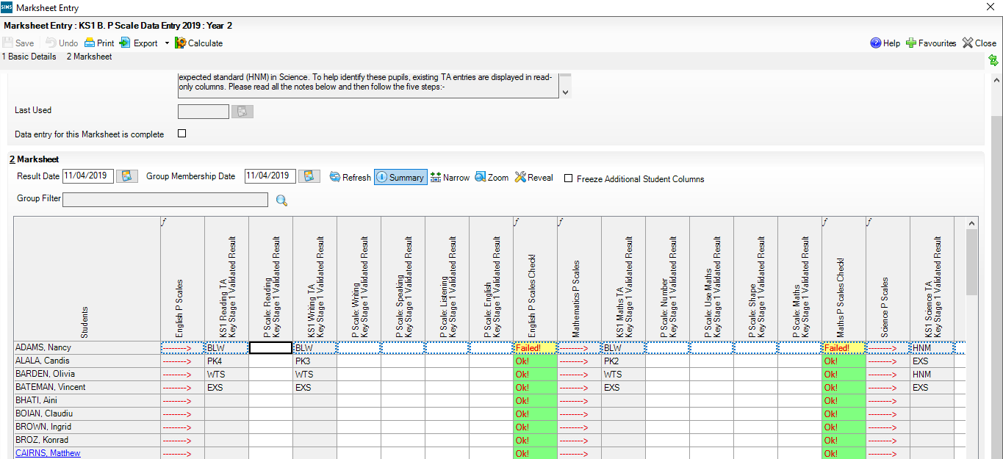

For pupils with a Science outcome of HNM, a P Scale entry MUST ALSO BE RECORDED IF THE PUPIL IS SEN.
For pupils with a Mathematics outcome of BLW, ensure that there is a P Scale entry for Mathematics or complete for each of the components.

For pupils with an English Reading or Writing outcome of BLW, ensure that there is a P Scale entry for these components or for English.

Once data has been entered, click the Calculate button to apply validation rules. Pupils with issues will be shown as Failed! Amend data as necessary and then click Calculate again. Click on Save.

Additional P Scale Information

Important Notes to Remember:
P Scale parameters for an assessment cannot be present for both overall subject and for subject component, unless all parameters are recorded as NOTSEN.
If Reading is BLW, then English or Reading P Scale should be entered. Speaking and Listening are optional.
If Writing is BLW, the English or Writing P Scale should be entered. Speaking and Listening are optional.
Reading and Writing must both be set to BLW if overall English P Scale is in use.

P SCALE ACCEPTABLE ENTRIES
KS1 C. Test Outcomes 2019 – Optional

This marksheet can be used to enter results of the new curriculum (Assessment without Levels) tests that support the Teacher Assessments made as part of the Key Stage 1 arrangements from 2019 onwards.
The new tests assess the range of ability that the majority of pupils are expected to demonstrate. The outcomes of these tests will be provided in the form of a scaled score, where a score of 100 represents the standard expected at the end of the key stage.

The tests consist of:
- Reading
- Maths Arithmetic
- Maths Reasoning
It is expected that raw score to scaled score conversion tables for KS1 will be available on 5th June 2019 on www.gov.uk.

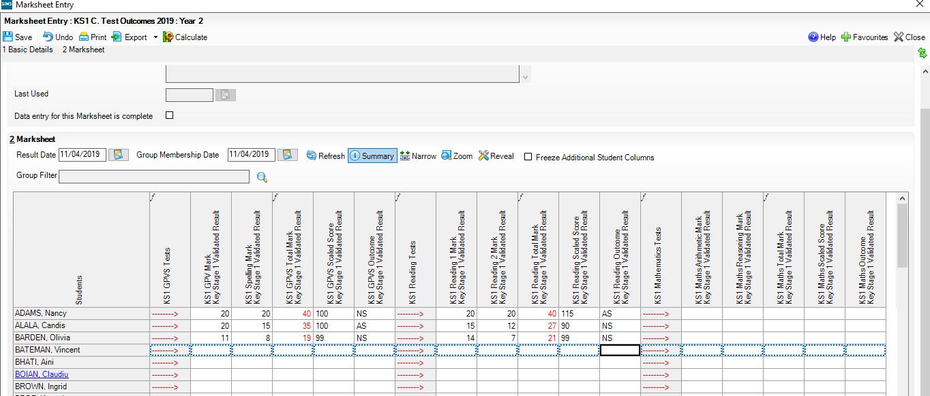

There is no validation checks performed on the results entered for test outcomes.

The following tests at Key Stage 1 are optional:
- Grammar, Punctuation and Vocabulary
- Spelling
Schools wishing to offer these tests can enter the outcome under the columns that contain GPVS on the marksheet that correspond to these tests.

- A scaled score and an outcome also need to be defined. Using the graphic below as a guide, enter a scaled score and outcome

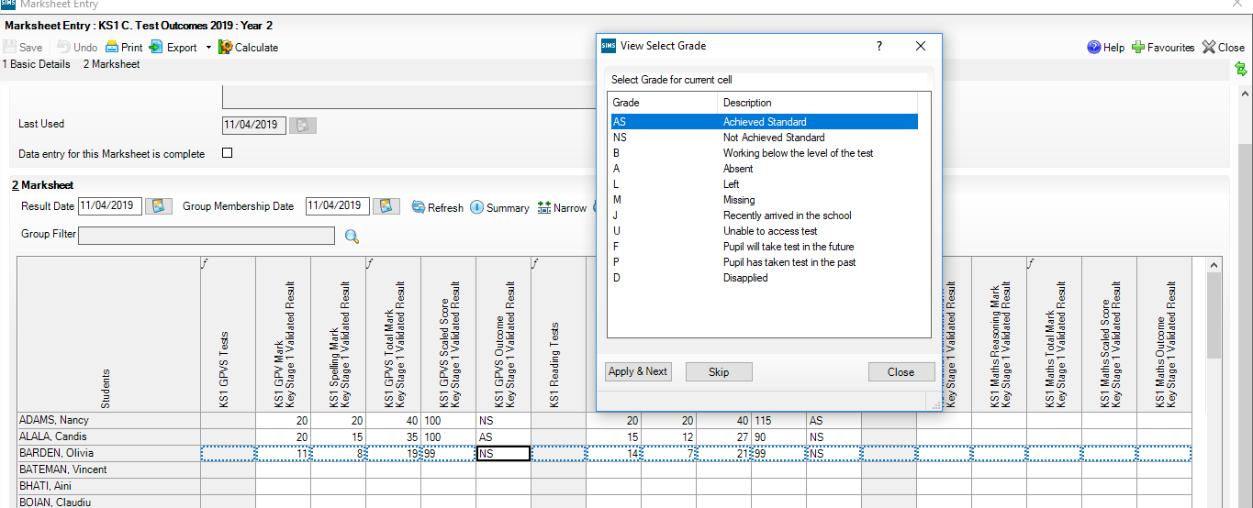

Scaled Scores for each – Reading and Maths will accept entries of between 0 – 999.
NB. The STA have decided that the scale will centre around 100. (For example the maximum score could be 130 and the minimum 80.)

On completion click on Save.

KS1 D. Broadsheet (Review) 2019
This marksheet can be used to review the Test, Teacher Assessment and P Scale results of the new curriculum (Assessment without Levels) that have been entered in support of the Key Stage 1 arrangements from 2019 onwards.

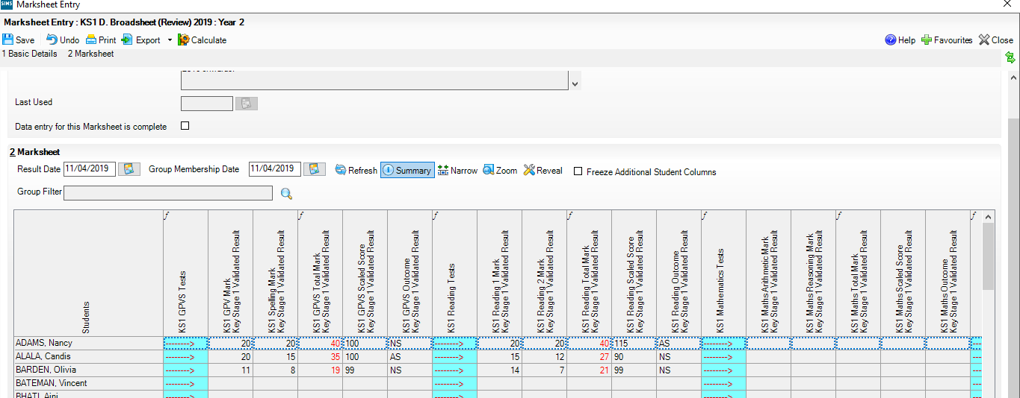

The results displayed in the Broadsheet Review marksheet are separated by coloured spaces to differentiate the different teacher assessments and tests.

Note: This marksheet is for review purposes only. If you wish to amend any of the data shown in it, please use marksheets KS1 A, B or C. Once amendments have been made you can then view the marksheet again.

Step 5 - Using the Wizards for Reporting to Parents
Once all the results are entered on the marksheets the following report can be produced:

KS1 P1 Student England 2019
Produces an individual report for each pupil.

- Go to Tools | Performance | Assessment | Wizard Manager.
- Select the Key Stage 1 Wizard England 2019. Click the Next button.
- Leave the Group Selection as it is. Click the Next button.
- At the marksheet window, click Next.
- Choose the report – KS1 P1 Student England 2019.

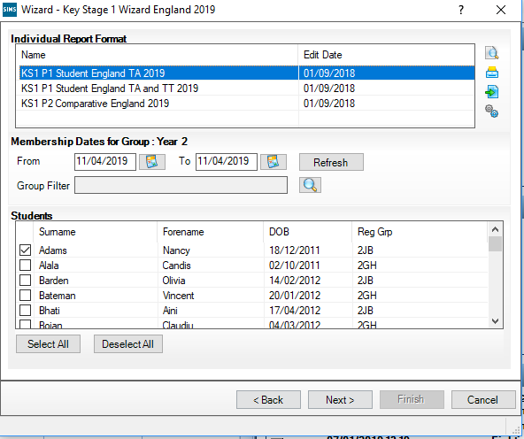
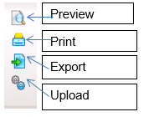
- To preview a report ensure one of the pupils is ticked then click the Preview Report icon.

- To print the reports choose Select All. Click the Print icon.

Key Stage 1 P1 Individual Student Report for 2019

Graphical representation of the detail displayed in the report.

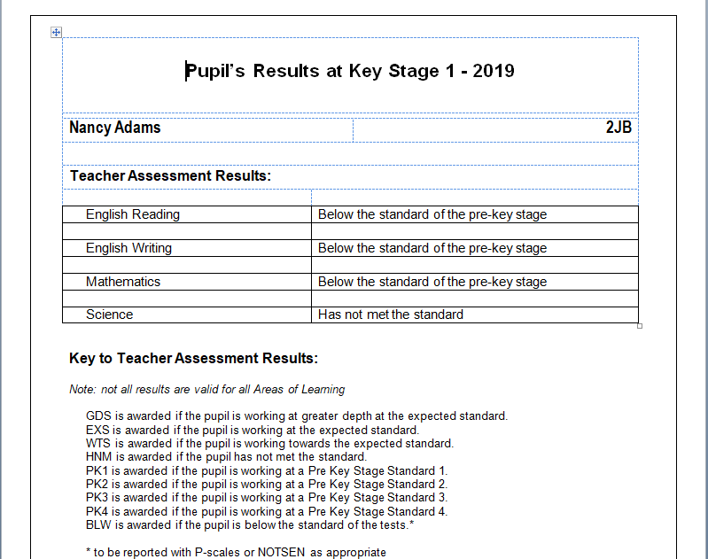

Step 6 - Upload Reports

A copy of each child’s report can be saved in the Document Server. This can then be viewed at any time.

- Once reports have been generated they can be uploaded, either individually or in bulk, by clicking the Upload icon.

- To view the copy open the Pupil Details screen for the child and select Linked Documents in the Links panel on the right. The report will open as read only.

Step 7 – Exporting KS1 results in a CTF file to send to the Authority

Once the appropriate assessments have been entered for all pupils, the results need to be exported to the Local Authority (LA). This is not done in Assessment Manager, but in SIMS.net by creating a CTF to the LA.

The LA may ask for results by way of a CTF. The procedure for transferring the results will vary from one Local Authority to another. Please check the advice given by your LA before proceeding.

The following steps show the process for Year 2.

For creating a CTF for pupils from more than one year group please see http://faq.scomis.org/kb15034/.

For creating a CTF including leavers please see http://faq.scomis.org/kb15037/.

  - Go to Routines | Data Out | CTF | Export CTF

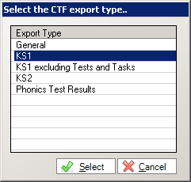

Select KS1 from the Export type options. The CTF will contain export files including KS1 Data, UPN, Surname, Forename, DOB and Gender.

  - In the Student Options area, enter a tick against ‘Include students already exported’, and ensure that the View is set to “Current Students”, then click Refresh Students.

  - Click the down arrow on the ‘Year Group’ column heading and select Year 2 to show just the Year 2 pupils.

  - Right mouse click in the first cell under Destination / Other and click on Select All.

  - All the cells appear highlighted.

  - Left click in the first highlighted cell under Destination/ Other and select your authority from the list.

  - Click on Export CTF button – a CTF will be created and placed in the normal export directory setup to hold the CTFs as defined in Tools | Setups | CTF.
  - A confirmation will appear with the name of the file.

823 – An example of your Local Authority Number

2999 – An example of your School Number

KS1 – Results you are exporting

878LLLL – Export destination - eg Local Authority

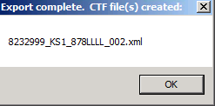

Make a note of the filename here in case of a query with the Local Authority.

At this point, please confirm that you have the correct number of students in the file as expected.

Sending the Results File to Your LA
The CTF containing results should now be sent to your Local Authority. Upload the file to the LA in the normal way prescribed by them.

Submission Deadline – 27th June 2019.

Step 8 - Exporting the Results Using the Key Stage Manager Wizard

If it is required, you can use the Key Stage Manager wizard to export results to a XML file. The routine will also pick up any other statutory results, for example Early Years Foundation Stage Profile. These can be deselected by clicking the tick to the left of the Aspect.
- Click Next on the Individual Report screen.
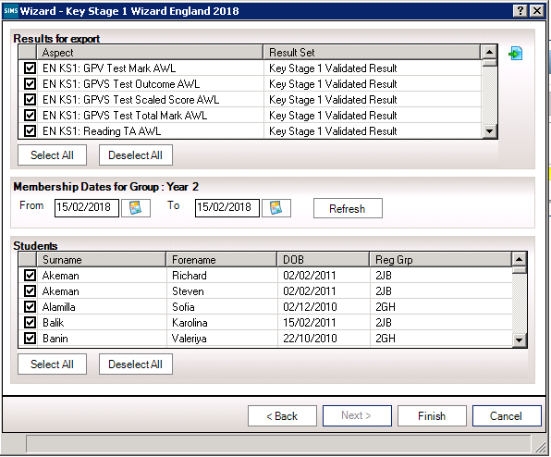
Export

- The group membership dates display the current date by default. If these dates need to be changed, click the Refresh button to display the pupils who are on roll between the selected dates for the particular group.
- Deselect the check boxes adjacent to any pupils for whom results do not need exporting.
- Click the Export button, enter a name for the results file and navigate to the location where the file is to be saved.
- Click Save and a message that The XML file has been created successfully will be displayed at the bottom of the Export screen.
- Click the Finish button to exit the wizard.
- Upload the file to the LA in the normal way as prescribed.

