SIMS .net Assessment

Key Stage Wizard 2019

Key Stage 2

Version 1.1

REVISION HISTORY

Version | Change Description | Date
1.0 | Updated to 7.186 | 15/04/2019
1.1 | Amendments from Babcock | 26/04/2019
1.2 | Added permissions required to carry out Key Stage procedures | 27/06/19

Key Stage 2 Statutory Teacher Assessment Data Collection 2019 – Change for Academic Year 2018/2019

Removal of teacher assessment for English reading and mathematics

Schools are no longer required to make statutory teacher assessment (TA) judgements in English reading and mathematics. This change has been made in order to reduce assessment burdens on schools, as set out in the government response to the 2017 public consultation on Primary assessment in England. However, Reading and Maths are to be reported if the student is working at the pre-key stage Standard. P scales should continue to be used for statutory assessment of pupils not engaged in subject-specific study at the end of KS2. See details below:

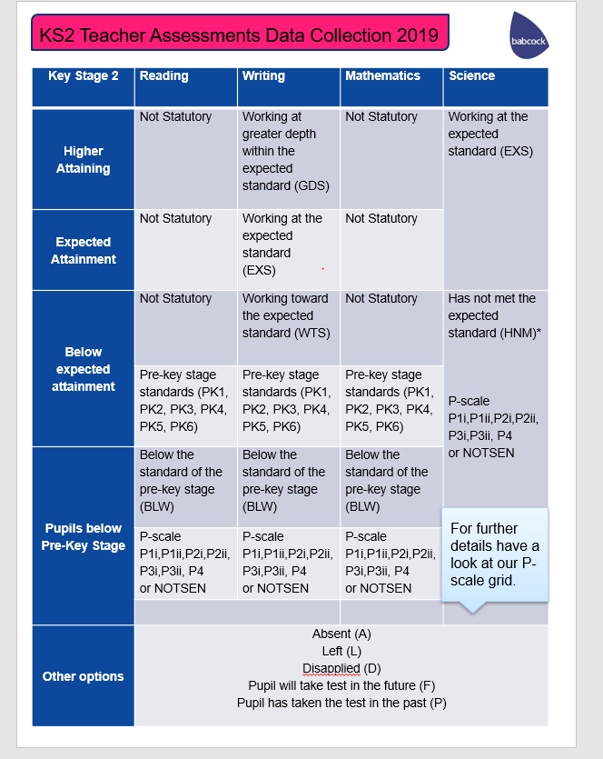

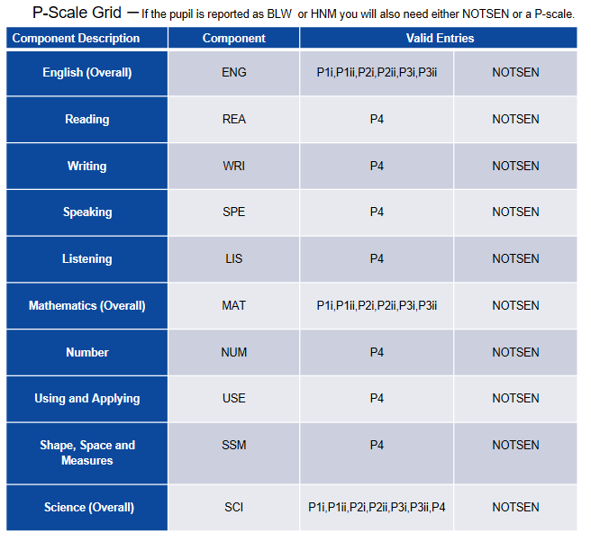

An error will occur if you try to add both a overall subject P-scale (eg English) and a subject component P-scale (eg Reading).

When NOTSEN is submitted as a valid result for a P scale, it indicates that the pupil is not on the SEN register but not yet working at PK1 standard. English as a second language is the most common reason for this.

Introduction

SIMS .net's Key Stage Wizards allow schools to easily manage their End of Key Stage results including:

- Recording each pupil’s attainment at the end of each Key Stage
- Producing reports for each pupil showing their Key Stage results
- Exporting results to the LA and other schools via a CTF
- Using the results as part of a tracking system within SIMS .net Assessment

The Wizards are automatically placed in an AMPA folder on each school’s computer as part of the upgrade process. They can be found in the following locations:-

- Hosted Schools:
F:\Public\AMPA\England Primary (and Middle Deemed Primary)\Assessment Manager
- Non-Hosted Schools:
C:\Program Files\SIMS\SIMS.net\AMPA\ England Primary (and Middle Deemed Primary)\Assessment Manager

As these Teacher Assessments form part of the CTF that accompanies children if they transfer between schools, it is a statutory requirement that where you are using alternative software for collection of assessment results, the data is also imported into SIMS.

Please refer to your software supplier for guidance and instructions on how to do this.

Permissions:

Please note, to carry out the Key Stage process, users will need access to Class Teacher/Registration Tutor (to enter their own results) but to have access to enter all the results users will need Assessment Co-Ordinator or Assessment Operator.

Step 1 - Check SIMS .net Version

In order to use the 2019 Wizards you must be using the Spring 2019 Main Release version of SIMS .net or later. To check:

Go to Help | About SIMS .net.

Check that the version of SIMS .net is 7.186 or higher.

Step 2 - Identify the KS2 Pupils

If all pupils being assessed are in Year 6 continue to Step 3.

If pupils outside of the year are being included in the Key Stage 2 assessment, or some of the Year 6 pupils are not being assessed - please refer to the notes for Creating a User Defined Group by clicking on the link below:

http://faq.scomis.org/kb15030/

Step 3 - Import the Wizard for Key Stage 2

- Go to Routines | Data in | Assessment | Import.
- If you get a message at this point advising you that there are some new or updated resources to import, you are advised to click Yes and import everything available
- Select the file to import from by clicking on the browser (magnifying glass) and then navigate to the folder
- Hosted Schools:
F:\Public\AMPA \England Primary (and Middle Deemed Primary) \Assessment Manager
- Non-Hosted Schools:
C:\Program Files\SIMS\SIMS.net\AMPA \England Primary (and Middle Deemed Primary) \Assessment Manager
- Highlight the 'Key Stage 2 Wizard England 2019'.
- Click Open.
- Click Finish and then Yes when asked Do you want to proceed?
- After a short pause you will then get an Activity Log that shows what has been imported. Click Close.

Step 4 - Enter Results

- Go to Tools | Performance | Assessment | Wizard Manager.

- Leave the filter on Incomplete and highlight Key Stage 2 England 2019.

- Click Next.

- Click the browser (magnifying glass).

- The Group Selector appears. Click the + next to 'Year Group' and choose Year 6 or the user defined group that you may have created earlier, then click Apply. This places this group in the box.

- Click Next. At the Marksheet window highlight the marksheet you wish to use and click on the Pencil icon on the right hand side to enter results.

There are 4 marksheets to choose from:

KS2 A. Teacher Assessments 2019
This marksheet can be used to store the outcome for the KS2 Reading, Writing, Mathematics and Science Performance Descriptor of the new curriculum (Assessment without Levels) from 2019 onwards.

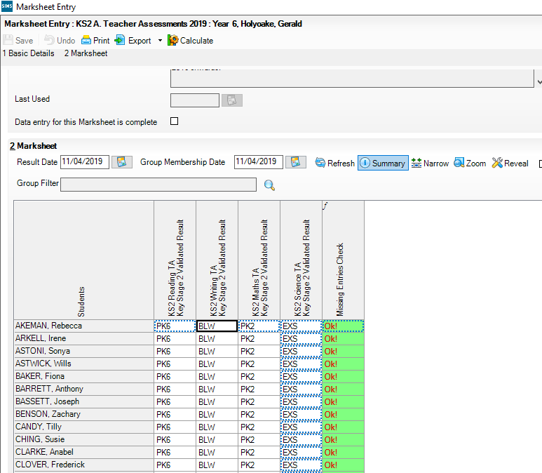
Save
Calculate
NOTE: To amend a result that has already been saved, right click on the cell that contains the result, select View/Edit Result History, click on the result under the Result Column and type the amended result. Click on the Close button. Click Calculate and click Save.
Click the Calculate button. The final two columns alert you to any missing results. Continue entering results until completed.

Click the Save button.
Enter the result for English Reading and Writing, Mathematics and Science.

Hint: You can just type in the result or right click in the first empty cell and Select Grade for Cell. Double clicking on the appropriate result will populate the cell and move you to the next one. Click close when finished and click SAVE in the top left hand corner.

KS2 B. P Scale Data Entry 2019
This marksheet enables you to enter a P Scale assessment for pupils at Key Stage 2, who are working below the standard of the Pre Key Stage (BLW) in Reading, Writing or Mathematics, or optionally for those who have not met the expected standard (HNM) in Science. To help identify these pupils, existing TA entries are displayed in read-only columns.

IMPORTANT NOTE:
The D grade should be used to signify a Disapplied grade in the KS2 Science TA Key Stage 2 Validated Result column. This is in keeping with the grades used in the other teacher assessments for Reading, Writing and Maths at Key Stage 2. Additional P Scale information can be found on the following page.

If you enter BLW for a Teacher Assessment – a P Scale is required. (Please see next page).
Once all results are entered click the Save button and close the marksheet to return to the Wizard and the list of marksheets.

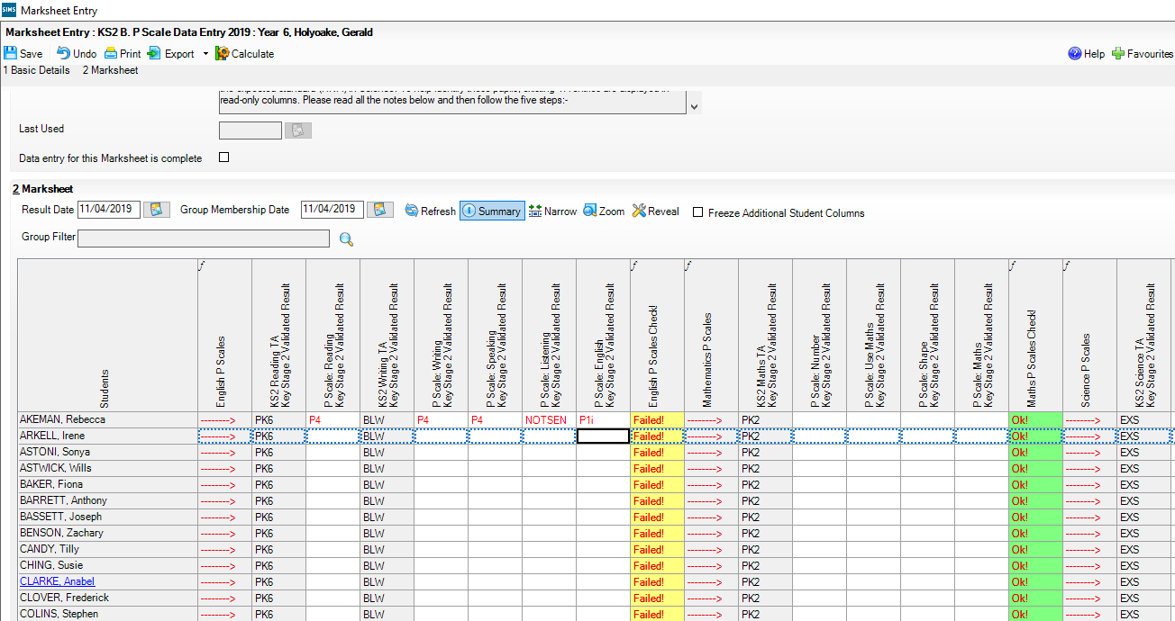
For pupils with a Mathematics outcome of BLW, ensure that there is a P Scale entry for Mathematics or complete for each of the components.
For pupils with a Science outcome of HNM, a P Scale entry is optional.
For pupils with an English Reading or Writing outcome of BLW, ensure that there is a P Scale entry for these components or for English.

Additional P Scale Information
Once data has been entered, click the Calculate button to apply validation rules. Pupils with issues will be shown as Failed! Amend data as necessary and then click Calculate again. Click on Save.

Important Notes to Remember:
P Scale parameters for an assessment cannot be present for both overall subject and for subject component, unless all parameters are recorded as NOTSEN.
If Reading is BLW, then English or Reading P Scale should be entered. Speaking and Listening are optional.
If Writing is BLW, the English or Writing P Scale should be entered. Speaking and Listening are optional.
Reading and Writing must both be set to BLW if overall English P Scale is in use.

P SCALE ACCEPTABLE ENTRIES
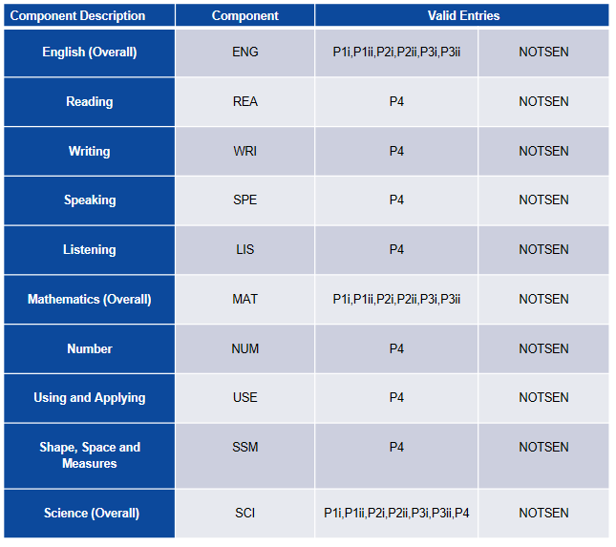
KS2 C. Test Outcomes 2019

This Marksheet can be used to enter results of the new curriculum (Assessment without Levels) tests that support the Teacher Assessments made as part of the KS2 arrangements from 2019 onwards.

The new tests assess the range of ability that the majority of pupils are expected to demonstrate. The outcomes of these tests will be provided in the form of a scaled score, where a score of 100 represents the standard expected at the end of the key stage. The new tests consist of:
- Grammar, Punctuation and Vocabulary.
- Spelling.
- Reading.
- Maths Arithmetic.
- Maths Reasoning.

It is expected that Pupil results (raw scores and scaled scores) and marked script images will be available on NCA tools from 10th July. Raw score to scaled score conversion tables available on www.gov.uk will also be available from 10th July.
A marksheet is available containing columns which will enable you to record results of the reformed curriculum tests that support the teacher assessments.
There are no validation checks performed on the results entered for test outcomes.

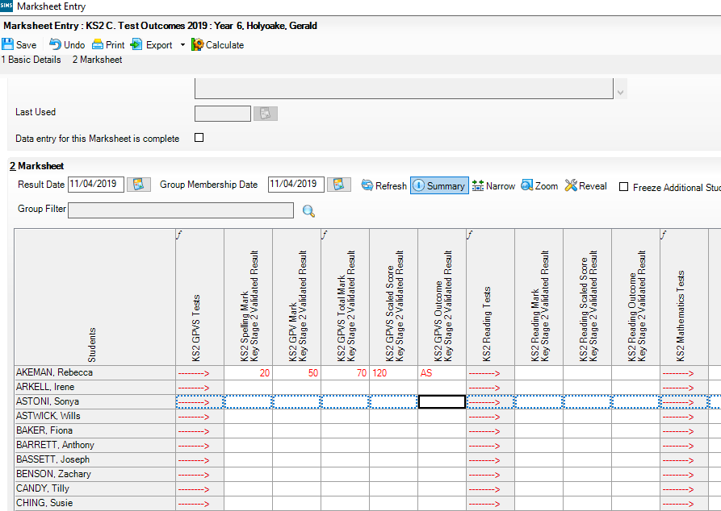

KS2 D. Broadsheet Review 2019
This marksheet can be used to review the Test, Teacher Assessments and P Scale results of the new curriculum (Assessment without Levels) that have been entered in support of the Key Stage 2 arrangements from 2019 onwards.

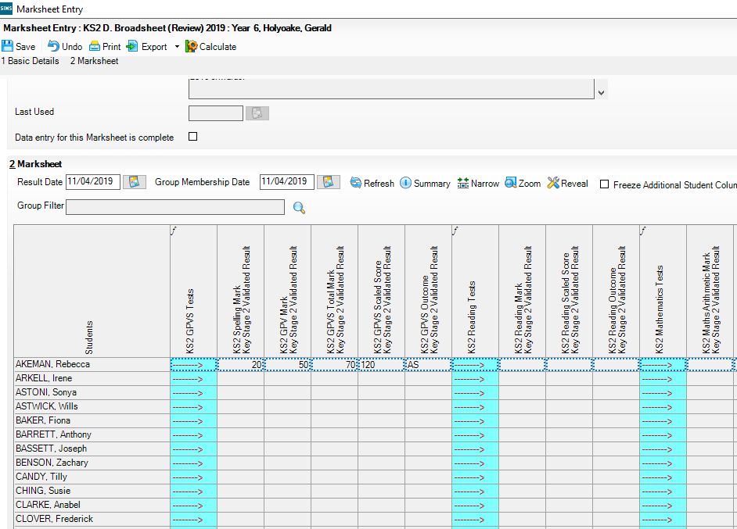

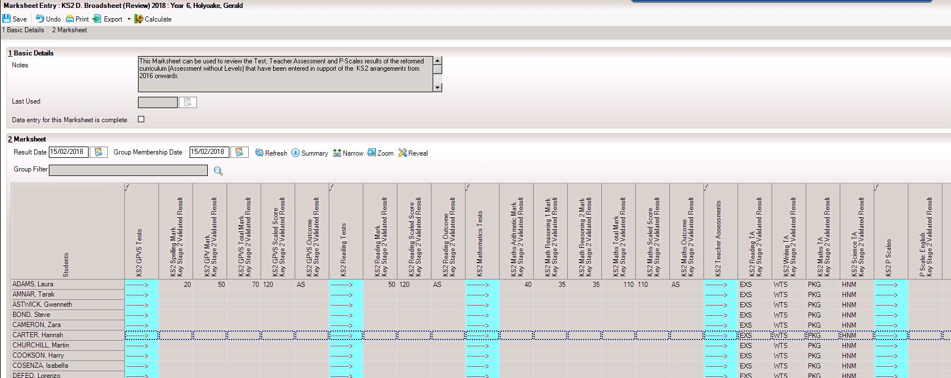

The results displayed in the Broadsheet Review marksheet are separated by coloured spaces to differentiate the different teacher assessments and tests.

Note: This marksheet is for review purposes only. If you wish to amend any of the data shown in it, please use marksheets KS2 A, B or C. Once amendments have been made you can then view the marksheet again.

Step 5 - Using the Wizards for Reporting to Parents
Once all the results are entered on the Marksheets the following report can be produced

KS2 P1 Student England 2019
Produces an Individual Report for each pupil.

- Go to Tools | Performance | Assessment | Wizard Manager.

- Select the Key Stage 2 Wizard England 2019. Click the Next button.

- Leave the Group Selection as it is. Click the Next button.

- At the marksheet, click Next.

- Choose the report – KS2 P1 Student England 2019.

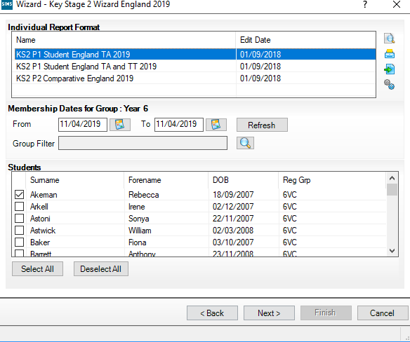

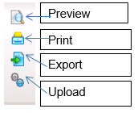

- To preview a report ensure one of the pupils is ticked then click the Preview Report icon.

- To print the reports choose Select All. Click the Print icon.

Key Stage 2 P1 Individual Student Report 2019

Graphical representation of the detail displayed in the report.

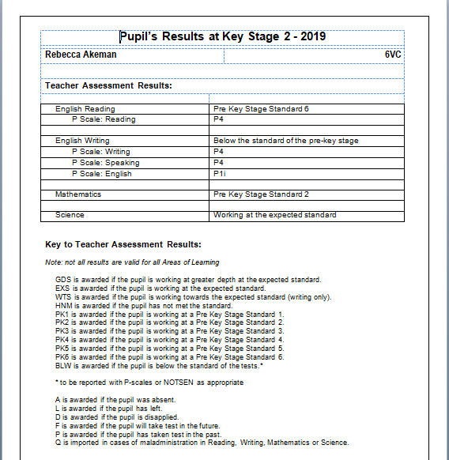

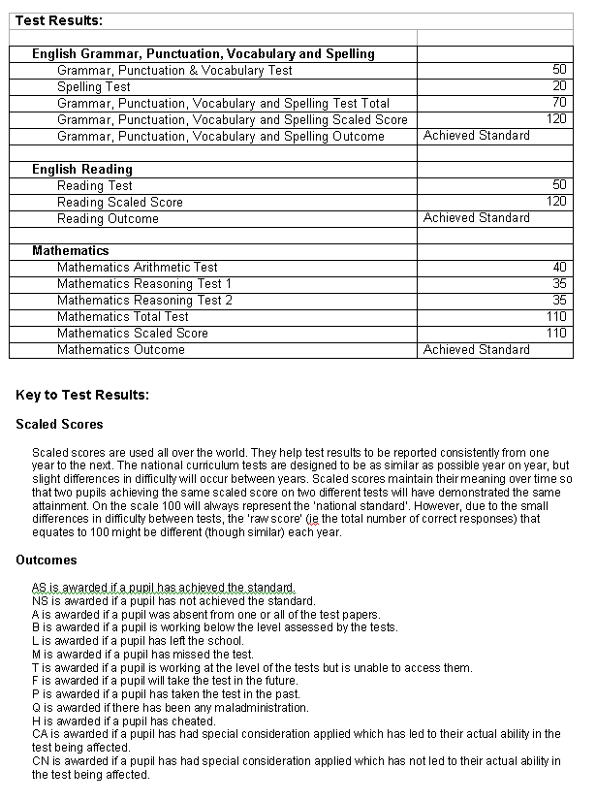

Step 6 - Upload Reports

A copy of each child’s report can be saved in the Document Server. This can then be viewed at any time.

- Once reports have been generated they can be uploaded, either individually or in bulk, by clicking the Upload icon.

- To view the copy open the Pupil Details screen for the child and select Linked Documents in the Links panel on the right. The report will open as read only.

Step 7 - Exporting KS2 Results in a CTF file to send to the NAA.

Once the appropriate assessment levels or test scores have been entered for all pupils, the results need to be exported to the National Assessment Agency. This is not done in Assessment Manager, but in SIMS.net by creating a CTF to the NAA (National Assessment Agency).

Creating the NAA Destinations (please note you may already have this setup)

In Tools | Setups | CTF

Click on the hyperlink to Alternative Destinations.

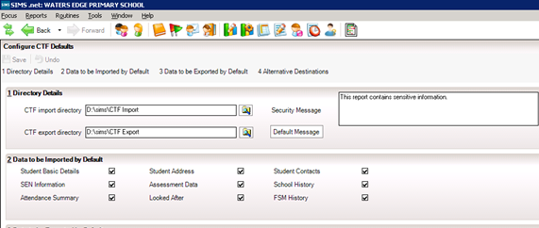

Panel 4 will show you the Alternative Destinations that you have on the system. If NAALLLL is NOT already showing - click New to add a new destination. The following screen will appear:

- Enter the code e.g. NAALLLL and the description ‘National Assessment Agency or NAA”

- Click OK.

- Click Save.

- Click Close.

You will need to logout and back into SIMS at this point, to refresh the destination information and allow you to select it in the next stage.

Creating a CTF File

The following steps show the process for Year 6.

For creating a CTF for pupils from more than one year group please see http://faq.scomis.org/kb15034/.

For creating a CTF including leavers please see http://faq.scomis.org/kb15037/.

Go to Routines/Data Out/CTF/Export CTF
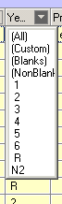
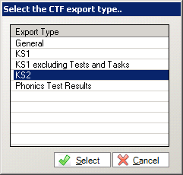
Select KS2 from the list of export types. This will transfer KS2 Teacher Assessments.

  - Click the down arrow on the ‘Year Group’ column heading.

  - Select Year 6 from the drop down list.

  - Ensure that all pupils with results to be exported have a UPN. (You can click on the UPN column header to sort this column, which will bring any pupils with blank UPNs to the top of the list).

Please follow these notes carefully - the process does not work properly if the selections are not made in a specific way:
First, click into any cell in the ‘Destination LA/Other’ column.

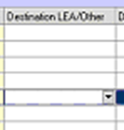
Do not click on the arrow that appears in the field at this stage: Instead right-click in the cell and a pop-up menu will appear.

  - Click Select All and the entire grid will be highlighted.

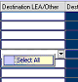

  - Now click the arrow in the cell, then scroll through the list using the mouse, not the keyboard and select ‘National Assessment Agency’ destination. This destination should now appear as the destination for all.
  - Click on Export CTF and the CTF file will be created for those pupils within your selected year 6 with a destination and a UPN.

823 – An example of your Local Authority Number

2999 – An example of your School Number

KS2 – Results you are exporting

NAALLLL – Results exported and export destination - eg National Assessment Agency

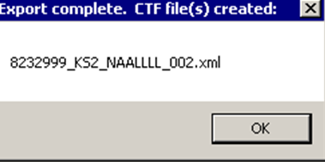

Sending the Results File to the NAA

At this point, please confirm that you have the correct number of students in the file as expected.

The CTF containing results should now be sent to the NAA, using the ‘Teacher Assessment’ link within the NAA website.

Instructions on uploading results to the NAA can be found on the following link:
https://faq.scomis.org/kb21060/

UNLESS otherwise prescribed by your LA, please do not send the CTF to your LA as they cannot process this submission for you.

The following process is for reference only.
More information on the submission of Teacher Assessment and P Scale data can be found on the following website
https://www.gov.uk/guidance/2019-key-stage-2-assessment-and-reporting-arrangements-ara
Schools must submit all teacher assessment data as per the DfE rules for 2019. These should be submitted via NCA Tools no later than 27th June 2019.
If you experience any problems uploading Teacher Assessments or downloading results from the NCA Tools website please email assessments@education.gov.uk or contact the national curriculum assessments helpline on 0300 303 3013.

Step 8 - Exporting CTF to Secondary Schools
KS2 results are automatically included in the CTF that should be sent to the receiving secondary school. Results can also be exported from the wizards if required but they will not be in CTF format.
KS2 Teacher Assessments have to be submitted to the NCA Tools website electronically. This should have been completed by the due date.

Submitting the Completed CTF to Secondary Schools
The following information is taken from the Assessment and Reporting Arrangements 2019 for Key Stage 2 Pupils.

- From the SIMS Home Page, go to the route Routines | Data Out | CTF.
- Select Export CTF.
- Highlight the option General. This option will transfer General data along with all Key Stage 2 results.
- Click Select.
- Ensure that the tick is activated in – Include students already exported and Refresh Students.
- Choose the year group – Year 6.
- Select all relevant fields and ensure that you also include Assessment Data and the option to Include KS1 Tasks/Tests.
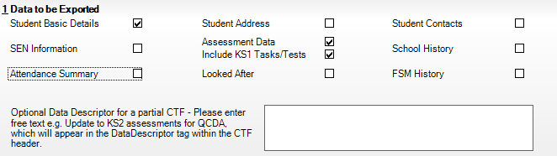
- Create a CTF in the usual way, by selecting the pupils for each destination school.
- Use your usual secure file transfer routines to transfer the data to the receiving schools. Close the export CTF file.

Step 9 - Exporting Results using the Key Stage Wizard Manager
The Key Stage Manager wizard can also be used to export results as a XML file: The results export routine will, by default, transfer each piece of statutory data that the SIMS system has recorded. For example the pupil’s EYFS, Phonics, Key stage 1 and Key Stage 2 results, if they exist.
- Select Tools | Performance | Assessment | Wizard Manager.
- Choose Key Stage 2 Wizard England 2019 and click Next until you get to the Results Export screen.
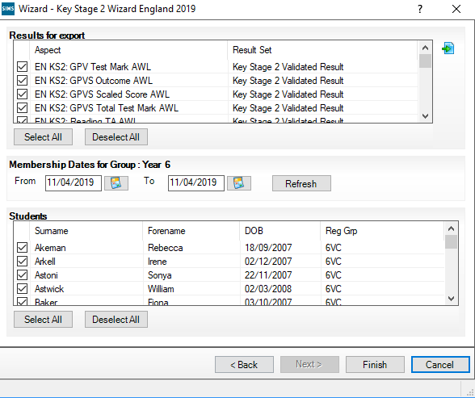

- The group membership dates display the current date by default. If these dates need to be changed, click the Refresh button to display the pupils who are on roll between the selected dates for the particular group.
- Deselect the check boxes adjacent to any pupils for whom results are not to be exported.
- Click the Export button, enter a name for the results file and navigate to the location where the file is to be saved.
- Click the Finish button.
- A message is displayed showing that the export is complete.
- Click OK and exit from the wizard by clicking the Finish button.

