SIMS .net Assessment

Key Stage Wizard 2019

Year 1 and Year 2 Phonics

Version 1.1

REVISION HISTORY

Version | Change Description | Date
1.0 | Updated to 7.186 | 11/4/19
1.1 | Amendments from Babcock | 26/4/19
1.2 | Amendments re: Permissions | 27/6/19

Introduction

The phonics screening check is designed to confirm whether pupils in Year 1 have learnt phonic decoding to an appropriate standard. Children who do not achieve the standard should be re-checked in Year 2.

The Year 1 and Year 2 Phonics Screen Wizards are automatically placed in a folder on each school’s computer as part of the upgrade process. They can be found in the following locations:-
- Hosted Schools:
F:\Public\AMPA\England Primary (and Middle Deemed Primary)\Assessment Manager
- Non-Hosted Schools:
C:\Program Files\SIMS\SIMS.net\AMPA\England Primary (and Middle Deemed Primary)\Assessment Manager

As these Teacher Assessments form part of the CTF that accompanies children if they transfer between schools, it is a statutory requirement that where you are using alternative software for collection of assessment results, the data is also imported into SIMS.

Permissions:

Please note, to carry out the Key Stage process, users will need access to Class Teacher/Registration Tutor (to enter their own results) but to have access to enter all the results users will need Assessment Co-Ordinator or Assessment Operator.

Step 1 - Check SIMS .net Version

In order to use the 2019 Wizards you must be using the Spring 2019 Main Release version of SIMS .net or later. To check:

- Go to Help | About SIMS .net.
- Check that the version of SIMS .net is 7.186 or higher

Step 2 - Import the Year 1 Phonics Screen Wizards 2019

- Select Routines | Data In | Assessment | Import. If you see a screen similar to the one below, click Yes.

- Once the update has completed, Close the activity log.
Otherwise select Routines | Data In | Assessment | Import. Browse to:

- Hosted Schools:
F:\Public\AMPA\England Primary (and Middle Deemed Primary)\Assessment Manager
- Non-Hosted Schools:
C:\Program Files\SIMS\SIMS.net\AMPA\England Primary (and Middle Deemed Primary)\Assessment Manager

Select Assessment Manager.

- Select the file to import by clicking the Browser button

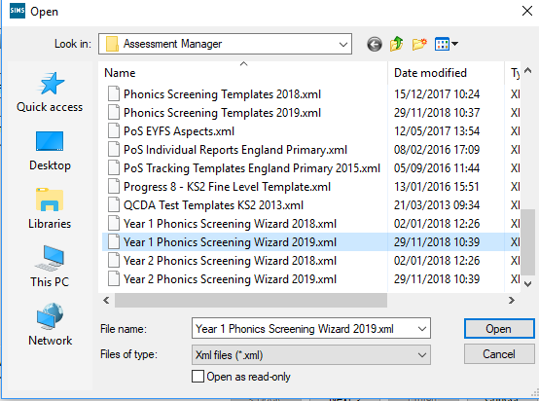

4. Click Open. Click on Finish in the Import window and then Yes when asked Are you sure you want to proceed?

5. After a short pause you will then get an Activity Log that shows what has been imported. You may like to print this for future reference. Click Close.

REPEAT THE ABOVE PROCESS AND IMPORT THE YEAR 2 PHONICS SCREENING WIZARD 2019 .XML IF YOU HAVE PUPILS REQUIRING THE YEAR 2 RECHECK.

Step 3 – Preparing to Enter Results for Year 1 Phonics

- Go to Tools | Performance | Assessment | Wizard Manager.

- Leave the filter on ALL and highlight Year 1 Phonics Screening Wizard 2019

- Click Next.

- Click the browser (magnifying glass).

- The Group Selector appears. Click the + next to 'Year Group' and choose Year 1 then click Apply. This places this group in the box.

- Click Next for the Marksheet Entry window. Highlight the marksheet and click on the Pencil icon on the right hand side to display the marksheet.

When the threshold values have been validated by the DfE on Monday 24th June 2019, a phonics threshold mark will then need to be entered. Details on how to do this are explained on Page 13 at the end of this document. Marks can be entered and sent to the Local Authority at any time prior to publication of the threshold details.
The ‘phonics mark’ will be the mark from 0-40 for those children who have taken the phonics screening check.

IMPORTANT NOTE:
For those children who are absent, did not take the check or have left. The mark field must be left blank and the phonics grade of A, D or L entered accordingly in the Grade column.

Description | Process | Mark | Phonics Grade
Child took the phonics screening check and met the required standard. | A mark of 0 – 40 is entered from the screening check outcome. The grade will be applied automatically when the threshold is released by DfE | 0 – 40 | Wa
Child took the phonics screening check and did not meet the required standard. |  |  | Wt
Absent | Leave the Marks column blank and enter the grade as per the list to the right. Please do not enter 0 in the Marks column. | Leave blank | A
Child did not take the phonics screening check |  |  | D
Child has left the school |  |  | L

Step 4 – Enter Results

- From the marksheet enter a value of between 0 and 40 into the Mark for Phonics Check Year 1 column, or a grade as defined using the table above for reference.
- Click Save. This will calculate the Data Check column.

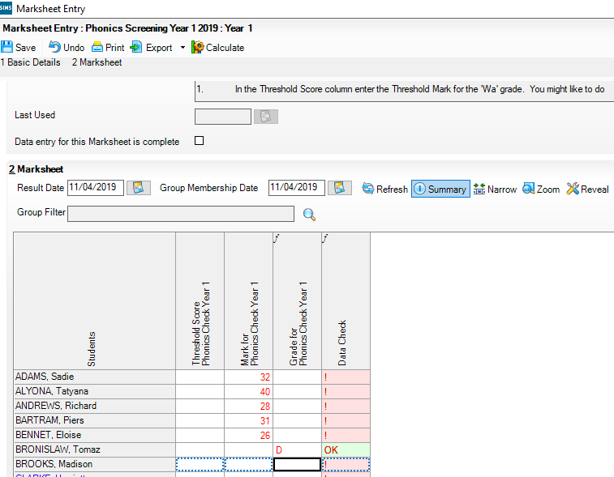
The Data Check will show an ! which indicates there is a Threshold mark missing (this is acceptable at this point of the process).
OK is displayed as a check for those pupils who are A, D or L and who did not take part in the check.

To enter L (Left), D (Disapplied) or A (Absent), type the letter directly into the Grade for Phonics Check Year 1 column.
Leave the mark column blank for those pupils who have Left, are Absent or have been Disapplied or did not take the screening check. Please do not put a 0 in this column.
This column must be left blank until after the publication of the Threshold Mark by the DfE on 24th June 2019

NOTE: To amend a result that has already been saved, right click on the cell that contains the result, select View/Edit Result History, click on the result under the Result Column and type the amended result. Click on the Close button. Click Calculate and click Save.

Remember:
Marks can be entered and sent to the Local Authority at any time prior to publication of the threshold details.

Step 5 – Preparing to Enter Results for Year 2 Phonics Recheck and Establishing who requires the Recheck.

- If you have any Year 2 Pupils who have been re-tested you will need to enter the results in the Year 2 Phonics Screening Wizard

- Go to Tools | Performance | Assessment | Wizard Manager.

- Leave the filter on ALL and highlight Year 2 Phonics Screening Wizard 2019

- Click Next.

- Click the browser (magnifying glass).

- The Group Selector appears. Click the + next to 'Year Group' and choose Year 2 then click Apply. This places this group in the box.

- Click Next for the Marksheet Entry window. Highlight the marksheet and click on the Pencil icon on the right hand side to display the marksheet.

- A marksheet is populated with the Year 2 pupils and columns relating to the assessments that need to be entered. If Year 1 Phonics results were entered into the corresponding wizard last year, they will be displayed automatically.

IMPORTANT NOTE:
Currently the Year 2 Phonics Wizard 2019 has been predefined with a threshold score of 32. Therefore, if the threshold remains at 32 no further action is required.

When the threshold values have been validated and confirmed by the DfE on Monday 24th June 2019, if the phonics threshold mark is changed then the new mark will then need to be entered. Details on how to do this will be available from the Scomis website: http://news.scomis.org/new2820/ (Ctrl + click).

Step 6 – Establishing who requires the Year 2 Phonics Recheck and Enter Results
Click on Calculate to identify those requiring a Year 2 recheck. This will be defined as a Yes in the Year 2 Check Required? column.
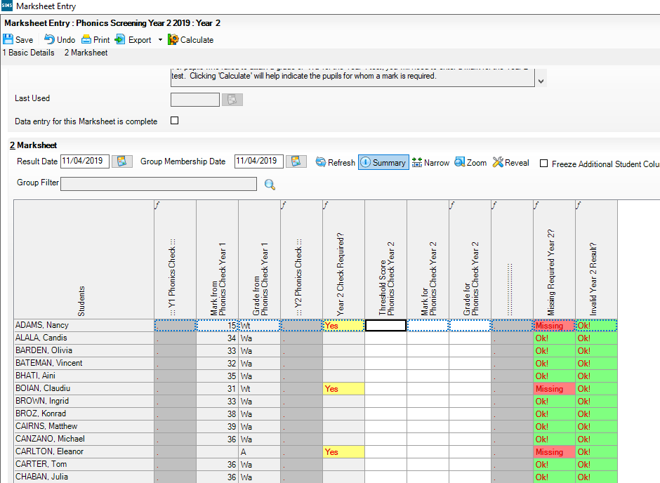
Type a value of 0-40 into the Marks for Phonic Check Year 2 column for those pupils who have undertaken a Year 2 recheck only. Click Calculate at the top of the screen to populate the Grade for Phonics Check Year 2 column. Click Save at the top of the screen.

Leave the mark column blank for those pupils who have Left, are Absent or have been Disapplied or did not take the screening check. Please do not put a 0 in this column.
L, A or D can be typed directly into the Grade for Phonics Check Year 2 column where applicable. OK! Is displayed as a check for those pupils who are A, D or L and who did not take part in the check.

NOTE: To amend a result that has already been saved, right click on the cell that contains the result, select View/Edit Result History, click on the result under the Result Column and type the amended result. Click on the Close button. Click Calculate and click Save.

You may have pupils who have joined you in Year 2 and subsequently had some that have left. To identify these pupils run the Migration Report – http://faq.scomis.org/kb17178/ (Ctrl + click).

Step 7 - Using the Wizards for Reporting to Parents for Year 1 and Year 2 Phonics
Once all the results are entered on the marksheets the following reports can be produced:
KS1 Y1 Phonics Student Eng 2019
This will generate an individual report for each pupil.

KS1 Y1 Phonics Comparative Eng 2019
The comparative report compares the percentages by Phonics results for the school in 2019 with the national results for 2016.

KS1 Y2 Phonics Student Eng 2019
This will generate an individual report for each pupil.

KS1 Y2 Phonics Comparative Eng 2019
The comparative report compares the percentages by Phonics results for the school in 2019 with the national results for 2016.

- Select Tools | Performance | Assessment | Wizard Manager.
- Select the Year 1 Phonics Screening Wizard 2019
- Click the Next button.
- The group selection may be left as it is. Click the Next button.
- At the marksheet window, click Next.
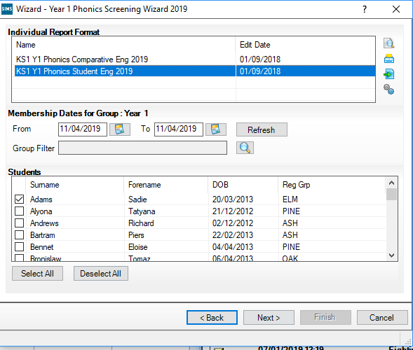
Upload
Export
Print
Preview

- To preview a report, ensure one of the pupils is ticked then click the Preview Report icon.

- To print the reports choose Select All. Click the Print icon. Reports will be printed from Word for those pupils selected. Close Word without saving.

KS1 Y1 Phonics Student Eng 2019

The report consists of two pages:

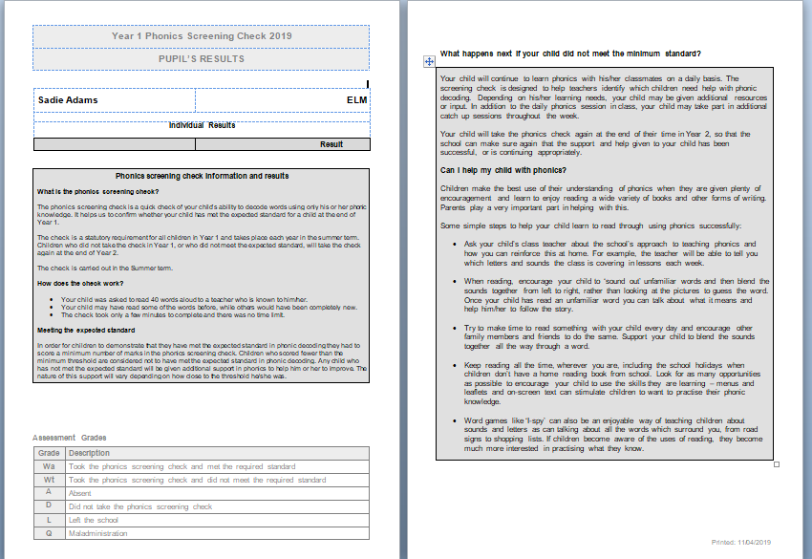

KS1 Y1 Phonics Comparative Eng 2019

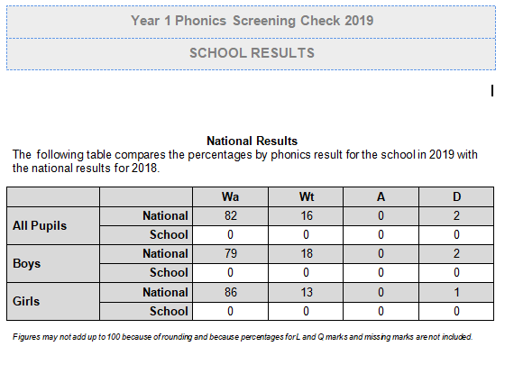

REPEAT THE PROCESS ON PAGE 5 TO GENERATE THE FOLLOWING YEAR 2 PHONICS REPORTS.

KS1 Y2 Phonics Student Eng 2019

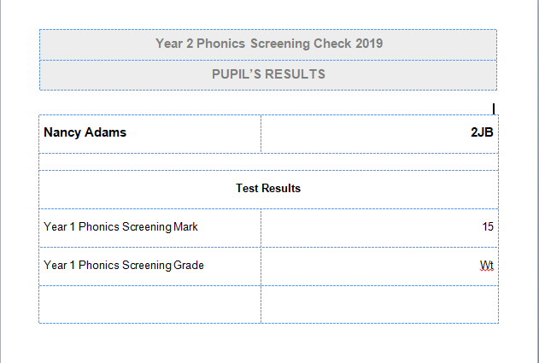

KS1 Y2 Phonics Comparative Eng 2019

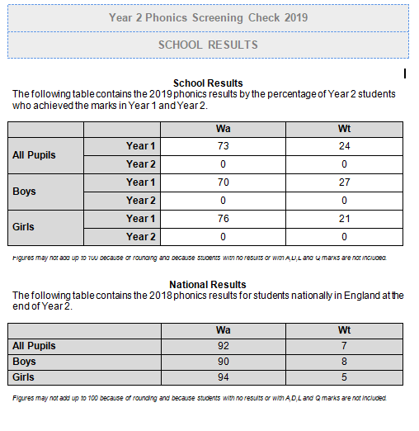
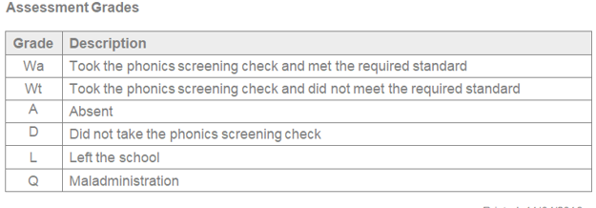

Step 8 - Upload Reports

A copy of each child’s report can be saved in the Document Server. This can then be viewed at any time.

- Once reports have been generated they can be uploaded, either individually or in bulk, by clicking the Upload icon.

- To view the copy open the Pupil Details screen for the child and select Linked Documents in the Links panel on the right. The report will open as read only.

Step 9 – Exporting Phonics results in a CTF file to send to the Authority
Year 1 and Year 2 Phonics results need to be sent to the LA. The LA may ask for results by way of a CTF.

NOTE: The procedure for uploading the CTF file will vary from one Local Authority to another. Some Local Authorities may require one file containing both Year 1 and Year 2 whilst others will require two separate files one for each year group. Please check the advice given by your Local Authority before proceeding.

Step by Step – Create a CTF File for pupils from Year 1 and Year 2

Go to Routines | Data Out | CTF | Export CTF

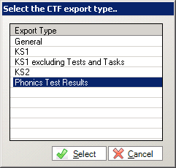

Select Phonics test results from the Export type options

  - In the Student Options area, enter a tick against ‘Include students already exported’, and ensure that the View is set to “Current Students”, then click Refresh Students.

  - Right mouse click on the Year Group Column and Select Sort Ascending

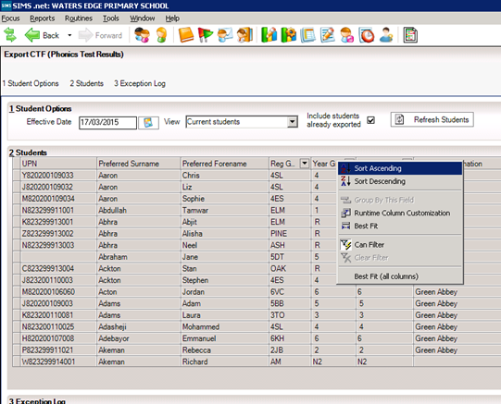
05/05/04/2019

  - Year 1 pupils should be at the top of the list.

4. Hold the shift key down continuously on your keyboard and scroll down the list of pupils – left click on the last pupil in Year 1 – all year 1 pupils are highlighted.

5. Release the shift key and hold the Ctrl key down continuously on your keyboard to select any Year 2 pupils who have been re-tested. If you select someone by mistake click again and it will deselect them.

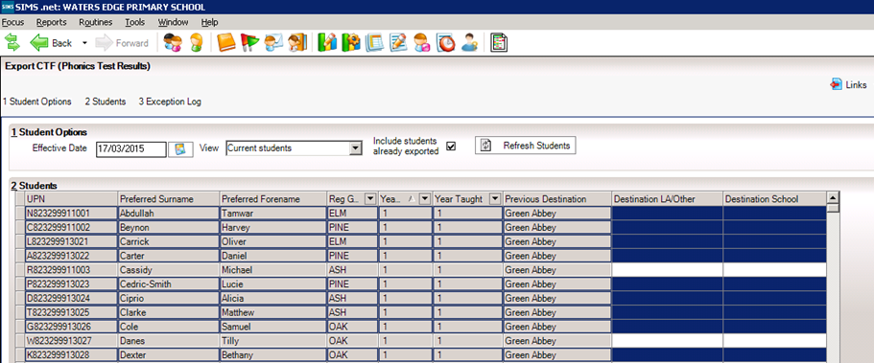

6. Release the control key when all the required pupils have been selected.

- Left Click into Destination LA/Other on the last pupil you have selected. Click on the down arrow to display the list of Local Authorities.

NB Selecting a pupil further up the list will deselect all the other pupils so make sure you click next to the last selected pupil.

8. Select your authority from the list.

9. All the selected pupils should be showing with the authority in the Destination LA / Other column.

10.Click on the Export CTF – the CTF file will be created for those pupils within your selected Year 1 and Year 2 where appropriate with a destination and a UPN.

- A confirmation will appear with the name of the file.

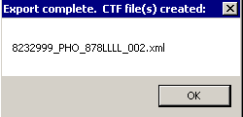
823 – An example of your Local Authority Number

2999 – An example of your School Number

PHO – Results you are exporting

823LLLL – Results exported and export destination - eg Local Authority

Make a note of the filename here in case of a query with the Local Authority:
At this point, please confirm that you have the correct number of students in the file as expected.

Step 10 - Sending the Results File to Your LA
The CTF containing results should now be sent to your Local Authority. Upload the file to the LA in the normal way prescribed by them.

Submission Deadline – 27th June 2019 (Devon Schools).

Step 11 – Entering the Threshold Score and calculating the outcome for Year 1 Phonics.
The threshold score will be published on Monday 24th June 2019. This will be available from www.gov.uk
- Reopen the Wizard via Tools | Performance | Assessment | Wizard Manager.
- Select the Year 1 Phonics Screening Wizard 2019, and then click Next until you get to the marksheet section.
- Click on the Phonics Screening Year 1 2019 marksheet and then click the Pencil icon.
- Right-click in the column heading Threshold Score.
- Choose Select Grade for Column.
- Highlight the Threshold Score as defined by the DfE, and then click OK.
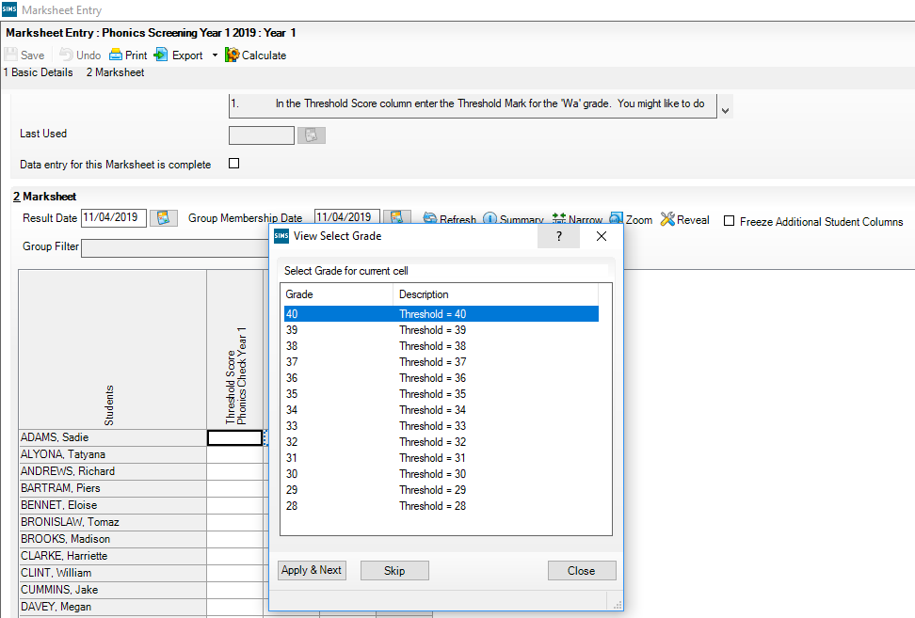

- The column will flood fill the threshold score for each pupil.
NOTE: Data used here is only an example.
- Click Calculate.
- A phonics outcome grade will be displayed.
- Click Save and then click Close.

