Salary Calculator

Focus | Personnel | Salary Calculator

Click the Plus to add a new Salary Calculation or the Pencil to edit an existing calculation

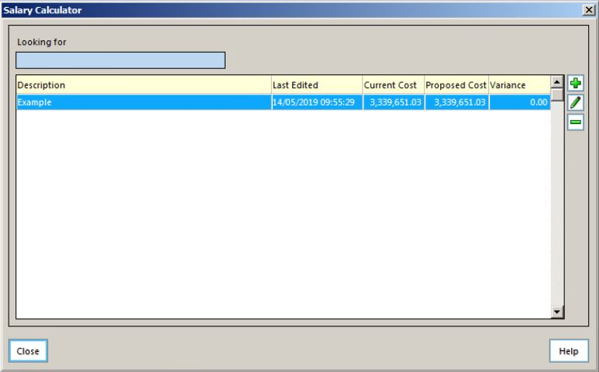

Highlight a member of staff and click the pencil to create a Salary Calculation or click the Plus to add a new record for a member of staff that might be joining in the future.

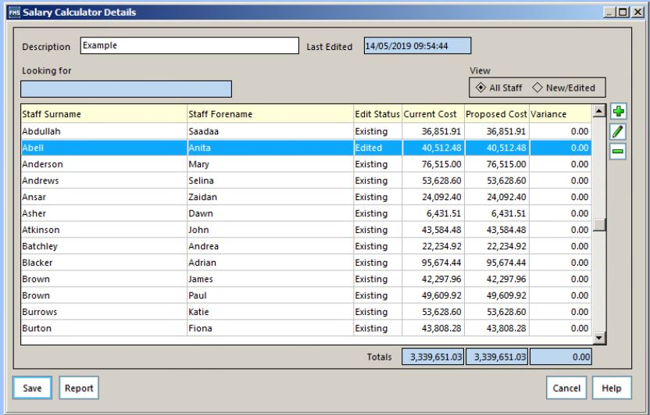

It is important to note that if in SIMS, a Service Term is ticked to have Spinal Progression (increment) then the Salary Calculator will automatically appropriate that progression in September. If the member of staff will not be eligible for the Spinal Progression, it will be necessary to create two entries for the Scale. In the example below, the Spinal Progression was September. One entry is on scale point 1, 1st April to 31 August, the next entry, also on Scale Point 1 starts on the 1st September to 31st March. This will prevent the Salary Calculator incrementing the member of staff up the pay scale.

