Creating a report to determine which Aspect is contained in an Assessment Template/Marksheet.

Firstly, you may wish to determine which aspect you are looking for. To do this, open the student record and click on the “Assessment” shortcut on the right-hand side:

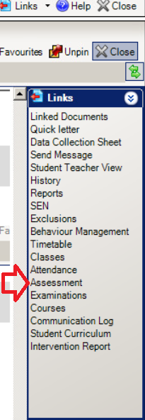

This will show a summary of all of the student’s assessment results (check the date range and also tick the box “Display All”)

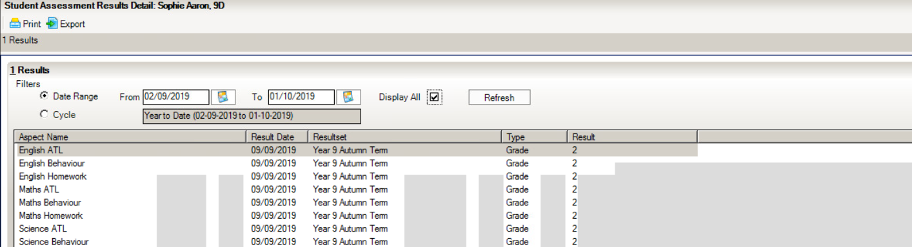

Then, go to: Reports/Design

Click on “Create a new report”

Scroll down to “Assessment Manager” and click on the + symbol. Choose “Aspect”
Then click on Next.

Under “Select fields to be included in the report”:

Select:
Aspect Name
Related – Templates
Click on the + next to Templates and select Template name

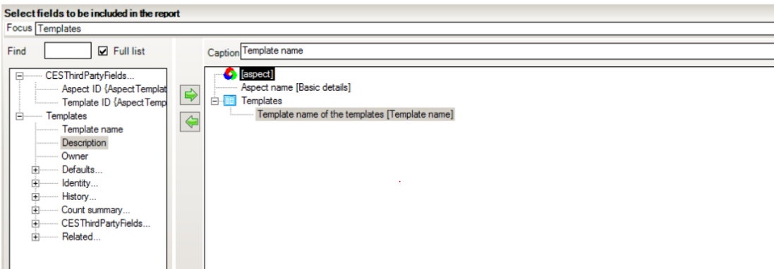

Then click Next

Under Define Filter
Click on New and select Aspect name
Set the Condition to “equals” and enter the name of the aspect eg “GA KS5 Target English Lang”
Tick the box Prompt at runtime
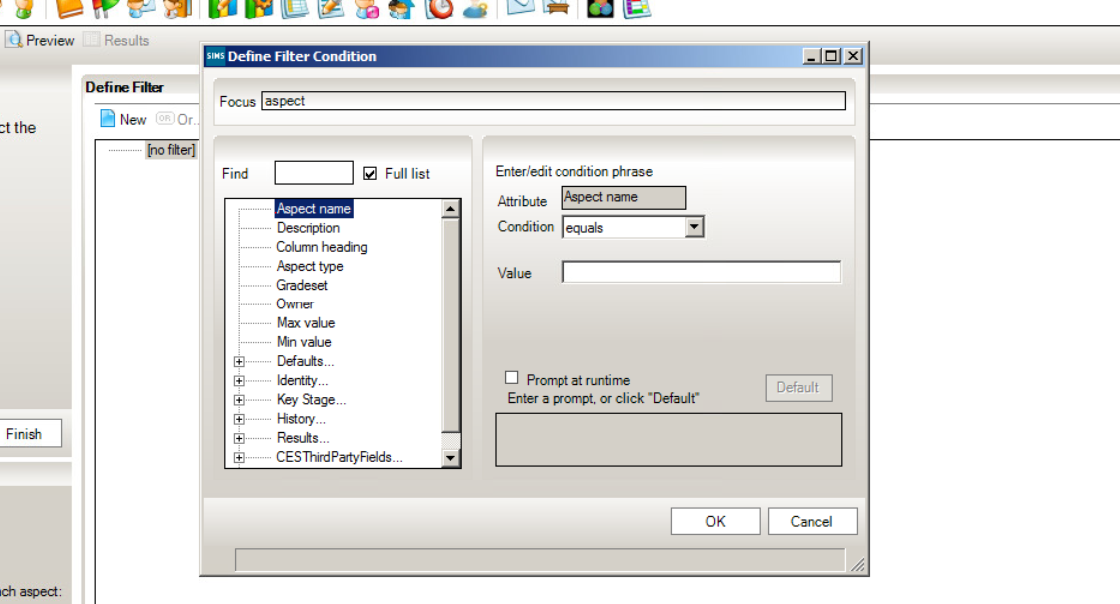

Then click on Ok.

You are now ready to preview the results – click on “Preview”

