CAS Post 16 Value Added Ready Reckoner

These Instructions are based on the Excel spreadsheet Ready_reckoner_-_unamended_2018, provided by the DfE in October 2018, and so any questions about the list of subjects and the calculations thus produced from the valued added data included in that spreadsheet, should be addressed to the DfE.
Prerequisites
- The school must have aspects and complete set of predicted or actual results for one result set for post 16 students in Assessment Manager.
- The grade sets used in the school’s aspects must match the grade and points used by the DfE, e.g. A*=60 points for a single A level for example.
- Each student must have a KS4 Average Points Score stored in an aspect in SIMS. This score now needs to use the ‘new’ KS4 points system, i.e. a C = 4 points etc. Note that if any student does not have an APS score, the report will not function correctly and give some error messages. If you wish to use this report for students where the APS has been recorded using the old points values, these must be converted or copied to an aspect using the nearest new points values since those are the only Value Added Graphs available.
- The zip file of the SIMS. net report definition, CAS Post16 VA Ready Reckoner v3.1.RptDef and the Excel template, ExcelCAS Post16 VA Ready Reckoner v3.1, must be downloaded from My Account and extracted to a suitable location

Instructions
There are essentially two parts to the preparation of the report, firstly to ensure the correct data is extracted from SIMS in the report definition, and then secondly that the list of aspects extracted from SIMS is mapped to the correct subject in the Excel template. Once those two parts are put together, the report should run to give the expected output.
The SIMS. net report
- Import the SIMS. net report definition, CAS Post16 VA Ready Reckoner v3.1.RptDef
- Open the report definition in design view and resave it with a suitable new name. (This is so you are able to edit it which is not possible with an imported definition)
- There are two edits which may need to be made:
  - In the data fields section:
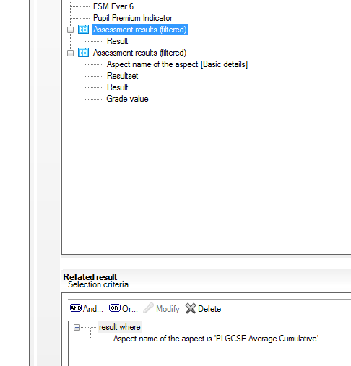
The first sub report is looking to find the students’ KS4 average points score in the aspect PI GCSE Average Cumulative aspect, which is where it would be if the school used the PI calculation process in Exams Organiser for the students’ KS4 results that year. If your students have that average points score in a different aspect, then modify the value to that required
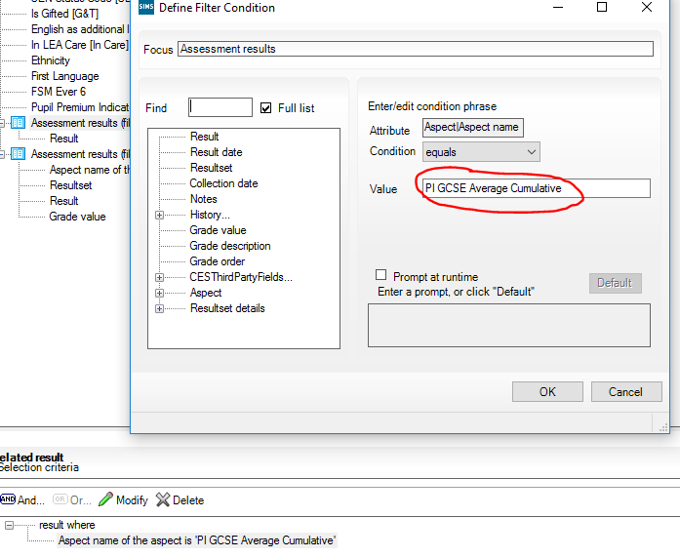
  - The second edit may be a bit more complicated, depending on how consistent you have been in naming the aspects used for the predicted grades in Assessment Manager:
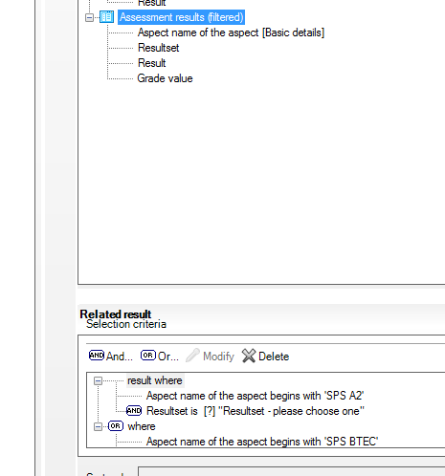
The default shown here is looking for aspects beginning with SPS A2 or SPS BTEC and then gives the user a choice of result set at run time. The end results required at this point is to extract the results from SIMS for a set number of aspects and a single result set which contain the data required but not to extract data which is not wanted. The intricacies of doing this are beyond these instructions and very much depend on the naming conventions used by the school.
  - Once these two steps are completed, save the report definition.

The Excel template
- Open the Excel template ExcelCAS Post16 VA Ready Reckoner v3.1, ignoring any error messages. Macros must be enabled.
- Find and open the Qualification Lookup tab, and look in column M.
- Column currently contains an example list of aspects. This list needs to be replaced with a list of the aspects used by the school and which will have the results in them when the report which has been altered above is run for a particular result set.
- Once this list is entered, it is then a case, as in the examples, of finding the exact matching qualification from the list starting in column A of the same tab, and copying and pasting all of the row into columns N to W next to the school’s aspect.
- Once this list is complete, save and exit the Excel template.
Putting the report together
- Open the SIMS. net report definition in design view.
- Click the Default Output link on the left
- Click the Standard Portrait radio button
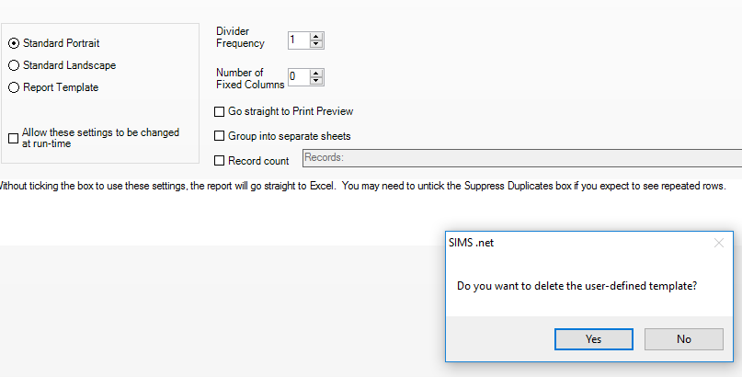
- Click yes to the above question, then click the Report template radio button
- Browse to the Excel template edited above, open it and then save the report definition
Running the report
- Click Reports, run report, and choose the report definition you saved above. (If you were the one who saved it, it will be in your My reports; if not it will be in the student focus.)
- Choose the same results set if the question is asked more than once and choose the single year group.
- Once the report has run, it must be saved as a macro enabled spreadsheet
- The important tabs to look are:
  - The student tab
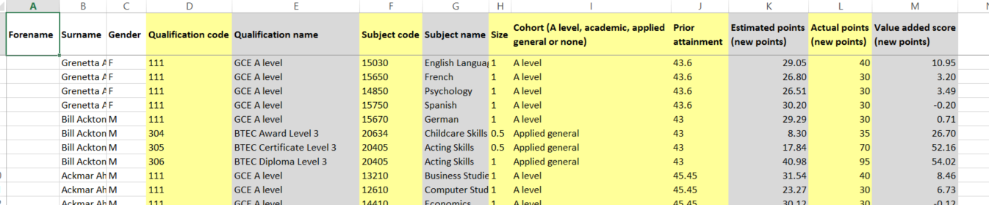
This gives each student, all of the subjects they have taken, and their value added score in each.

  - The Headline Measures
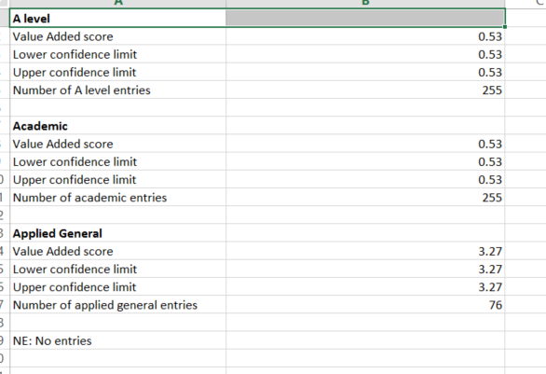
This gives the school’s value added headline figures for each type of qualification
  - The subject tab
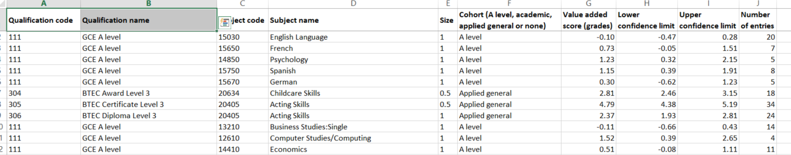
This lists each subject and the value added score for each along with the number of students taking that subject
  - The Subject Chart
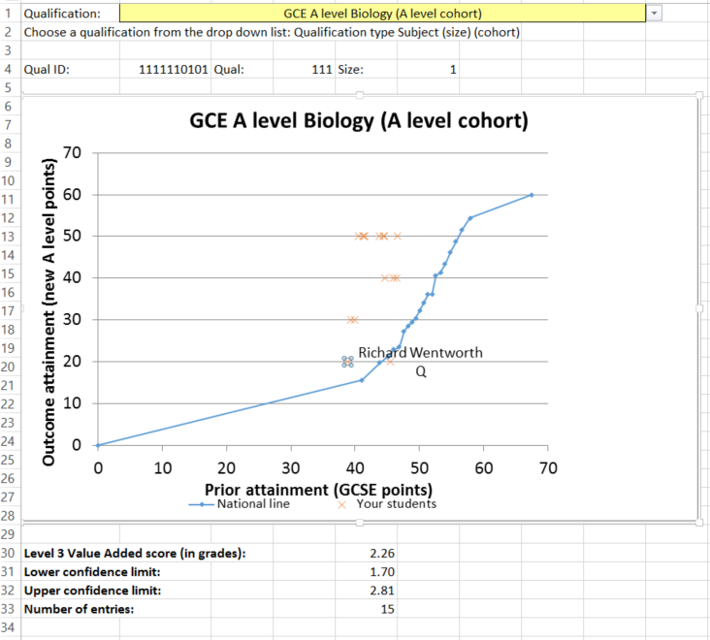
This has a drop down choice of each subject in yellow at the top, and when chosen the national chart for that subject is displayed, along with an x for each student taking that subject mapping their prior attainment against their current score. It is possible to double click on an x to find the name of any particular student.
Post 16 Value Added Ready Reckoner v3.1
The Excel file has been updated to include a tab with a Box plot of the value added and upper and lower confidence limits. The maximum and minimum values on the vertical axis are 3.00 and -3.00. The maximum number of subjects is 40. If you require a broader range or more subjects then edit this on your excel file before you reattach the excel file to the report in SIMS

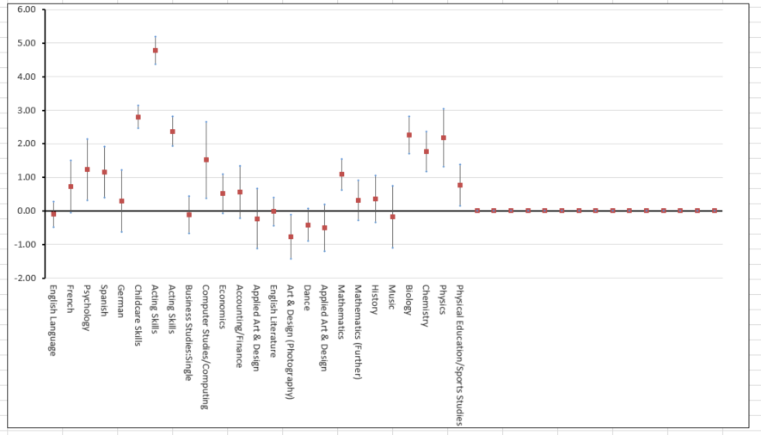
To edit the range
Right click the graph and select Format Plot Area. From the Plot Area Options menu select Vertical Axis, then the bar chart icon, then axis options. Change the minimum and maximum values as required in the format axis window on the right.
To increase or decrease the number of subjects shown
Right click the graph, and chose Select Data from the menu. In the legend entries on the left select each of the 3 options in turn (Value added score, Lower confidence limit and Upper confidence limit) and click on edit. In the series values box reduce the number from 41 to one more than the number of subjects you want your graph to show

