Babcock have produced an Excel Spreadsheet for recording end of year assessments for Reception, Year 1 Phonics, Year 2 and Year 6 pupils. These sheets look to take a March Assessment for Reading, Writing and Maths and to assign this a Security Rating.

For schools using SIMS it would be possible to put this data in using SIMS Assessment Marksheets. Scomis have produced 4 mark sheets which Schools can import into their SIMS and use to record this data.

There are 3 simple steps
1 Download and Import the Templates
2 Attach the relevant Year Group or Class to the template
3 Fill in the Marksheets which can then be exported into Excel.

1 Download and Import the Templates
Download the Babcock Assessments .xml file in this FAQ
Log on to SIMS – you will need to have School Administrator or Assessmnet Co-Ordinator permissions.

Routines – Data In – Assessment – Import
Browse to the Babcock Assessments.xml file and select it for import

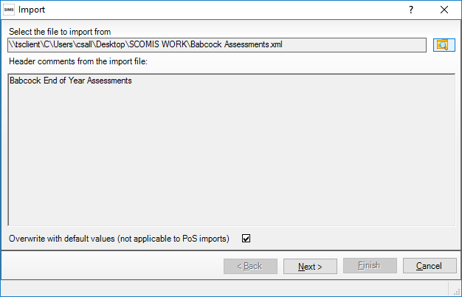
Click Next
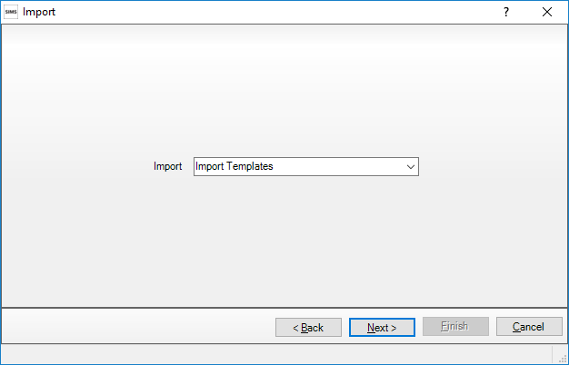
Make sure Import Templates is selected and click Next
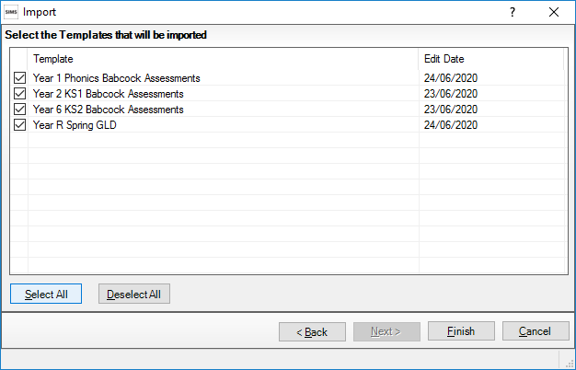
Select all the templates to import and click Finish
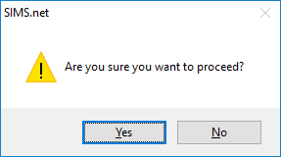
Say Yes to proceed
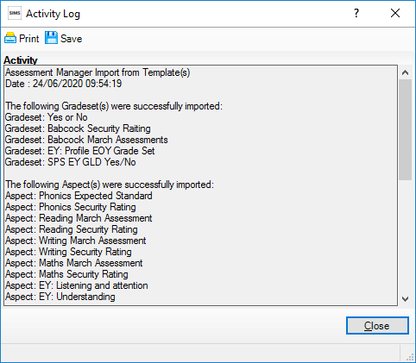
You should get a message that these have been successfully imported

2 Attach the relevant Year Group or Class to the template
Focus - Assessment – Template
Browse to the Year 6 KS2 Babcock Assessments Template
In Section 2 click New
Choose Year 6 from the Year Group area and any classes from the Registration Group Area.

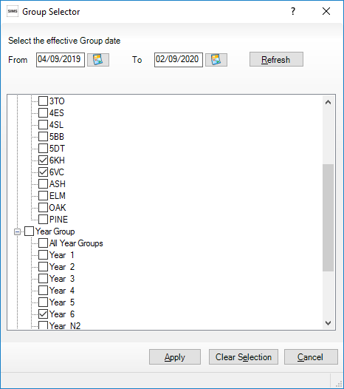
Save the template and the Marksheets are available for use.

3 Fill in the Marksheets which can then be exported into Excel.
Focus – Assessment – Marksheet Entry
Find the Marksheet you created in Step 2. Double-click to open.
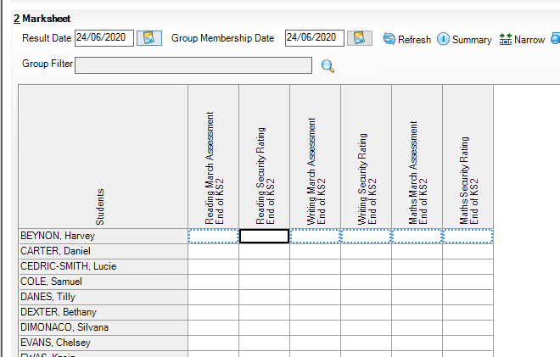

Right -click the first cell and choose selcct Grade for Cell – this brings up a Grade Picker where you can click a value to enter data in the cell. The system then moves down to the next student

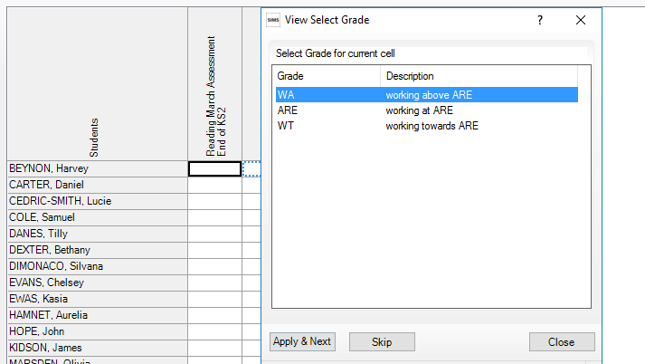

Repeat until you have entered all the grades required. Save your grades

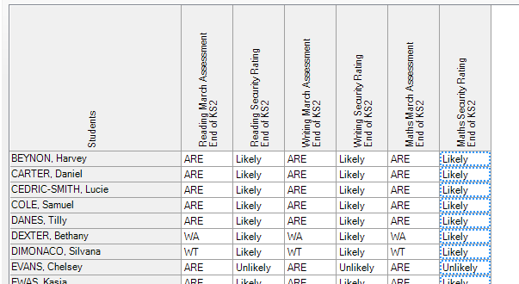

If required you can then Export to Excel using the Export button

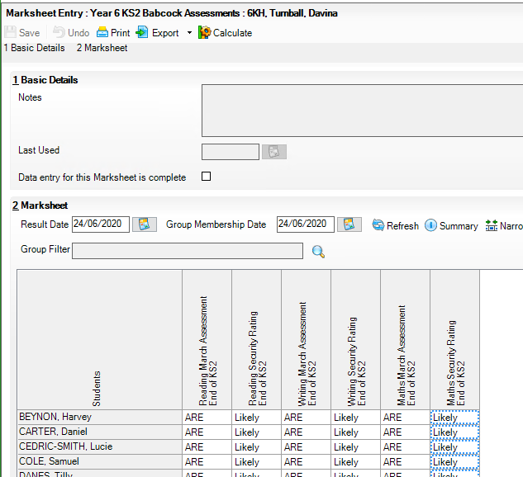

If you wish to Add more information about the students you can right-click the Students Column Heading and add Additional Columns

