To create/delete a new Band in Nova

Click this icon and the popup message appears. Click No to create an empty new band. If you want all the blocks stretched across two bands, click Yes. This is used occasionally but stretching blocks across two bands can be done later.

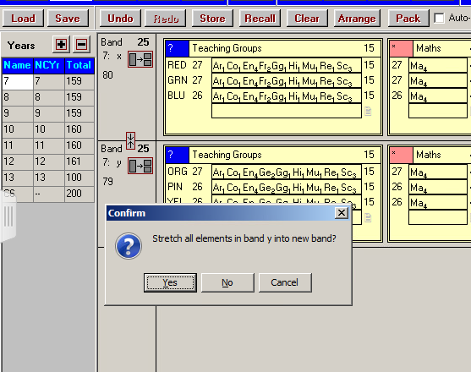

The empty new band will have been given the next letter eg. z

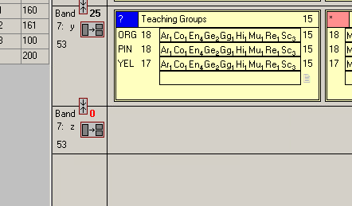

You can change the name :

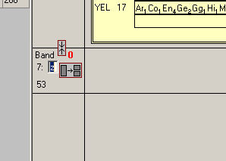

Right click to Add a block and drag in the subject from the right hand panel and add the number of classes eg 4

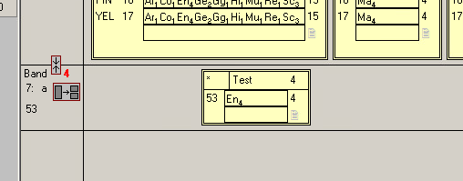

To delete a band click here If you don’t delete the block first the block will be merged with the band above.

