SIMS .net Assessment

Phonics Check
Autumn 2021
for Year 2 pupils

Version 1.2

REVISION HISTORY

Version | Change Description | Date
1.0 | Updated for Autumn 2021 | 29/07/2021
1.1 | Babcock update | 5/10/2021
1.2 | Update screenshots Autumn 2021 | 12/10/2021

Introduction
Due to the COVID pandemic the Department for Education and Standards and Testing Agency delayed the assessment and return of the Year 1 Phonics Screening Check which was due in June 2021.

This is a statutory requirement.

The phonics screening check is an annual statutory data collection for Year 1 pupils that takes place each June.

Phonics teaches people to read by relating sounds with letters and words. The phonics screening check is designed to check whether pupils understand phonics to an appropriate standard.

You must submit phonics screening check assessment data for year 1 pupils in all:

schools maintained by the local authority
academies
free schools
special schools (schools for children with special educational needs or disabilities)

What happens next?

The Phonics Screening Assessment Data is to be collected for the present Year 2 pupils that missed the June collection when they were in Year 1. This will now take place after Autumn half term (between 12 November and the end of the Autumn Term).

At schools discretion a choice of the past papers from 2017, 2018 or 2019 can be used for the screening.

Schools should return results to their Local Authority before the end of the Autumn Term.

Please Note:
- No data is to be collected for Year 3 pupils that missed a year 2 resit in June and no future data will be collected for those pupils.
- No data is to be collected for current Year 1 students as that collection will happen as usual in June 2022.

Important Dates

22 October 2021 | Deadline for schools requiring Braille copies of the test to apply to the DFE for materials
Second half of the Autumn Term | Schools must administer a past version of the phonics screening check to year 2 pupils.
By the End of Autumn Term or earlier if advised by the Local Authority | Schools must forward CTF result files to Local Authorities by the end of term or by the date given by their LA.
Between 6 December 2021 and  21 January 2022. | Local Authorities must forward the results to the DfE via COLLECT

Schools Administration of the Check
Please use the Phonics Screening Year 1 Template already in SIMS to collect the data.

When creating marksheets, please ensure that when data is entered the actual date is correct. (Do not backdate to last term).

For further DFE collection guidance click here

For further DFE administering the check guidance click here

For links to previous screening check materials for 2017, 2018 and 2019 click here

Permissions:

Please note, to carry out the Phonics process, users will need SIMS permissions of Class Teacher/Registration Tutor (to enter their own results) but to have access to enter all the results users will need Assessment Co-Ordinator or Assessment Operator permissions.

Step 1 - Check SIMS .net Version

In order to export and return the 2021 CTF Phonics Test Results (For Autumn Term Screening Check Only) you will need to be using the Autumn 2021 Main release version of SIMS.net.

To check that your system is ready:

- From your SIMS Homepage: Go to Help | About SIMS.net.
- Check that the version of SIMS.net is 7.202

Step 2 - Preparing to Enter Results for Year 1 Phonics

- Go to Tools | Performance | Assessment | Wizard Manager.

- Leave the filter on ALL and highlight Year 1 Phonics Screening Wizard 2021 (dated 01/09/2020) You may need to expand the name column to see the whole of the name.

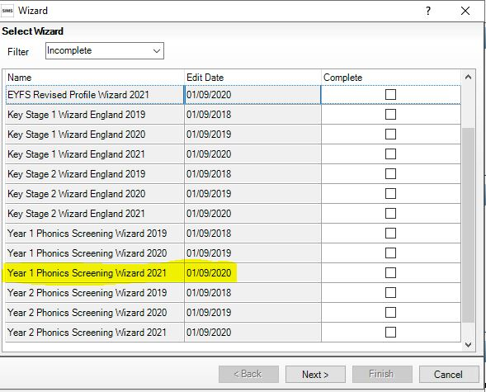

- Click Next.

- You may be offered to update the Assessment Manager resources at this stage, please choose Yes and update to bring in all the templates you may need.

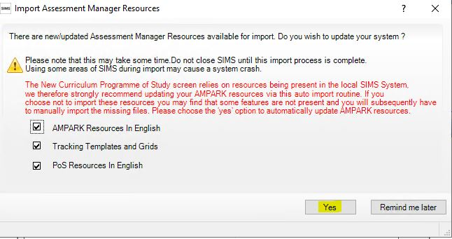

- Once the import has completed, you may have to go back to choose the Wizard template again, follow Step 2 again above and once you have clicked Next

- Click the browser (magnifying glass).

- The Group Selector appears. Click the + next to 'Year Group' and choose Year 2 then click Apply.

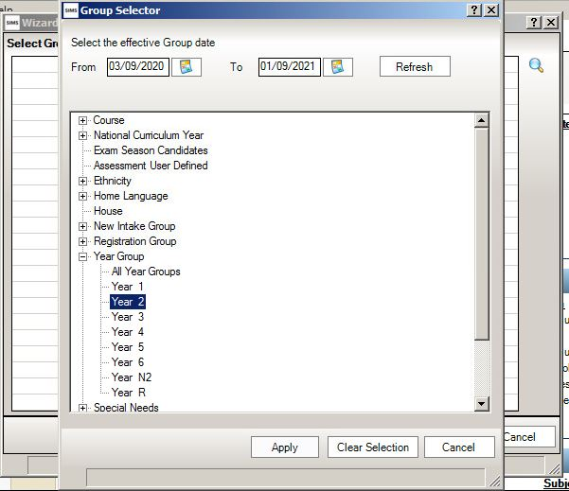
Select Year 2 and Apply

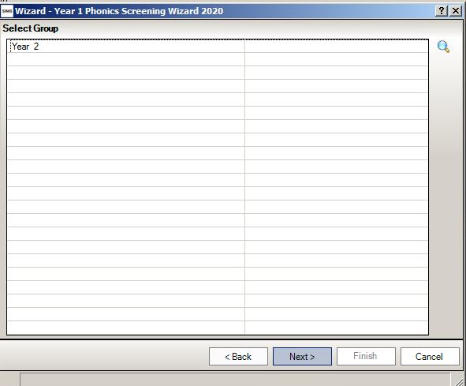

- Click Next for the Marksheet Entry window.

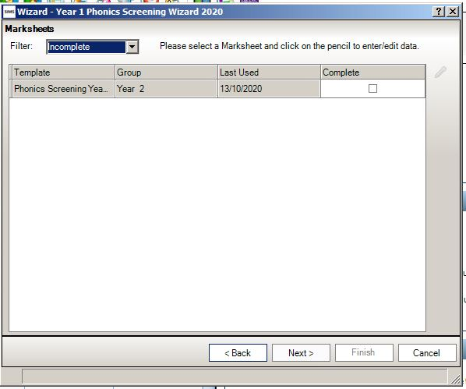
Year 2 will now show in the group box.

Click to highlight the marksheet.

- Highlight the Phonics marksheet and then the Pencil will become available. Click on the Pencil icon on the right-hand side to display the marksheet.

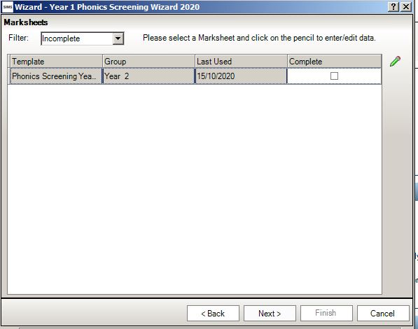
The pencil will now be available, Click the pencil

Step 3 – Enter Results
- Please check and update the Threshold Score column if necessary to show 32.
- From the marksheet enter a value of between 0 and 40 into the Mark for Phonics Check Year 1 column, or a grade as defined using the guidance table on page 10 below for reference.
- Click Save. This will calculate the Data Check column.

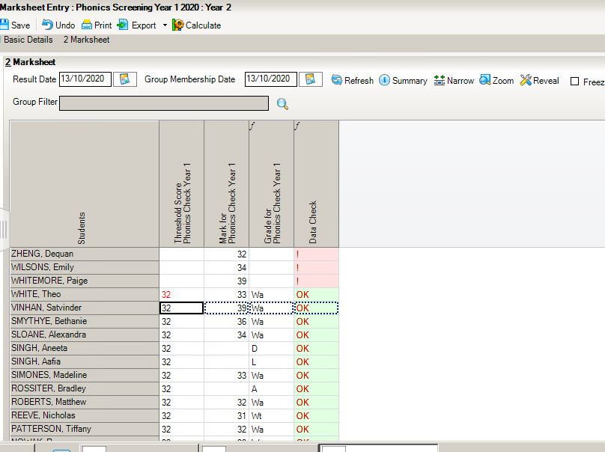
To enter L (Left), D (Disapplied) or A (Absent), type the letter directly into the Grade for Phonics Check Year 1 column.
The Data Check will show an ! which indicates there is a Threshold mark missing

OK is displayed as a check for those pupils who are A, D or L and who did not take part in the check.

Leave the mark column blank for those pupils who have Left, are Absent or have been Disapplied or did not take the screening check.
Please do not put a 0 in this column.
This column must show the 32 Threshold Mark.
If not pre-populated right click on column heading and choose 32 from list.

NOTE:
To amend a result that has already been saved, right click on the cell that contains the result, select View/Edit Result History, click on the result under the Result Column and type the amended result. Click the Close button. Click Calculate and Click Save.

IMPORTANT NOTE:
ONLY for Pupils working out of Year
For schools with pupil(s) working out of year and taking the Phonics check (eg; those in NC year 3 but working as year 2) please see Step 4 below.

Children who are absent, on your planned checking day may be checked on their return to school anytime during the 14th November to end of the Autumn Term or when your Local Authority have advised.
For those children that remain long term absent, do not take the check or have left. The mark field must be left blank and the phonics grade of A, D or L entered accordingly in the Grade column.

Guidance on marking
The threshold values will remain at 32 and the ‘phonics mark’ will be the mark from 0-40 for those children who have taken the phonics screening check.
Description | Process | Mark | Phonics Grade
Child took the phonics screening check and met the required standard. | A mark of 0 – 40 is entered from the screening check outcome.  The grade will be applied automatically related to the threshold of 32 | 32 – 40 | Wa
Child took the phonics screening check and did not meet the required standard. |  | 0 – 31 | Wt
Absent | Leave the Marks column blank and enter the grade as per the list to the right. | Leave blank | A
Child did not take the phonics screening check | Leave the Marks column blank and enter the grade as per the list to the right. | Leave blank | D
Child has left the school | Leave the Marks column blank and enter the grade as per the list to the right. | Leave blank | L

Step 4 – There is no requirement in the Autumn check to re-check any Yr 3 pupils.
However, if you have children working out of year once you have administered the check for the Year 2 cohort, you will need to go back to the wizard in step 2. At point 5 in the Group Selector choose the Year 3 cohort and then when entering results enter results for only those being checked.
If there are several students it may be easier to create a user defined group for those working out of year, this can then be picked up in the Group Selector instead of the whole Year 3 group.
If you would like to choose this option our FAQ will guide you through making a user defined group. https://faq.scomis.org/kb15030/

Step 5 – Exporting Phonics results in a CTF file to send to the Local Authority
The Year 2 Phonics results need to be sent to the LA. The LA may ask for results by way of a CTF.

NOTE: There is a new CTF export type in the SIMS Autumn 7.202 update which is to be used to upload the CTF file to the Local Authority. The procedure for uploading the CTF file will vary from one Local Authority to another. Please check the advice given by your Local Authority before proceeding.

Step by Step – Create a CTF File for pupils in Year 2

Go to Routines | Data Out | CTF | Export CTF

Select the new Phonics Test Results (For Autumn Term 2021 1st Screening Check Only) from the Export type options

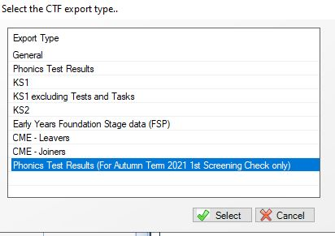

  - In the Student Options area, enter a tick against ‘Include students already exported’, and ensure that the View is set to “Current Students”, then click Refresh Students.

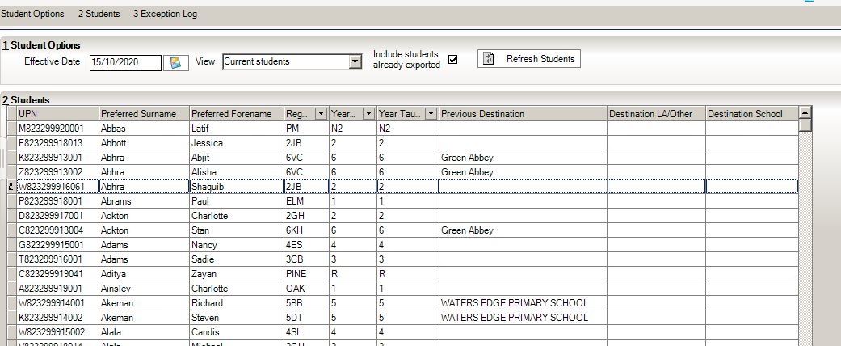
Set View to Current Students

Tick include students already exported

Click to Refresh Students

  - Right mouse click on the Year Group Column and if you do not have any out of year students select only Year 2– If you have some out of year students being checked Select Sort Ascending so you may add any additional year 3 that are working as year 2.

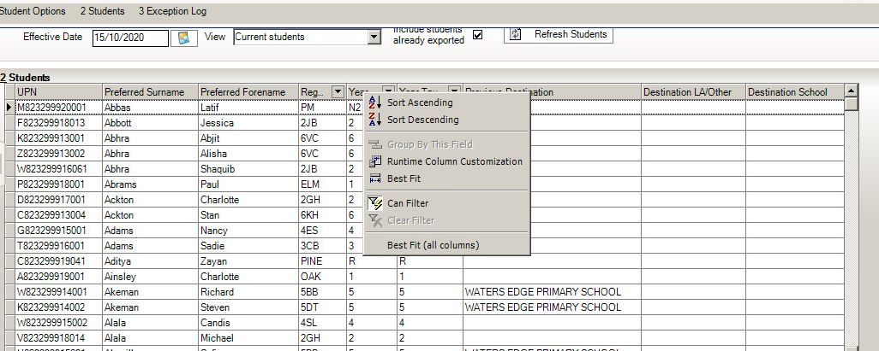
Right Click Year Group heading

Click to sort ascending
05/05/04/2019

  - Scroll past the Year 1 pupils who should be at the top of the list.

4. Highlight the first Year 2 pupil and hold the shift key down continuously on your keyboard whilst you scroll down the list of pupils – left click on the last pupil in Year 2 – all Year 2 pupils will now be highlighted. Release the shift key when all the pupils required have been selected.

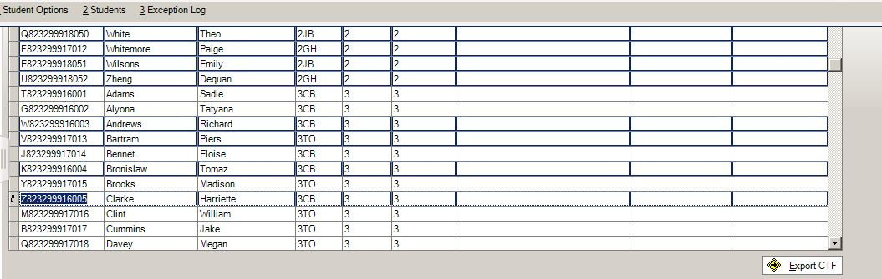

5. If you have pupils out of year that have taken the screening please select them by
holding down the Ctrl key and clicking each one to add to the highlighted selection.

6. Once all you require are selected left Click into Destination LA/Other on the last pupil
you have selected. Click on the down arrow to display the list of Local Authorities

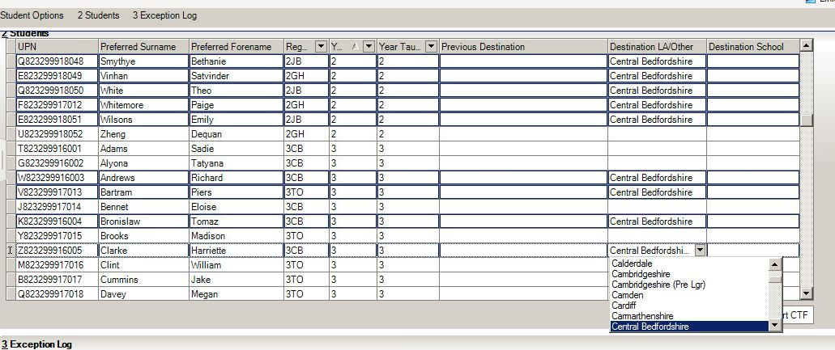

NB Selecting a pupil further up the list will deselect all the other pupils so make sure you click destination LA/Other column of the last selected pupil.

7. Select your Local Authority from the list.

8. All the selected pupils should be showing with the authority in the Destination LA / Other column.

9.Click Export CTF – a single CTF file will be created for all the selected pupils. A confirmation will appear with the name of the file.

823 – An example of your Local Authority Number

2999 – An example of your School Number

PHO – Results you are exporting

823LLLL – Results exported and export destination - eg Local Authority

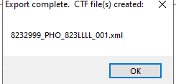

At this point, please confirm that the number of students in the file is correct and as expected.

Make a note of the filename here in case of a query with the Local Authority:

Step 6 – Sending the Results File to your Local Authority
The CTF containing results should now be sent to your Local Authority.
Upload the file to the Local Authority in the normal way prescribed by them by the date they have set.
Information for Devon Schools may be found at https://faq.scomis.org/kb367771/

Step 7 - Using the Wizards for Reporting to Parents for Phonics
Once all the results are entered on the marksheets the following reports can be produced:

KS1 Y1 Phonics Student Eng 2021 (Autumn 2020 for Year 2 pupils)
This will generate an individual report for each pupil.

KS1 Y1 Phonics Comparative Eng 2021 (Autumn 2020 for Year 2 pupils)
The comparative report compares the percentages by Phonics results for the school in 2019 with the national results for 2016.

- Select Tools | Performance | Assessment | Wizard Manager.
- Select the Year 1 Phonics Screening Wizard 2021 (dated 01/09/2020)
- Click the Next button.
- The group selection may be left as it is. Click the Next button.
- At the marksheet window, click Next.

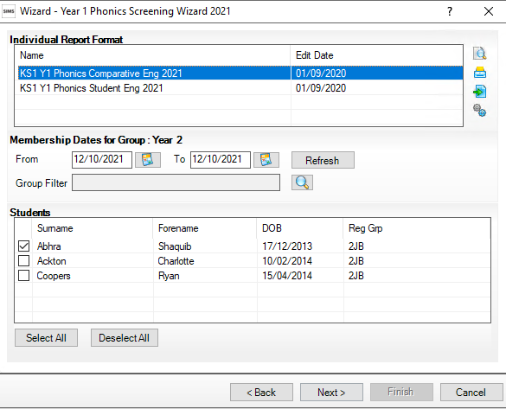
Print
Upload
Export
Preview

- To preview a report, ensure one of the pupils is ticked then click the Preview Report icon.

- To print the reports choose Select All. Click the Print icon. Reports will be printed from Word for those pupils selected. Close Word without saving.

KS1 Y1 Phonics for Yr2 Student Eng 2020
(please note this is an example so the year information is not accurate)

The report consists of two pages:

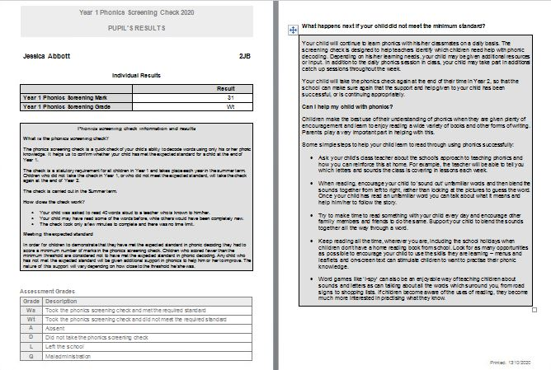

KS1 Y1 Phonics for Year 2 Students Comparative Eng 2020
(please note this is an example so the year information is not accurate)

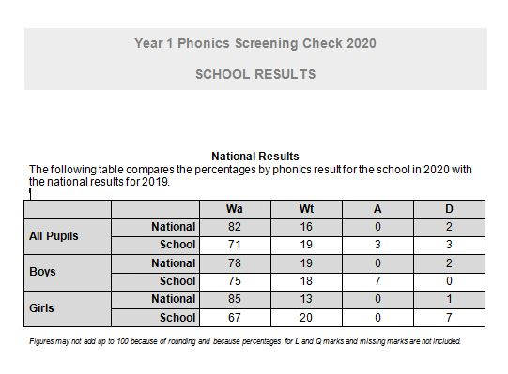

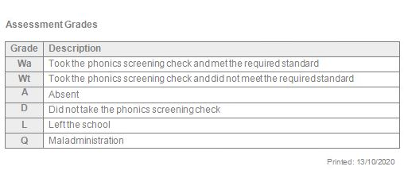

Step 8 - Upload Reports

A copy of each child’s report can be saved in the Document Server. This can then be viewed at any time.

- Once reports have been generated they can be uploaded, either individually or in bulk, by clicking the Upload icon.

- To view the copy open the Pupil Details screen for the child and select Linked Documents in the Links panel on the right. The report will open as read only.

