SIMS .net Assessment

Key Stage Wizard 2024

Early Years Foundation

Profile

Version 4.0

REVISION HISTORY

Version | Change Description | Date
1.0 | Updated to 7.186 | 11/04/2019
2.0 | Updated 7.204 | May 2022
3.0 | Updated 7.210 | April 2023
4.0 | Updated to 7.216 | April 2024

Introduction
This book covers the process from beginning to end for the Early Years Foundation Stage, including importing the wizard, entering results, printing the reports and exporting the results.
By the end of this book, you should have completed the following:

To do | Page | Completed
Importing the Wizard Marksheets | 4-6
Entering your results | 7-12
Create results CTF | 13- 16
Create Reports | 16-17

As these Teacher Assessments form part of the CTF that accompanies children if they transfer between schools, it is a statutory requirement that where you are using alternative software for recording assessments, the data is also imported into SIMS.

Please refer to your software supplier for guidance and instructions on how to do this.

The EYFS profile must be completed for each child who will be five years old on or before
30th June 2024 unless:
• an exemption from the profile has been granted for the setting by the Secretary of State;
• the child is continuing in EYFS provision beyond the year in which they turn five;

Step 1-Check SIMS .net Version

In order to use the 2024 Wizards, you must be using the Spring 2024 Main Release version of SIMS .net or later. To check:

Go to Help | About SIMS .net.

Check that the version of SIMS .net is v7.216

Please note: If you buy the Hosted service from Scomis then your SIMS will automatically be updated to the new SIMS.net v7.214

Step 2 – Identify the Early Years Foundation Stage Pupils
If the Reception year in SIMS includes all the pupils being assessed continue to Step 3.
If pupils outside of the Reception year are being included in the EYFS assessment, or some of the Reception pupils are not being assessed, please refer to the notes for Creating a User Defined Group by clicking on the link below.
http://faq.scomis.org/kb15030/

Step 3-Import the Wizard for EYFS Profile 2024
- Select Routines | Data In | Assessment | Import. If you see a screen similar to the one below, click Yes.
- Once the update has completed, Close the activity log.
If you DON’T see the box above, then you will need to browse to the folder locations -
- Select the file to import by clicking the Browser button.

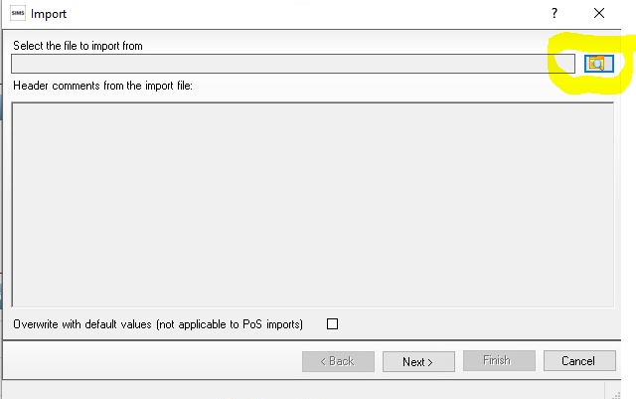

You will then need to go to the following file location -
- Hosted Schools:
F:\Public\AMPA\ England Primary (and Middle Deemed Primary)\Assessment Manager
- Non-Hosted Schools:
C:\Program Files\SIMS\SIMS.net\AMPA \England Primary (and Middle Deemed Primary)\Assessment Manager

3. Select the EYFS Revised Profile Wizard 2024 and click on Open
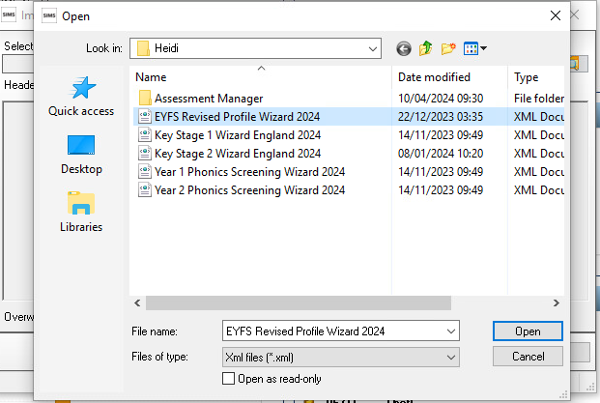
It will then show the below

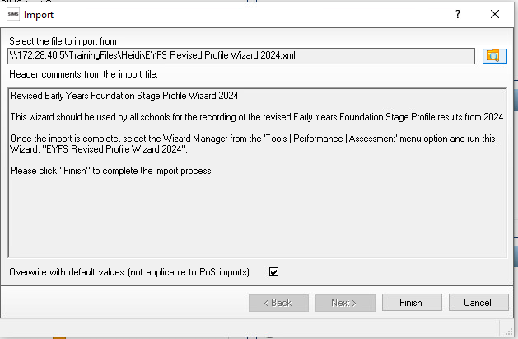
4. The Overwrite with default values check box should be ticked then select Finish. Click the Yes button when asked ‘Do you want to proceed?’

- An Activity Log shows what has been imported.
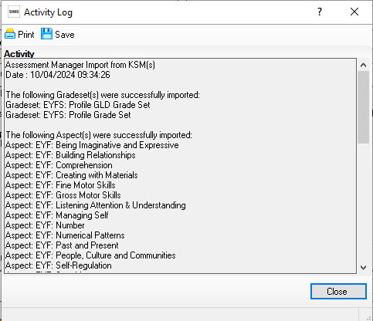

You can then click Close.

Step 4-Enter Results
Now you have imported your marksheet it is time to enter your results.
- Go to Tools | Performance | Assessment | Wizard Manager.
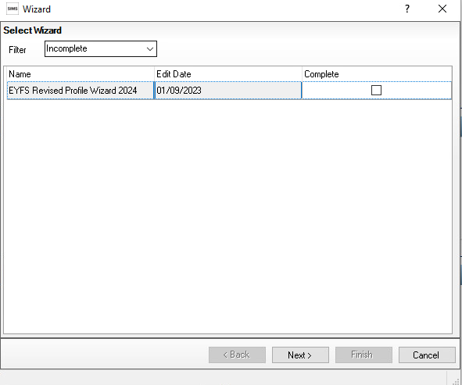
If other wizards have been imported in the past they will also appear in the list.
Leave the filter on Incomplete and find the wizard which is going to be worked with – in this case EYFS Revised Profile Wizard 2024.
- Click the Next button.

- From the Select Group screen, click the Browser button (magnifying glass) to display the Selector dialog.
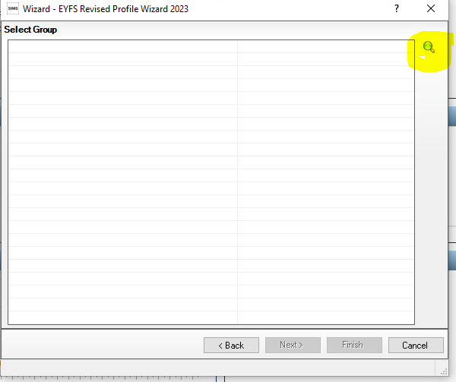
- Click the + icon next to Year Group and select Year R
OR the + button next to User Defined Groups to select the user defined group, if you created one earlier, then click the Apply button. This places this group on the Select Group screen.
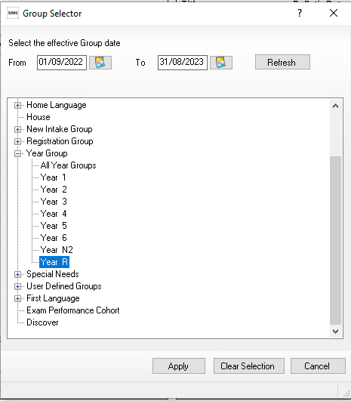
Click the + icon next to Year Group and select Year R then click the Apply button.

Or the + button next to User Defined Groups to select the user defined group, if you created one earlier, if applicable. Then click the Apply button. This places this group on the Select Group screen.

5.Once your Year R group is showing Click the Next button.
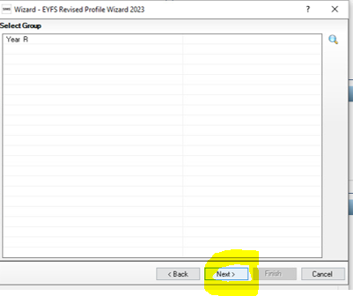

6. The following screen appears listing the marksheets available
Click on EYFS Revised Profile 2024 so it highlights blue.

Click on the Pencil icon to open the marksheet.
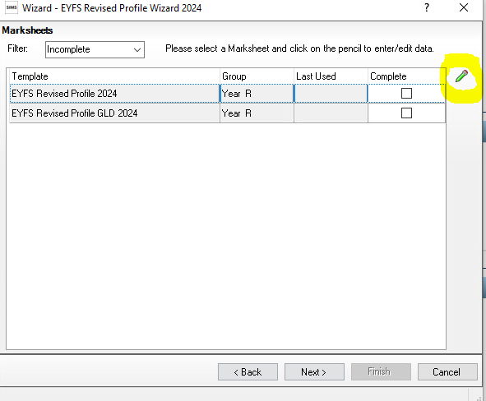
A marksheet with the Year R pupils is displayed (or the User Defined Group if you created one earlier) and columns relating to the 17 assessments that need to be entered.
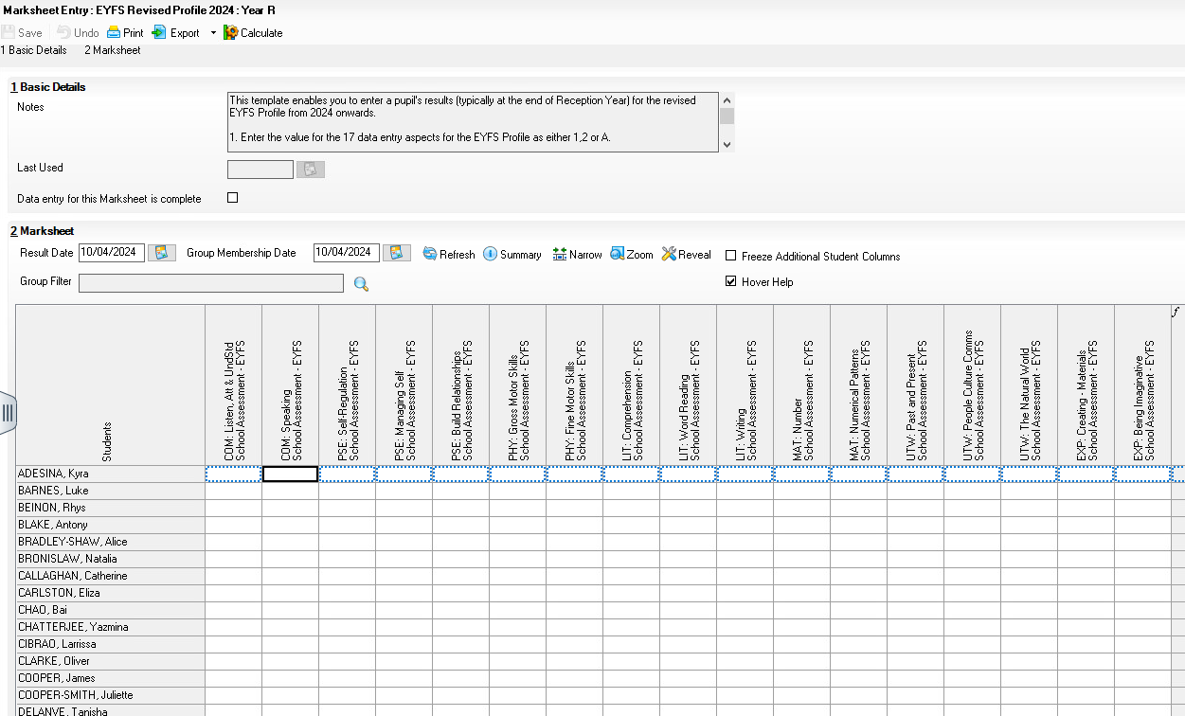
Now it is time to enter your results
- Click in a cell next to a pupils name and enter one of the following marks a 2 (Expected), 1 (Emerging) or A (Can only be used if an exemption has been granted) for each pupil in the appropriate white cells.
- For a quicker method of entering results - right click your mouse on the first cell you wish to enter a result into and choose Select Grade for Cell to display the dialogue box. Double clicking on a result from the dialogue box will enter it into the cell and move down to the next pupil so you can repeat the process.
Alternatively, you can right click in the grey column heading and choose Select Grade for Column. This will allow you to flood fill a column with the most popular result. You can then click into individual cells and change to the appropriate grade before clicking Save.

3. Once all these columns are completed click the Save button.
4. Click on the Calculate button to populate the Data Check and formula columns. The Data Check column is used to check there is an entry for each area for each pupil and alert you to any missing results.
Calculate
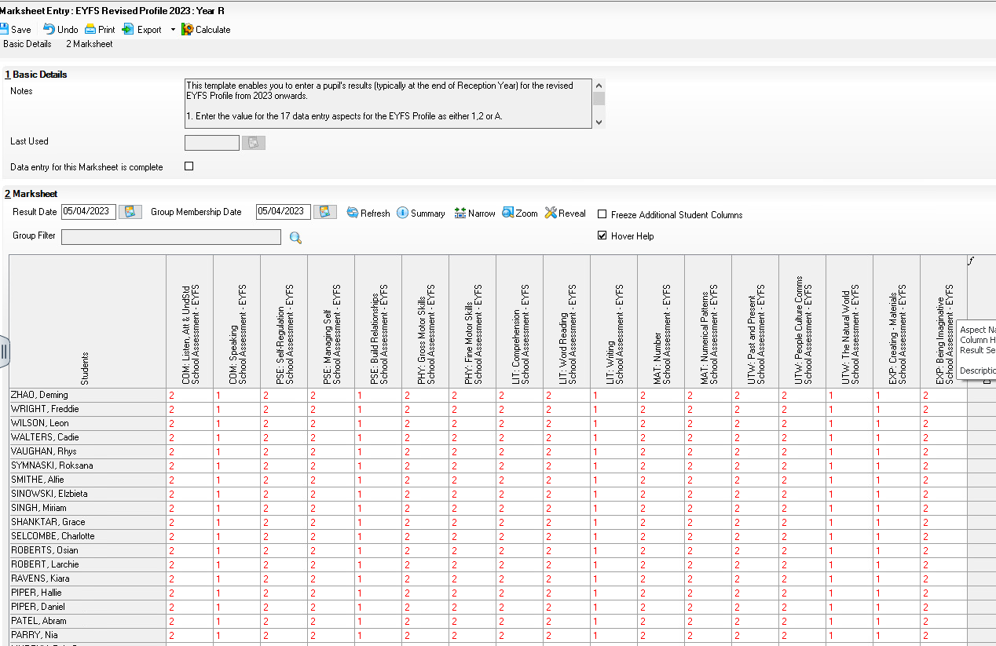
5. Enter any missing results by clicking in the empty cell.

Once you are happy you have entered all your results you can Close the marksheet from the top right corner. Make sure you have clicked Save before you close because it won’t prompt you if you haven’t.

Good Level Development
You will have noticed there are two marksheets for EYFS. The EYFS Revised Profile (which is the one you just entered marks for) and the EYFS Revised Profile GLD 2024. The GLD stands for Good Level of Development and this marksheet is automatically populated once you have entered your results into your EYFS Revised Profile 2024 marksheet.
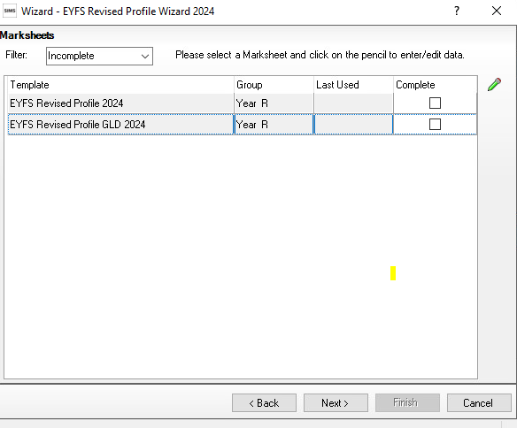
Highlight EYFS Profile Good Development 2024.

Click on the Pencil icon to open the marksheets.
You can select the GLD marksheet and click on the pencil icon to open. You should see all marks already populated. Click on Calculate. This will indicate if Good Level of Development has been achieved by putting a green Y or a red N next to the results.
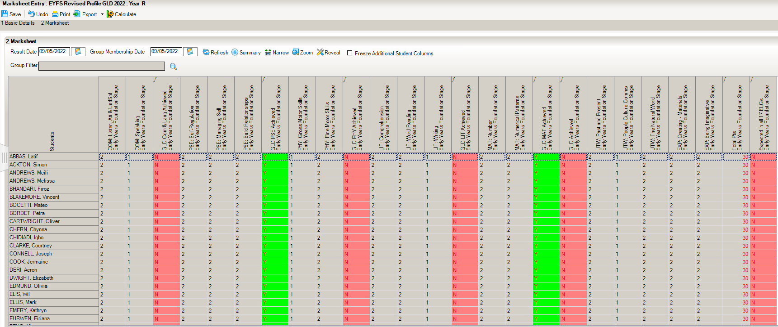

How to delete an incorrect grade in a marksheet
Results are stored against the student. Deleting a result from a marksheet does not delete it from the student which means the result will repopulate the marksheet each time it is opened.
To delete the result permanently:
- Open up the relevant marksheet
- Right click on the incorrect result
- Select ‘view/edit result history’
- Select the result and click on the red cross and click yes when prompted. There may be two results and you will need to click the red cross to delete both.
- Click Close

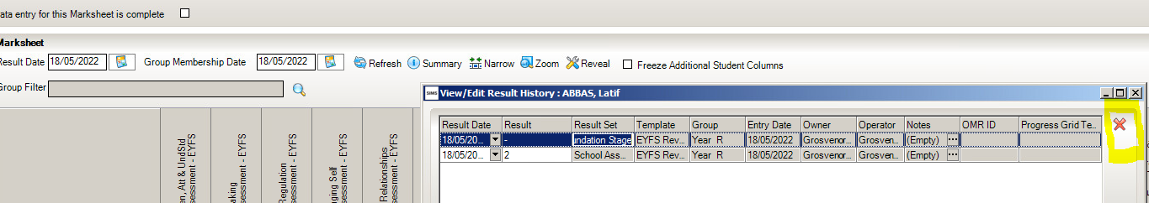

Step 5-Exporting EYFS Results in a CTF file to send to the Local Authority

Once the appropriate assessments have been entered for all pupils, you can close the Wizard and go back to your SIMS home screen. The results need to be exported to your Local Authority (LA). This is done by creating a CTF and sending it to your LA

The procedure for transferring the results will vary from one Local Authority to another. Please check the advice given by your LA before proceeding.

The following steps show the process for Year Reception.

- Go to Routines | Data Out | CTF | Export CTF
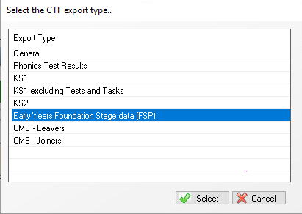
Select Early Years Foundation Stage data (FSP) from the Export Type options. Click Select

- This will then open a list of all your pupils.

- Click the down arrow on the ‘Year Group’ column heading and select Year Reception to show just the Reception pupils.

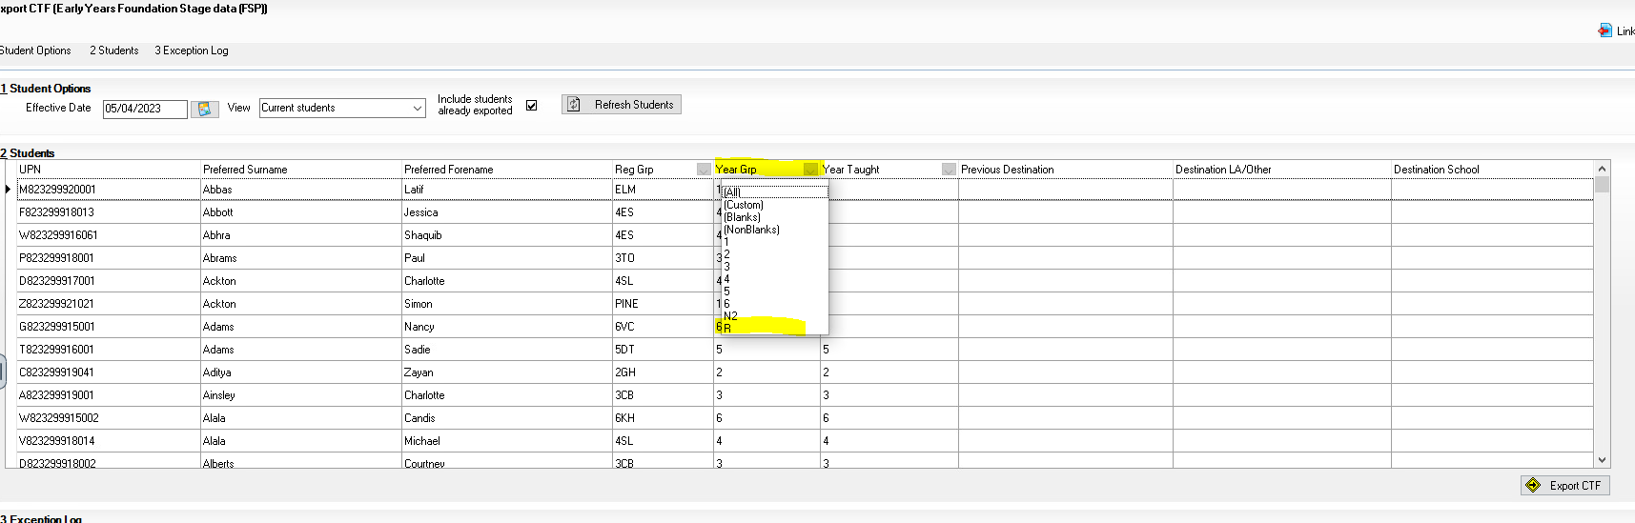

- You will now need to enter your LA into the Destination/ LA/Other column. You can select more than one pupil at a time by using the Shift key on your Keyboard.

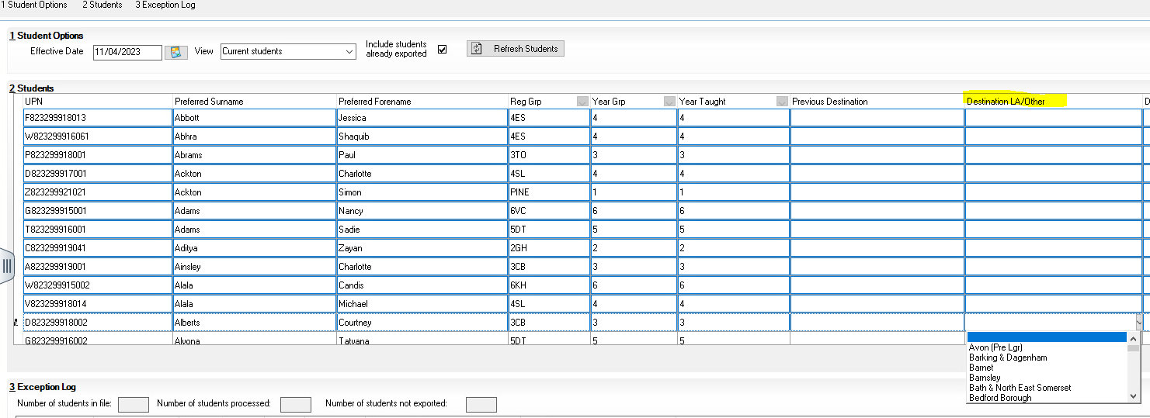
- Once ALL of your Year R pupils are showing with your LA next to them you can click Export CTF.

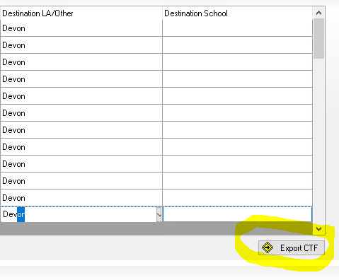

The following message may appear.
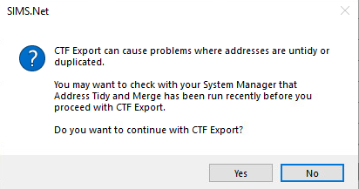
For the time being - Click Yes

A confirmation will appear with the name of the file.
823 – An example of your Local Authority Number

2999 – An example of your School Number

FSP – Results you are exporting (FSP stands for Foundation Stage pupils)

878LLLL –Export destination – e.g., Local Authority

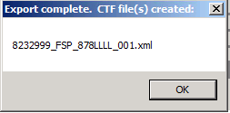

Make a note of the filename in case of a query with your Local Authority:

For creating a CTF for pupils from more than one year group please see http://faq.scomis.org/kb15034/.

For creating a CTF including leavers please see http://faq.scomis.org/kb15037/.

Step 6-Sending the Results File to Your LA
The CTF containing the results should now be sent to your Local Authority. Upload the file to the LA in the normal way prescribed by them.

Submission Date – 30th June 2023

Step 7- Using the Wizards for Reporting to Parents
You can also create reports to send to parents.

To access and use the reports:
- Go to Tools | Performance | Assessment | Wizard Manager.
- Select the EYFS Profile Wizard 2024 Click the Next button.
- Leave the group selection as it is. Click the Next button.
- At the marksheet, click Next.
- Choose the report you want to produce e.g., EYFS Profile Pupil Report 2024
- To preview a report, ensure one of the pupils is ticked then click the Preview Report icon
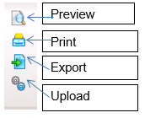
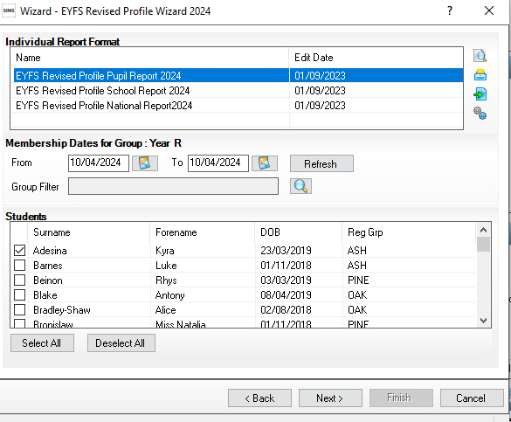

Three reports are listed.
  - EYFS Revised Profile Pupil Report 2024 - This report is an individual student report
  - EYFS Revised Profile School Report 2024 - this compares a pupil against school results
  - EYFS Revised Profile National Report 2024 - This compares a pupil’s 2024 results against 2022 National results.

Upload Reports
If you like you can save a copy of these reports to each pupils Linked Documents in SIMS.
A copy of each child’s report can be saved in the Document Server. This can then be viewed at any time.

- Once reports have been generated, they can be uploaded, either individually or in bulk, by clicking the Upload icon.

- To view the copy, open the Pupil Details screen for the child and select Linked Documents in the Links panel on the right. The report will open as read only.

