SIMS .net Assessment

Key Stage Wizard 2024

Key Stage 1

Version 4.0

REVISION HISTORY

Version | Change Description | Date
1.0 | Updated to 7.186 | 05/05/2019
2.0 | Updated to 7.204 | 07/05/2022
3.0 | Updated 7.210 | April 2023
4.0 | Updated to 7.216 | April 2024

Update from the DFE for 2024- PLEASE READ

-Following the 2017 consultation on primary assessment, we announced in July 2022 that end of KS1 assessments will no longer be statutory from the academic year 2023 to 2024 onwards. This took effect from 1 September 2023.
The following KS1 assessments are now optional:
- teacher assessment judgements in English reading, English writing, mathematics and science
- tests in English reading and mathematics (the English grammar, punctuation and spelling test will also remain optional)
- where relevant, using the pre-key stage standards or engagement model
There is no legal requirement for schools or local authorities to report KS1 teacher assessment data back to us and we will not ask them to do so. There is also no requirement to report results from end of KS1 assessments to parents. As with other years in which there are no statutory assessments, there will still be a requirement for headteachers to provide an annual report to parents or carers about a pupil’s general progress in year 2.
This means no CTF for KS1 is required to be sent to your LA or the DFE. For further information please visit- https://www.gov.uk/government/collections/national-curriculum-assessments-key-stage-1-tests
From <https://www.gov.uk/government/collections/national-curriculum-assessments-key-stage-1-tests>

Introduction
If your school would still like to complete the KS1 assessments and send reports to parents then please see the following guide.

This book covers the process from beginning to end for the Key Stage 1 Key Stage including importing the wizard, entering results and printing the reports.
By the end of this book, you should have completed the following:

To do | Page | Completed
Importing the Wizard Marksheets | 4-6
Entering your results | 7-13
Create Reports | 13-16

Step 1 – Check SIMS .net Version
In order to use the 2024 Wizards, you must be using the Spring 2024 Main Release version of SIMS .net or later. To check:

- Go to Help | About SIMS .net
- Check that the version of SIMS .net is 7.216 or higher.

Step 2 – Identify the KS1 Pupils
- If all pupils being assessed are in Year 2 continue to Step 3.
- If pupils outside of the year are being included in the Key Stage 1 assessment, or some of the Year 2 pupils are not being assessed – please refer to the notes for Creating a User Defined Group by clicking on the link below.
http://faq.scomis.org/kb15030/

Step 3 - Import the Wizard for Key Stage 1 for 2024

- Select Routines | Data In | Assessment | Import. If you see a screen similar to the one below, click Yes.
- Once the update has completed, Close the activity log.
If you DON’T see the box above then you will need to browse to the folder locations-
- Select the file to import by clicking the Browser button.

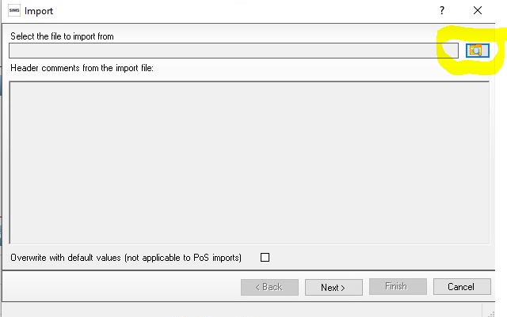

You will then need to go to the following file location -
- Hosted Schools:
F:\Public\AMPA\ England Primary (and Middle Deemed Primary)\Assessment Manager
- Non-Hosted Schools:
C:\Program Files\SIMS\SIMS.net\AMPA \England Primary (and Middle Deemed Primary)\Assessment Manager
3. Select the Key Stage 1 Wizard England 2024 and click on Open
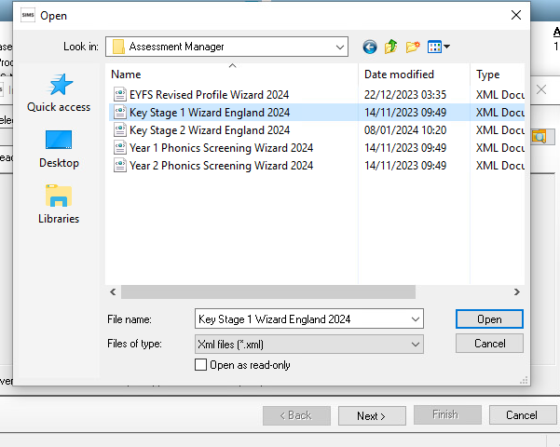
It will then show the below
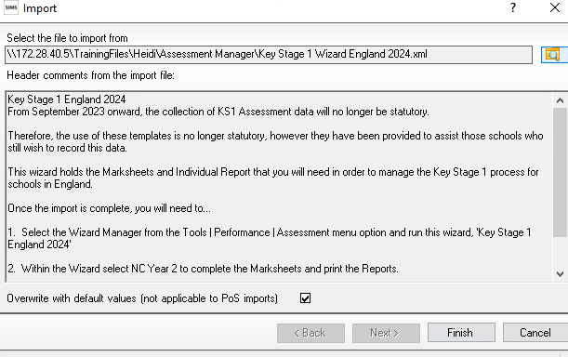
4. The Overwrite with default values check box should be ticked then select Finish. Click the Yes button when asked ‘Do you want to proceed?’

- An Activity Log shows what has been imported.
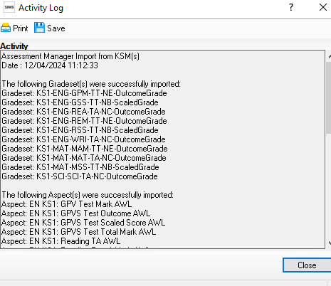

You can then click Close

Step 4 - Enter Results
Now you have imported your marksheet it is time to enter your results.
- Go to Tools | Performance | Assessment | Wizard Manager.

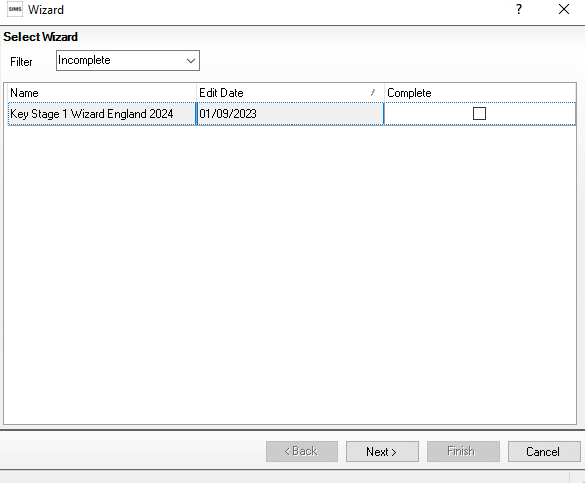

If other wizards have been imported in the past they will also appear in the list.
Leave the filter on Incomplete and find the wizard which is going to be worked on – in this case Key Stage 1 Wizard England 2024.
- Click the Next button.

- From the Select Group screen, click the Browser button (magnifying glass) to display the Selector dialog.

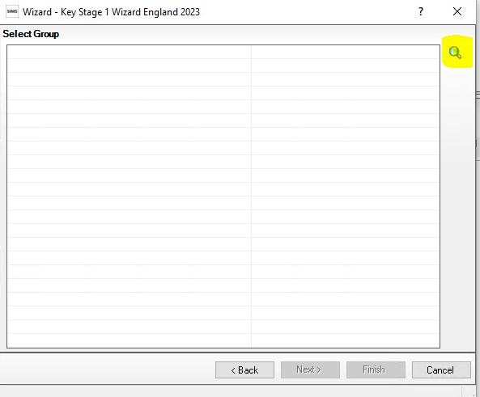

- Click the + icon next to Year Group and select Year 2
OR the + button next to User Defined Groups to select the user defined group, if you created one earlier, then click the Apply button. This places this group on the Select Group screen.

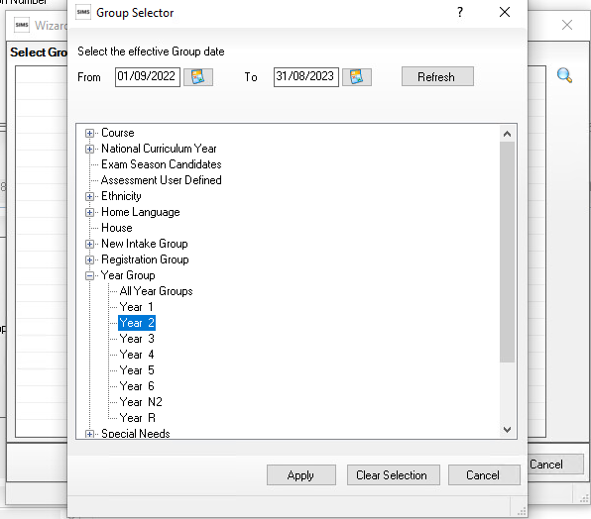
Click the + icon next to Year Group and select Year 2 then click the Apply button.

Or the + button next to User Defined Groups to select the user defined group, if you created one earlier, if applicable. Then click the Apply button. This places this group on the Select Group screen.

5.Once your Year 2 group is showing Click the Next button.

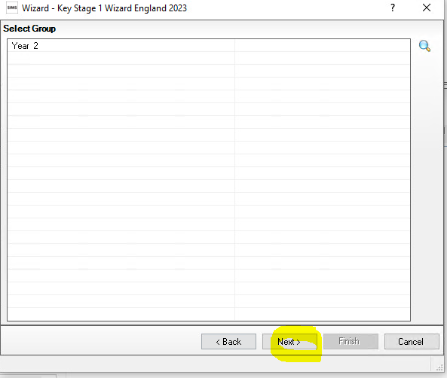

6. The following screen appears listing the marksheets available

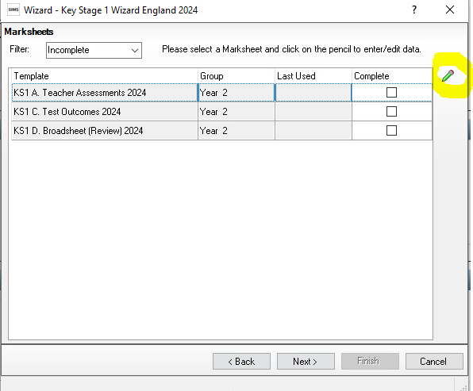
Highlight KS1 A teacher Assessment 2024.

Click on the pencil icon to open the marksheet.

There are 3 marksheets to choose from:

KS1 A. Teacher Assessments 2024
This marksheet can be used to store the outcome for the KS1 Reading, Writing, Mathematics and Science Performance Descriptor of the new curriculum (Assessment without Levels) from 2022 onwards.

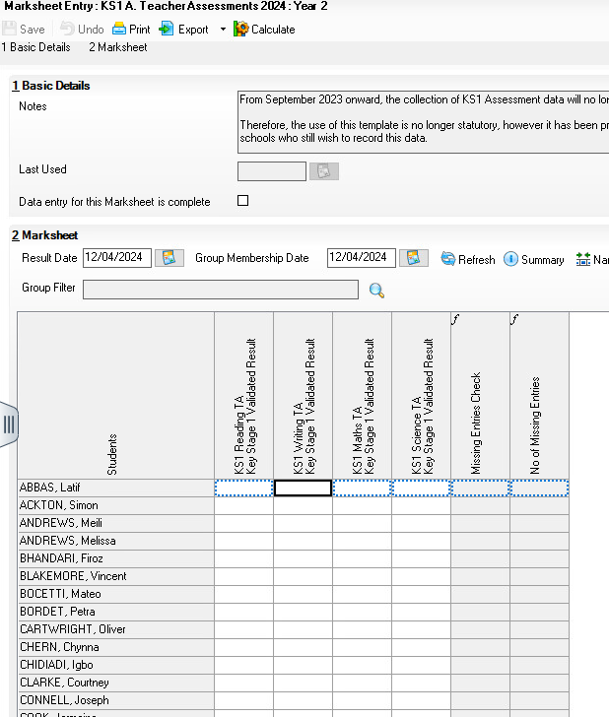
Enter the result for English Reading and Writing, Mathematics and Science.

Hint: You can just type in the result or right click in the first empty cell and Select Grade for Cell and click SAVE in the top left-hand corner.
Click the Calculate button. The final two columns alert you to any missing results. Continue entering results until completed.

Click the Save button.

KS1 C. Test Outcomes 2022 – Optional

This marksheet can be used to enter results, the curriculum (Assessment without Levels) Teacher Assessments results.
The tests assess the range of ability that the majority of pupils are expected to demonstrate. The outcomes of these tests will be provided in the form of a scaled score, where a score of 100 represents the standard expected at the end of the key stage.

The tests consist of:
- Reading
- Maths Arithmetic
- Maths Reasoning
It is expected that raw score to scaled score conversion tables for KS1 will be available on www.gov.uk.

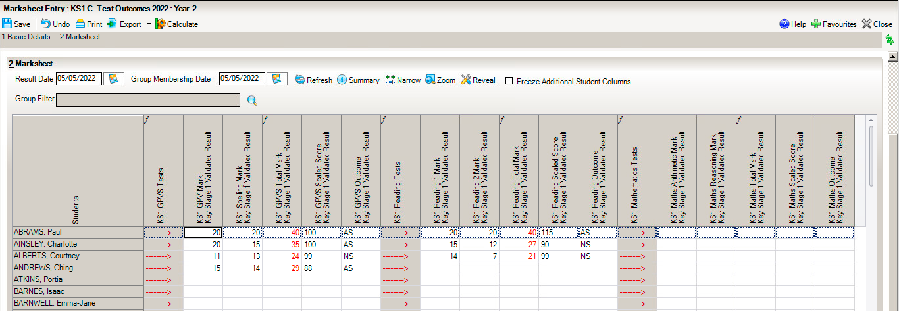

- A scaled score and an outcome also need to be defined. Using the graphic below as a guide, enter a scaled score and outcome.

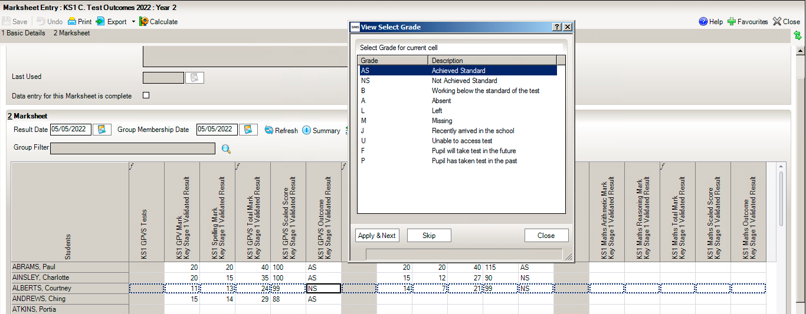

Scaled Scores for each – Reading and Maths will accept entries of between 0 – 999.

On completion click on Save.

KS1 D. Broadsheet (Review) 2024
This marksheet can be used to review both the Test marksheet and the Teacher Assessment marksheet.

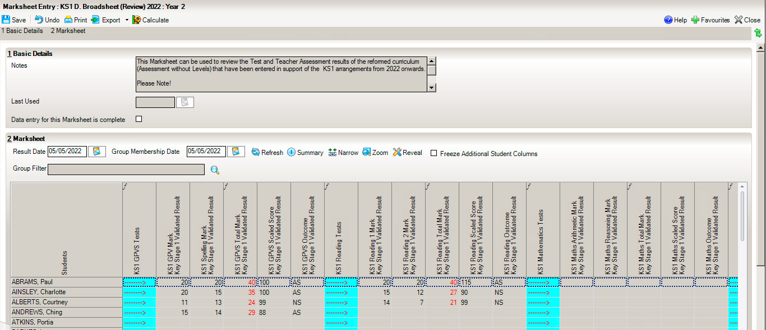

The results displayed in the Broadsheet Review marksheet are separated by coloured spaces to differentiate the different teacher assessments and tests.

Note: This marksheet is for review purposes only. If you wish to amend any of the data shown in it, please use the other two marksheets.
How to delete an incorrect grade in a marksheet
Results are stored against the student. Deleting a result from a marksheet does not delete it from the student which means the result will repopulate the marksheet each time it is opened.
To delete the result permanently:
- Open up the relevant marksheet
- Right click on the incorrect result
- Select ‘view/edit result history’
- Select the result and click on the red cross and click yes when prompted. There may be two results and you will need to click the red cross to delete both.
- Click Close
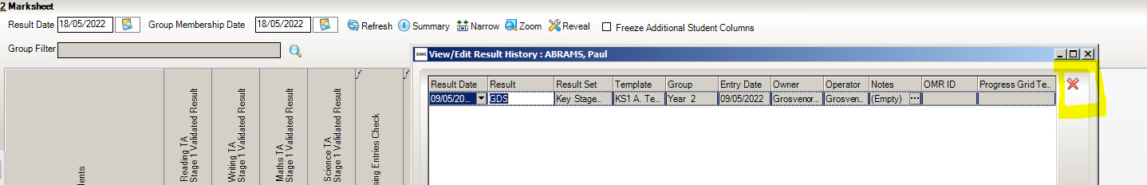

Step 5 - Using the Wizards for Reporting to Parents
Once all the results are entered on the marksheets the following report can be produced:

KS1 P1 Student England 2024
This produces an individual report for each pupil.

- Go to Tools | Performance | Assessment | Wizard Manager.
- Select the Key Stage 1 Wizard England 2024. Click the Next button.
- Leave the Group Selection as it is. Click the Next button.
- At the marksheet window, click Next.
- Choose the report – KS1 P1 Student England 2024.
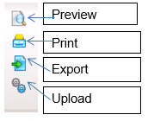
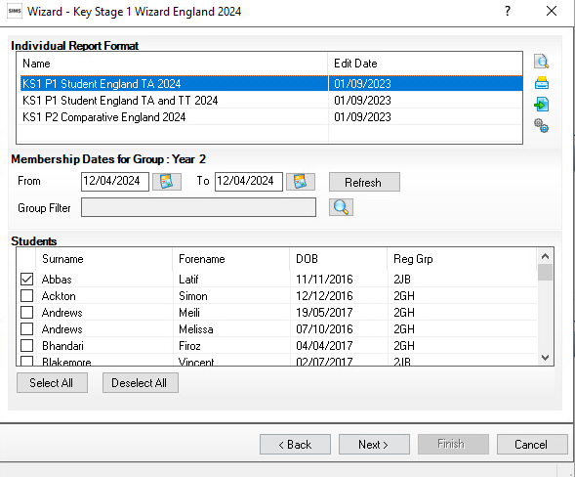

- To preview a report, ensure one of the pupils is ticked then click the Preview Report icon.

- To print the reports choose Select All. Click the Print icon.

There are three reports
- KS1 P1 Student England TA 2024 - Individual student report with just the Teacher Assessment result.
- KS1 P1 Student England TA and TT 2024 - Teacher assessment result and the Test results.
- KS1 P2 Comparative England 2024 - This compares your schools results with 2023 National results.

Step 6 - Upload Reports

If required, you can save a copy of these reports to each pupils Linked Documents in SIMS.
A copy of each child’s report can be saved in the Document Server. This can then be viewed at any time.

- Once reports have been generated, they can be uploaded, either individually or in bulk, by clicking the Upload icon.

- To view the copy, open the Pupil Details screen for the child and select Linked Documents in the Links panel on the right. The report will open as read only.

As previously stated, you no longer need to provide your KS1 results to the DFE or your LA. So no CTF needs to be created. For more information please see- https://www.gov.uk/government/collections/national-curriculum-assessments-key-stage-1-tests

