SIMS .net Assessment

Key Stage Wizard 2024

Key Stage 2

Version 4.0

REVISION HISTORY

Version | Change Description | Date
1.0 | Updated to 7.186 | 15/04/2019
2.0 | Updated to 7.204 | 10/05/2022
3.0 | Updated to 7.210 | 14/04/2023
4.0 | Updated to 7.216 | 11/04/2023

Key Stage 2 Statutory Teacher Assessment Data Collection 2024

Below are the codes to be used for this academic year. Please see further information on grades here-
https://www.gov.uk/government/publications/key-stage-2-teacher-assessment-guidance/key-stage-2-teacher-assessment-guidance#teacher-assessment-codes

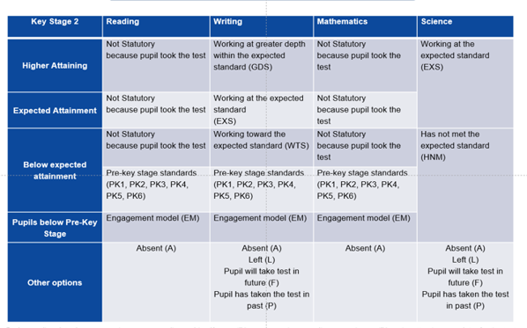

Introduction

This book covers the process from beginning to end for the Key Stage 2 Process including importing the wizard, entering results, printing the reports, and exporting the results.
By the end of this book, you should have completed the following:

To do | Page | Completed
Importing the Wizard Marksheets | 5-7
Entering your results | 7-12
Create Reports | 13-14
Create results CTF | 15-19

As these Teacher Assessments form part of the CTF that accompanies children if they transfer between schools, it is a statutory requirement that if you are using alternative software for collection of assessment results, the data is also imported into SIMS.

Please refer to your software supplier for guidance and instructions on how to do this.

Step 1 - Check SIMS .net Version

In order to use the 2024 Wizards you must be using the Spring 2024 Main Release version of SIMS .net or later. To check:

Go to Help | About SIMS .net.

Check that the version of SIMS .net is 7.216 or higher.

Please note: If you buy the Hosted service from Scomis then your SIMS will automatically be updated to the new SIMS.net v7.216

Step 2 - Identify the KS2 Pupils

If all pupils being assessed are in Year 6 continue to Step 3.

If pupils outside of the year are being included in the Key Stage 2 assessment, or some of the Year 6 pupils are not being assessed - please refer to the notes for Creating a User Defined Group by clicking on the link below:

http://faq.scomis.org/kb15030/

Step 3 - Import the Wizard for Key Stage 2
- Select Routines | Data In | Assessment | Import. If you see a screen similar to the one below, click Yes.
- Once the update has completed, Close the activity log.
If you DON’T see the box above, then you will need to browse to the folder locations -
- Select the file to import by clicking the Browser button.

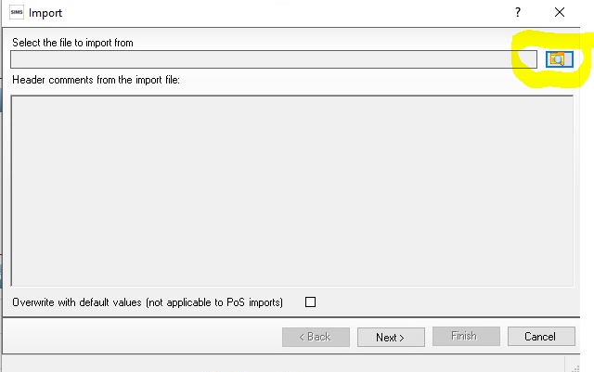

You will then need to go to the following file location -
- Hosted Schools:
F:\Public\AMPA\ England Primary (and Middle Deemed Primary)\Assessment Manager
- Non-Hosted Schools:
C:\Program Files\SIMS\SIMS.net\AMPA \England Primary (and Middle Deemed Primary)\Assessment Manager

3. Select the Key Stage 2 Wizard England 2024 and click on Open
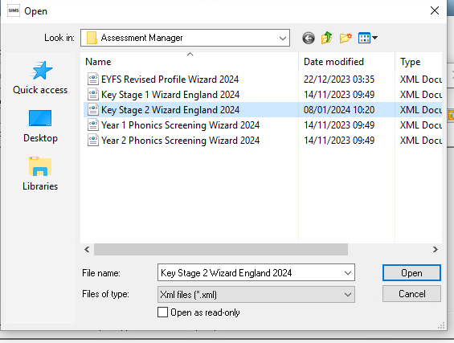
It will then show the below

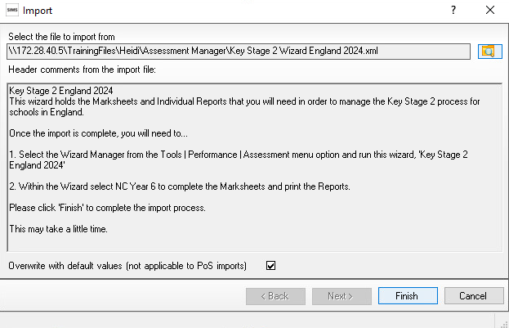
4. The Overwrite with default values check box should be ticked then select Finish. Click the Yes button when asked ‘Do you want to proceed?’
5. An Activity Log shows what has been imported.
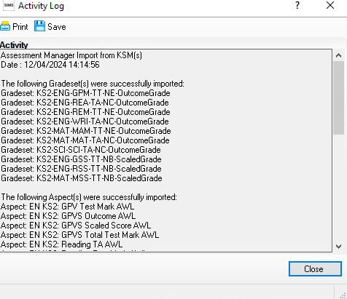

You can then click Close.

Step 4-Enter Results
Now you have imported your marksheet it is time to enter your results.
- Go to Tools | Performance | Assessment | Wizard Manager.
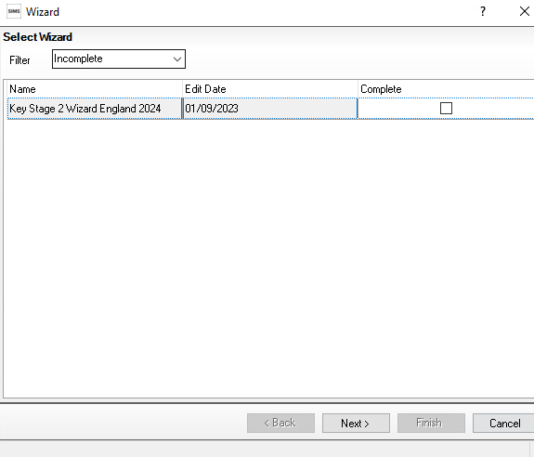
If other wizards have been imported they will also appear in the list.
Leave the filter on Incomplete and find the wizard which is going to be worked with – in this case Key Stage 2 Wizard England 2024.
- Click the Next button.

- From the Select Group screen, click the Browser button (magnifying glass) to display the Selector dialog.
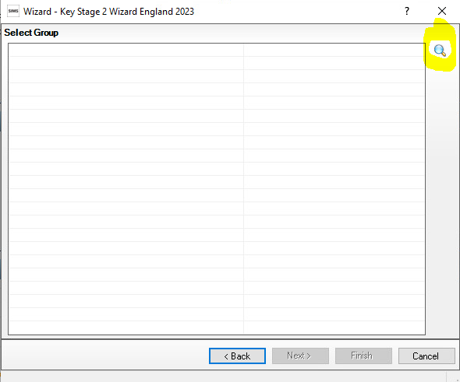
- Click the + icon next to Year Group and select Year 6
OR the + button next to User Defined Groups to select the user defined group, if you created one earlier, then click the Apply button. This places this group on the Select Group screen.
Click the + icon next to Year Group and select Year 6 then click the Apply button.

Or the + button next to User Defined Groups to select the user defined group, if you created one earlier, if applicable. Then click the Apply button. This places this group on the Select Group screen.

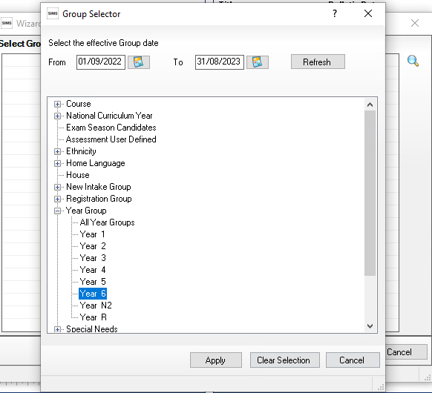

- Once your Year 6 group is showing as below click the Next button
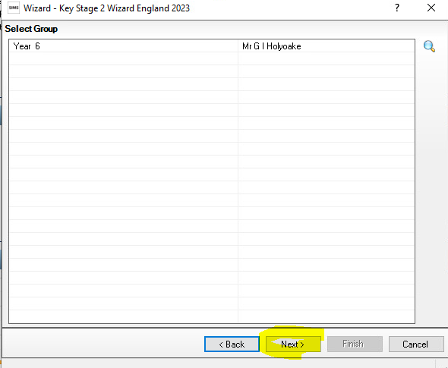

7. The following screen appears listing the marksheets available

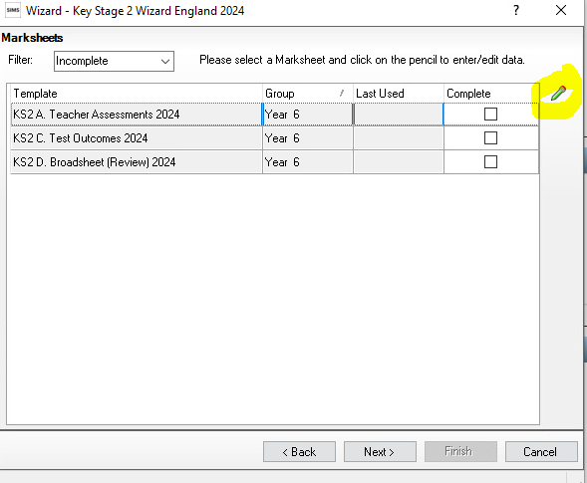
Highlight KS2 Teacher Assessments 2023.

Click on the Pencil icon to open the marksheet.
There are 3 marksheets to choose from:

KS2 A. Teacher Assessments 2024
This marksheet can be used to store the outcome for the KS2 Reading, Writing, Mathematics and Science Performance Descriptor of the new curriculum (Assessment without Levels) from 2024 onwards.
Save
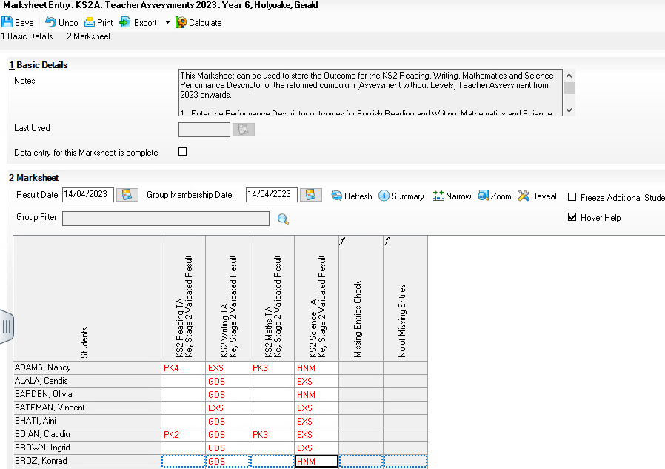
Enter the result for English Reading and Writing, Mathematics and Science.
Hint: You can just type in the result or right click in the first empty cell and Select Grade for Cell. Double clicking on the appropriate result will populate the cell and move you to the next one. Click close when finished and click SAVE in the top left hand corner.
Calculate
Click the Calculate button. The final two columns alert you to any missing results. Continue entering results until completed.

Click the Save button.
Once all results are entered click the Save button and close the marksheet to return to the Wizard and the list of marksheets.

Below is the 2024 KS2 teacher assessment technical level. Please note the column for Reading and Maths regarding pupils not needing a grade if they’re working at the standard of the national curriculum.
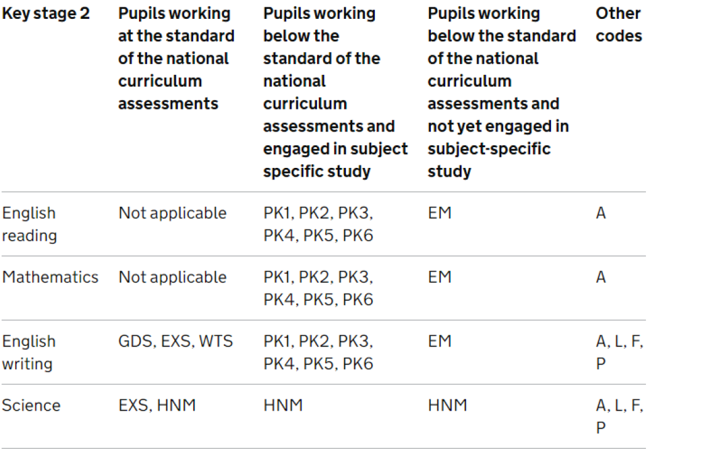

KS2 C. Test Outcomes 2024
This Marksheet can be used to enter results of the curriculum (Assessment without Levels) tests that support the Teacher Assessments

The tests assess the range of ability that the majority of pupils are expected to demonstrate. The outcomes of these tests will be provided in the form of a scaled score, where a score of 100 represents the standard expected at the end of the key stage. The new tests consist of:
- Grammar, Punctuation and Vocabulary.
- Spelling.
- Reading.
- Maths Arithmetic.
- Maths Reasoning.

A marksheet is available containing columns which will enable you to record results of the reformed curriculum tests that support the teacher assessments.
There are no validation checks performed on the results entered for test outcomes.

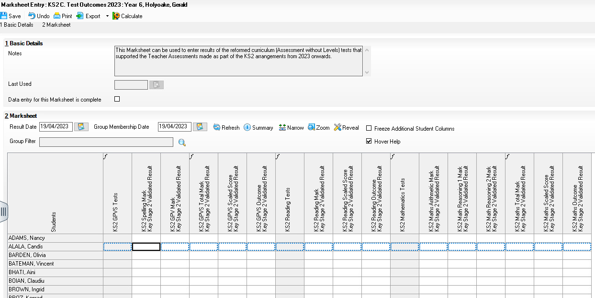

KS2 D. Broadsheet Review 2024
This marksheet can be used to review the Test and Teacher Assessments results of the curriculum (Assessment without Levels) that have been entered in support of the Key Stage 2 arrangements.

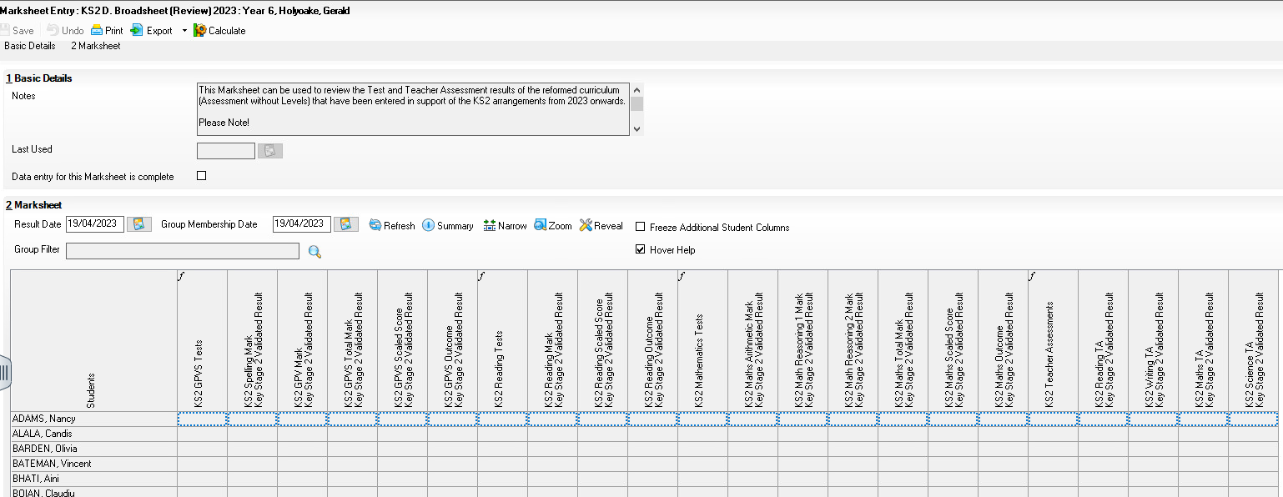

Note: This marksheet is for review purposes only. If you wish to amend any of the data shown in it, please use the Teacher assessment or Test Outcomes marksheets. Once amendments have been made you can then view the broadsheet marksheet again.

How to delete an incorrect grade in a marksheet
Results are stored against the student. Deleting a result from a marksheet does not delete it from the student which means the result will repopulate the marksheet each time it is opened.
To delete the result permanently:
- Open up the relevant marksheet
- Right click on the incorrect result
- Select ‘view/edit result history’
- Select the result and click on the red cross and click yes when prompted. There may be two results and you will need to click the red cross to delete both.
- Click Close
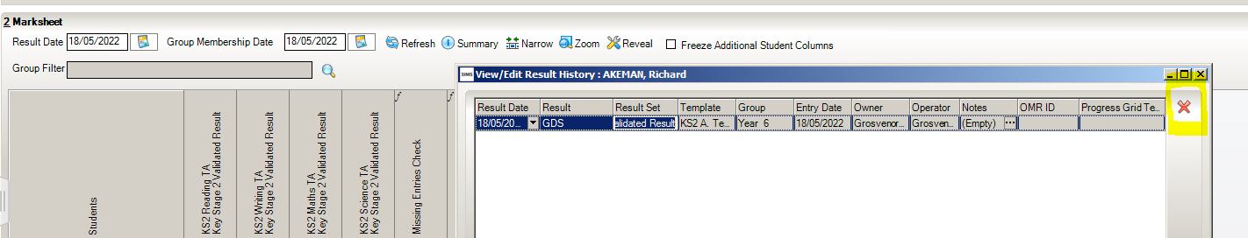

Step 5 - Using the Wizards for Reporting to Parents
Once all the results are entered on the Marksheets there are 3 reports that can be run.

KS2 P1 Student England TA 2024
Produces an Individual Report showing the Teacher assessment results for each pupil.
KS2 P1Student TA and TT 2024
Produces an Individual Report showing the Teacher assessment and Test results for each pupil.
KS2 P2 Comparative England 2024
This shows comparative grades with national Statistics

To find the reports go to:

- Tools | Performance | Assessment | Wizard Manager.

- Select the Key Stage 2 Wizard England 2024. Click the Next button.

- Leave the Group Selection as Year 6. Click the Next button.

- At the marksheet, click Next.

- Choose the report required.
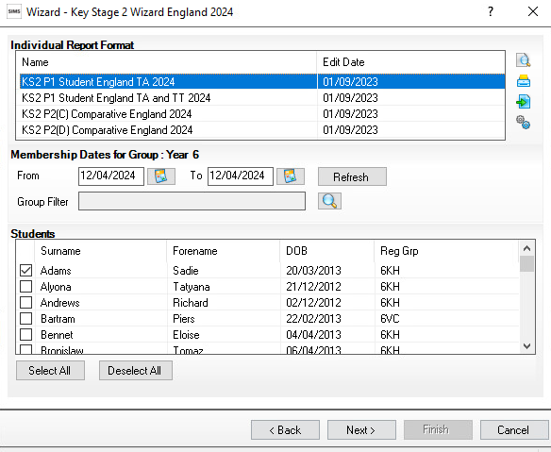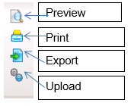

- To preview a report ensure one of the pupils is ticked then click the Preview Report icon.

- To print the reports choose Select All. Click the Print icon.

Step 6 - Upload Reports

A copy of each child’s report can be saved to your documents. This can then be viewed at any time.

- Once reports have been generated they can be uploaded, either individually or in bulk, by clicking the Upload icon.

- To view the copy open the Pupil Details screen for the child and select Linked Documents in the Links panel on the right. The report will open as read only.

Step 7 - Exporting KS2 Results in a CTF file to send to the Primary Assessment Gateway

Once the appropriate assessment levels or test scores have been entered for all pupils, the results need to be exported to the Primary Assessment Gateway which replaces the National Assessment Agency website used in previous years. Although the website is different the process in which to create the CTF is still the same.

To send a CTF to the Primary Assessment Gateway (PAG) you need to set up the below (please note you may already have this setup )

In Tools | Setups | CTF

Click on the hyperlink to Alternative Destinations.

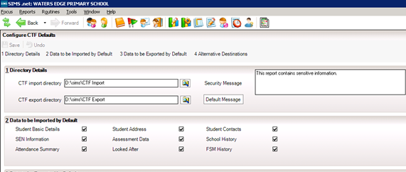

Panel 4 will show you the Alternative Destinations that you have on the system. If NAALLLL is NOT already showing - click New to add a new destination. The following screen will appear:

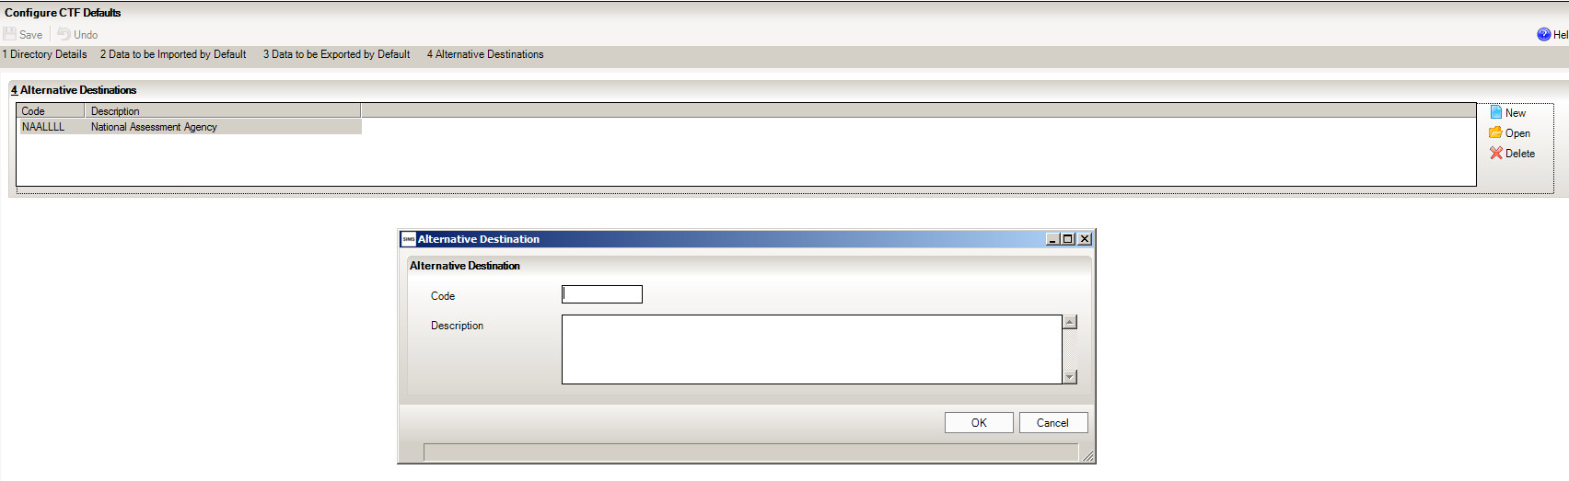

- Enter the code e.g. NAALLLL and the description ‘National Assessment Agency or NAA”

- Click OK.

- Click Save.

- Click Close.

Although the website has changed the DFE has confirmed you can still use the NAALLLL (National Assessment Agency) destination.

You will need to logout and back into SIMS at this point, to refresh the destination information and allow you to select it in the next stage.

Step 8-Creating a CTF File

The following steps show the process for Year 6.

For creating a CTF for pupils from more than one year group please see http://faq.scomis.org/kb15034/.

For creating a CTF including leavers please see http://faq.scomis.org/kb15037/.

To create your CTF go to Routines/Data Out/CTF/Export CTF
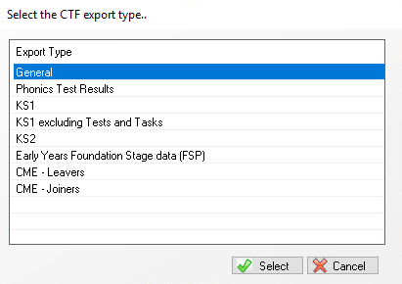

- This will then open a list of all your pupils.

- Click the down arrow on the ‘Year Group’ column heading and select Year 6 to show just the Year 6 pupils.

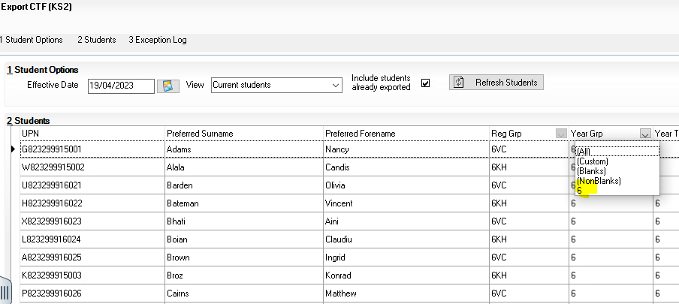

- You will now need to enter National Assessment Agency into the Destination/ LA/Other column. You can select more than one pupil at a time by using the Shift key on your Keyboard.
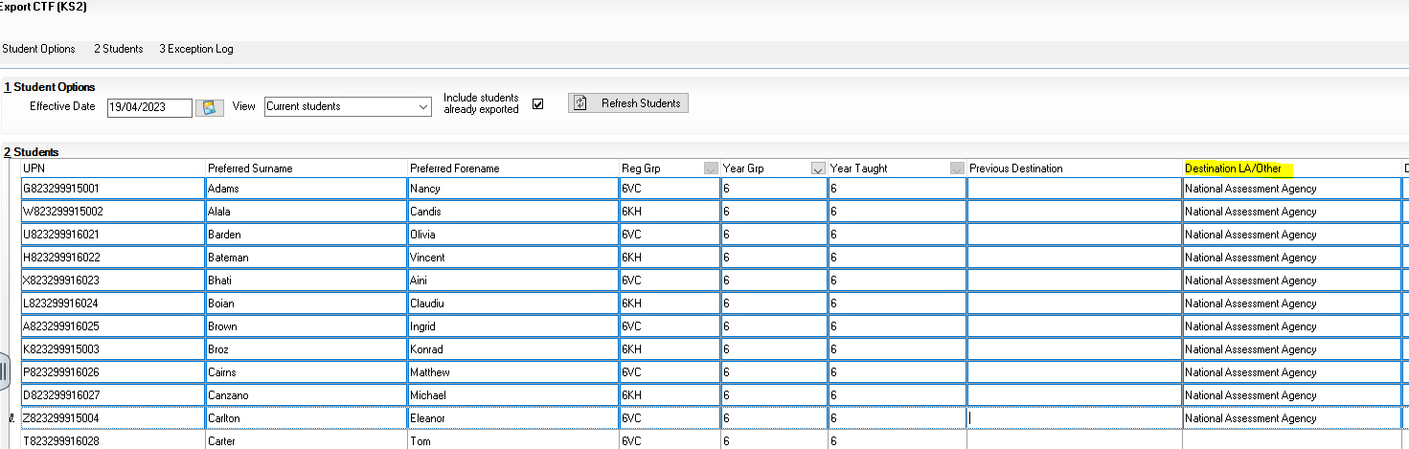

- Once ALL of your Year 6 pupils are showing with National Assessment Agency next to them you can click Export CTF.

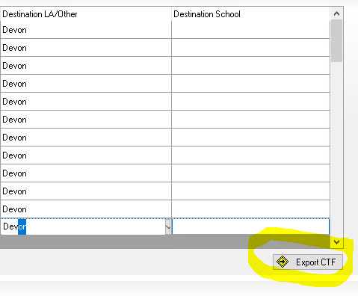

The following message may appear.
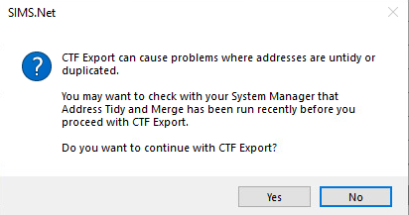
For the time being - Click Yes

A confirmation will appear with the name of the file.

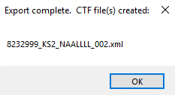

Make a note of the filename in case of a query with your Local Authority:

Step 9-Sending the Results File to PAG

The CTF containing results should be sent to the Primary Assessment Gateway

Instructions on uploading results to the Primary Assessment Gateway can be found on the following link:
https://faq.scomis.org/kb21060/
UNLESS otherwise prescribed by your LA, please do not send the CTF to your LA as they cannot process this submission for you.

The following process is for reference only.
Please see the technical specification from the DFE below
https://www.gov.uk/guidance/using-the-primary-assessment-gateway
Schools must submit all teacher assessment data as per the DfE rules for 2024. These should be submitted via The Primary assessment gateway Tools no later than 28th June 2024.
If you experience any problems uploading Teacher Assessments or downloading results from the PAG website please email assessments@education.gov.uk or contact the national curriculum assessments helpline on 0300 303 3013.

