SIMS .net Assessment

Key Stage Wizard 2024

Year 1 and Year 2 Phonics

Version 4.0

REVISION HISTORY

Version | Change Description | Date
1.0 | Updated to 7.186 | 11/04/19
2.0 | Updated to 7.204 | 05/05/22
3.0 | Updated to 7.210 | April 2023
4.0 | Updated to 7.216 | April 2024

Introduction

The phonics screening check is designed to confirm whether pupils in Year 1 have learnt phonic decoding to an appropriate standard. Children who do not achieve the standard should be re-checked in Year 2.

By the end of this book, you should have completed the following:

To do | Page | Completed
Importing the Wizard Marksheets | 3-6
Entering your results | 6-12
Create results CTF | 13-16
Create Reports | 16-18
Entering Threshold score (cannot be completed before 26th June | 19

As these Teacher Assessments form part of the CTF that accompanies children if they transfer between schools, it is a statutory requirement that where you are using alternative software for collection of assessment results, the data is also imported into SIMS.

Please refer to your software supplier for guidance and instructions on how to do this.

Step 1 - Check SIMS .net Version

In order to use the 2024 Wizards, you must be using the Spring 2024 Main Release version of SIMS .net or later. To check:

- Go to Help | About SIMS .net.
- Check that the version of SIMS .net is v7.216

Please note: If you buy the Hosted service from Scomis then your SIMS will automatically be updated to the new SIMS.net v7.216

Step 2 - Import the Year 1 Phonics Screen Wizards 2024
- Select Routines | Data In | Assessment | Import. If you see a screen similar to the one below, click Yes.
- Once the update has completed, Close the activity log.
If you DON’T see the box above, then you will need to browse to the folder locations -
Select the file to import by clicking the Browser button.

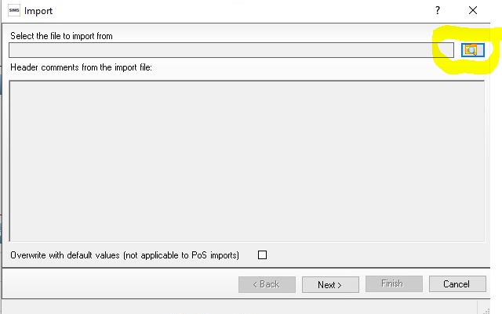

You will then need to go to the following file location -
- Hosted Schools:
F:\Public\AMPA\ England Primary (and Middle Deemed Primary)\Assessment Manager
- Non-Hosted Schools:
C:\Program Files\SIMS\SIMS.net\AMPA \England Primary (and Middle Deemed Primary)\Assessment Manager

- Select the Year 1 Phonics screening wizard 2024 and click Open
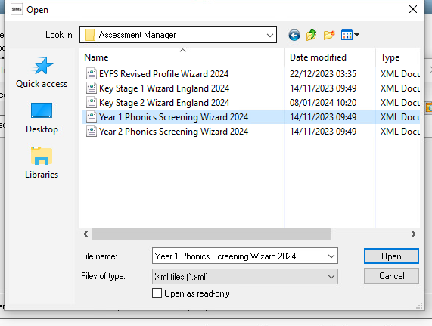
It will then show the below
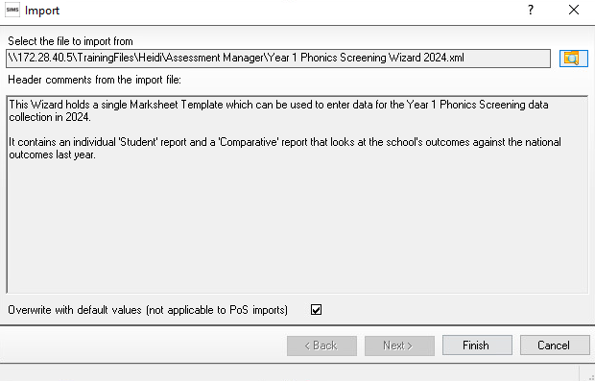

The Overwrite with default values check box should be ticked then select Finish. Click the Yes button when asked ‘Do you want to proceed?’
- An Activity Log shows what has been imported.
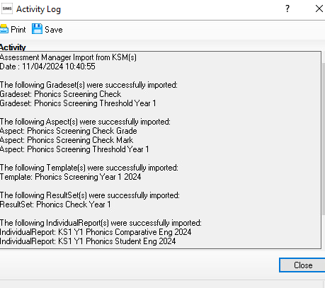

You can then click Close.
REPEAT THE ABOVE PROCESS AND IMPORT THE YEAR 2 PHONICS SCREENING WIZARD 2024 IF YOU HAVE PUPILS REQUIRING THE YEAR 2 RECHECK.

Step 3 – Preparing to Enter Results for Year 1 Phonics

- Go to Tools | Performance | Assessment | Wizard Manager.

- Leave the filter on Incomplete and highlight Year 1 Phonics Screening Wizard 2024

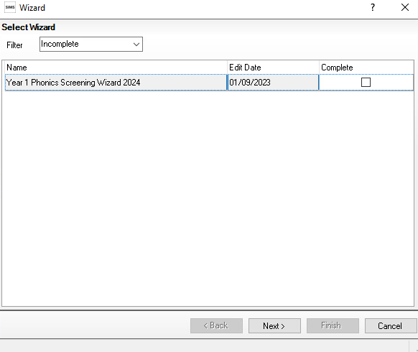

- Click Next.

- Click the browser (magnifying glass).

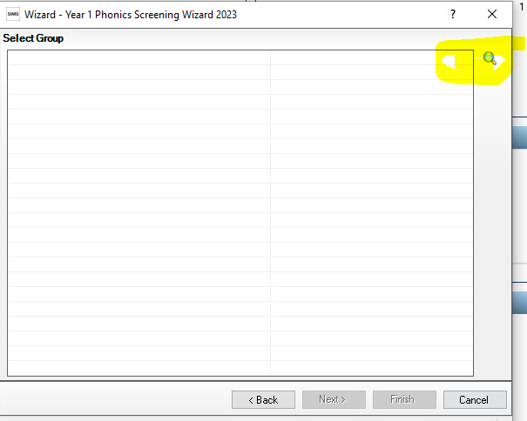

- The Group Selector appears. Click the + next to 'Year Group' and choose Year 1 then click Apply. This places this group in the box.

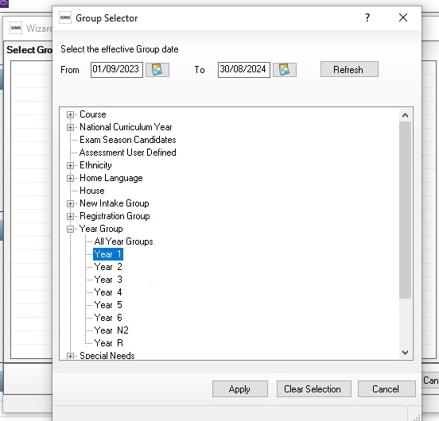
Click the + icon next to Year Group and select Year 1 then click the Apply button.

Or the + button next to User Defined Groups to select the user defined group, if you created one earlier, if applicable. Then click the Apply button. This places this group on the Select Group screen.

- Once your Year 1 group is showing Click the Next button.

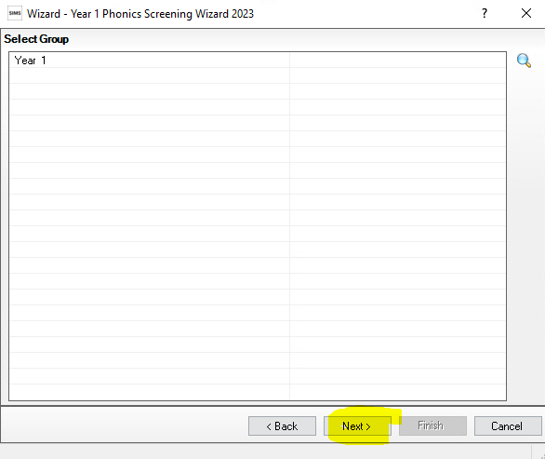

- The following screen appears listing the marksheet
Highlight Phonics Screening Year 1 2024.

Click on the pencil icon to open the marksheet.
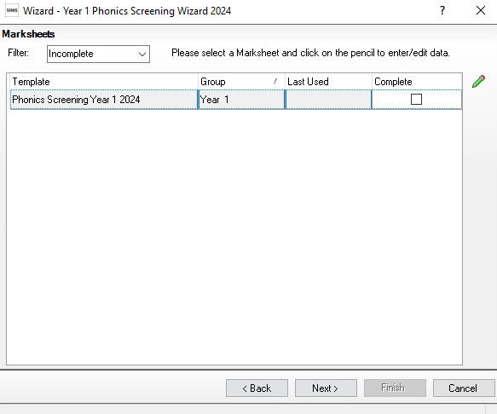

A marksheet with the Year 1 pupils is displayed

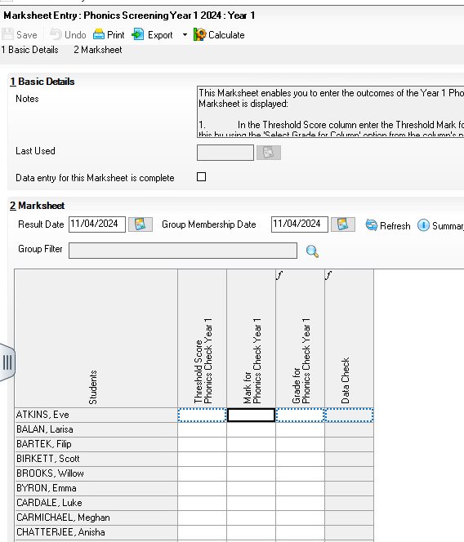

There are three columns.
The first is the Threshold score, this is the mark that pupils aim towards in order to pass their Phonics Year 1. The Threshold mark will be released by the DFE on the 24th June, this means you can’t fill this first column in until after June 24th. If they fall below this mark in Year 1 pupils will tend to re-sit in Year 2 (This of course depends on different circumstances).
The second column is the results column where you enter the numerical value the pupil scored. The Phonics mark is between 0-40.
The third column is automatically filled in once you have entered all your results and clicked Calculate.

IMPORTANT NOTE:
For those children who are absent, did not take the check or have left, the mark field must be left blank, and the phonics grade of A, D or L entered accordingly in the Grade column.
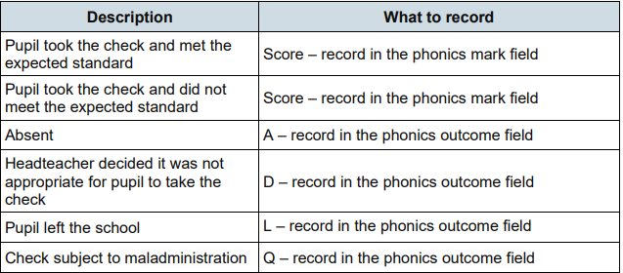

Step 4 – Enter Results
- From the marksheet enter a value of between 0 and 40 into the Mark for Phonics Check Year 1 column, or a grade as defined using the table above for reference.
- Click Save. This will calculate the Data Check column.
To enter L (Left), D (Disapplied) or A (Absent), type the letter directly into the Grade for Phonics Check Year 1 column.
This column must be left blank until after the publication of the Threshold Mark by the DfE on 24th June 2024
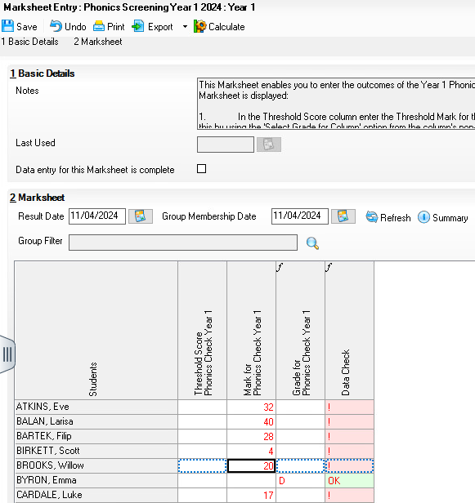
The Data Check will show an ! which indicates there is a Threshold mark missing (this is acceptable at this point of the process).
OK is displayed as a check for those pupils who are A, D or L and who did not take part in the check.

Leave the mark column blank for those pupils who have Left, are Absent or have been Disapplied and therefore did not take the screening check. Please do not put a 0 in this column.

Step 5 – Preparing to Enter Results for Year 2 Phonics Recheck and Establishing who requires the Recheck.

- If you have any Year 2 Pupils who have been re-tested, you will need to enter the results in the Year 2 Phonics Screening Wizard

- As you did with the Year 1 Phonics Wizard Go to Tools | Performance | Assessment | Wizard Manager.

- 3. Leave the filter on ALL and highlight Year 2 Phonics Screening Wizard 2024

- Click Next.

- Click the browser (magnifying glass).

- The Group Selector appears. Click the + next to 'Year Group' and choose Year 2 then click Apply. This places this group in the box.

- Click Next for the Marksheet Entry window. Highlight the marksheet and click on the Pencil icon on the right-hand side to display the marksheet.

- A marksheet is populated with the Year 2 pupils and columns relating to the assessments that need to be entered. If Year 1 Phonics results were entered into the corresponding wizard last year, they will be displayed automatically.

When the threshold values have been validated and confirmed by the DfE on Monday 24th June 2024, if the phonics threshold mark is changed then the new mark will then need to be entered. Details on how to do this will be available from the Scomis website - faq.scomis.org

Step 6 – Establishing who requires the Year 2 Phonics Recheck and Enter Results

Once you have opened the Phonics Screening Year 2 2024 marksheet you can identify who requires a resit result
Click on Calculate to identify those requiring a Year 2 recheck. This will be defined as a Yes in the Year 2 Check Required? column. Although your Year 2 Teacher will probably be aware of who these pupils are.
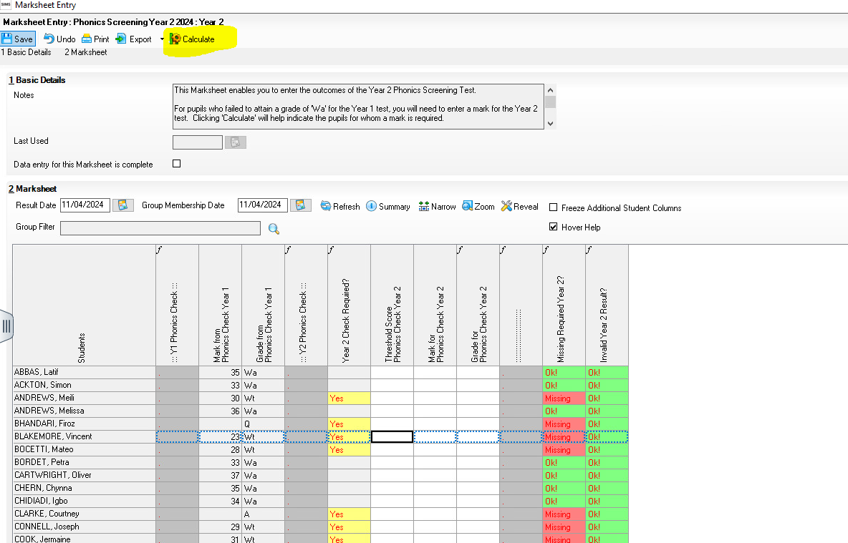
Type a value of 0-40 into the Marks for Phonics Check Year 2 column for those pupils who have undertaken a Year 2 recheck only. Click Calculate at the top of the screen to populate the Grade for Phonics Check Year 2 column. Click Save at the top of the screen.

Leave the mark column blank for those pupils who have Left, are Absent or have been Disapplied and therefore did not take the screening check. Please do not put a 0 in this column.
L, A or D can be typed directly into the Grade for Phonics Check Year 2 column where applicable. OK! Is displayed as a check for those pupils who are A, D or L and who did not take part in the check.

Deleting incorrectly entered phonics results
Results are stored against the student. Deleting a result from a marksheet does not delete it from the student which means the result will repopulate the marksheet each time it is opened.
To delete the result permanently:
- Open up the relevant marksheet
- Right click on the incorrect result
- Select ‘view/edit result history’
- Select the result and click on the red cross and click yes when prompted. There may be two results and you will need to click the red cross to delete both.
- Click Close

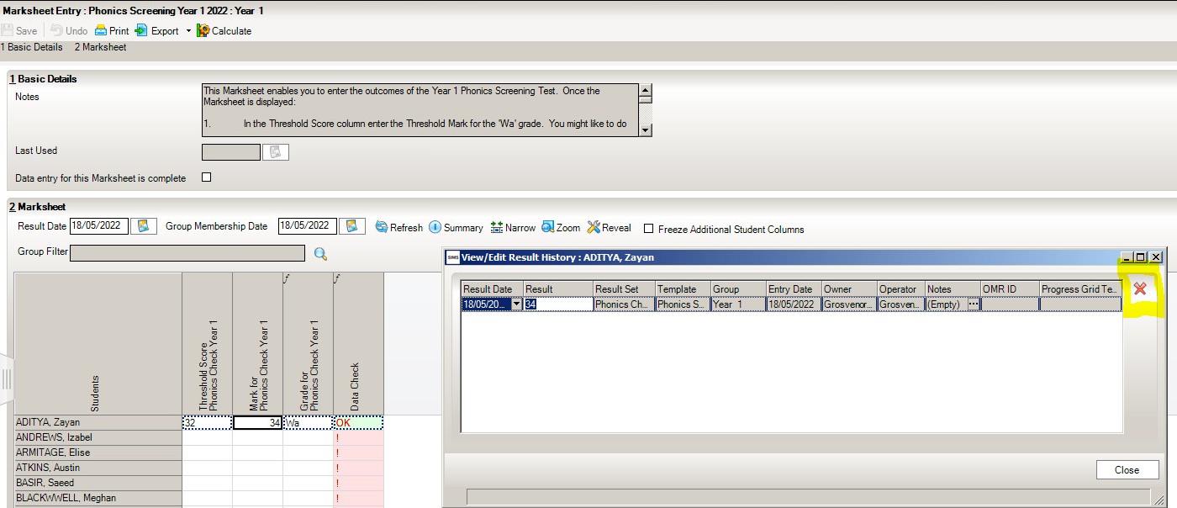

Step 7 – Exporting Phonics results in a CTF file to send to the Authority
Once the appropriate assessments have been entered for all pupils, you can close the Wizard and go back to your SIMS home screen. The results need to be exported to your Local Authority (LA). This is done by creating a CTF and sending it to your LA

Year 1 and Year 2 Phonics results need to be sent to the LA.

NOTE: The procedure for uploading the CTF file will vary from one Local Authority to another. Some Local Authorities may require one file containing both Year 1 and Year 2 whilst others will require two separate files one for each year group. Please check the advice given by your Local Authority before proceeding.

Step by Step – Create a CTF File for pupils from Year 1 and Year 2

Go to Routines | Data Out | CTF | Export CTF

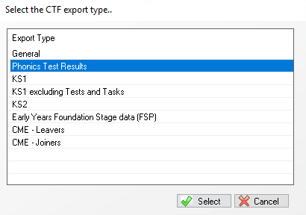

PLEASE CHECK WITH YOUR LA IF THEY WANT 2 SEPARATE CTF’S OR ONE COMBINED CTF. Most will want them in 1 CTF.

  - Right click your mouse on the Year Group Column and Select Sort Ascending

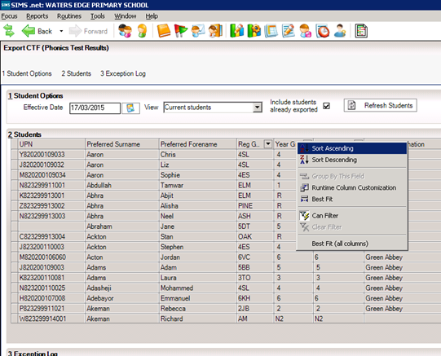
05/05/04/2019

  - Year 1 pupils should be at the top of the list.

3. Hold the shift key down continuously on your keyboard and scroll down the list of pupils – left click on the last pupil in Year 1 – all year 1 pupils are highlighted.

4. Release the shift key and hold the Ctrl key down continuously on your keyboard to select any Year 2 pupils who have been re-tested. If you select someone by mistake, click again and it will deselect them. ONLY SELECT YEAR 2 PUPILS WHO HAVE BEEN RETESTED.

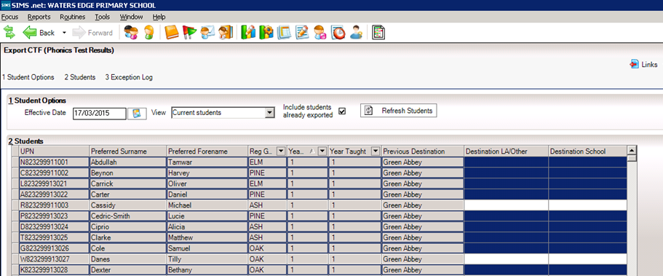

6. Release the control key when all the required pupils have been selected.

- Left Click into Destination LA/Other on the last pupil you have selected. Click on the down arrow to display the list of Local Authorities.

8. Select your authority from the list.

9. All the selected pupils should be showing with the authority in the Destination LA / Other column.

10.Click on the Export CTF – the CTF file will be created for those pupils within your selected Year 1 and Year 2 where appropriate with a destination.

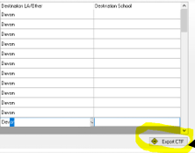

The following message may appear.
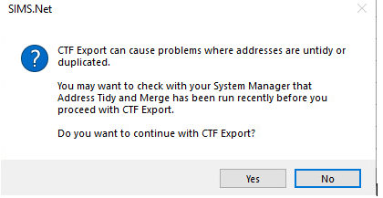
For the time being - Click Yes

- A confirmation will appear with the name of the file.

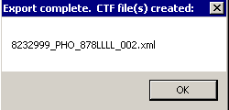
823 – An example of your Local Authority Number

2999 – An example of your School Number

PHO – Results you are exporting

823LLLL – Results exported and export destination - eg Local Authority

Make a note of the filename here in case of a query with the Local Authority:

Step 8 - Sending the Results File to Your LA
The CTF containing results should now be sent to your Local Authority. Upload the file to the LA in the normal way prescribed by them. Your LA will advise how and when they want this done
Submission Deadline to DFE – 1st July 2024

Step 9 - Using the Wizards for Reporting to Parents for Year 1 and Year 2 Phonics
Once all the results are entered on the marksheets the following reports can be produced:
KS1 Y1 Phonics Student Eng. 2024
This will generate an individual report for each pupil.

KS1 Y1 Phonics Comparative Eng. 2024
The comparative report compares the percentages by Phonics results for the school in 2024 with the national results for 2023.

KS1 Y2 Phonics Student Eng. 2024
This will generate an individual report for each pupil.

KS1 Y2 Phonics Comparative Eng. 2024
The comparative report compares the percentages by Phonics results for the school in 2024 with the national results for 2023.

- Select Tools | Performance | Assessment | Wizard Manager.
- Select the Year 1 Phonics Screening Wizard 2024
- Click the Next button.
- The Year group selection may be left as it is. Click the Next button.
- At the marksheet window, click Next.
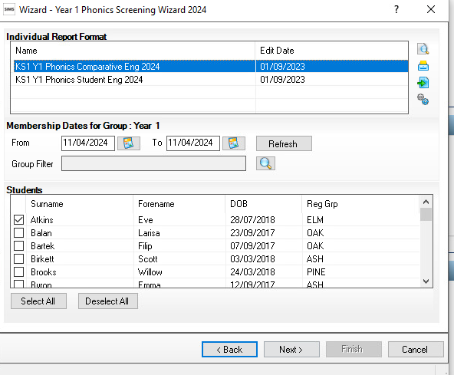
Upload
Export
Print
Preview

- To preview a report, ensure one of the pupils is ticked then click the Preview Report icon.

- To print the reports choose Select All. Click the Print icon. Reports will be printed from Word for those pupils selected.

REPEAT THE PROCESS with the Year 2 Wizard TO GENERATE THE YEAR 2 PHONICS REPORTS.

Step 10 - Upload Reports
If required, you can save a copy of these reports to each pupils Linked Documents in SIMS.

A copy of each child’s report can be saved in the Document Server. This can then be viewed at any time.

- Once reports have been generated, they can be uploaded, either individually or in bulk, by clicking the Upload icon.

- To view the copy, open the Pupil Details screen for the child and select Linked Documents in the Links panel on the right. The report will open as read only.

Step 11 – Entering the Threshold Score and calculating the outcome for Year 1 Phonics.
Once the Threshold score has been released you can enter the mark into the Marksheet. The threshold score will be published on Monday 24th June 2024. This will be available from www.gov.uk
- Reopen the Wizard via Tools | Performance | Assessment | Wizard Manager.
- Select the Year 1 Phonics Screening Wizard 2024, and then click Next until you get to the marksheet section.
- Click on the Phonics Screening Year 1 2024 marksheet and then click the Pencil icon.
- Right-click in the column heading Threshold Score.
- Choose Select Grade for Column.
- Highlight the Threshold Score as defined by the DfE, and then click OK.
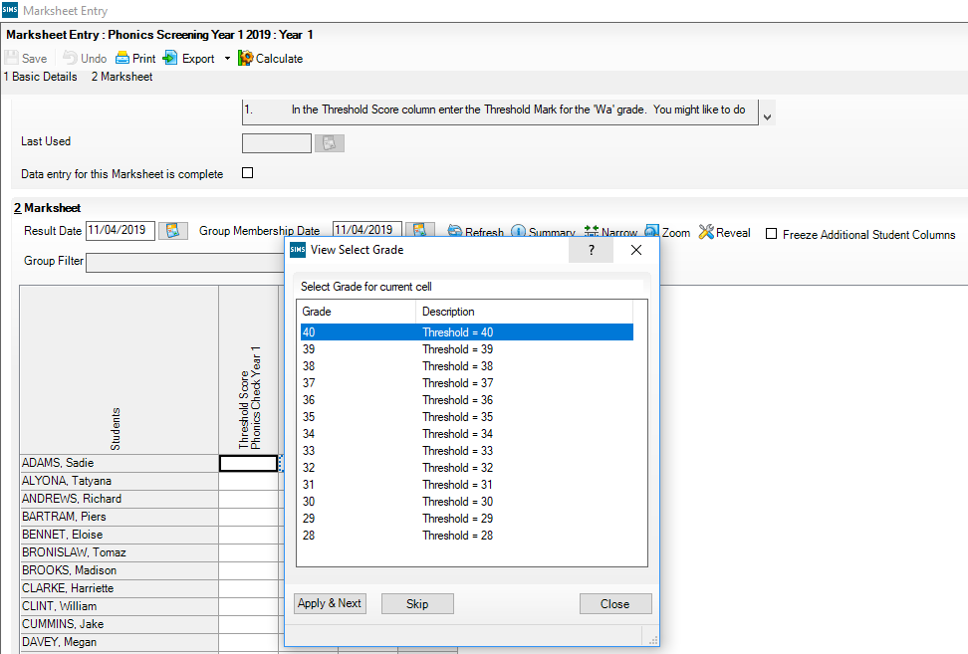

- The column will flood fill the threshold score for each pupil.
NOTE: Data used here is only an example.
- Click Calculate.
- A phonics outcome grade will be displayed.
- Click Save and then click Close.

