Pre-Admissions in Bromcom
Here is a brief guide on how to carry out the following tasks with regards to Pre-Admissions;
• Creating a Pre-Admission Group
• Adding Students Manually Adding a student Via CTF/ATF
• Communication Using MCAS to share/collect information Sending Messages to parents
• Managing Admissions Finalise Admissions/Admitting Students

Check Admissions Set-Up The Admission Numbers, and Admission Settings, can configured from Config > Administration > Admission Settings.
(A detailed guide can be found here: How to Set and Format your Admission Numbers – Bromcom – Documentation Centre
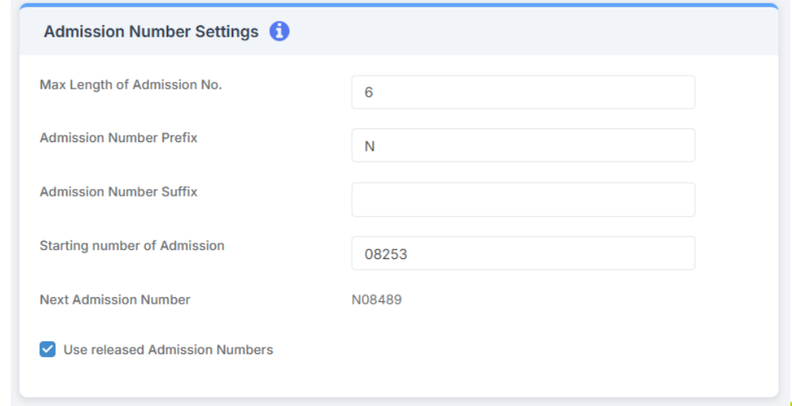

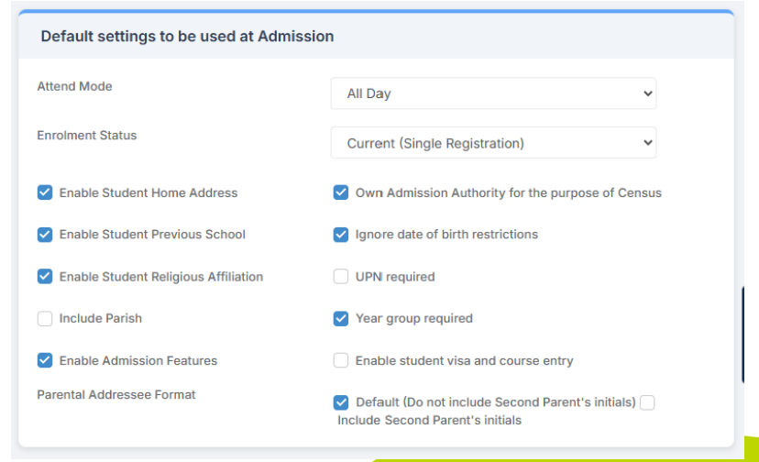

Creating a Pre-Admission Group
(A detailed guide can be found here: How to Create a Pre-Admission Group and View Pre-Admission Students – Bromcom – Documentation Centre)
Eg, Reception 2025 Children who are going into Reception in September 2025 will typically have a birthday between 1st September 2020 and 31st August 2021
N2 1st September 2021 – 31st August 2022
N1 1st September 2022 – 31st August 2023

Modules > Administration > Pre-Admission Groups>New
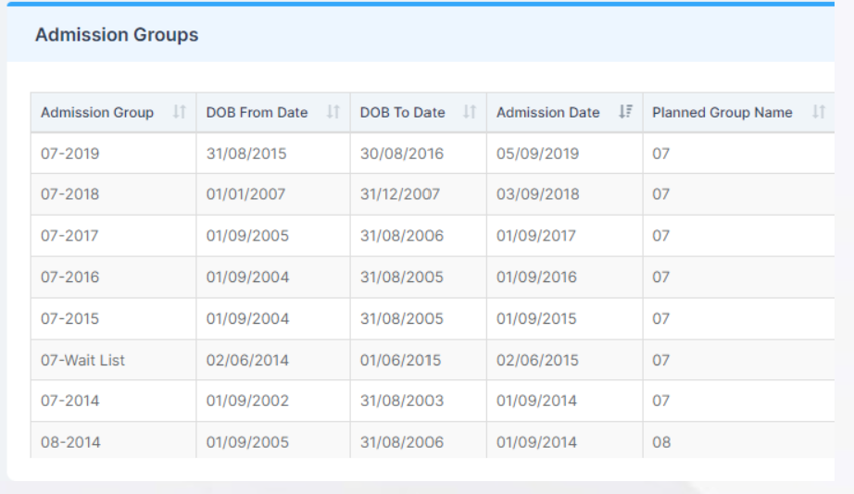
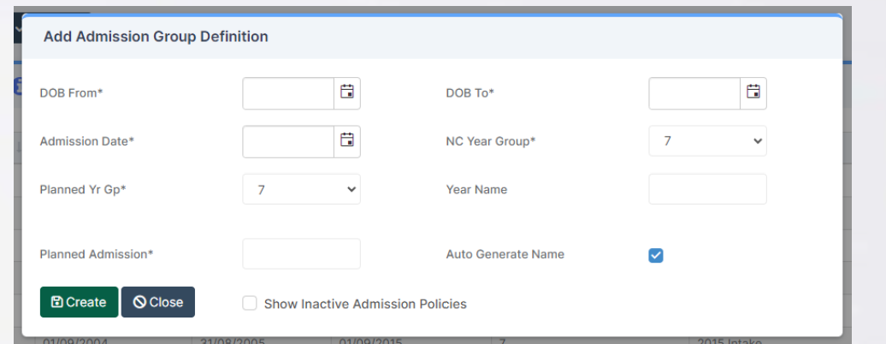

Adding Students
(A detailed guide can be found here: How to Add a New Student – Bromcom – Documentation Centre)
Manually; From the Left hand menu, click Students to open the Student List Page.
It is advisable to check the Student hasn’t already been added to avoid duplicate records, this can be done by typing the Student name in the top right Search Names box.
Once you are happy that the Student does not exist on the MIS click the top left New button.
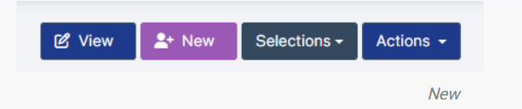
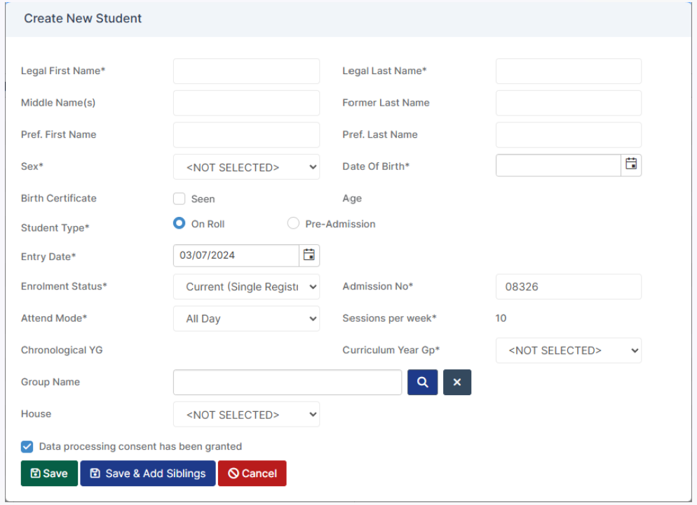

Or Via CTF Import/ ATF Import – Click Actions and select CTF Import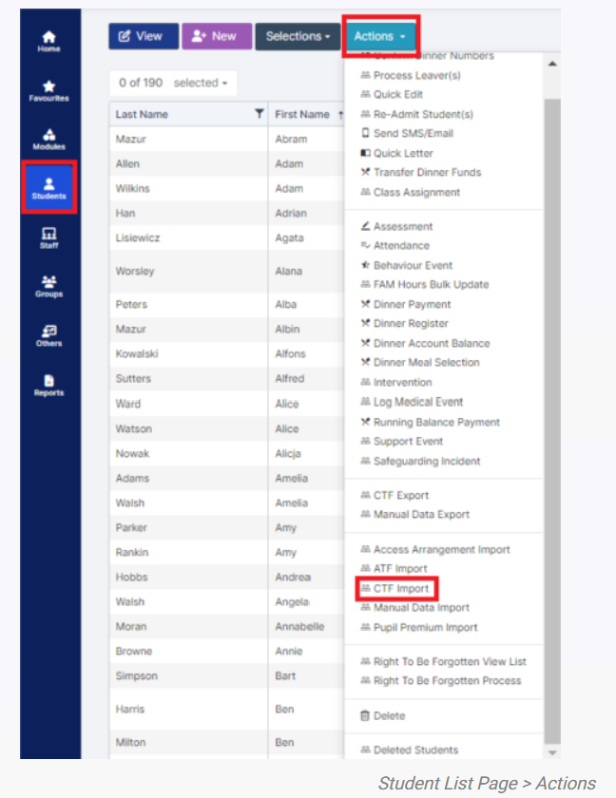

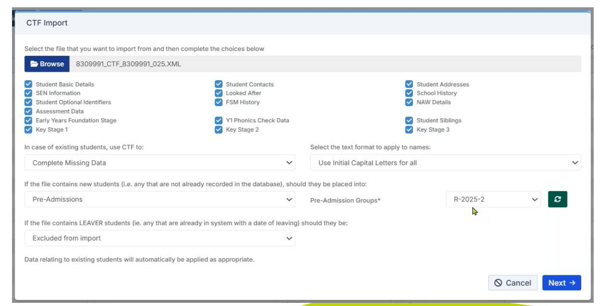

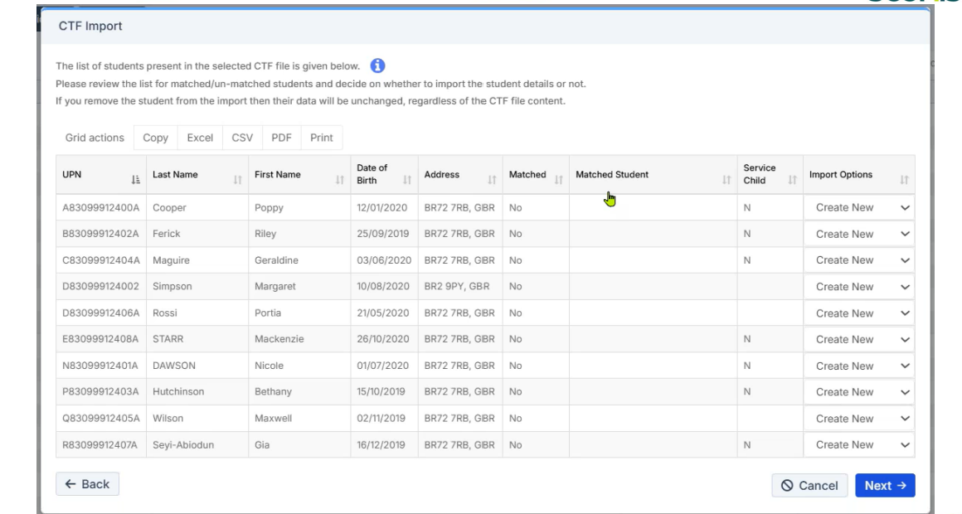
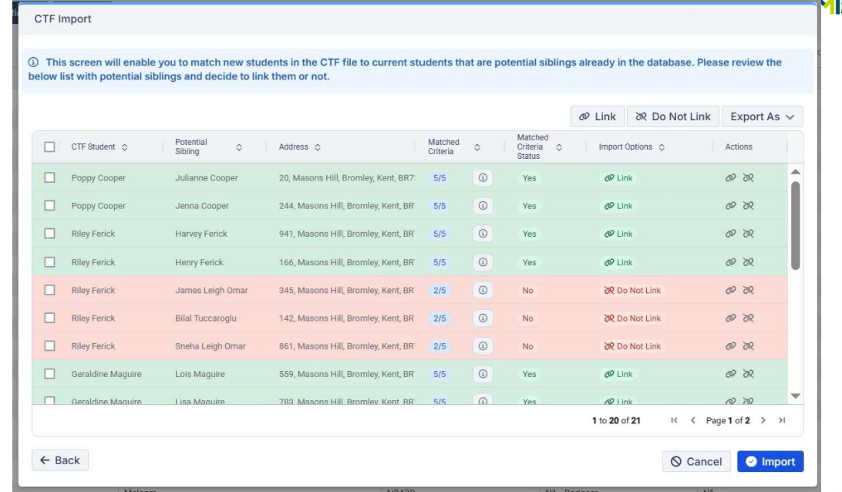
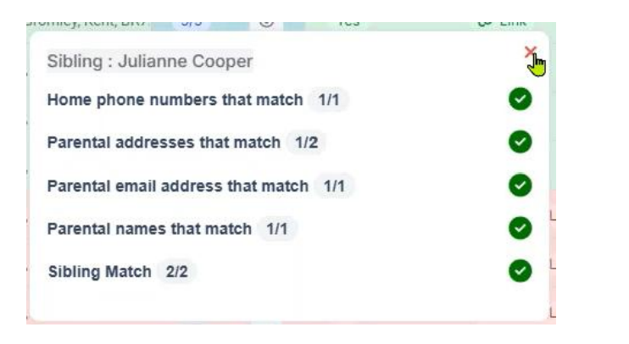

Or Via ATF Import - Click Actions and select ATF Import

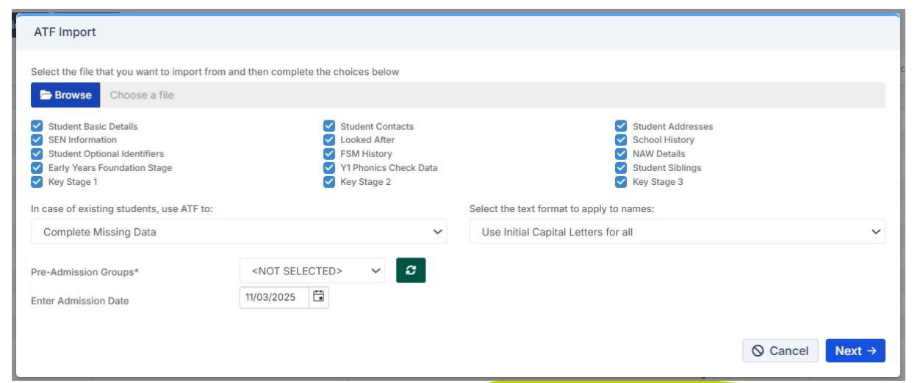

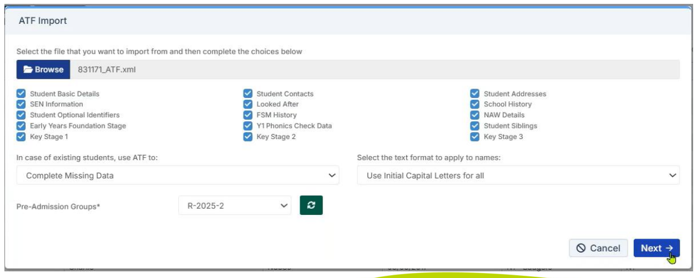
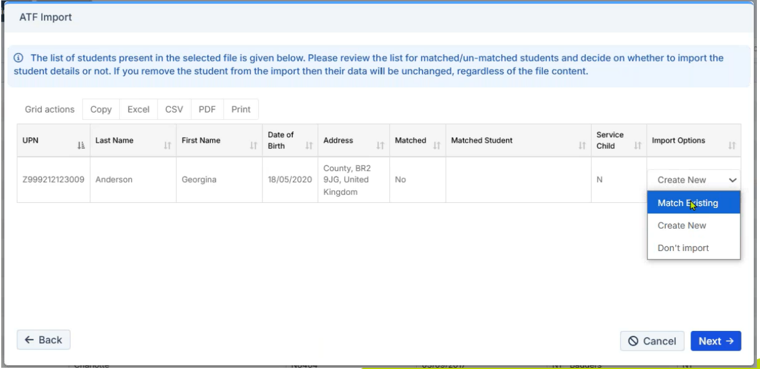

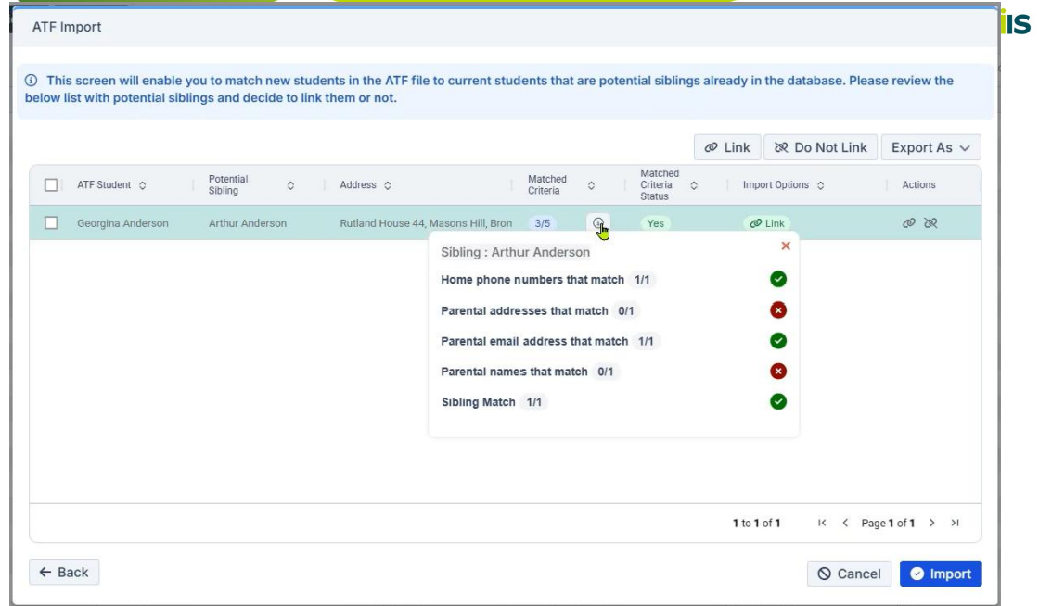

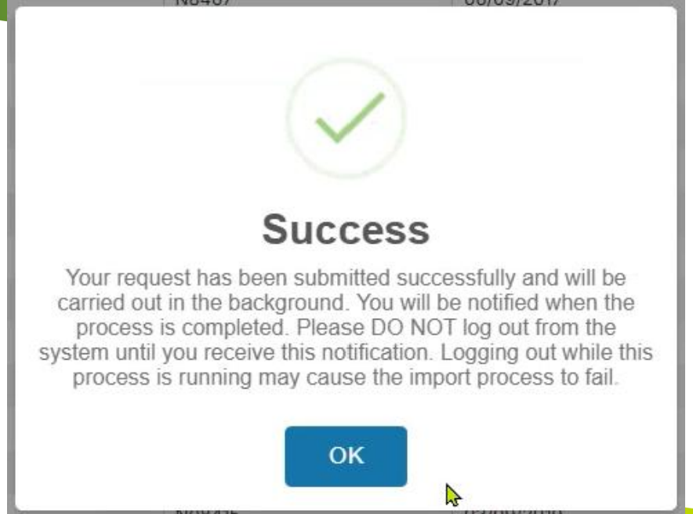

My Child at School (MCAS) – To add the new students to MCAS, go to :Modules > MyChildAtSchool > Administration > User Accounts>New (A detailed guide can be found here: How to Create MCAS User Accounts – Bromcom – Documentation Centre)
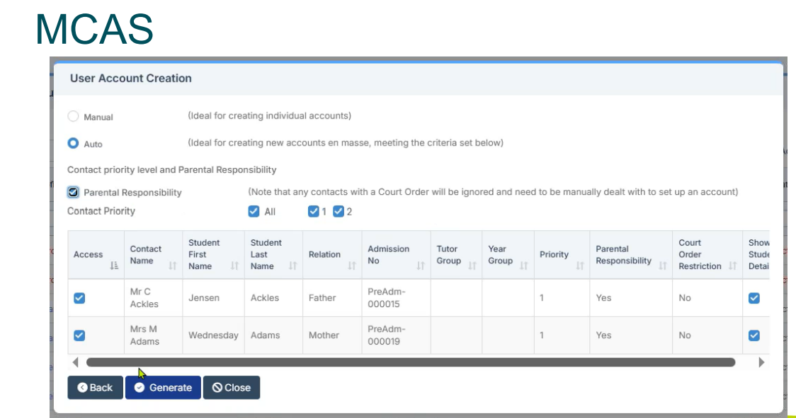

Student And Contact Details
From the left Menu go to Config > MyChildAtSchool > Student And Contact Details.
Student And Contact Details – defines what Student Information and Contact Details will be displayed and what can be Edited when selecting the Data Collection Form options on the Parent Portal.
There are 5 sections that can be selected from the Information that can be viewed for dropdown menu.
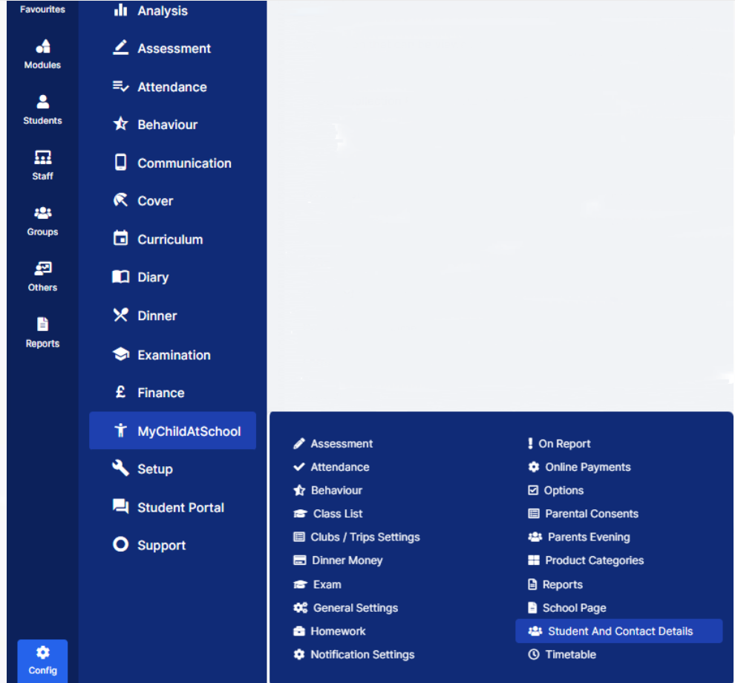
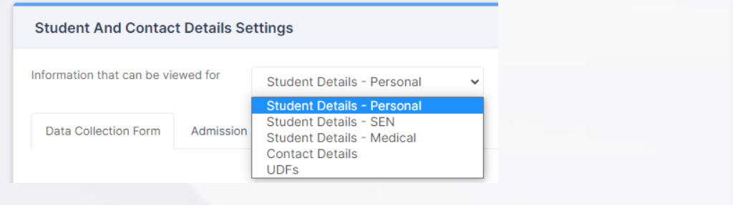
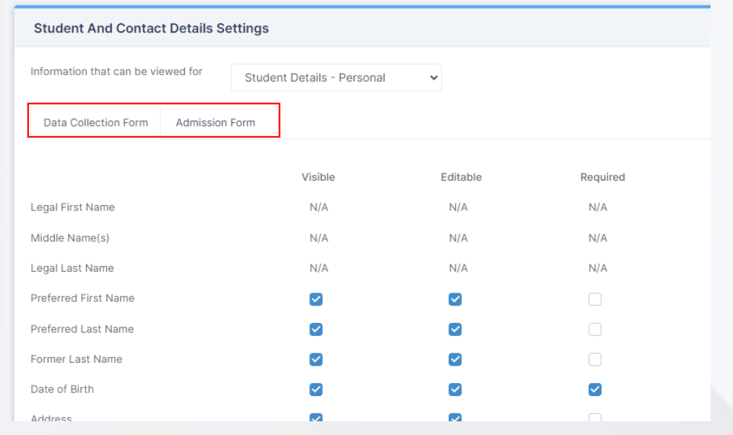

Look up Tables – Parental Consent Types – Config>Administration>Lookup Tables
Lookup Tables contain data options for dropdown boxes in the MIS. These are used in a variety of areas across the MIS where the dropdown options are not statutory, some notable examples include Parental Consents and Dietary Needs.
(A detailed guide can be found here: How to Edit Lookup Tables – Bromcom – Documentation Centre
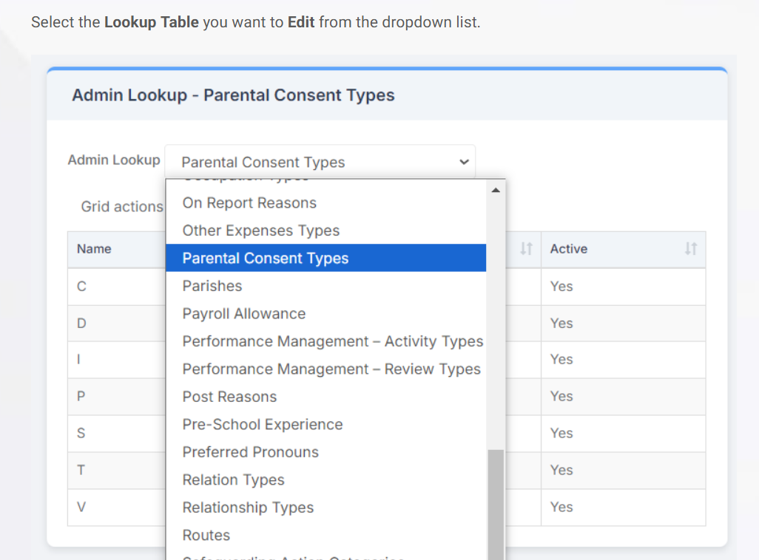

Configure MCAS for Parental Consent - From the left Menu go to Config > MyChildAtSchool > Parental Consents. (A detailed guide can be found here: How to Configure Parental Consents for MyChildAtSchool – Bromcom – Documentation Centre
This will open the Parental Consent Settings page, select the options you want and click the Save button.
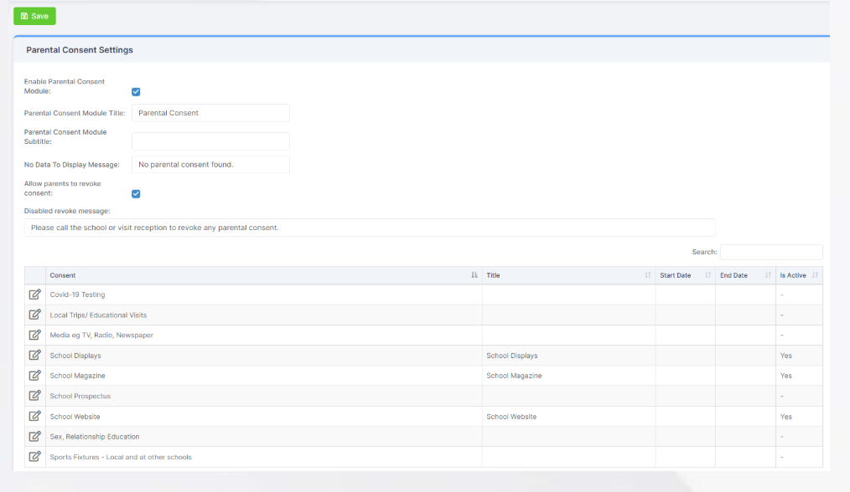

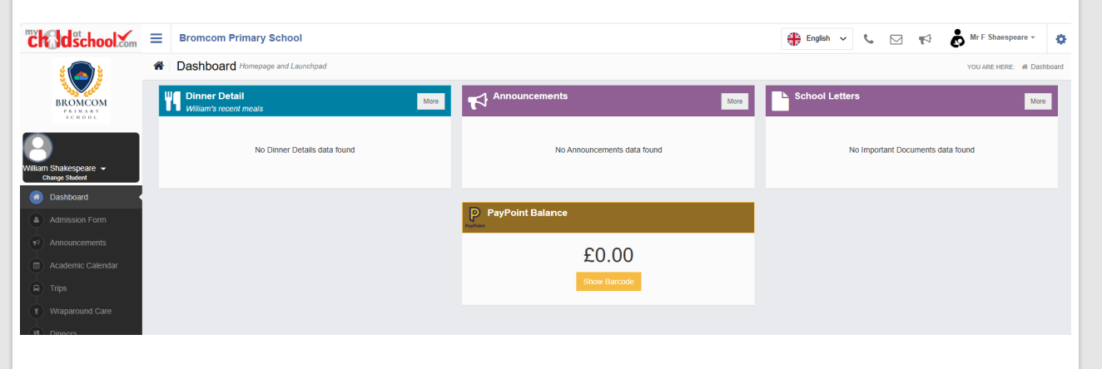
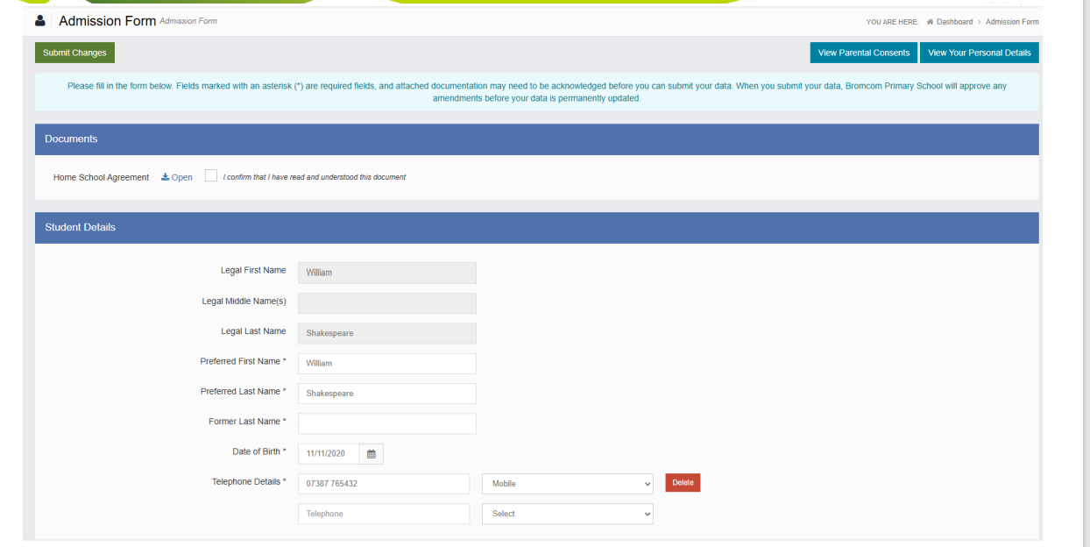

Sending an SMS or Email
To do this from the left Menu go to Students and select one or more Students.
Once you have selected the Students, click the Actions button and select the Send SMS/Email option. (A detailed guide can be found here: How to Send an SMS Message or Email to Students – Bromcom – Documentation Centre
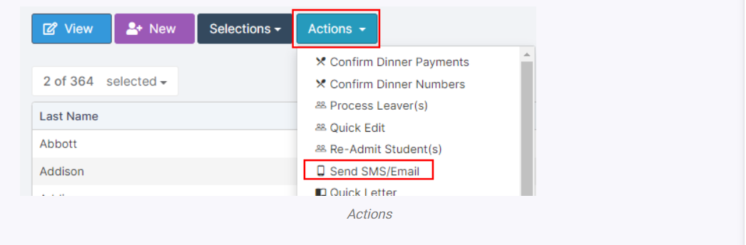

Finalise Admissions - For this process, you will need to go to Modules>Administration>Finalise Admissions. (A detailed guide can be found here: How to Finalise Admissions – Bromcom – Documentation Centre)

Once the page loads, you would then select the desired Pre-Admission group from the dropdown.
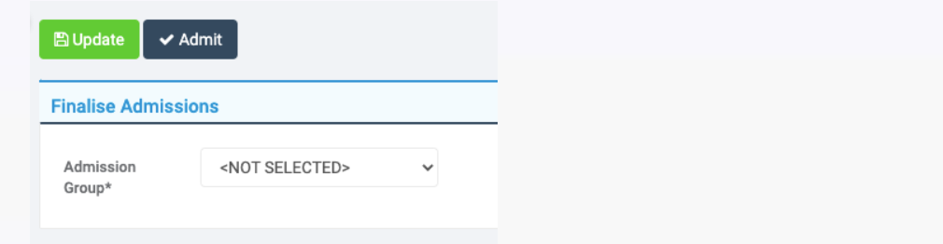
Depending on the group you select, you should see your Pre-Admission Students in this group with a Pre-Admission number.
